xxxx-Part.7d

Date: 2008-03-18

Information Technology – Geographic Information
Framework Data Content Standard
Part 7d: Transit

Contents
Introduction vi
1 Scope 1
2 Normative references 1
3 Maintenance authority 2
3.1 Level of responsibility 2
3.2 Contact information 2
4 Terms and definitions 2
5 Symbols, abbreviated terms, and notations 3
6 Transit system requirements 4
6.1 Introduction 4
6.2 The context of the transit system 5
6.3 TransitFeature 5
6.4 TransitStop 6
6.5 ConnectionSeg 6
6.6 TransitPath 6
6.7 TimePoint 6
6.8 Pattern 6
6.9 TransitRoute 6
6.10 Block 6
6.11 PTVehicle 6
6.12 TransferCluster 6
6.13 Landmark 6
6.14 Facility 6
6.15 Amenity 6
6.16 Fare 6
6.17 Trip 6
7 Code lists 6
7.1 AmenityType code list 6
7.2 FacilityType code list 6
7.3 FareType code list 6
7.4 FarePolicyType code list 6
7.5 ObstacleType code list 6
7.6 PatternType code list 6
7.7 RouteDirectionType code list 6
7.8 StatusType code list 6
7.9 TransitServiceType code list 6
Annex A (informativive) Trip itinerary planning use case 6
A.1 Introduction 6
A.2 Supported operation 6
A.2.1 Overview and description 6
A.2.2 Concept of operations 6
A.2.3 Enumeration of needs 6
A.3 Functional requirements for supported operation 6
A.3.1 Overview of requirements 6
A.3.2 Detailed functional requirements 6
A.4 Mapping data requirements to current transit model 6
A.5 Guidance on how to specify a fare table using TCIP standard on fare collection business objects (NTCIP 1408:2001) 6
A.5.1 General 6
A.5.2 Fare tables and fare policy type 6
A.5.3 Calculating the cost based on fare media type 6
A.5.4 Defining the time period table 6
A.5.5 Defining fare instruments 6
A.5.6 Identifying exceptions 6
Annex B (informative) Public transportation stop inventory sharing use case 6
B.1 Supported operation 6
B.1.1 Overview and description 6
B.2 Enumeration of needs 6
B.3 Functional requirements for supported operation 6
B.3.1 Overview 6
B.4 Mapping data requirements to current transit model 6
Annex C (informative) Unplanned re-routing use case 6
C.1 Supported operation 6
C.1.1 Overview and description 6
C.1.2 Enumeration of needs 6
C.2 Functional requirements for supported operation 6
C.2.1 Overview 6
C.3 Mapping data requirements to current transit model 6
Annex D (informative) Address extension to the transit model 6
Annex E (informative) Bibliography 6
Figures
Figure 1 – The transit system 4
Figure 2 – TransitFeature 6
Figure 3 – TransitStop 6
Figure 4 – ConnectionSeg 6
Figure 5 – TransitPath 6
Figure 6 – TimePoint 6
Figure 7 – Pattern 6
Figure 8 – TransitRoute 6
Figure 9 – Block 6
Figure 10 – PTVehicle 6
Figure 11 – TransferCluster 6
Figure 12 – Landmark 6
Figure 13 – Facility 6
Figure 14 – Amenity 6
Figure 15 – Fare 6
Figure 16 – Trip 6

Figure B.1 – Sample regional bus stop database structure 6

Figure D.1 – Illustration of address segment information requirements 6
Figure D.2 – Suggested information attributes for AddressSeg and Address classes 6
Figure D.3 – Data model extension to support address information transmission 6

Tables
Table 1 – Data dictionary for TransitStop 6
Table 2 – Data dictionary for ConnectionSeg 6
Table 3 – Data dictionary for TransitPath 6
Table 4 – Data dictionary for TimePoint 6
Table 5 – Data dictionary for Pattern 6
Table 6 – Data dictionary for TransitRoute 6
Table 7 – Data dictionary for Block 6
Table 8 – Data dictionary for PTVehicle 6
Table 9 – Data dictionary for TransferCluster 6
Table 10 – Data dictionary for Landmark 6
Table 11 – Data dictionary for Facility 6
Table 12 – Data dictionary for Amenity 6
Table 13 – Data dictionary for Fare 6
Table 14 – Data dictionary for Trip 6
Table 15 – CodeList for AmenityType 6
Table 16 – CodeList for FacilityType 6
Table 17 – CodeList for FareType 6
Table 18 – CodeList for FarePolicyType 6
Table 19 – CodeList for ObstacleType 6
Table 20 – CodeList for PatternType 6
Table 21 – CodeList for RouteDirectionType 6
Table 22 – CodeList for StatusType 6
Table 23 – Codelist for TransitServiceType 6

Table A.1 – Trip itinerary planning (TIP) functional requirements 6
Table A.2 – Trip planning data requirements 6
Table A.3 – Fare definition steps 6
Table A.4 – Fare zone table (FcFareZoneTable) 6
Table A.5 – Fare distance calculations matrix (FcFareDistanceTable) 6
Table A.6 – Data element code values for select FcFareCharacterCost fields 6
Table A.7 – Example of a FcTimePeriod table for weekday (day type) 6
Table A.8 – TCIP definition of various fare instruments 6

Table B.1 – Potential users of shared data 6
Table B.2 – Detailed functional requirements 6

Table C.1 – Unplanned re-routing stakeholders 6
Table C.2 – Detailed functional requirements 6
Table C.3 – Data requirements for rerouting use case 6

Table D.1 – Data dictionary for AddressSeg and Address 6

Foreword
Geographic information, also known as geospatial information, both underlies and is the subject of much of the political, economic, environmental, and security activities of the United States. In recognition of this, the United States Office of Management and Budget issued Circular A-16 (revised 2002), which established the Federal Geographic Data Committee (FGDC) as a coordinating organization.
Work on this standard started under the Geospatial One-Stop e-Government initiative. The standard was developed with the support of the member agencies and organizations of the FGDC and aids in fulfilling a primary objective of the National Spatial Data Infrastructure (NSDI), that is, creation of common geographic base data for seven critical data themes. The seven core data themes are considered framework data of critical importance to the spatial data infrastructure.
As the Geographic Information Framework Data Content Standard was developed using public funds, the U.S. Government will be free to publish and distribute its contents to the public, as provided through the Freedom of Information Act (FOIA), Part 5 United States Code, Section 552, as amended by Public Law No. 104-231, “Electronic Freedom of Information Act Amendments of 1996”.

Introduction
The primary purpose of this part of the Geographic Information Framework Data Content Standard is to support the exchange of transit transportation data. This part seeks to establish a common baseline for the semantic content of transit transportation databases for public agencies and private enterprises. It also seeks to decrease the costs and simplify the exchange of transit transportation data among local, Tribal, State, and Federal users and producers. That, in turn, discourages duplicative data collection. Benefits of adopting this part of the standard also include the long-term improvement of the geospatial transit transportation data within the community, the improved integration of safety, emergency response, and enforcement data, and streamlined maintenance procedures.

Framework Data Content Standard – Transit
- Scope
The Geographic Information Framework Data Content Standard, Part 7d: Transit defines components of a model for describing public transportation (transit) systems, which is one of five modes that compose the Transportation theme of the digital geospatial data framework. The primary purpose of the Transit part of the standard is to support the exchange of spatial and temporal data related to public transportation. The emphasis in developing this part has been on supporting data exchange on a regional level to support itinerary planning, infrastructure inventories, and re-routing applications. It is the intent of this part to develop a consensus around a set of common definitions for real world transportation features to advance the goals of the NSDI. It is the intent of the part to set a common baseline that will foster the widest possible set of applications of public transportation data for both user and producer. It is also intended to foster improvements in the common spatial data infrastructure through enhanced data sharing and the reduction of redundant data production.
As a transportation mode, transit differs substantially from other modes such as rail and road in that core operational features of the transit system consist of spatial and temporal elements that rest upon the transportation infrastructure. The classes, features, and characteristics included in Transit (Part 7d) were developed as part of a comprehensive review of several use cases that have been documented here. Although these use cases addressed the operational requirements of a broad selection of transit business scenarios, they did not provide sufficient input to design an all-inclusive transit model. Additional use cases will be required to identify the universe of classes, features, and characteristics necessary to fully describe transit geographic base data.
This part of the Federal Geographic Data Content Standard can be implemented using a variety of software packages and is designed to accommodate data with or without geometry. It is designed to be able to depict the complete transit system at all levels of service and all functional classes that may be defined by a data-providing agency.
This part of the standard is a companion to the Transportation Base (Part 7). It is also one of five thematic parts devoted to one of five primary modes of transportation: Air (Part 7a), Rail (Part 7b), Roads (Part 7c), Transit (Part 7d), and Inland Waterways (Part 7e). There are a number of issues common to the transportation domain that, because of their broader applications are covered in the Transportation Base (Part 7). Other issues, specific to the Transit part, are discussed in the informative annexes.
Subsequent revisions to this part of the standard may lead to a more thorough treatment of specific technical and business issues, especially as the part is implemented. The developers of the current Transit part recognize the need to extend the model being developed in the Rail (Part 7b) part for the purposes of transit modeling.
The Transit part includes a data dictionary based on the conceptual schema presented below. To conform to this part, the user shall satisfy the requirements of the data dictionary. The user's conforming dataset shall include a value for each mandatory element, and a value for each conditional element for which the condition is true. It may contain values for any optional element. The data type of each value shall be that specified for the element in the data dictionary, and the value shall lie within the specified domain. This part only specifies the special requirements of conformance for a dataset containing transportation information. Conformance to the part requires additional actions specified in the Base Document (Part 0) and the appropriate modal parts 7a, 7b, 7c, 7d, and 7e.
- Normative references
Annex A of the Base Document (Part 0) lists normative references applicable to two or more parts of the standard, including those other than the transportation parts. No additional normative references are specified in the Transportation Base (Part 7). Informative references applicable to the Transit part only are listed in Annex E. Informative references applicable to two or more transportation parts only are listed in Annex C of the Transportation Base. Annex D of the Base Document lists informative references applicable to two or more of the parts, including those other than the transportation parts.
- Maintenance authority
  - Level of responsibility
The FGDC is the responsible organization for coordinating work on all parts of the Geographic Information Framework Data Content Standard. The United States Department of Transportation (USDOT), working with the FGDC, is the responsible organization for coordinating work on the Geographic Information Framework Data Content Standard, Part 7: Transportation Base and subparts (Parts 7a, 7b, 7c, and 7d, excluding 7e) and is directly responsible for development and maintenance of the transportation parts (excluding 7e) of the Framework Data Content Standard.
  - Contact information
Address questions concerning this part of the standard to:
Federal Geographic Data Committee Secretariat
c/o U.S. Geological Survey
590 National Center
Reston, Virginia 20192 USA
Telephone: (703) 648-5514
Facsimile: (703) 648-5755
Internet (electronic mail): gdc@fgdc.gov
WWW Home Page: http://fgdc.gov
- Terms and definitions
Definitions applicable to the Transit part are listed here. Other terms and definitions applicable to multiple transportation parts of the standard are listed in the Transportation Base (Part 7). More general terms and definitions can be found in the Base Document (Part 0) part of the standard. Users are advised to consult these documents for a complete set of definitions.

4.1
amenity
elements of a physical feature, a fixed location, or a transit facility
NOTE An amenity may be described by one or more characteristics, or attributes, such as the year of construction or its current condition.
EXAMPLE The amenities of a public transportation stop may include the shelter, platform announcement panel, and benches.

4.2
block
sequence of revenue and non-revenue trips to which a transit vehicle may be assigned
NOTE A block begins when the vehicle leaves a vehicle base and ends when it returns to a vehicle base.

4.3
facility
physical place that is used by a transit agency
EXAMPLE Transit facilities can include vehicle base, stop point, transit center, or administration building.

4.4
pattern
unique, non-branching, ordered sequence of time points, street links, or public transportation stops to be followed by a transit vehicle in scheduled service

4.5
public transportation vehicle
revenue conveyance in a transit fleet

4.6
stop
location where public transport customers may board or alight from a transit vehicle in revenue service

4.7
time point
location along a pattern where trips are assigned arrival, dwell, or departure time periods

4.8
transfer cluster
collection of one or more public transportation stops where transfer between routes is convenient

4.9
trip
one-way scheduled movement of a transit vehicle between starting and ending time points
EXAMPLE A revenue-service trip will be an instance of a pattern.
- Symbols, abbreviated terms, and notations
The following symbols, abbreviations, and notations are applicable to the Transit part. Those common to two or more transportation parts are listed in the Transportation Base (Part 7). Symbols, abbreviations, and notations applicable to multiple parts, including the transportation parts, are listed in the Base Document (Part (0).
ADA – American Disabilities Act
CIS – Customer Information Service
ITS – Intelligent Transportation System
PTVehicle – Public Transit Vehicle
TA – Transit authority
TIP – Trip Itinerary Planning
USNG – United States National Grid
WMATA – Washington Metropolitan Area Transit Authority
- Transit system requirements
  - Introduction
The transit system model describes the geographic locations, interconnectedness, and characteristics of public transportation in the larger transportation system. The transit system includes physical and non-physical components representing primarily the bus mode of travel, though subsequent versions of this part of the standard will include rail transit (for example, subway, light rail) as well.
Transit systems include physical infrastructure components such as public transportation stops and facilities, as well as non-physical features such as routes and patterns that are used to define the movement of public transportation vehicles.

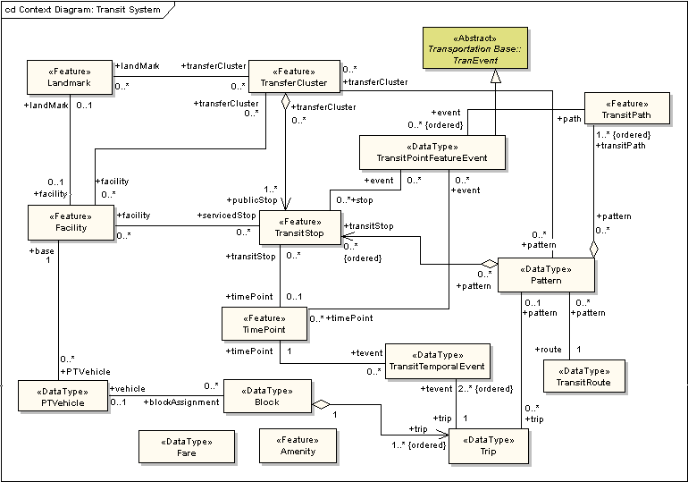
Figure 1 – The transit system

As shown in Figure 1, the framework transportation transit system has several principal features, including TransitStop, TimePoint, TransitPath, and Pattern. Transit paths are the portions of the physical transportation system (that is to say, roads) that are defined by the application domain using some business rules that may vary according to the business and technical requirements.
Other features shown include:
- TransferCluster
- Landmark
- Facility
- PTVehicle
- Amenity
- Block
- TransitRoute
- Trip
- Fare
These are discussed in subsequent sections.
  - The context of the transit system
This version of the Transit part is closely related to the Transportation Base (see Figure 2 in the Transportation Base). To ensure maximum utility in a variety of contexts, this transit model does not prescribe any specific business rules for the segmentation of the transportation network. The focus of this part is to define a way to encode transit features and their attributes.
  - TransitFeature
TransitFeatures are objects that represent real world public transport phenomena. TransitFeature is shown in Figure 2 and is a subtype of TranFeature. TimePoint, Facility, Amenity, and TransitStop are all subtypes of TransitFeature.

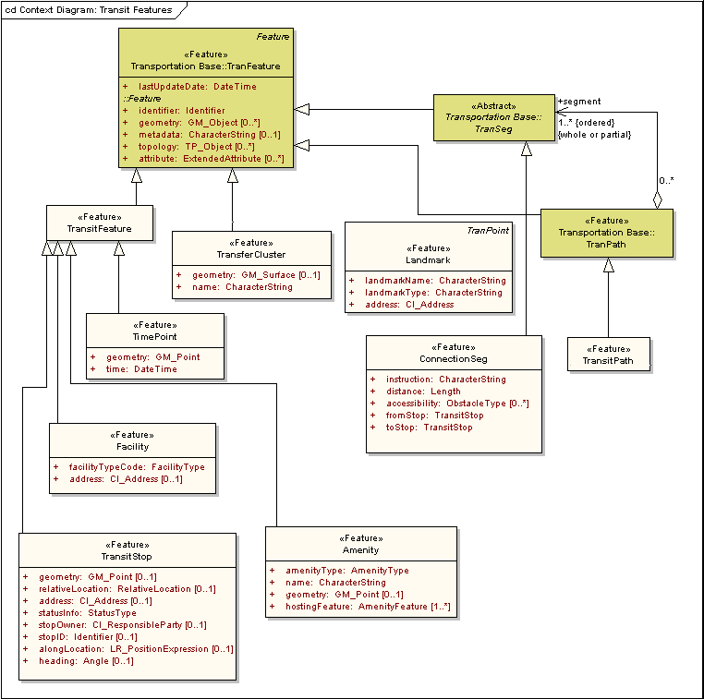
Figure 2 – TransitFeature

  - TransitStop
TransitStop is a central feature of the transit model because it conveys positional information that represents the key business need of providing service to travelers. For that reason, the feature is deemed essential to the exchange of transit data. The TransitStop is shown in Figure 3 as a type of TransitFeature. TransitStop has the geometry of type GM_Point as defined in ISO 19107.
TransitStop is a Facility and may optionally be represented by its geometry. The TransitStop may be contained in a cluster of stops that form a TransferCluster wherein a transit rider may change routes. A TransitStop may optionally be associated with a TimePoint. A Pattern may be represented as a series of zero or more ordered TransitStops, or a series of TransitStops may be used to define a path along a TransitPath. The TransitStop is tied to the coverage geometry as well as the linear description of its environment including relativeLocation associated with the nearest intersection, alongLocation, heading and address. Service status conditions such as statusInfo and stopOwner are key attributes to determine usage and responsibility.

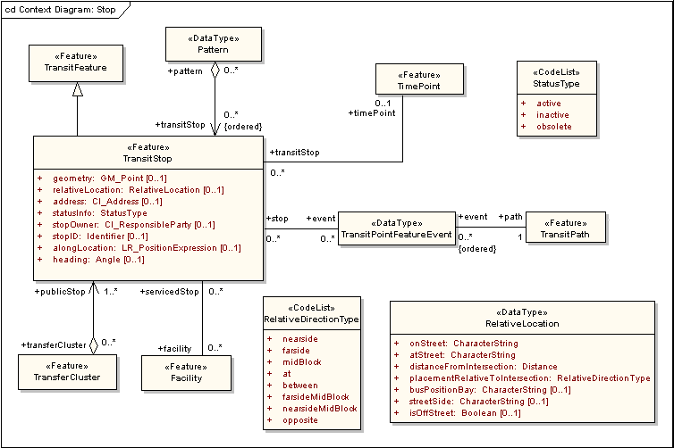
Figure 3 – TransitStop
Table 1 – Data dictionary for TransitStop
Line | Name/Role Name | Definition | Obligation/  Condition | Maximum Occurrence | Data Type | Domain
 | TransitFeature |  |  |  | <<Feature>>
 | TransitStop |  |  |  | <<Feature>> | Lines 3-15
 | geometry | Shape and geo-location of a TransitStop | O | 1 | <<Type>>  GM_Point | Defined in ISO 19107
 | relativeLocation | Place near another known place | O | 1 | <<DataType>>  RelativeLocation
 | address | Single combination of street name, postal community, State, and postal code | O | 1 | <<DataType>>  CI_Address | Defined in ISO 19115
 | statusInfo | Information on operational type applicable to the stop | M | 1 | <<CodeList>>  StatusType | Unrestricted
 | stopOwner | Organization that has jurisdiction over the transit stop | O | 1 | <<DataType>>  CI_ResponsibleParty | Defined in ISO 19115
 | stopID | Unique identifer for a transit stop | O | 1 | <<DataType>>  Framework::Identifier | Unrestricted
 | alongLocation | Place next to a street or address | O | 1 | <<Type>>  LR_PositionExpression | Defined in ISO 19133
 | heading | Direction of travel or orientation of a transit vehicle | O | 1 | Angle
 | Role name: pattern |  | O | * | <<DataType>>  Pattern
 | Role name: timePoint |  | O | 1 | <<Feature>>  TimePoint
 | Role name: event |  | O | * | <<DataType>>  TransitPointFeature  Event
 | Role name: facility |  | O | * | <<Feature>>  Facility
 | Role name: transferCluster |  | O | * | <<Feature>>  TransferCluster
 | TimePoint |  |  |  | <<Feature>> | Line 17
 | Role name: transitStop |  | O | * | <<Feature>>  TransitStop
 | TransitPath |  |  |  | <<Feature>> | Line 19
 | Role name: event |  | O | * | <<DataType>>  TransitPointFeature  Event
 | Facility |  |  |  | <<Feature>> | Line 21
 | Role name: servicedStop |  | O | * | <<Feature>>  TransitStop
 | TransferCluster |  |  |  | <<Feature>> | Line 23
 | Role name: publicStop |  | 1 | * | <<Feature>>  TransitStop
 | Pattern |  |  |  | <<DataType>> | Line 25
 | Role name: transitStop |  | O | * | <<Feature>>  TransitStop
 | TransitPointFeatureEvent |  |  |  | <<DataType>> | Lines 27-28
 | Role name: path |  | M | 1 | <<Feature>>  TransitPath
 | Role name: stop |  | O | * | <<Feature>>  TransitStop
 | RelativeLocation |  |  |  | <<DataType>> | Lines 30-36
 | onStreet | On street carriageway | M | 1 | CharacterString | Unrestricted
 | atStreet | At street | M | 1 | CharacterString | Unrestricted
 | distanceFromIntersection | Distance from intersection | M | 1 | Distance | Real
 | placementRelativeToIntersection | Feature placement relative to intersection | M | 1 | <<CodeList>  RelativeDirectionType | Unrestricted
 | busPositionBay | Position of bus bay | O | 1 | CharacterString | Unrestricted
 | streetSide | Side street | O | 1 | CharacterString | Unrestricted
 | isOffStreet | Is on (or off) street | O | 1 | Boolean | True or False

  - ConnectionSeg
A ConnectionSeg is a linear path allowing transit riders to move from one TransitStop to another, and is shown in Figure 4. The segment may be defined as a walking path, bike path, escalator, or other modal connection. ConnectionSeg is a subtype of TranSeg and describes a linear feature that allows a transit rider to move between TransitStops. Attributes include distance, fromStop, toStop, and connection instructions. Accessibility information in the form of ObstacleTypes may optionally be provided for ConnectionSegs.

Figure 4 – ConnectionSeg
Table 2 – Data dictionary for ConnectionSeg
Line | Name/Role Name | Definition | Obligation/  Condition | Maximum Occurrence | Data Type | Domain
 | ConnectionSeg |  |  |  | <<Feature>> | Lines 38-42
 | instruction | Suitable ordered set of directions (TranSegs to follow or turns to make) that describe in plain English how to get from fromStop to toStop (for example, walking directions between to places) | M | 1 | CharacterString | Unrestricted
 | distance | Length of the ConnectionSegment | M | 1 | Length | Real
 | accessibility | Conditions that prevent persons with disabilities from using/traversing the ConnectionSegment | O | * | <<CodeList>>  ObstacleType | Unrestricted
 | fromStop | Stop point identifier wherein the ConnectionSegment starts | M | 1 | <<Feature>>  TransitStop | Unrestricted
 | toStop | Stop point identifier wherein the ConnectionSegment ends | M | 1 | <<Feature>>  TransitStop | Unrestricted

  - TransitPath
TransitPath is a linear section of the transit network, which is designed for the movement of PTVehicles. TransitPath is a subtype of TranPath and is shown in Figure 5. Consequently, TransitPath has geometry of type GM_MultiCurve as defined in ISO 19107, and a topology of type TP_Complex. A TransitPath is an ordered set of zero or more TimePoint, TransitStop, or transportation segments from TranPath. Each TimePoint or TransitStop occurs at a location along the TransitPath. A TransitPath may also be known as a time point interval, route segment, variant or route pattern. TransitPaths may optionally have one or more patterns associated with it. These options reflect the wide variety of business practices in the transit community.

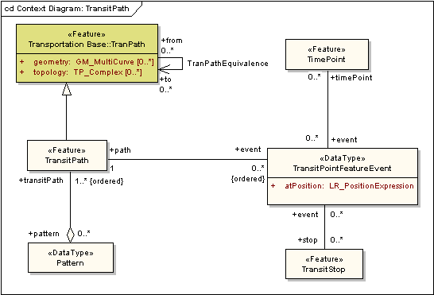
Figure 5 – TransitPath
Table 3 – Data dictionary for TransitPath
Line | Name/Role Name | Definition | Obligation/  Condition | Maximum Occurrence | Data Type | Domain
 | TransitPath |  |  |  | <<Feature>> | Lines 44-45
 | Role name: event |  | O | * | <<DataType>>  TransitPointFeature  Event
 | Role name: pattern |  | O | * | <<DataType>>  Pattern
 | Pattern |  |  |  | <<DataType>> | Line 47
 | Role name: transitPath |  | M | * | <<Feature>>  TransitPath
 | TimePoint |  |  |  | <<Feature>> | Line 49
 | Role name: event |  | O | * | <<DataType>>  TransitPointFeature  Event
 | TransitStop |  |  |  | <<Feature>> | Line 51
 | Role name: event |  | O | * | <<DataType>>  TransitPointFeature  Event
 | TransitPointFeatureEvent |  |  |  | <<DataType>> | Lines 53-56
 | atPosition |  | M | 1 | <<Type>>  LR_PositionExpression | Defined in ISO 19133
 | Role name: path |  | M | 1 | <<Feature>>  TransitPath
 | Role name: timePoint |  | O | * | <<Feature>>  TimePoint
 | Role name: stop |  | O | * | <<Feature>>  TransitStop

  - TimePoint
The TimePoint is a location where trips are assigned arrival, dwell, or departure time periods. TimePoint is a subtype of TransitFeature and is shown in Figure 6. The position of a TimePoint is expressed as type GM_Point. One or more TransitStops may optionally be associated with a TimePoint, as they sometimes (but not always) are associated with a TimePoint as part of the scheduling process. An ordered sequence of TimePoints demarcates a Trip. Each TimePoint in the sequence becomes a TransitTemporalEvent of the Trip. A TimePoint may occur more than once in a single trip, however, each occurrence is a unique temporal event. A TimePoint can be associated with zero to many (non-ordered) TransitTemporalEvents.

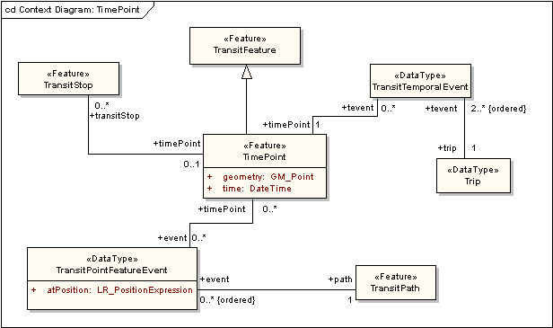
Figure 6 – TimePoint
Table 4 – Data dictionary for TimePoint
Line | Name/Role Name | Definition | Obligation/  Condition | Maximum Occurrence | Data Type | Domain
 | TransitFeature |  |  |  | <<Feature>>
 | TransitStop |  |  |  | <<Feature>> | Line 59
 | Role name: timePoint |  | O | 1 | <<Feature>>  TimePoint
 | TimePoint |  |  |  | <<Feature>> | Lines 61-65
 | geometry | Shape and geo-location of a TimePoint | M | 1 | <<Type>>  GM_Point | Defined in ISO 19107
 | time | Point or period when something occurs | M | 1 | DateTime | Valid historical or current time
 | Role name: event |  | O | * | <<DataType>>  TransitPointFeature  Event
 | Role name: transitStop |  | O | * | <<Feature>>  TransitStop
 | Role name: event |  | O | * | <<DataType>>  TransitTemporalEvent
 | TransitPath |  |  |  | <<Feature>> | Line 67
 | Role name: event |  | O | * | <<DataType>>  TransitPointFeature  Event
 | TransitPointFeatureEvent |  |  |  | <<DataType>> | Lines 69-71
 | atPosition |  | M | 1 | <<Type>>  LR_PositionExpression | Defined in ISO 19133
 | Role name: timePoint |  | O | * | <<Feature>>  TimePoint
 | Role name: path |  | M | 1 | <<Feature>>  TransitPath
 | Trip |  |  |  | <<DataType>> | Line 73
 | Role name: event |  | M | * | <<DataType>>  TransitTemporalEvent
 | TransitTemporalEvent |  |  |  | <<DataType>> | Lines 75-76
 | Role name: timePoint |  | M | 1 | <<Feature>>  TimePoint
 | Role name: trip |  | M | 1 | <<DataType>>  Trip

  - Pattern
Pattern, as shown in Figure 7, is defined as an ordered sequence of TransitStops or TransitPaths that is followed by a transit vehicle in scheduled service. A Pattern may consist of zero to many ordered TransitStops or one to many ordered TransitPaths. A Pattern has one TransitRoute associated with it. Optionally, a Pattern may have one or more TransferClusters and one or more Trips associated with it.

Figure 7 – Pattern
Table 5 – Data dictionary for Pattern
Line | Name/Role Name | Definition | Obligation/  Condition | Maximum Occurrence | Data Type | Domain
 | TransferCluster |  |  |  | <<Feature>> | Line 78
 | Role name: pattern |  | O | * | <<DataType>>  Pattern
 | TransitStop |  |  |  | <<Feature>> | Line 80
 | Role name: pattern |  | O | * | <<DataType>>  Pattern
 | TransitPath |  |  |  | <<Feature>> | Line 82
 | Role name: pattern |  | O | * | <<DataType>>  Pattern
 | Pattern |  |  |  | <<DataType>>> | Lines 84-92
 | patternType | Class of Pattern | O | 1 | <<CodeList>>  PatternType | Unrestricted
 | routeDirection | Description of the bearing of a route | O | 1 | <<CodeList>>  RouteDirectionType | Unrestricted
 | transitServiceType | Class of the operations provision to the customer such as regular, express, charter, and so on | O | 1 | <<CodeList>>  TransitServiceType | Unrestricted
 | timetableVersion | Unique identifier that associates the parts of a transit schedule | O | 1 | CharacterString | Unrestricted
 | Role name: transferCluster |  | O | * | <<Feature>>  TransferCluster
 | Role name: transitStop |  | O | * | <<Feature>>  TransitStop
 | Role name: transitPath |  | M | 1 | <<Feature>>  TransitPath
 | Role name: trip |  | O | * | <<DataType>>  Trip
 | Role name: route |  | M | 1 | <<DataType>>  TransitRoute
 | Trip |  |  |  | <<DataType>> | Line 94
 | Role name: pattern |  | O | 1 | <<DataType>>  Pattern
 | TransitRoute |  |  |  | <<DataType>> | Line 96
 | Role name: pattern |  | O | * | <<DataType>>  Pattern

  - TransitRoute
A TransitRoute is a collection of patterns in revenue service with a common identifier. As shown in Figure 8, TransitRoute is a DataType associated with Patterns. One or more Patterns may optionally be associated with a TransitRoute and one TransitRoute is associated with a Pattern. A TransitRoute contains attributes that support the Transit Rider. The timeTableHeader is a summary of publically recognized TimePoints contained in a group of Patterns oriented in the same route direction, and is used to generate timetables.

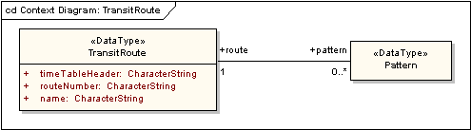
Figure 8 – TransitRoute
Table 6 – Data dictionary for TransitRoute
Line | Name/Role Name | Definition | Obligation/  Condition | Maximum Occurrence | Data Type | Domain
 | Pattern |  |  |  | <<DataType>> | Line 98
 | Role name: route |  | M | 1 | <<DataType>>  TransitRoute
 | TransitRoute |  |  |  | <<DataType>> | Lines 100-102
 | timeTableHeader | Sequence of TimePoint identifiers and/or their names used to define the order of TimePoints for all Patterns of the TransitRoute in a RouteDirection | M | 1 | CharacterString | Unrestricted
 | routeNumber | Unique identifier for a TransitRoute recognized by the agency | M | 1 | CharacterString | Unrestricted
 | name | Unique identifier for a TransitRoute recognized by the customer | M | 1 | CharacterString | Unrestricted
 | Role name: pattern |  | O | * | <<DataType>>  Pattern

  - Block
A Block is a sequence of trips over which a PTVehicle is assigned from pull out time to pull in time. A Block is associated with Trip as well as PTVehicle. Block is shown in Figure 9 and its composition includes scheduling information such as pull-in time, pull-out time, the pull-in base and pull-out base, status, and timetable version. There may be one-to-many ordered Trips associated with a Block, and one PTVehicle may optionally be associated with a Block.

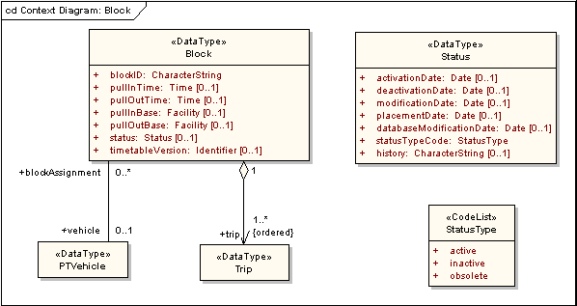
Figure 9 – Block
Table 7 – Data dictionary for Block
Line | Name/Role Name | Definition | Obligation/  Condition | Maximum Occurrence | Data Type | Domain
 | Block |  |  |  | <<DataType>> | Lines 105-113
 | blockID | Unique identifier for a block | M | 1 | CharacterString | Unrestricted
 | pullinTime | Moment at which a transit vehicle is scheduled to arrive at its Base from its last TimePoint of its scheduled revenue service | O | 1 | Time | Valid historical or current time
 | pullOutTime | Moment at which a transit vehicle is scheduled to depart its Base to arrive at its first TimePoint of its scheduled revenue service | O | 1 | <<Feature>>  Time | Valid historical or current time
 | pullInBase | Facility in which a revenue vehicle arrives after it completes its scheduled revenue service | O | 1 | <<Feature>>  Facility | Unrestricted
 | pullOutBase | Facility from which a revenue vehicle leaves in order to begin its scheduled revenue service | O | 1 | Facility | Unrestricted
 | status | Condition of a person, place or thing | O | 1 | <<DataType>>  Status
 | timetableVersion | Unique identifier that associates the parts of a transit schedule | O | 1 | <<DataType>>  Framework::Identifier | Unrestricted
 | Role name: trip |  | M | * | <<DataType>>  Trip
 | Role name: vehicle |  | O | 1 | <<DataType>>  PTVehicle
 | Status |  |  |  | <<DataType>> | Lines 115-121
 | activationDate |  | O | 1 | Date | Unrestricted
 | deactivationDate |  | O | 1 | Date | Unrestricted
 | modificationDate |  | O | 1 | Date | Unrestricted
 | placementDate |  | O | 1 | Date | Unrestricted
 | databaseModificationDate |  | O | 1 | Date | Unrestricted
 | statusTypeCode |  | M | 1 | <<CodeList>>  StatusType | Unrestricted
 | history |  | O | 1 | CharacterString | Unrestricted
 | Trip |  |  |  | <<DataType>>
 | PTVehicle |  |  |  | <<DataType>> | Line 124
 | Role name: blockAssignment |  | O | * | <<DataType>>  Block

  - PTVehicle
PTVehicle is the data type that contains the public transportation vehicle, and PTVehicle refers to any public transit conveyance. PTVehicle is shown in Figure 10, and contains information about the vehicle including vehicle capacity, vehicle type, as well as real-time routing and scheduling status. A PTVehicle is assigned to one vehicle base or Facility (at a time), and zero to many Blocks may be associated with a PTVehicle.

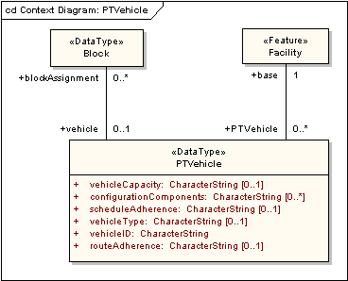
Figure 10 – PTVehicle
Table 8 – Data dictionary for PTVehicle
Line | Name/Role Name | Definition | Obligation/  Condition | Maximum Occurrence | Data Type | Domain
 | Facility |  |  |  | <<Feature>> | Line 126
 | Role name: PTVehicle |  | O | * | <<DataType>>  PTVehicle
 | PTVehicle |  |  |  | <<DataType>> | Lines 127-135
 | vehicleCapacity | Maximum number of people that can safely ride the vehicle at any one time | O | 1 | CharacterString | Unrestricted
 | configurationComponents | List of physical input and output components | O | * | CharacterString | Unrestricted
 | scheduleAdherence | Time that a PTVehicle is ahead or behind its scheduled trip. The convention used is positive numbers indicate the PTVehicle is late and negative numbers indicating the PTVehicle is early | O | 1 | CharacterString | Unrestricted
 | vehicleType | Kind of vehicle within the agency fleet | O | 1 | CharacterString | Unrestricted
 | vehicleID | Unique identifier for a PTVehicle | M | 1 | CharacterString | Unrestricted
 | routeAdherence | Distance by which a PTVehicle is outside its expected path | O | 1 | CharacterString | Unrestricted
 | Role name: block assignment |  | O | * | <<DataType>>  Block
 | Role name: base |  | M | 1 | <<Feature>>  Facility
 | Block |  |  |  | <<DataType>> | Line 137
 | Role name: vehicle |  | O | 1 | <<DataType>>  PTVehicle

  - TransferCluster
The TransferCluster is closely related to TransitStop since it is a collection of TransitStops where transit passengers can change routes. The TransferCluster has a geometry type of GM_Polygon as defined in ISO 19107 and is shown in Figure 11. The TransferCluster may be associated with zero to many Landmarks, or may be associated with zero to many Facilities. The TransferCluster is also a subtype of TranFeature. The TransferCluster may also optionally be associated with one or more Patterns. One or more TransitStops are aggregated to form a TransferCluster.

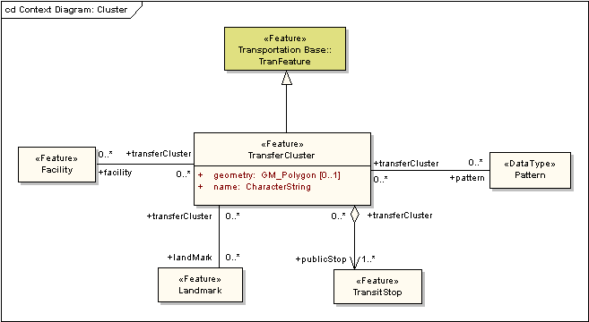
Figure 11 – TransferCluster
Table 9 – Data dictionary for TransferCluster
Line | Name/Role Name | Definition | Obligation/  Condition | Maximum Occurrence | Data Type | Domain
 | TransferCluster |  |  |  | <<Feature>> | Lines 139-144
 | geometry | Shape and geo-location of a TransferCluster | O | 1 | <<Type>>  GM_Polygon | Defined in ISO 19107
 | name | Designation of a TransferCluster | M | 1 | CharacterString | Unrestricted
 | Role name: pattern |  | O | * | <<DataType>>  Pattern
 | Role name: publicStop |  | M | * | <<Feature>>  TransitStop
 | Role name: landMark |  | O | * | <<Feature>>  Landmark
 | Role name: facility |  | O | * | <<Feature>>  Facility
 | Facility |  |  |  | <<Feature>> | Line 146
 | Role name: transferCluster |  | O | * | <<Feature>>  TransferCluster
 | Landmark |  |  |  | <<Feature>> | Line 148
 | Role name: transferCluster |  | O | * | <<Feature>>  Transfercluster
 | TransitStop |  |  |  | <<Feature>> | Line 150
 | Role name: transferCluster |  | O | * | <<Feature>>  TransferCluster
 | Pattern |  |  |  | <<DataType>> | Line 152
 | Role name: transferCluster |  | O | * | <<Feature>>  TransferCluster

  - Landmark
A Landmark is a point of interest. Landmark is shown in Figure 12 and is a subtype of TranFeature. Landmark has a geometry type of GM_Point as defined in ISO 19107. Landmark is comprised of a name, a type, and an address. There may be zero-to-many TransferClusters associated with a Landmark. One Facility may optionally be associated with a Landmark.

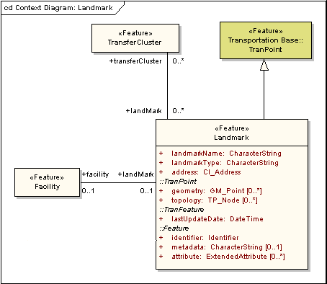
Figure 12 – Landmark
Table 10 – Data dictionary for Landmark
Line | Name/Role Name | Definition | Obligation/  Condition | Maximum Occurrence | Data Type | Domain
 | TransferCluster |  |  |  | <<Feature>> | Line 154
 | Role name: landMark |  | O | * | <<Feature>>  Landmark
 | Landmark |  |  |  | <<Feature>> | Lines 156-166
 | landMarkName | Designation for a Landmark | M | 1 | CharacterString | Unrestricted
 | landMarkType | Category of Landmark | M | 1 | CharacterString | Unrestricted
 | address | Single combination of street name, postal community, State, and postal code | M | 1 | <<DataType>>  CI_Address | Defined in ISO 19115
 | Transportation Base::  TranPoint::geometry | Shape and geolocation of a feature | O | * | <<Type>>  GM_Point | Defined in ISO 19107
 | Transportation Base::  TranPoint::topology | Connectivity of the participating elements | O | * | <<Type>>  TP_Node
 | Transportation Base::  TranFeature::lastUpdateDate | Timestamp indicating when the Landmark object was last edited | M | 1 | DateTime | Valid historical or current date and time
 | Framework::Feature:: identifier | Feature identifier for the Landmark | M | 1 | <<DataType>>  Framework::Identifier | Unrestricted
 | Framework::FeatureCollection::  Feature::metadata | Structured or unstructured metadata as defined by the community of practice | O | 1 | CharacterString | May be text or structured metadata fragment
 | Framework::Feature::attribute | Producer-defined attribute for inclusion in transfer | O | 1 | <<DataType>>  Framework::ExtendedAttribute | Unrestricted
 | Role name: transferCluster |  | O | * | <<Feature>>  TransferCluster
 | Role name: facility |  | O | 1 | <<Feature>>  Facility
 | Facility |  |  |  | <<Feature>> | Line 168
 | Role name: landMark |  | O | 1 | <<Feature>>  Landmark

  - Facility
A Facility is a physical place that is used by a transit agency. Examples of transit facilities include parking locations, rail yards, and administrative offices. The Facility is a subtype of TransitFeature and is shown in Figure 13. Facility consists of a facility type code (code list given in Figure 13 below) and an address. One or more TransferClusters, TransitStops, and PTVehicles may optionally be associated with a Facility. One Landmark may optionally be associated with a facility. Figure 13 also shows that Facility is a subtype of TransitFeature.

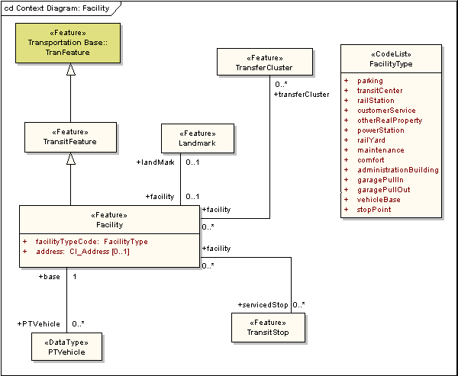
Figure 13 – Facility
Table 11 – Data dictionary for Facility
Line | Name/Role Name | Definition | Obligation/  Condition | Maximum Occurrence | Data Type | Domain
 | TransitFeature |  |  |  | <<Feature>>
 | Facility |  |  |  | <<Feature>> | Lines 171-176
 | facilityTypeCode | Designation for a class of facility | M | 1 | <<CodeList>>  FacilityType | Unrestricted
 | address | Single combination of street name, postal community, State, and postal code | O | 1 | <<DataType>>  CI_Address | Defined in ISO 19115
 | Role name: landMark |  | O | 1 | <<Feature>>  Landmark
 | Role name: transferCluster |  | O | 1 | <<Feature>>  TransferCluster
 | Role name: servicedStop |  | O | * | <<Feature>>  TransitStop
 | Role name: PTVehicle |  | O | * | <<DataType>>  PTVehicle
 | Landmark |  |  |  | <<Feature>> | Line 178
 | Role name: faclity |  | O | 1 | <<Feature>>  Facility
 | TransferCluster |  |  |  | <<Feature>> | Line 180
 | Role name: facility |  | O | * | <<Feature>>  Facility
 | TransitStop |  |  |  | <<Feature>> | Line 182
 | Role name: facility |  | O | * | <<Feature>>  Facility
 | PTVehicle |  |  |  | <<DataType>> | Line 184
 | Role name: base |  | M | 1 | <<Feature>>  Facility

  - Amenity
Amenity refers to the elements of a physical feature, a fixed location, or a transit facility and is shown in Figure 14. The amenities of a public transportation stop, for example, may include the shelter, schedule displays, and bike racks. Amenity is a subtype of TransitFeature and may have a geometry of GM_Point. Amenity consists of the amenityType (code list given in Figure 14), name, and the hostingFeature, a TransitStop or Facility.

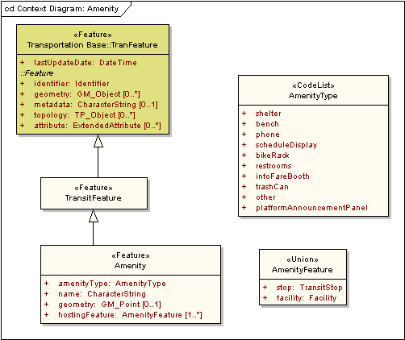
Figure 14 – Amenity
Table 12 – Data dictionary for Amenity
Line | Name/Role Name | Definition | Obligation/  Condition | Maximum Occurrence | Data Type | Domain
 | TransitFeature |  |  |  | <<Feature>>
 | Amenity |  |  |  | <<Feature>> | Lines 184-188
 | amenityType | Class of amenity | M | 1 | <<CodeList>>  AmenityType | Unrestricted
 | name | Designation for an amenity | M | 1 | CharacterString | Unrestricted
 | geometry | Shape and geo-location of a Amenity | O | 1 | <<Type>>  GM_Point | Defined in ISO 19107
 | hostingFeature | Feature with which this amenity is associated | M | * | <<Union>>  AmenityFeature | Unrestricted
 | AmenityFeature |  |  |  | <<Union>> | Lines 192-193
 | stop |  | M | 1 | TransitStop
 | facility |  | M | 1 | Facility

  - Fare
The Fare is a data type that describes the cost for riding a transit vehicle. Fare is shown in Figure 15. The fareValue is expressed as a real number, and is based on the fromStop and the toStop attributes. The FareType is the type of fare, such as reduced (for example, senior citizen, student, and so on), full-fare, transfer, or special. FarePolicyTypes are the methods by which customer fares are determined within an agency or between agencies. The code lists for FareType and FarePolicyType are given in Figure 15.

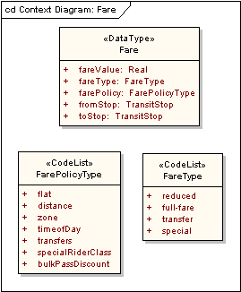
Figure 15 – Fare
Table 13 – Data dictionary for Fare
Line | Name/Role Name | Definition | Obligation/  Condition | Maximum Occurrence | Data Type | Domain
 | Fare |  |  |  | <<DataType>> | Lines 195-199
 | fareValue | Monetary or ride amount | M | 1 | Real | Valid real number
 | fareType | Method by which the fareValue is determined | M | 1 | <<CodeList>>  FareType | Unrestricted
 | farePolicy | Method in which the fare structure is organized | M | 1 | <<CodeList>>  FarePolicyType | Unrestricted
 | fromStop | Origin of a customer's transit ride | M | 1 | <<Feature>>  TransitStop | Unrestricted
 | toStop | Destination of a customer’s transit ride | M | 1 | <<Feature>>  TransitStop | Unrestricted

  - Trip
A Trip is a one-way scheduled movement of a transit vehicle between starting and ending TimePoints. Each trip is an instance of a Pattern. Trip is a data type and is shown in Figure 16. One Pattern may optionally be associated with a Trip. One or more ordered Trips are aggregated to create one Block. Trip is demarcated by an ordered sequence of TimePoints. A Trip is composed of two or more ordered 'times' (TransitTemporalEvent instances). Each TimePoint in the sequence becomes a TransitTemporalEvent of the Trip. A TimePoint may occur more than once in a single trip, however, each occurrence is a unique temporal event.

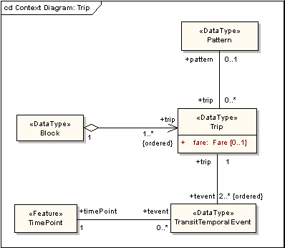
Figure 16 – Trip

Table 14 – Data dictionary for Trip
Line | Name/Role Name | Definition | Obligation/  Condition | Maximum Occurrence | Data Type | Domain
 | TimePoint |  |  |  | <<Feature>> | Line 201
 | Role name: tevent |  | O | * | <<DataType>>  TransitTemporalEvent
 | TransitTemporalEvent |  |  |  | <<DataType>> | Lines 203-204
 | Role name: timePoint |  | M | 1 | <<Feature>>  TimePoint
 | Role name: trip |  | M | 1 | <<DataType>>  Trip
 | Block |  |  |  | <<DataType>> | Line 205
 | Role name: trip |  | M | 1 | <<DataType>>  Trip
 | Trip |  |  |  | <<DataType>> | Lines 208-210
 | fare |  | O | 1 | <<DataType>>  Fare
 | Role name: tevent |  | M | * | <<DataType>>  TransitTemporalEvent
 | Role name: pattern |  | O | 1 | <<DataType>>  Pattern
 | Pattern |  |  |  | <<DataType>>  Pattern | Line 212
 | Role name: trip |  | O | * | <<DataType>>  Trip

- Code lists
  - AmenityType code list
AmenityType is a CodeList of values for the attribute amenityType.

Table 15 – CodeList for AmenityType
Name | Definition
shelter | Covered structure for passenger waiting
bench | Seat for passenger waiting
phone | Public Telephone
scheduleDisplay | Display for transit schedule
bikeRack | Racks for bicycles
restrooms | Public restrooms
infoFareBooth | Information/fare booth, kiosk, or display
trashCan | Trash receptacle
other | Amenity type not otherwise listed
platformAnnouncementPanel

  - FacilityType code list
FacilityType is a CodeList of values for the attribute facilityTypeCode.

Table 16 – CodeList for FacilityType
Name | Definition
parking | Parking for private vehicles
transitCenter | Centralized transit facility
railStation | Rail stop with associated station
customerService | Transit customer relations facility
otherRealProperty | Other real estate
powerStation | Electric power station
railYard | Switchyard for rail cars and locomotives
maintenance | Miscellaneous maintenance facility
comfort | Restrooms for transit agency personnel
administrationBuilding | Transit administrative office
garagePullIn | Base where transit vehicle arrives following completion of revenue service
garagePullOut | Base where transit vehicle departs to complete its assigned revenue service
vehicleBase
stopPoint

  - FareType code list
FareType is a CodeList of values for the attribute fareType.

Table 17 – CodeList for FareType
Name | Definition
reduced | Discounted fare
full-fare | Regular fare
transfer | The cost for a proof of payment that permits transferring to another mode or service
special | Special fare

  - FarePolicyType code list
FarePolicyType is a CodeList for the attribute farePolicy.

Table 18 – CodeList for FarePolicyType
Name | Definition
flat | Single price
distance | Distance-based pricing policy
zone | Zone-based pricing policy
timeOfDay | Time-based pricing policy
transfers | Inter-route transfer pricing policy
specialRiderClass | Fares for special classes of riders
bulkPassDiscount | Bulk ticket pricing policy

  - ObstacleType code list
ObstacleType is a CodeList for the attribute accessibility.

Table 19 – CodeList for ObstacleType
Name | Definition
stairs | Set of steps
noGradePassage | No paved path
narrowSidewalk | Constricted walkway

  - PatternType code list
PatternType is a CodeList for the attribute patternType.

Table 20 – CodeList for PatternType
Name | Definition
revenue | Path representing a scheduled service provision for transit customers
revenueNonScheduled | Path representing an unscheduled service provision for transit customers
training | Path driven by transit operators in training
maintenance | Path driven by transit maintenance personnel to test transit vehicles
otherNonRevenue | A scheduled or unscheduled path over which service typically is not provided to transit customers
pullIn | Path between the last revenue service TimePoint of a Block and Pull-In location (for example, base entrance)
pullOut | Path between the Pull-Out location (for example, base exit) and first revenue service TimePoint in a Block
deadhead | Nonrevenue TransitPath between two revenue patterns
invalid | Not a known path

  - RouteDirectionType code list
RouteDirectionType is a CodeList for the attribute routeDirection.

Table 21 – CodeList for RouteDirectionType
Name | Definition
inbound | Traveling Inbound typically toward the business district according to the route direction
outbound | Traveling Outbound typically away from the business district according to the route direction
circular | Traveling clockwise or counterclockwise in a circular direction
north | Traveling in a northerly direction
south | Traveling in a southerly direction
east | Traveling in a easterly direction
west | Traveling in a westerly direction
northeast | Traveling in a northeasterly direction
northwest | Traveling in a northwesterly direction
southeast | Traveling in a southeasterly direction
southwest | Traveling in a southwesterly direction
clockwise | Traveling clockwise in a circular direction
counterclockwise | Traveling counterclockwise in a circular direction

  - StatusType code list
StatusType is a CodeList for the attributes statusInfo and statusTypeCode.

Table 22 – CodeList for StatusType
Name | Definition
active | In active service
inactive | Not in active service
obsolete | Rendered obsolete

  - TransitServiceType code list
TransitServiceType is a CodeList for the attribute transitServiceType.

Table 23 – Codelist for TransitServiceType
Name | Definition
regular | Local or typical service
express | Rapid service; may be due to fewer stops along the pattern
circular | Service operating in a circle
radial | Operations that coordinates service from a central location
feeder | Service that collects passengers from outlying locations to a centralized route
jitney | Service which allows potential customers to flag a transit vehicle
limited | Service which is limited to fewer stops
charter | Contracted services
school | Services provided to serve schools
special | Special services
operatorTraining | Service for operator to train on a route or pattern
maintenance | Service used for maintenance
noService | No service provided
stand-by | Operations waiting to provide services if necessary
extra | Operations that are ready to provide services if needed

- (informativive)
Trip itinerary planning use case
  - Introduction
In developing this part of the Framework Data Content Standard, specific transit use cases were utilized to assist in defining the transit model. While these use cases are not comprehensive in defining all the potential uses of transit data, they were critical in providing focus for the development team. In future versions of the Transit part, additional use cases will be developed to facilitate expansion of the transit model.
  - Supported operation
    - Overview and description
A customer seeks information related to point-to-point travel plans that includes public transportation services such as bus, rail, or other mode. The trip itinerary request may be based on several key criteria such as origin, destination, travel date/time, amenities desired, traveler profile, trip constraints (that is to say, lowest cost, shortest time, fewest transfers, mode, accessibility, time of day, day of week), and one way or return trip. Trip plan may include real-time information on schedule adherence, route adherence, and service changes due to “incidents” (see Annex C, Unplanned rerouting use case).
    - Concept of operations
Detailed below is the concept of operations for the trip itinerary planning use case.
- Customer generates a trip request identifying origin, destination, and time/date of travel (potentially specifying preference criteria pertaining to cost, transfer, mode/carrier, and so on)
- The Trip Planning System verifies that request is complete and accurate. When verified it processes customer request and generates a trip plan
- The Trip Planning System verifies that the scheduled data is still valid on all legs for near term (review trip plan against reroutes, updates, and planned events). If there are exceptions, the system regenerates the itinerary
For trip plans in the near future, the system checks real-time status of service. If there are exceptions, it regenerates the itinerary.
    - Enumeration of needs
The following functions are needed to respond to customer requests for trip itinerary requests.
Request and verify customer trip criteria.
- Provide options for selecting origin and destination
  - Potential origin and destination names should be comprehensive including addresses, vanity addresses, intersections, Landmarks (for example, malls, squares, hospitals, and so on), community centers (for example, Hyde Park in Chicago)
- Provide service and amenity options for different modes
  - Date
  - Departure or arrival time
  - Service area
  - Routes/trips
  - Public transportation stops
- Provide options for criteria selection (“minimizing”) including
  - Shortest trip (travel time , trip distance)
  - Shortest walking/driving distance (access/egress)
  - Least number of transfers
  - Least costly
- Provide options for including/excluding various criteria including
  - Mode
  - Via landmark
  - Amenity at stop point (for example, parking availability, accessibility)
  - Service types (for example, express or local)
  - Route
  - Fare media (for example, pass, cash, credit card)
  - Accessibility
Provide transit trip itinerary plan based on customer criteria.
- Provide driving or walking/biking directions and distances to/from selected public transportation stops to/from origin/destination
  - Identify obstacles, barriers, accessibility, amenities for directions to/from public transportation stops
- Provide directions for walking between transfer points
- Provide transit information on planned bus route numbers, travel direction, schedules and current operations including route numbers, departure/arrival times and locations, and transfers within a mode and between modes
- Provide service information on different modes including planned and unplanned detours and real-time schedule adherence information
- Provide amenity information on public transportation stops
- Provide fare cost information for planned trip
- Provide estimated travel time for the itinerary
- Provide a written trip itinerary summary containing the sequential unlinked trip making activities including origin, boarding bus stop location and ID number, first transit route, alighting location, transfer to 2nd bus route information including boarding & alighting, and so on, until the final destination
To meet these user needs, the following data needs should be supported.
- Provide a topologically complete and logically consistent transportation network including street names and addresses, alternate street names, cities, zip codes, barriers
- Provide a complete list of street names and landmarks including park and rides, transit centers, and neighborhood locations
- Provide a complete and logically consistent transit network and features
  - Patterns, public transportation stops and time points over all transit modes, and transfer points
  - Revenue trip times (particularly detailed bus trip schedules referenced to trip pattern spatially on a stop-by-stop or TimePoint-by-TimePoint level), and estimated transfer and wait times at stop points (by time of day)
- Provide fare information for all combinations of itineraries (including transfers)
- Provide real-time schedule adherence data
- Provide park-n-ride, transit center data on location, size, amenity, and other characteristics description
- Provide bus stops list on American Disabilities Act (ADA), amenity, shelter, and other relevant characteristics
- Provide unplanned rerouting information (see Unplanned Re-routing use case)
  - Functional requirements for supported operation
    - Overview of requirements
The Trip itinerary plan (TIP) use case is supported through various requirements.
- Request and verify trip itinerary request
- Provide trip itinerary plan to customer
    - Detailed functional requirements
Table A.1 below provides detailed functional requirements for TIP operations.

Table A.1 – Trip itinerary planning (TIP) functional requirements
Requirements
TIP.1 – Request and verify trip itinerary criteria
TIP.1.1 – The system shall provide options to the customer to create an itinerary request. The information components needed for this requirement are:
Information on service area, modes, routes, public transportation stop points
- Information on origin, destination, date, and time of travel
- Information on service types and trips per route (including attributes of each trip in the route, for example, wheel chair accessibility, bike, or ski rack)
- Information on fare media accepted
- Information on public transportation stop points, their amenities, and accessibility
- Information on allowable criteria selection features (include and exclude; minimize)
TIP.1.2 – The system shall verify that the customer request is complete and accurate. In addition to the information components listed in TIP 1.1, this requirement needs the following information components:
- Information on addresses, vanity addresses, landmarks, alternate street names
- Complete list of street names and landmarks
TIP.2 – Provide transit trip itinerary plan to the customer
TIP 2.1 – The system shall develop a transit trip itinerary based on customer criteria. To accomplish this, the systems shall determine several alternative itineraries. The internal functions are:
- The location of entry and exit into the transit network
- The most efficient path from entry to exit in the transit network (based on selected criteria), this may require incorporating walking and wait times at transfer locations
- Walking directions for transfer
- Walking and driving directions from/to origin/destination and to/from entry/exit points including barriers, obstacles, and modal network connections within the transportation network
- List of amenities at specific public transportation stop points associated with plan
- Calculate fares and allowable fare media (including transfers) per leg as well as total cost
- Calculate total travel time
- Calculate total walking time
- Generate return trip (if requested)
The information components needed for this requirement are:
- For Origin/Destination and Walking and Driving Directions
- Topologically complete and logically consistent transportation network including street names and complete addresses
- For Developing the Transit Trip Plan
- Complete and logically consistent transit network and features
  - Patterns, public transportation stop points and time points over all transit modes, and transfer points
  - Revenue trip times (each bus trip can be geo-referenced by trip pattern spatially on a stop-by-stop or TimePoint-by-TimePoint level), and estimated transfer and wait times at stop points (by time of day)
- Fare Information for all combinations of itineraries (including transfers)
TIP 2.2 – The system shall verify the trip itinerary plan against any planned or unplanned detours, delays or special services. The information components needed for this function are:
- Unplanned rerouting along the trip plan
- Status of Planned/construction of TranSeg along the trip plan
- Special service schedules (auxiliary parking facilities that are used as pick-up/drop-off points)
<<The information components needed to support this function are not included in the Data Mapping section>>
TIP 2.3 – The system shall provide real-time updates on itineraries that are scheduled for the near future (for example, within an hour). The information components needed for this function are:
- Estimated departure/arrival times of vehicles designated to perform selected trips in itinerary
<<The information components needed to support this function are not included in the Data Mapping section>>

  - Mapping data requirements to current transit model
The data requirements necessary for trip itinerary planning use case are described in Table A.2 below.

Table A.2 – Trip planning data requirements
Data Requirements | Definitions | Assumptions/Conditions
Public transportation stop | An established location where public transport customers may board or alight from a transit vehicle in revenue service | Attributes: see Annex B (informative) Public transportation stop inventory sharing use case  Include:  - Wait times  - Fare Zone (if applicable)
Amenity | The elements of a physical feature, a fixed location, or a transit facility. The amenities of a public transportation stop, for example, may include the shelter, platform announcement panel, and benches. An amenity may be described by one or more characteristics, or attributes, such as the year of construction or its current condition | Unique ID, name, type. Domain types: list the known types and add “other”
Transfer clusters | A transfer cluster is a geographic location that encompasses more than one bus stop where a customer can move from one route to another. Defined the same as TransferCluster | Transfer cluster could have an associated impedance. Then it might not be accessible. TransferClusters need to be composed of public transportation stops and unique identifier. Impedance, walking directions between stop points should also be included
Patterns (including routes) | A unique, non-branching, ordered sequence of TimePoints, street links, public transportation stops from the beginning of a route to the end of a route | Patterns provide the path of the trips, temporal service information is contained in the trips. Patterns serve a function similar to “anchor points” in Part 7c: Roads. The density of TimePoints is directly related to the accuracy needed in the schedule  The pattern is an ordered sequence of road segments, as well as time points, and stops. But transit agencies usually use the whole segment, rather than portions of segments, even when the public transportation stop occurs in the middle of the block  Fields include:  - Pattern type  - Service type – local/express  - Schedule version  Model Element:  - Ordered sequence of streets (TranSeg) that make up the pattern, which furnishes geometry  Note: At Washington Metropolitan Area Transit Authority (WMATA), path/route is an ordered sequence of TimePoints. For trip planning, there is an ordered set of road segments or an ordered set of TimePoints
Streets |  | Street links:  - ID  TranSeg:  - Status  - length  - geometry (optional)  - topology (optional)  All other attributes that pertain to roads are classified as linear or point events
Address ranges | Set of sequential numerical addresses along a street segment | See Annex D (informative) Address extension to the transit model
Landmarks | Points or areas of interest | Landmark attributes:  - Name  - Type  - Location
Parking lots | Locations where public or pay spaces are available for motor vehicles | Attributes:  - ID  - Public transportation stop(s) served  - Transit routes served and schedules  - Owner (optional)  - Facility phone (optional)  - Total spaces  - Operating hours  - Parking provided for each vehicle class (spaces, rates, permissible entrances, fill time, other information) (optional)  - Availability of charging facility for electric cars (optional)  - Bicycle storage and lock facility (optional)
Walking distance | TranSeg | Linear distance as measured by the geographic transportation network
Accessibility | Category of difficulty in accessing a location | Curb cuts and corners are needed for ADA compliance. They should be attached to the road segment
Obstacles to walking, grade data | Impediments to traversal of street and/or walkway areas | An attribute is added to the TranSeg; “walking permitted – yes/no.” The attribute is applied to each individual road segment. An obstacle could be a linear event, but is often just a Boolean attribute on a segment. Typically, one can walk along or walk over. The value applies to the entire segment
Fare data (based on distance, or zones, or flat) | Information on the calculation of transit access prices | Types of fare policies:  - Flat  - Distance  - Zone  - Time of day  - Transfers  - Special rider classes (elderly, youth, disabled)  - Bulk pass discount  Six-dimension table is required to handle the relationships between all the variations in fare types  See section for guidance on TCIP Fare Collection Fare Tables (NTCIP 1408)
Schedules | From TCIP: “A table that includes all the time points and trips on a route. Contained within the SchRoute is the Master Schedule Header information. Contained within SchTrip is the day type information” | For each route:  - Time table version  - Activation date  - Deactivation date  - All supported trips assembled by route direction, service type, and day type  - All supported trips in correspondence to the trip pattern number
Trips | One way scheduled movement of a transit vehicle between starting and ending time points | Attributes:  - ID  - Trip type  - Ordered sequence of time points with their times (of arrival)  - Pattern ID (associated with)  - Time table version
Pedestrian (sidewalks, bike paths, walking paths, centerline dividers) | Locations designated for pedestrian traffic | Attributes:  - TBD

  - Guidance on how to specify a fare table using TCIP standard on fare collection business objects (NTCIP 1408:2001)
    - General
The TCIP fare collection standard supports a variety of fare tables. Each is packaged as data stream of fare character costs that is based on the fare policy and fare media used. The fare table includes identifiers to the data stream definition through the table-type-id (zone or distance based fare tables) and list-of-fare-character-cost (fare media type) fields.
The steps for defining fare tables are defined in Table A.3 below. Each of these steps is discussed in more detail in the sections below.

Table A.3 – Fare definition steps
1. Develop fare tables for a specific agency/mode based on the validity date of the fare policy (that is to say, activation-datetime, deactivation-datetime)
2. Identify fare policy type and develop indices to define boarding/alighting pairs:
- Zone
- Distance
- Flat fare is a generalization from either the zone or distance based fare (one dimensional matrix)
3. Calculate the Cost based on Fare Media Type
4. Define the Time Period Table
5. Define the Fare Instruments
6. Identify Exceptions

FcFareTable ::=SEQUENCE {
id FC-FareTableID,
time-period-table-id FC-TimePeriodTabelID,
table-type-id CHOICE {
zone-table-id FC-FareZoneTableID,
distance-table-id FC-FareDistanceTableID } OPTIONAL,
mode CPT-Mode OPTIONAL,
agency-id CPT-AgencyID OPTIONAL,
activation-datetime CPT-DateTime OPTIONAL,
deactivation-datetime CPT-DateTime OPTIONAL,
list-of-fare-character-cost SEQUENCE OF FcFareCharacterCost,
input-parameters OCTET STRING OPTIONAL
--these are the base values of the table when an algorithm is
--specified in the FcFareCharacterCost record
}
    - Fare tables and fare policy type
- Develop fare tables for a specific agency/mode based on the validity date of the fare policy (that is to say, activation-datetime, deactivation-datetime)
- Identify fare policy type and develop indices to define boarding/alighting pairs:
- Zone
- Distance
- Flat fare is a generalization of either the zone or distance based fare (one dimensional matrix)
Zone based fare tables
Identify all combinations of boarding zones and alighting zones. Each cell has an index.

Table A.4 – Fare zone table (FcFareZoneTable)
Boarding / Alighting Zone | Zone 1 (boarding-zone-id) | Zone 2
Zone 1 (alighting-zone-id) | 1 (index) | 2
Zone 2 | 3 | 4

FcFareZoneTableEntry defines each cell index by boarding and alighting zones.
FcFareZoneTableEntry ::=SEQUENCE {
index FC-FareZoneIndex,
boarding-zone-id CPT-FareZoneID,
alighting-zone-id CPT-FareZoneID }
FcFareZoneTable lists all the cells contained in the table (see Table A.4). Because the table may be valid at certain times or certain days (for example, peak hour fares) an optional field may be set to specify the validity of the activation and deactivation of date/time. Furthermore, there is a business rule that for each FcFareZoneTable (identified by a separate index – FC-FareZoneTableID), each cell index (FC-FareZoneIndex) in the list-of-cell-indices shall be unique.
FcFareZoneTable ::=SEQUENCE {id FC-FareZoneTableID,
list-of-cell-indices SEQUENCE OF FC-FareZoneIndex,
activation-datetime CPT-DateTime OPTIONAL,
deactivation-datetime CPT-DateTime OPTIONAL,
agency-id CPT-AgencyID OPTIONAL}
Distance based fare tables
The Distance based fare tables are organized in a similar fashion. A basic matrix is defined by the FcFareDistanceTable (see Table A.5). Each entry or cell in the table is defined by a FcFareDistanceTableEntry. An assumption is made that there are a finite number of stop points in the system, and so, the FcFareDistanceTable is defined as a matrix of boarding and alighting stop points.

Table A.5 – Fare distance calculations matrix (FcFareDistanceTable)
Boarding / Alighting Stop Point | Stop # 1001 (boarding-stop-point-id) | Stop #1002
Stop # 1001 (alighting-stop-point-id) | 1 (index) | 2
Stop # 1002 | 3 | 4

FcFareDistanceTableEntry ::=SEQUENCE {
index FC-FareDistanceIndex,
boarding-stop-point-id CPT-StopPointID,
alighting-stop-point-id CPT-StopPointID }
The FcFareDistanceTable entry also includes a mandatory field on the type of distance that is calculated: linear (along the path) or line-of-sight. Similar to the zone based fare table, the distance table is identified by a unique index and each cell in the list-of-fare-cell-indices should be unique.
FcFareDistanceTable ::=SEQUENCE {
id FC-FareDistanceTableID,
type FC-FareDistanceType,
activation-datetime CPT-DateTime,
list-of-fare-cell-indices SEQUENCE OF FC-FareDistanceIndex }
    - Calculating the cost based on fare media type
The cost of a ride may be based on:
- Rider classification (for example, regular, senior, child)
- Service type (for example, regular, express, local, loop)
- Time (period) of day traveling (see definition of FcTimePeriodTable below)
- Fare instrument (see definition of FcFareInstrument below)
- Distance or zones traveled through (FcFareZoneTable and FcFareDistanceTable)
So the cost is based on a five dimensional table. The best way to approach defining the cost is to approach the first four fields: rider classification, service type, time period and fare instrument fixed and fill in the cost for the distance or zone policy.
For example, the fare at Metro MTA on a bus for a regular rider, riding on an express during morning peak using cash will pay a monetary cost of monetary-value. Each unique definition for the FcFareCharacterCost will be associated with a unique index (FC-FareCharacterCostIndex). (See Table A.6 for character code values.)
The amount of each character cost entry is defined by at least one of the following:
- Monetary cost
- Ride cost
- Algorithm for calculating the value of either ride or monetary cost
FcFareCharacterCost ::=SEQUENCE {
index FC-FareCharacterCostIndex,
rider-classification FC-RiderClassification,
service-type SCH-ServiceType OPTIONAL,
time-period-index FC-TimePeriodIndex OPTIONAL,
fare-type-index CHOICE {
fare-zone-index FC-FareZoneIndex,
fare-distance-index FC-FareDistanceIndex} OPTIONAL,
list-of-fare-instrument-ids SEQUENCE OF FC-FareInstrumentID,
monetary-value FC-FareCost OPTIONAL,
ride-value FC-RideValue OPTIONAL,
algorithm OCTET STRING OPTIONAL --(executable or algorithm for
-- calculating fare)
} (WITH COMPONENTS {..., monetary-value PRESENT}|
WITH COMPONENTS {..., ride-value PRESENT}|
WITH COMPONENTS {..., algorithm PRESENT})

Table A.6 – Data element code values for select FcFareCharacterCost fields
Data Element Name | Definition | Code Values
FC-RiderClassification | A means of classifying the types of riders on public transportation vehicles | FC-RiderClassification ::=INTEGER {  regular (1),  senior (2),  child (3),  student (4),  youth (5),  ada-customer (6),  promotional (7),  employee (8),  retired-employee (9),  public-assistance-customer (10)  -- 11-155 reserved  -- 156-255 local use  } (0..255)
SCH-ServiceType | Type of transit service provided | SCH-ServiceType ::=INTEGER { regular (1),  express (2),  circular(3),  radial (4),  feeder (5),  jitney (6),  limited (7),  nonRevenue (8),  unknown (9),  charter (10),  school (11),  special (12),  operatorTraining (13),  maintenance (14),  noService (15),  standBy (16),  extra (17)  -- 18-149 reserved  -- 150-255 local use  } (0..255)

    - Defining the time period table
The fcTimePeriod table may be defined for the calendar or by day type. Each cell (each column in Table A.7) in the FcTimePeriod table is defined by FcTimePeriodEntry.

Table A.7 – Example of a FcTimePeriod table for weekday (day type)
begin-time to end-time | 5:30-7:30 (early am) | 7:30-9:30 (morning peak) | 9:30-3:30  (mid-day) | 3:30-7:00 (afternoon peak) | 7:00-12:00 pm (night)
index [FC-TimePeriodIndex] | 1 | 2 | 3 | 4 | 5

FcTimePeriodEntry ::=SEQUENCE{
index FC-TimePeriodIndex,
begin-time TIME,
end-time TIME,
day CHOICE {
calendar-date CPT-CalendarDate,
day-type SCH-DayType }
}
The collection of FcTimePeriodEntry completes the FcTimePeriodTable. Each FC-TimePeriodIndex shall be unique for a single time period table (FC-TimePeriodTableID). A calendar may be designed for this format. Each segment of time within a calendar date may be assigned a unique identifier.
FcTimePeriodTable ::=SEQUENCE {
id FC-TimePeriodTableID,
list-of-time-period-indices SEQUENCE OF FC-TimePeriodIndex,
agency-id CPT-AgencyID OPTIONAL,
activation-date CPT-ActivationDate OPTIONAL,
deactivation-date CPT-DeactivationDate OPTIONAL
}
    - Defining fare instruments
Many transit agencies support various types of fare categories and instruments (see Table A.8 for instrument names and definitions). There are daily, weekly and monthly passes, combination passes, tickets, trip checks, transfers, tokens, rider cards, rider discount cards, “golden” passes, and of course, cash. There are four ways of defining fare instruments:
- Based on ride value
- Based on cash value
- Based on unlimited number of rides over a period of time
- Other
Also, fare instruments may be used in combination, for example, ten cents with a senior pass.

Table A.8 – TCIP definition of various fare instruments
Fare Instrument Name | Fare Instrument Definition
FcFareInstrument | The definition of a valid fare instrument that can be used by a specific public transportation service. A fare instrument may be defined as multiple value instruments, for example, ten cents with a senior pass
FcMonetaryInstrumentDefinition | The definition of a type of instrument that possesses a monetary value including cash (bills and coins), tokens, tickets, passes, and so on
FcFareMediaOtherDefinition | A fare instrument which does not fall into monetary, ride, or pass categories. (This may include an employee or retired identification card)
FcPassInstrumentDefinition | A fare instrument which contains unlimited number of rides over a period of time, for example, monthly, weekly, and daily passes
FcRideInstrumentDefinition | The definition of a fare instrument that possesses a ride value for a trip on a public transportation vehicle serving a transit agency or a region fare structure

Ride instrument definition
The ride instrument may be a token, ticket (like a transfer), pass fare card, or transit check. The value is expressed as a ride. There may be restrictions on the ride such as mode choice, route or line choices, or Transit agency providing the service.
FcRideInstrumentDefinition ::=SEQUENCE {
id FC-RideInstrumentID,
type FC-RideInstrumentType,
description FC-RideInstrumentDescription,
value FC-RideValue,
agency-id CPT-AgencyID,
list-of-modes-accepted SEQUENCE OF CPT-Mode OPTIONAL,
list-of-routes-accepted SEQUENCE OF SCH-RouteName OPTIONAL
list-of-lines-accepted SEQUENCE OF SCH-BlockName OPTIONAL }
FC-RideInstrumentType
- token (1)
- ticket (2)
- pass-fare-card (3)
- transit-check (4)
Pass instrument definition
The pass instrument is typically a card, magnetic stripe, flash, transit check, or smart card. The pass permits unlimited travel for a certain period of time. Although many places issue magnetic stripe or smart cards for the value of one ride or for a purse of cash, this category should not be confused with those alternative instrument classifications. In the FcPassInstrumentDefinition message, the expiration-datetime defines the time and date that the card expires. If the instrument is activated on first use, then the field is set on entry to the system. With the pass instrument, there may be restrictions associated with its use such as mode, routes, and lines. A transfer may also be defined as a pass instrument if the transfer is based on its use over a period of time, for example, two hours since issue.
FcPassInstrumentDefinition ::=SEQUENCE {
id FC-PassInstrumentID,
type FC-PassInstrumentType,
description-FC-PassInstrumentDescription OPTIONAL,
agency-id CPT-AgencyID OPTIONAL, --issuer of pass instrument
value FC-PassValue,
expiration-datetime FC-ExpirationDateTime OPTIONAL,
list-of-modes-accepted SEQUENCE OF CPT-MODE OPTIONAL,
list-of-routes accepted SEQUENCE OF SCH-RouteID OPTIONAL,
list-of-lines-accepted SEQUENCE OF SCH-BlockName OPTIONAL}
FC-PassInstrumentType
- mag-stripe (1),
- flash-pass (2),
- transit-check (3),
- smart-card (4)
Monetary instrument definition
The monetary instrument is defined by categories set by an international standardization body.
The FC-MonetaryInstrumentType is defined as:
“A list of authorities and global currencies as specified by a 3 character ISO 4217 currency code or six character CPT-AgencyID. The ISO 4217 format includes a two character country code based on ISO 3166 plus a one-character currency designator.”
This definition supports transit agencies that mint their own tokens. The default monetary authority in the USA is cents.
FcMonetaryInstrumentDefinition ::=SEQUENCE {
id FC-MonetaryInstrumentTypeID,
type FC-MonetaryInstrumentType,
description FC-MonetaryInstrumentDescription,
authority FC-MonetaryInstrumentAuthority,
value FC-MonetaryInstrumentValue }
FC-MonetaryInstrumentType
- bill (1), --bill
- coin (2), --coin
- token (3), --token
- ticket (4), --ticket
- debit (5),
  - debit: money is in user’s acct and transferred to transit authority (TA) acct;
  - card is external to TA
- stored-value (6),
  - --stored value: prepaid cash; internal cash instrument
  - --issued by property
- charge (7), -- charge: Federal institution extends credit
- hybrid (8), --hybrid
- transit-check (9), -- transit check
- Check-card (10) --check card
Other fare media definitions
As described above, FcFareMediaOtherDefinition describes any other type of fare media. No value is provided for this type of instrument. Special rules shall be defined by the agency and vendor for the vendor product.
FcFareMediaOtherDefinition ::=SEQUENCE {
id FC-FareMediaOtherID,
description FC-FareMediaOtherDescription,
agency-id CPT-AgencyID OPTIONAL }
Fare instrument definition
The fare Instrument defines all the fare instruments that are permitted for paying for services. In the fare instrument definition, multiple payment methods may be defined. So, using the example cited in this section: “ten cents with a senior pass”, the senior pass may be defined as a FcFareMediaOtherDefinition and ten cents as FcMonetaryInstrumentDefinition with a value of ten cents. The fare instrument definition is provided with a unique identifier (id FC-FareInstrumentID). The ID may then be inserted into the FcFareCharacterCost.list-of-fare-instrument-ids as a permissible fare instrument.
FcFareInstrument ::=SEQUENCE {
id FC-FareInstrumentID,
agency-id CPT-AgencyID,
monetary-instrument-type-id FC-MonetaryInstrumentTypeID OPTIONAL,
ride-instrument-id FC-RideInstrumentID OPTIONAL,
pass-instrument-id FC-PassInstrumentID OPTIONAL,
fare-media-other-id FC-FareMediaOtherID OPTIONAL,
riders-on-fi-max FC-RidersOnFIMax OPTIONAL,
activation-datetime CPT-DateTime OPTIONAL,
expiration-datetime FC-ExpirationDateTime OPTIONAL,
list-of-fi-standards SEQUENCE OF FC-FIStandard OPTIONAL,
instrument-physical-dimensions FOOTNOTE OPTIONAL }
(WITH COMPONENTS {..., monetary-instrument-type-id PRESENT}|
WITH COMPONENTS {..., ride-instrument-id PRESENT}|
WITH COMPONENTS {..., pass-instrument-id PRESENT}|
WITH COMPONENTS {..., fare-media-other-id PRESENT})
    - Identifying exceptions
There are always exceptions to the best fare policies. As such, the standard recognizes a way of defining exceptions. Exceptions are described for any combination of the fields that were described above. For example, boarding/alighting location pair, service type, mode, time period traveled, fare instrument type. The money-deduct and ride-deduct fields define the cost of the specific service defined by the other fields.
FcFareExceptionCell ::=SEQUENCE {
index FC-FareExceptionCellIndex,
boarding-stop-point-id CPT-StopPointID,
alighting-stop-point-id CPT-StopPointID OPTIONAL,
footnote FC-Footnote,
service-type SCH-ServiceType OPTIONAL,
mode CPT-Mode OPTIONAL,
list-of-time-period-indices SEQUENCE OF FC-TimePeriodIndex OPTIONAL,
monetary-instrument-id FC-MonetaryInstrumentTypeID OPTIONAL,
ride-instrument-id FC-RideInstrumentID OPTIONAL,
pass-instrument-id FC-PassInstrumentID OPTIONAL,
fare-media-other-id FC-FareMediaOtherID OPTIONAL,
money-deduct FC-ValueDeduct OPTIONAL,
ride-deduct FC-RideValueDeduct OPTIONAL
}
(WITH COMPONENTS {..., monetary-instrument-id, money-deduct PRESENT}|
WITH COMPONENTS {..., ride-instrument-id, money-deduct PRESENT}|
WITH COMPONENTS {..., pass-instrument-id, money-deduct PRESENT}|
WITH COMPONENTS {..., fare-media-other-id, money-deduct PRESENT}|
WITH COMPONENTS {..., monetary-instrument-id, ride-deduct PRESENT}|
WITH COMPONENTS {..., ride-instrument-id, ride-deduct PRESENT}|
WITH COMPONENTS {..., pass-instrument-id, ride-deduct PRESENT}|
WITH COMPONENTS {..., fare-media-other-id, ride-deduct PRESENT})
Each cell is defined by a unique index and stored in the FcFareExceptionTable. The exception table is associated with a fare table. The thought is that the exception table is incorporated by the vendor as an exception to relevant list-of-fare-character-cost fields in the main fare table.
FcFareExceptionTable ::=SEQUENCE {
id FC-FareExceptionTableID,
activation-date CPT-ActivationDate,
deactivation-date CPT-DeactivationDate OPTIONAL,
table-id FC-FareTableID OPTIONAL,
--index identifying exception to a fare table
time-period-table-id FC-TimePeriodTableID OPTIONAL,
agency-id CPT-AgencyID OPTIONAL, --that accepts exception
list-of-fare-cell-indices SEQUENCE OF FC-FareExceptionCellIndex}
- (informative)
Public transportation stop inventory sharing use case
  - Supported operation
    - Overview and description
Different transit organizations capture spatial and attribute information about public transportation stops using a variety of methods, with varying levels of accuracy, and for different business reasons. Quite often the geographic areas in which different agencies operate are overlapping. Even if they do not overlap, two agencies may provide services that are complimentary. There is a growing list of reasons organizations need to share information about public transportation stops. They include but are not limited to:
- Public Safety
- Avoiding duplication of effort (data collection)
- Data maintenance
- Coordination of maintenance activities
- Supporting ITS applications
- Coordination of marketing activities
- More reliable data for trip planning activities
- Cartographic output
- Ridership analysis
- System planning
Complicating the sharing of this information is the fact that different organizations define public transportation stops differently. More importantly they may capture the spatial information about the same real world feature differently. For example, for one organization, the location of a bus stop is the location of the pole holding the bus stop sign. Another organization may capture the bus stop as the location of the bus when passengers are boarding and alighting. Another possible spatial definition is a GPS coordinate that would be captured by an on board GPS receiver at varying times of the day. A fourth representation may be a linear referenced feature along a centerline network, thus tying the accuracy of the bus stop to the accuracy of the centerline network. Because of these factors it is imperative that the information in a bus stop inventory be sharable independent of the geography.
  - Enumeration of needs
Table B.1 lists functions that would be performed using a regional public transportation stop inventory. Many of these functions are currently being performed however a regional public transit stop database would make these functions more efficient. To be consistent with other use cases, an actor has been identified who would perform each function.

Table B.1 – Potential users of shared data
Actor | Responsibilities
Maintenance personnel | Maintain a facilities inventory of all maintainable facilities associated with public transportation stops. This would allow coordination with other maintenance operations divisions within the same geographic area
Customer service personnel | Identify stop amenities to the public for specific stops
Public safety personnel | Comprehensive maps and images of real world features when responding to emergency incidents. This would also provide the ability to plan and analyze public transit data across a large geographic area in conjunctions with emergency operations. An example would be the sniper incidents around Washington, DC, in the fall of 2002
Route planners / system planners | Plan for increased or decreased service based on the service of neighboring jurisdictions
Operations personnel | Provide necessary data to Intelligent Transportation System (ITS) applications

  - Functional requirements for supported operation
    - Overview
Table B.2 lists data requirements for public transportation stop data sharing. There is one indispensable requirement for a regional public transportation stop inventory: a unique identifier for the public transportation stop. The unique identifier shall be something that each organization can maintain independently. It shall not be a number or series of characters that has an alternate meaning.

Table B.2 – Detailed functional requirements
Requirements
PTS.1 – Public transportation stop data sharing
PTS 1.1 – A regional public transportation stop inventory shall support the sharing of stop information across multiple agencies. The information components required for this requirement are:
- A unique identifier
- Latitude / Longitude (if exists)
- Heading (if exists)
- Date last update (if exists)
- United States National Grid (USNG) Address (if exists)
Optional data shall also be included if it exists such as the following:
- Ridership data
- Route data
- Status (active, retired, and so on)
- Amenity information
- Engineering data (sidewalk, curb, and so on)
The format of the optional data is not overly important as long as each table of associated information is linked to the regional ID

  - Mapping data requirements to current transit model
Figure B.1 shows a data requirement mapping example from the Washington Metro Area Transit Authority (WMATA). Items in bold reflect minimum requirements for this specific business application.

Figure B.1 – Sample regional bus stop database structure
- (informative)
Unplanned re-routing use case
  - Supported operation
    - Overview and description
As part of ongoing business operations, transit agencies often shall deviate from scheduled routings to accommodate a variety of dynamic situations. The duration for these deviations could be short or long depending on the event and the ability of the vehicle to return to the scheduled pathway. Examples of unplanned events requiring deviations from scheduled pathways include:
- Roadway accidents
- Unplanned or emergency construction activities
- Weather
These events usually result in an obstacle or blockage that closes the roadway to thru traffic necessitating the use of a detour. These detours are usually created in a spontaneous fashion, designed on the fly by field personnel, and then communicated to operations centers for ongoing use until the detour is no longer necessary. In emergency situations, first responders may designate detour routes. detour routings will likely affect the path the transit revenue vehicle takes, but they may also impact arrival/departure times, frequency of service, public transportation stop locations/accessibility, and others.
A more complex situation involves a mode-substitution in response to an unplanned reroute. In fixed guideway service (for example, rail), an outage due to vehicle blockage or guideway problems can result in the need to provide an alternate route via a different mode. Most agencies have contingency plans to accommodate such events, but the specifics of the reroute path, vehicles used, frequency of service, and so on, is dependent upon the timing, location, and longevity of the event. The mode change scenario is not within the scope of this use case.
    - Enumeration of needs
Table C.1 lists functions that are necessary to respond to unplanned reroutes. For each function, an actor has been identified who would perform the function.

Table C.1 – Unplanned re-routing stakeholders
Actor | Responsibilities
Field personnel (in consultation with operations center and first responders if present) | Identify appropriate detour path and new public transportation stops  Identify estimated duration of detour  Communicate path and public transportation stops to operations center  Assist passengers needing to transfer to new mode or vehicle  Identify cause and supervising agency (for example, EMS, utility, and so on) and key contact person; may also communicate duration of event. <<not in scope of our use case>>  Continue to communicate unplanned event status. <<not in scope of our use case>>
Vehicle | Receive and store new automated announcements, interior and exterior sign detail, and schedule adjustments
Driver | If driver receives run card via vehicle control head (mobile data terminal), acknowledge receipt of alternative route  Provide verbal announcements of new public transportation stops and transfer points
Customer information | Inform customers of detour route path and duration  Inform customers of changes to public transportation stop locations and times
Operations center | Identify affected routes and specific trips  Provide operators with driving directions for detour route  Identify new patterns and routing  Adjust schedules for connecting services  Generate and provide driver and/or vehicles with new automated announcements, interior and exterior sign detail, and schedule adjustments  Coordinate incident response with supervising agency <<not in scope of our use case>>

  - Functional requirements for supported operation
    - Overview
The requirements for supporting the rerouting use case are:
- Identifying the changes to the transit system
- Communicating those changes to various components of the system that need it. These are expanded below in Table C.2

Table C.2 – Detailed functional requirements
Requirements
RR.1 – Identify necessary changes in scheduled paths and public transportation Stops.
RR 1.1 – Field personnel and the operations center shall work together to identify the optimal detour path and changes in public transportation stop locations. This requirement shall contain the following information components:
- Information about the incident such as location, type of incident (for example, fire, flood, and so on), estimated duration
- Area affected, including streets and intersections
- Duration of event
- Obstacles to walking
- Navigable streets
- Public transportation stops excluded by the event
- Public transportation stops created as a result of the event
RR 1.2 – The operations center shall identify impacts on subsequent trips for the rerouted vehicles and impacts on public transportation stops outside of the immediate area affected by the event. This may include adjusting schedules of connecting services. The information components required for this requirement are:
- Information about the incident such as location, type of incident (for example, fire, flood, and so on), estimated duration
- Area affected
- Duration of event
- Navigable streets
- Facility locations
- Additional public transportation stops and facilities excluded by the event
RR.2 – Communicate changes in schedule.
RR 2.1 – The operations center shall communicate information about schedule changes to drivers, customer information, and revenue vehicles. This information may have to be communicated via a variety of mechanisms depending on the location of the receiver and the duration of the event. For example, on-duty drivers may need to receive the information by radio or digitally over a wireless communications link, whereas drivers who will experience the change in service on subsequent days may receive the information via hardcopy. The information components required for this requirement are:
- Information about the incident such as location, type of incident (for example, fire, flood, and so on)
- Area affected
- Estimated duration of event
- Public transportation stops excluded by the event
- Public transportation stops created as a result of the event
- Driving instructions
- Revenue vehicles affected
In addition, if the reroute is of sufficient duration to incorporate within the information and scheduling systems within the agency, then the following information is required:
- Ordered set of street segments making up the reroute path.
- Ordered set of TimePoints making up the reroute path.
- Ordered set of public transportation stops making up the reroute path
- New times or time offsets at affected TimePoints
- New signage for the vehicle
- New voice announcements for the vehicle
RR 2.2 – The customer information systems shall communicate information about schedule changes to customers. The information components required for this requirement are:
-- On Bus and Off Bus:
- Information about the incident such as location, type of incident (for example, fire, flood, and so on)
- Area affected
- Estimated duration of event
- Public transportation stops excluded by the event
- Public transportation stops created as a result of the event
-- On Bus Customer Information Service (CIS)
- Announcement of public transportation stops excluded by the event
- Announcements of new/temporary public transportation stops created as a result of the event
- Announce estimated delay
- New signage for the vehicle
-- Off Bus CIS
- Routes affected
- Estimated delay (new times) at public transportation stops
- Alternate path (with new/temporary public transportation stops)

  - Mapping data requirements to current transit model
See Table C.3 below for the data entities necessary for the rerouting use case include block, trip, route, public transportation stop, facility, and road segment.

Table C.3 – Data requirements for rerouting use case
Requirement | Model Element
Obstacles to walking | TranSeg
Navigable streets | TranSeg
Excluded public transportation stops | TranSeg, TransitStop, Facility, Block
New public transportation stops | TranSeg, TransitStop, Facility, Block
Driving instructions | TranSeg
Affected vehicles | Block, PTVehicle
New times (or delay offset) | Trip, TimePoint,
New signage | Block, PTVehicle
New announcement and sign triggers | Pattern (if duration of event is sufficiently long)
- (informative)
Address extension to the transit model
This annex describes a general approach to support the transmittal of address information relevant to the operation of transit systems. Terms such as “road segment” are used in a general sense in this annex and do not necessarily refer to features in Part 7: Tansportation Base, Part 7c: Roads, or Part 7d: Transit. In future versions of this standard, the methods and terms described here will be integrated with the transportation model as a whole.
Address information is useful for several transit-related applications, such as itinerary planning and facility management. Addresses may define the location of customers, their designations, and the fixed facilities used by transit service providers. Specifically, the transit model needs to support transmittal of physical addresses, such as those defined by the proposed FGDC Street Address Data Standard for situs or delivery locations. This requirement includes a need to also identify the location of these physical addresses on the transportation system utilized by the transit service. The traditional approach, and the one supported by this proposal, is to define the addresses that exist along a particular street segment. This information is later used to place a physical address along the street segment.
Address segments represent a contiguous portion of a named street with a continuous range of physical address numbers and a single combination of street name, postal community, State, and postal code. An address segment applies to all or part of a road segment. There may be one or more address segment records for each road segment feature. This model means that a single address segment cannot span multiple road segment features, and that each road segment feature can be subdivided into multiple, logically separate address ranges.

Figure D.1 – Illustration of address segment information requirements

Figure D.1 shows four address segments covering three city blocks, each of which is represented in the local road database using a single road segment feature. Addressing jurisdiction changes in the middle of road segment B. (Jurisdiction could be stored in the road database using road segment linear events.) Each side of the road has its own address range, usually odd numbers on one side and even numbers on the other. In this example, street names and address segment patterns are unique to each city. Most street address database implementations use a single record with left- and right-side address ranges. However, a more robust data transfer mechanism would be constructed such that each address segment record contained the address range information applied to a single side of the road. This more complex structure allows the transmission of completely different address segment characteristics when, say, there are separate controlling political jurisdictions for each side of the road.
Addresses are located by GIS software along address segments using a process called geocoding. In this process, the first step is to find the address segment on which the subject address should be located. For example, given an address of 3521 Johnson St., the geocoding processor would search the database to find one or more address segments that could include this value. The data in Figure D.1 provide at least one candidate, 3501-3599 Johnson St., which applies to the left side of road segment C. (Geocoding processors identify the odd and even sides of the street addressing system by examining the terminal address range values and/or by referencing a field that indicates which side of the road contains odd numbers.) The second step is to do straight-line interpolation using the relative position of the subject address along a segment, assuming an equidistant spacing of address values. Thus, the address of 3521 Johnson St. would be placed at a position equal to the address’s offset distance along the address segment, as determined by:
Location = (Address – First Segment Address) / (Address Segment Range)
= (3521 – 3501) / (3599 – 3501)
= 20/98, or 20.4% from the start of the address segment
The first problem for the transit MAT model, with regard to accommodating the transfer of address information, is to provide the means for transmitting the address segment records and the addresses, which requires two object classes. Figure D.2 illustrates the attributes required to express the address segment (AddressSeg) and address (Address) information exchange needed under virtually all circumstances. The optionality of fields is expressed using the UML [0..1] notation. The first "ID" field shown in both classes may be used as a relational key in database implementations.

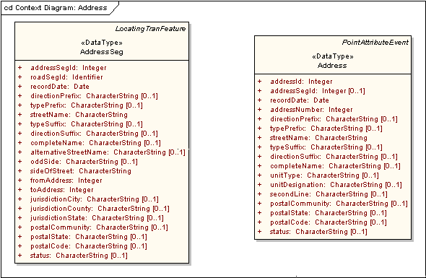
Figure D.2 – Suggested information attributes for AddressSeg and Address classes

As reflected in the mandatory fields, the address information transfer mechanism requires that road segment features exist if AddressSeg records are conveyed, but that Address records alone may be transmitted. See Part 7: Transportation Base and Part 7c: Roads for model feature classes that correspond to road segments, from which TransitSegment features may be derived. Figure D.3 shows an illustrative example of this portion of the transit MAT data model with the two address classes. RoadSeg (shorthand for road segment), RoadSubSeg (shorthand for road sub-segment), and TransitSegment (shorthand for a transit segment or path) are hypothetical feature classes that may include geometry. A TransitPath may be constructed from one or more RoadSubSeg features, each of which is part or all of a RoadSeg feature. A transportation agency may choose to represent the extent of a RoadSubSeg and/or an AddressSeg using a LinearAttributeEvent. Address classes extend Part 7c: Roads, but are required to meet transit model application needs.

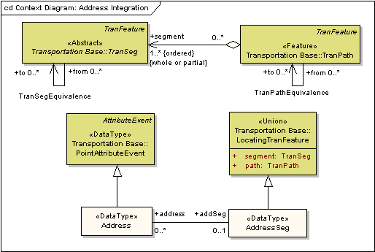
Figure D.3 – Data model extension to support address information transmission
Table D.1 – Data dictionary for AddressSeg and Address
Line | Name/Role Name | Definition | Obligation/  Condition | Maximum Occurrence | Data Type | Domain
 | AddressSeg |  |  |  | <<DataType>> | Lines 214-235
 | addressSegId | Unique identifier for the address segment. An address segment is a portion of a named street with a continuous range of address numbers and a single combination of street name, postal community name, State, and postal code. A new address segment is created when any one of these attributes changes. Hundred-number block ranges that reset incrementally at intersections often additionally define address segments. Separate address segments may describe left and right sides of a named street | M | 1 | Integer
 | roadSegId | Unique identifier for the roadway segment on which the address segment is located. Address segments cannot span multiple road segments, but multiple address segments may reference a single road segment | M | 1 | Identifier
 | recordDate | Date the record was created | M | 1 | Date
 | directionPrefix | Cardinal direction used to differentiate one portion of a named street from another based on its displacement from a central address cross street | O | 1 | CharacterString | North, east, south, west, northeast, northwest, southeast, and southwest; or their one- and two-character equivalents
 | typePrefix | Means of differentiating one kind of road from another, used to make otherwise duplicative names unique | O | 1 | CharacterString | Postal Addressing Standards, Publication 28, U.S. Postal Service, November 2000, Appendix C defines the domain, which includes such values as ST, AVE, DR, LANE, CIR, BLVD, and LOOP
 | streetName | Primary street name element, such as “Main” or “23rd | M | 1 | CharacterString
 | typeSuffix | Means of differentiating one kind of road from another, used to make otherwise duplicative names unique and coming after the primary street name component | O | 1 | CharacterString | Postal Addressing Standards, Publication 28, U.S. Postal Service, November 2000, Appendix C defines the domain, which includes such values as ST, AVE, DR, LANE, CIR, BLVD, and LOOP
 | directionSuffix | Cardinal direction used to differentiate one portion of a named street from another based on its displacement from a central address cross street and coming after the primary street name component | O | 1 | CharacterString | North, east, south, west, northeast, northwest, southeast, and southwest; or their one- and two-character equivalents
 | completeName | The full text of the street name with all applicable prefixes and suffixes, such as “N Main St.” Street names are typically decomposed in address databases into several constituent elements, expressed mainly as various prefixes and suffixes to the basic street name, as shown above. This field supports the transfer of a full street name as a single value | O | 1 | CharacterString
 | alternativeStreetName | Another name for the street (see completeName) | O | 1 | CharacterString
 | oddSide | The side of the street, as determined by applying the direction of increasing address numbers, on which odd numbered addresses are located. Used by some geocoding applications to properly place addresses along the address segment in lieu of using left- and right-side address ranges | O | 1 | CharacterString | Left, right, both, none, and unknown
 | sideOfStreet | Side of a street to which this address-segment record applies. There is no implicit requirement that a matching odd-numbered side record balance an even-numbered side of the street record; both sides may contain odd- or even-numbered addresses | M | 1 | CharacterString | Left, right, and both
 | fromAddress | Numeric value of the address that corresponds to the beginning point of the street segment. This is not necessarily the lowest address value however it can be. In a GIS each line has a beginning point and an end point. The directionality of the line is based on these points. The address range values correspond to this directionality. In Figure D.1, the fromAddress of road segment C would be 3599. In many systems, the fromAddress is broken down into both leftFromAddress and rightFromAddress | M | 1 | Integer
 | toAddress | Numeric value of the address that corresponds to the ending point of the street segment. This is not necessarily the highest address value, however it can be. In a GIS each line has a beginning point and an end point. The directionality of the line is based on these points. The address range values correspond to this directionality. In Figure D.1, the toAddress of road segment C would be 3500. In many systems the toAddress is broken down into both leftToAddress and rightToAddress | M | 1 | Integer
 | jurisdictionCity | City with addressing jurisdiction for this address segment | O | 1 | CharacterString | May be the official political unit’s text name or the FIPS code value used to represent this entity
 | jurisdictionCounty | County with addressing jurisdiction for this address segment. The term “county” includes parishes, townships, and similar terms, where applicable | O | 1 | CharacterString | May be the official political unit’s text name or the FIPS code value used to represent this entity
 | jurisdictionState | The State with addressing jurisdiction for this address segment. It is anticipated that only one of the three jurisdiction fields would be valid for any single address segment | O | 1 | CharacterString | Domain may be the official political unit’s text name or the FIPS code value used to represent this entity
 | postalCommunity | Name assigned by the postal authority for the general location within which the address information shall be unique. Postal community may differ from the name of the city with jurisdiction on this address segment | O | 1 | CharacterString
 | postalState | Name assigned by the postal authority for the State within which the address is located for delivery purposes. The term “State” includes provinces and similar terms, where applicable | O | 1 | CharacterString | Two-character State (in the U.S.) and province (in Canada) abbreviations
 | postalCode | General address location identifier used by the postal agency. In the United States, this is known as the ZIP code, and consists of five mandatory numbers and an optional “ZIP+4” extension consisting of a hyphen and four numbers | O | 1 | CharacterString
 | status | Status of the address segment record | O | 1 | CharacterString | Active, proposed, alternative, and retired
 | Role name: address |  | O | * | <<DataType>>  Address
 | Address |  |  |  | <<DataType>> | Lines 237-254
 | addressId | Unique identifier for an address record. An address, in the context of this model, is a physical address (also known as delivery or situs address), as defined in the proposed FGDC Street Address Data Standard | M | 1 | Integer
 | addressSegId | Unique identifier for the address segment. An address segment is a portion of a named street with a continuous range of address numbers and a single combination of street name, postal community name, State, and postal code. A new address segment is created when any one of these attributes changes. Hundred-number block ranges that reset incrementally at intersections often additionally define address segments. Separate address segments may describe left and right sides of a named street | M | 1 | Integer
 | recordDate | Date the record was created | M | 1 | Date
 | addressNumber | Portion of a street address that is not the street name, usually consisting of whole integer numbers with occasional fractional and alphabetic extensions. Address numbers generally identify an entire structure for the purposes of mail and package delivery | M | 1 | Integer
 | directionPrefix | Cardinal direction used to differentiate one portion of a named street from another based on its displacement from a central address cross street | O | 1 | CharacterString | North, east, south, west, northeast, northwest, southeast, and southwest; or their one- and two-character equivalents
 | typePrefix | Means of differentiating one kind of road from another, used to make otherwise duplicative names unique | O | 1 | CharacterString | Postal Addressing Standards, Publication 28, U.S. Postal Service, November 2000, Appendix C defines the domain, which includes such values as ST, AVE, DR, LANE, CIR, BLVD, and LOOP
 | streetName | Primary street name element, such as “Main” or “23rd | M | 1 | CharacterString
 | typeSuffix | Means of differentiating one kind of road from another, used to make otherwise duplicative names unique and coming after the primary street name component | O | 1 | CharacterString | Postal Addressing Standards, Publication 28, U.S. Postal Service, November 2000, Appendix C defines the domain, which includes such values as ST, AVE, DR, LANE, CIR, BLVD, and LOOP
 | directionSuffix | Cardinal direction used to differentiate one portion of a named street from another based on its displacement from a central address cross street and coming after the primary street name component | O | 1 | CharacterString | North, east, south, west, northeast, northwest, southeast, and southwest; or their one- and two-character equivalents
 | completeName | The full text of the street name with all applicable prefixes and suffixes, such as “N Main St.” Street names are typically decomposed in address databases into several constituent elements, expressed mainly as various prefixes and suffixes to the basic street name, as shown above. This field supports the transfer of a full street name as a single value | O | 1 | CharacterString
 | unitType | Type of mail delivery unit within a structure | O | 1 | CharacterString | Apartment, suite, unit, office, mail station, and building, plus their equivalent abbreviations
 | unitDesignation | Identifier for the delivery unit, such as a letter or number that is unique within the structure(s) reached through the combination of an address number and complete street name location. May be used even when unitType is [null] in order to convey address information; for example, for duplexes identified with a letter suffix appended to the numeric address conveyed in addressNumber | O | 1 | CharacterString
 | secondLine | Additional line for supplemental delivery address information, such as the floor on which an office is located | O | 1 | CharacterString
 | postalCommunity | Name assigned by the postal authority for the general location within which the address information shall be unique. Postal community may differ from the name of the city with jurisdiction on this address segment | O | 1 | CharacterString
 | postalState | Name assigned by the postal authority for the State within which the address is located for delivery purposes. The term “State” includes provinces and similar terms, where applicable | O | 1 | CharacterString | Two-character State (in the U.S.) and province (in Canada) abbreviations
 | postalCode | General address location identifier used by the postal agency. In the United States, this is known as the ZIP code, and consists of five mandatory numbers and an optional “ZIP+4” extension consisting of a hyphen and four numbers | O | 1 | CharacterString
 | status | Status of the address segment record | O | 1 | CharacterString | Active, proposed, alternative, and retired
 | Role name: addSeg |  | O | 1 | <<DataType>>  AddressSeg

- (informative)
Bibliography
The following documents contain provisions that are relevant to this part of the Framework Data Content Standard. Informative references applicable to two or more transportation parts only are listed in Annex C of the Transportation Base (Part 7). Annex D of the Base Document (Part 0) lists informative references applicable to two or more of the parts of the standard, including the transportation parts. For dated references, only the edition cited applies. For undated references, the latest edition of the referenced document applies.
ANSI and ISO standards may be purchased through the ANSI eStandards Store at http://webstore.ansi.org/ansidocstore/default.asp, accessed October 2006.
Federal Geographic Data Committee, Street address data standard, http://www.fgdc.gov/standards/projects/FGDC-standards-projects/street-address/index_html/?searchterm=Address%20Data%20Content%20standard, accessed October, (forthcoming)
Transit Standards Consortium, 2001, Bus stop inventory best practices and recommended procedures
NTCIP 1400:2000, Transit communications interface profile framework, Version 1.04, Draft NTCIP 1400 Amendment 1, September 2002
NTCIP 1401:2000, Standard on common public transportation (CPT) objects, Version 1.02, Draft NTCIP 1401 Amendment 1, September 2002
NTCIP 1402:2000, Standard on incident management (IM) objects, Version 1.02, Draft NTCIP 1402 Amendment 1, September 2002
NTCIP 1403:2000, Standard on passenger information (PI) objects, Version 1.02, Draft NTCIP 1403 Amendment 1, September 2002
NTCIP 1404:2000, Standard on scheduling/runcutting (SCH) objects, Version 1.02, Draft NTCIP 1404 Amendment 1, September 2002
NTCIP 1405:2000, Standard on spatial representation (SP) objects, Version 1.02, Draft NTCIP 1405 Amendment 1, September 2002
NTCIP 1406:2001, Standard on on-board (OB) objects, Version 1.02, Draft NTCIP 1406 Amendment 1, September 2002
NTCIP 1407:2001, Standard on Control Center (CC) objects, Version 1.02, Draft NTCIP 1407 Amendment 1, September 2002
U.S. Postal Service, 2000, Publication 28 – Postal addressing standards

