xxxx-Part.7b

Date: 2008-03-18

Information Technology – Geographic Information
Framework Data Content Standard
Part 7b: Rail

Contents
Introduction v
1 Scope 1
2 Conformance 1
3 Normative references 2
4 Maintenance authority 2
4.1 Level of responsibility 2
4.2 Contact information 2
5 Terms and definitions 2
6 Symbols, abbreviated terms, and notations 3
7 The transportation feature meta model 3
8 Rail system 3
8.1 General 3
8.2 Segmentation model 5
8.2.1 RailPoint 11
8.2.2 RailSeg 11
8.2.3 RailTrack 13
8.2.4 RailPath 16
8.3 Linear reference system 16
8.4 Rail event model 16
8.4.1 RailAttributeEvent 16
8.4.2 RailFeatureEvent 18
8.5 Facilities and administrative areas model 23
8.5.1 RailStation 25
8.5.2 RailCommunicationTower 28
8.5.3 RailPlatform 31
8.5.4 RailWaysideDetectionDevice 34
8.5.5 RailYard 37
8.5.6 RailBridge 40
8.5.7 RailControlPoint 44
8.5.8 RailFuelingFacility 47
8.5.9 RailLinearOccupancy 50
8.5.10 RailSignal 53
8.5.11 RailSwitch 56
8.5.12 RailTransportationCrossing 59
8.5.13 RailUtilityCrossing 62
8.6 Code lists and enumerations 65
8.6.1 Code lists 65
8.6.2 Enumerations 68
Annex A (normative) Normative references 70
Annex B (informative) Railway use cases 71
B.1 Introduction 71
B.1.1 Emergency response use case 71
B.1.2 Emergency stop use case 71
B.1.3 Incident reporting use case 72
Figures
Figure 1 – Different representation of the rail network 4
Figure 2 – TransFeature example 5
Figure 3 – Rail segmentation model 6
Figure 4 – RailPoint 11
Figure 5 – RailSeg 12
Figure 6 – RailTrack 13
Figure 7 – RailAttributeEvent model 17
Figure 8 – RailFeatureEvent model 19
Figure 9 – RailFacilityOrAdminFeature 23
Figure 10 – RailStation 25
Figure 11 – RailCommunicationTower 28
Figure 12 – RailPlatform 31
Figure 13 – RailWaysideDetectionDevice 34
Figure 14 – RailYard 37
Figure 15 – RailBridge 40
Figure 16 – RailControlPoint 44
Figure 17 - RailFuelingFacility 47
Figure 18 – RailLinearOccupancy 50
Figure 19 – RailSignal 53
Figure 20 – RailSwitch 56
Figure 21 – RailTransportationCrossing 59
Figure 22 – RailUtilityCrossing 62
Tables
Table 1 – Data dictionary for segmentation model 7
Table 2 – Data dictionary for RailTrack 14
Table 3 – Data dictionary for Rail event model 20
Table 4 – Data dictionary for RailFacilityOrAdminFeature 24
Table 5 – Data dictionary for RailStation 26
Table 6 – Data dictionary for RailCommunicationTower 29
Table 7 – Data dictionary for RailPlatform 32
Table 8 – Data dictionary for RailWaysideDetectionDevice 35
Table 9 – Data dictionary for RailYard 38
Table 10 – Data dictionary for RailBridge 41
Table 11 – Data dictionary for RailControlPoint 45
Table 12 – Data dictionary for RailFuelingFacility 48
Table 13 – Data dictionary for RailLinearOccupancy 51
Table 14 – Data dictionary for RailSignal 54
Table 15 – Data dictionary for RailSwitch 57
Table 16 – Data dictionary for RailTransportationCrossing 60
Table 17 – Data dictionary for RailUtilityCrossing 63
Table 18 – CodeList for ClearanceLimitType 65
Table 19 – CodeList for ControlPointType 65
Table 20 – CodeList for OwnershipType 65
Table 21 – CodeList for PlatformHeightType 66
Table 22 – CodeList for PlatformType 66
Table 23 – CodeList for RailServiceType 66
Table 24 – CodeList for RailYardType 66
Table 25 – CodeList for TrackType 67
Table 26 – CodeList for TransportationCrossingType 67
Table 27 – CodeList for SignalType 67
Table 28 – CodeList for SwitchAngleType 68
Table 29 – CodeList for UtilityCrossingType 68
Table 30 – CrossingLevelKind enumeration 68
Table 31 – TravelDirectionKind enumeration 69
Foreword
Geographic information, also known as geospatial information, both underlies and is the subject of much of the political, economic, environmental, and security activities of the United States. In recognition of this, the United States Office of Management and Budget issued Circular A-16 (revised 2002), which established the Federal Geographic Data Committee (FGDC) as a coordinating organization.
Work on this standard started under the Geospatial One-Stop e-Government initiative. The standard was developed with the support of the member agencies and organizations of the FGDC and aids in fulfilling a primary objective of the National Spatial Data Infrastructure (NSDI), that is, creation of common geographic base data for seven critical data themes. The seven core data themes are considered framework data of critical importance to the spatial data infrastructure.
As the Geographic Information Framework Data Content Standard was developed using public funds, the U.S. Government will be free to publish and distribute its contents to the public, as provided through the Freedom of Information Act (FOIA), Part 5 United States Code, Section 552, as amended by Public Law No. 104-231, “Electronic Freedom of Information Act Amendments of 1996”.

Introduction
The primary purpose of this part of the Geographic Information Framework Data Content Standard is to support the exchange of rail transportation data. This part seeks to establish a common baseline for the semantic content of rail transportation databases for public agencies and private enterprises. It also seeks to decrease the costs and simplify the exchange of rail transportation data among local, Tribal, State, and Federal users and producers. That, in turn, discourages duplicative data collection. Benefits of adopting this part of the standard also include the long-term improvement of the geospatial rail transportation data within the community, improved integration of safety, emergency response, and enforcement data, and streamlined maintenance procedures.

Framework Data Content Standard – Rail
- Scope
The Geographic Information Framework Data Content Standard, Part 7b: Rail defines components of a model for describing the railway system, which is one of five modes that compose the Transportation theme of the NSDI framework data. The primary purpose of this part of the standard is to support the exchange of transportation data related to the railway system. It is the intent of the part to allow the widest utility of railway transportation data for the user and producer of transportation information by enhancing data sharing and reducing redundant data production.
At a high level, the rail system described in this part of the Framework Data Content Standard is made up of rail features, which can have geographic locations and characteristics. These rail features can be interconnected in various ways to represent rail networks for routing applications. While the Rail Modeling Advisory Team (MAT) initially considered defining the content for detailed, engineering level datasets, this part of the standard focuses on a generalized view of the rail network that enables the broadest variety of operational uses. It is anticipated that the current version of the part will be suitable for some engineering applications. However, the development team recognizes that all engineering needs will not be satisfied by this part of the standard. It is anticipated that future versions of the Rail part will better define the content for rail engineering datasets in order to satisfy the data sharing needs of the entire rail community.
This part of the Framework Data Content Standard can be implemented using a variety of software packages and is designed to accommodate data encoded with or without geometry as well as to support the exchange of data encoded in a variety of geographic information systems. It is designed to be able to depict the complete rail system at all levels of service and all functional classes that may be defined by a data-providing agency. It also accommodates assets associated with the rail system that are typically used for navigation, safety, and measurement.
The Rail part will initially apply to NSDI framework transportation data produced or disseminated by or for the Federal Government. According to Executive Order 12906, Coordinating Geographic Data Acquisition and Access: The National Spatial Data Infrastructure, Federal agencies collecting or producing geospatial data, either directly or indirectly (for example, through grants, partnerships, or contracts with other entities), shall ensure, prior to obligating funds for such activities, that data will be collected in a manner that meets all relevant standards adopted through the Federal Geographic Data Committee (FGDC) process.
Because of the North American scope of the railway network, this part attempts to address the differences between Canadian and U.S. definitions of railway, related concepts, and terminology to harmonize the model to be applicable to both user communities. The rail development team is composed of representative stakeholders from both countries that address these issues as appropriate.
- Conformance
This thematic part includes a data dictionary based on the conceptual schema presented below. To conform to this part, the user shall satisfy the requirements of the data dictionary. The user's conforming dataset shall include a value for each mandatory element, and a value for each conditional element for which the condition is true. It may contain values for any optional element. The data type of each value shall be that specified for the element in the data dictionary and the value shall lie within the specified domain. This part only specifies the special requirements of conformance for a dataset containing information on the rail system. Conformance to the part requires additional actions specified in the Base Document (Part 0) and the Transportation Base (Part 7).
- Normative references
Annex A lists normative references applicable only to the Rail part. No additional normative references are specified in the Transportation Base (Part 7). Annex A of the Base Document (Part 0) lists normative references applicable to two or more parts of the standard, including those other than the transportation parts. Informative references applicable to two or more transportation parts only are listed in Annex C of the Transportation Base. Annex D of the Base Document lists informative references applicable to two or more of the parts, including those other than the transportation parts.
- Maintenance authority
  - Level of responsibility
The FGDC is the responsible organization for coordinating work on all parts of the Geographic Information Framework Data Content Standard. The United States Department of Transportation (USDOT), working with the FGDC, is the responsible organization for coordinating work on the Geographic Information Framework Data Content Standard, Part 7: Transportation Base and subparts (Parts 7a, 7b, 7c, and 7d, excluding 7e) and is directly responsible for development and maintenance of the transportation parts (excluding 7e) of the Framework Data Content Standard.
  - Contact information
Address questions concerning this part of the standard to:
Federal Geographic Data Committee Secretariat
c/o U.S. Geological Survey
590 National Center
Reston, Virginia 20192 USA
Telephone: (703) 648-5514
Facsimile: (703) 648-5755
Internet (electronic mail): gdc@fgdc.gov
WWW Home Page: http://fgdc.gov
- Terms and definitions
Definitions applicable to the Rail part are listed here. Other terms and definitions applicable to multiple transportation parts of the standard are listed in the Transportation Base (Part 7). More general terms and definitions can be found in the Base Document (Part 0) part of the standard. Users are advised to consult these documents for a complete set of definitions.

5.1
amalgamated station
named geographic area that contains one or more station points

5.2
non-operating property
land or asset that is not dedicated to the direct operation of the railway
NOTE A non-operating property can have buildings on it, but will not have active tracks on it.

5.3
operating property
land or asset required for the operation of the rolling stock, whether it is in movement or at a standstill
EXAMPLE Rail Right-of-Way

5.4
railroad administrative region
geographic region where a railroad operates and that is managed by a supervisor, superintendent, manager, vice-president, or other designated person of responsibility
NOTE Such a geographic region is not necessarily limited to the boundaries of the real property owned by the railroad.

5.5
rail network
set of rail features and their topological relationships which together define all possible movements through the rail system

5.6
rail system
physical and non-physical components representing the rail mode of travel that allow the movement of goods and people between locations

5.7
station, or station point
named location where railroad or non-railroad revenue and/or operating business occurs
NOTE A station or station point does not necessarily have to be a building.
- Symbols, abbreviated terms, and notations
The following symbols, abbreviations, and notations are applicable to the Rail part. Those common to two or more transportation parts are listed in the Transportation Base (Part 7). Symbols, abbreviations, and notations applicable to multiple parts, including the transportation parts, are listed in the Base Document (Part (0).
DTL – Direct to Locomotive
FSAC – Freight Station Accounting Code
SPLC – Standard Point Location Code
- The transportation feature meta model
A feature is an abstraction of a real world phenomenon that is of interest to the application. Instances of features that share common characteristics are organized in classes. Classes are object realizations of the Metaclasses defined in the ISO Rules for Application Schemas Standard [ISO 19109], and instances of the types described in the ISO Feature Catalogs Standard [ISO 19110]. Rail Segments (RailSeg) and intersections are examples of Feature Types.
- Rail system
  - General
This part of the Framework Data Content Standard attempts to accommodate the principal aspects of rail transportation including geographic locations, interconnectedness, and characteristics of the transportation system. The rail transportation system includes physical and non-physical components representing the rail mode of travel that allow the movement of goods and people between locations. It also includes the supporting infrastructure necessary for rail operations and maintenance.
The transportation infrastructure is the physical component of the entire transportation system. Thus, the Transportation theme includes many modes, or subthemes. Geospatial data depicting airport facilities, rail, road, transit, and inland waterway systems represent the transportation infrastructure that make up this part of the Framework Data Content Standard. Each subtheme has developed a part that accommodates the uniqueness of that mode. The Rail part is a companion document to the Transportation Base and deals only with railways.
This part of the standard considers the engineering and operational requirements of the rail network. As shown in Figure 1, from the operational point of view applications are not necessarily required to capture each track individually. Instead, a collection of adjacent tracks is represented as a centerline. For rail engineering applications, it is required to capture each rail track from point-of-switch to point-of-switch. This part uses a variety of ways to describe the rail network for both operational and engineering applications. However, all aspects of the model hinge on three main components: segments, points, and events. Segments represent portions of the physical rail network that are defined by the application domain using business rules that may vary between operational and engineering applications. Therefore, in this part of the standard, RailSeg represents two somewhat different semantics:
- Each RailSeg may represent a track, which extends between two points-of-switch. This is depicted in the “Engineering” view in Figure 1.
- Each RailSeg represents one or more adjacent tracks. In this case, RailSeg has an attribute which indicates the number of tracks it represents. This is depicted in the “Operational” view in Figure 1, where Seg 2 is the representative of Track 1 and Track 2.

Figure 1 – Different representation of the rail network

RailPoints represent discrete locations of interest along the rail network that represent segment termini. Events represent attributes that occur along or near the rail network. To encourage a maximum of utility in a variety of contexts, the Rail part accommodates two different views of rail network. However, it does not prescribe any specific business rules for segmentation, or locating points and attributes along the rail network. The focus of this part is to define a way to encode rail segments, their start and end points, and their attributes, which may have varying values along each segment. The rail model contains five parts that help to group its components:
- A segmentation model, derived from the Transportation Base model that defines segments and their associated geometries and topology
- A tracks and segments package defining the representation of rail where each segment is the centerline of the rail or an individual track
- A linear reference system (LRS), which defines a measurement method used to apply attributes to segments by locating their endpoints and defining their extent
- An event model which defines a method to model attributes that may have values that may change along the length of a segment or path and to linearly locate features along segments and paths
- A facilities or administrative areas package defining the important features in a rail system
  - Segmentation model
Figure 3 shows that RailPath, RailSeg, and RailPoint are subclasses of TranPath, TranSeg, and TranPoint respectively, and inherit the properties of these classes. RailPath, RailSeg, and RailPoint are the three central features in this model. For a full discussion of the general transportation segmentation model, users are advised to consult the Framework Data Content Standard, Part 7: Transportation Base.
A TranSeg is a linear section of the physical transportation network. For example, in Figure 2 below, there exists a road that is fifteen miles long; at miles 5 (Pt 2) and 10 (Pt 3) there are intersections. The road is divided into separate pieces at those points. Those pieces, labeled Seg 1, Seg 2, and Seg 3, would represent TranSegs in Figure 3. In the Transportation Base, TranSegs are described by the following attributes: status, fieldMeasure, length, geometry and topology.

Figure 2 – TransFeature example

TranPoints are associated with TranSegs. TranPoints define where TranSegs start and end. In Figure 2, each segment is bounded by two circles. Seg 1 is bounded by circles labeled Pt 1 and Pt 2, Seg 2 is bounded by circles labeled Pt 2 and Pt 3, and Seg 3 is bounded by circles labeled Pt 3 and Pt 4. These circles would represent TranPoints in Figure 3. In the Transportation Base, TranPoints are described by the geometry and topology attributes.
TranPaths are an aggregate of TranSegs representing how they are organized and used. More specifically, a TranPath is comprised of an ordered list of whole or partial TranSegs. In Figure 2 above, a path representing Route 1 between the circle labeled Pt 1 and the circle labeled Pt 4 would consist of the segments labeled Seg 1, Seg 2, and Seg 3; in that order. These segments, listed in order from 1 to 3, would represent a TranPath in Figure 3. In the Transportation Base, TranPath is described by the attributes geometry and topology. In the Rail part, TranPaths are further defined by the subclass RailPath. RailPaths inherit all the attributes and properties of TranPaths but are described further by the following attributes: name, startingPlace, endingPlace, isActive, and operator.

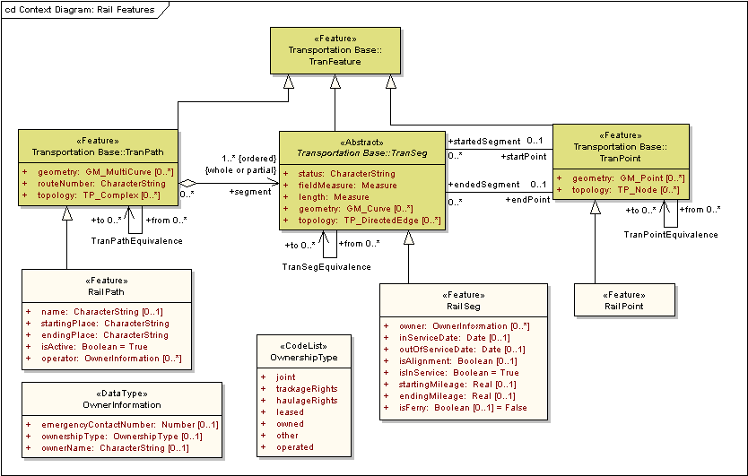
Figure 3 – Rail segmentation model

Table 1 – Data dictionary for segmentation model
Line | Name/Role Name | Definition | Obligation/  Condition | Maximum Occurrence | Data Type | Domain
 | Transportation Base::TranFeature | Abstraction of a real world transportation phenomenon |  |  | <<Feature>>
 | Transportation Base::  TranPath | Ordered collection of one or more, whole or partial, TranSegs to represent a route within the transportation network |  |  | <<Feature>> | Lines 3-8
 | geometry | Shape and geolocation of a feature | O | * | <<Type>>  GM_MultiCurve | Defined in ISO 19107
 | routeNumber | Route identifier | M | 1 | Characterstring | Unrestricted
 | topology | Connectivity of the participating elements | O | * | <<Type>>  TP_Complex | Defined in ISO 19107
 | Role name: segment | An ordered list of whole or partial TranSegs | M | * | <<Abstract>>  Transportation Base::  TranSeg
 | Role name: from | Source TranPath in equivalency | C/part of equivalency? | * | <<Feature>>  Transportation Base::  TranPath | Whole or partial TranPaths
 | Role name: to | Destination TranPath in equivalency | C/part of equivalency? | * | <<Feature>>  Transportation Base::  TranPath | Whole or partial TranPaths
 | RailPath | Ordered collection of one or more, whole or partial, RailSegs to represent a route within the railroad network |  |  | <<Feature>> | Lines 10-14
 | name | Word or phrase that constitutes the distinctive designation of RailPath | O | 1 | CharacterString | Unrestricted
 | startingPlace | Point at which the RailPath begins | M | 1 | CharacterString | Unrestricted
 | endingPlace | Point at which the RailPath ends | M | 1 | CharacterString | Unrestricted
 | isActive | Denotes whether or not the RailPath is active | M | 1 | Boolean | True or False
 | operator | Person(s) or organization(s) that operates the RailPath | O | * | <<DataType>>  OwnerInformation | Unrestricted
 | Transportation Base::TranSeg | Linear section of a physical transportation system designed for, or the result of, human or vehicular movement |  |  | <<Abstract>> | Lines 16-24
 | status | Condition of a TranSeg | M | 1 | CharacterString | Unrestricted
 | fieldMeasure | Length of segment, as determined in the field; if isAnchorSection = True, then this is the official length of the segment for the LRS | M | 1 | Measure | Defined in ISO 19103
 | length | Length of the TranSeg feature, which may differ from the field measured length due to differences in calculation | M | 1 | Measure | Defined in ISO 19103
 | geometry | Shape and geolocation of a feature. | O | * | <<Type>>  GM_Curve | Defined in ISO 19107
 | topology | Connectivity of the participating elements | O | * | <<Type>>  TP_DirectedEdge | Defined in ISO 19107
 | Role name: from | Source TranSeg in equivalency | C/part of equivalency? | * | <<Abstract>>  Transportation Base::  TranSeg | Whole or partial TranSegs
 | Role name: to | Destination TranSeg in equivalency | C/part of equivalency? | * | <<Abstract>>  Transportation Base::  TranSeg | Whole or partial TranSegs
 | Role name: startPoint | TranPoint corresponding to segment start | O | 1 | <<Feature>>  Transportation Base::  TranPoint
 | Role name: endpoint | TranPoint corresponding to segment end | O | 1 | <<Feature>>  Transportation Base::  TranPoint
 | RailSeg | A linear section of a physical transportation system designed for railroad movement |  |  | <<Feature>> | Lines 26-33
 | owner | Person(s) or organization(s) that possess RailSeg | O | * | <<DataType>>  OwnerInformation | Unrestricted
 | inServiceDate | Date the RailSeg was placed into service | O | 1 | Date | Valid historical or current date and time
 | outOfServiceDate | Date the RailSeg was taken out of service | O | 1 | Date | Valid historical or current date and time
 | isAlignment | Denotes whether or not the RailSeg is an Alignment | O | 1 | Boolean | True or False
 | isInService | Denotes whether or not the RailSeg is in service | M | 1 | Boolean | True or False
 | startingMileage | Mile at which the RailSeg begins | O | 1 | Number | Real Numbers
 | endingMileage | Mile at which the RailSeg ends | O | 1 | Number | Real Numbers
 | isFerry | Denotes whether or not the RailSeg represents a Ferry crossing | O | 1 | Boolean | True or False
 | Transportation Base::TranPoint | Point along the transportation system that has some special significance either for starting or ending a segment |  |  | <<Feature>> | Lines 35-40
 | geometry | Shape and geolocation of a feature | O | * | <<Type>>  GM_Point | Defined in ISO 19107
 | topology | Connectivity of the participating elements | O | * | <<Type>>  TP_Node | Defined in ISO 19107
 | Role name: startedSegment | Segment that starts at the transportation point | O | * | <<Abstract>>  Transportation Base::  TranSeg | Unrestricted
 | Role name: endedSegment | Segment that ends at the transportation point | O | * | <<Abstract>>  Transportation Base::  TranSeg | Unrestricted
 | Role name: from | Source TranPoint in equivalency | C/part of equivalency? | * | <<Abstract>>  Transportation Base::  TranPoint | Unrestricted
 | Role name: to | Destination TranPoint in equivalency | C/part of equivalency? | * | <<Abstract>>  Transportation Base::  TranPoint | Unrestricted
 | RailPoint | Point along the rail system that has some special significance either for starting or ending a RailSeg |  |  | <<Feature>>
 | OwnerInformation |  |  |  | <<DataType>> | Lines 43-45
 | emergencyContactNumber |  | O | 1 | Number
 | ownershipType |  | O | 1 | <<CodeList>>  OwnershipType | Unrestricted
 | ownerName |  | O | 1 | CharacterString | Unrestricted

    - RailPoint
A RailPoint is a location along the rail network that has significance either for starting or ending a RailSeg. RailPoint, shown in Figure 4, is a subclass of TranPoint. RailPoints, therefore, inherit all the geometric and topological properties associated with TranPoint. Geometry is restricted to be of type GM_Point and topology to be of type TP_Node. Both GM_Point and TP_Node are defined in ISO 19107. Referring to Figure 3, the reader will notice that RailPoints are associated with RailSegs in the roles of startPoint and endPoint.
No requirements are specified on where to place RailPoints, except to satisfy the requirements for start and endpoints for RailSeg, and that whatever segmentation method is employed, it is applied consistently throughout the dataset.
For a complete data dictionary of the RailPoint feature, please reference Table 1.

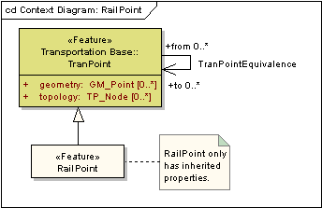
Figure 4 – RailPoint

    - RailSeg
A RailSeg represents a linear section of the physical rail network designed for the movement of trains. RailSeg extends TranSeg and is depicted in Figure 5. Within the Rail part, RailSeg may be defined in a variety of ways for a given stretch of rail track. For example, a single RailSeg can represent either the entire identified area of tracks (for example, a section that has more than one track) between two points or a separate RailSeg can be defined for each track. RailSegs can have geometry of type GM_Curve as defined in ISO 19107. RailSeg can also have a topology of type TP_DirectedEdge, as defined in ISO 19107. According to ISO 19107, GM_Curve extends GM_OrientableCurve and therefore has direction. The direction of a RailSeg is determined by the “from” and “to” RailPoints.
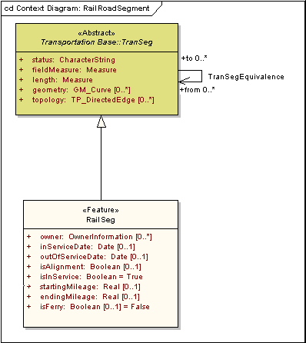
Figure 5 – RailSeg

The reason TP_DirectedEdge has been introduced is to facilitate the representation of feature topology through its combinatorial structures, independent of its geometry. For example, in the implementation of the Rail part, a data provider may choose to represent only the geometry of a RailSeg, which implies a direction inherited from GM_OrientableCurve. Another data provider may choose not to supply rail feature geometry and only provide the orientation of the RailSeg using its topology attribute.
RailSegs can have an integer-valued attribute that identifies the number of tracks it represents. Since the number of tracks can vary along the length of a RailSeg, it is more properly represented as a RailLinearAttributeEvent. A RailSeg has a unique identifier and it is highly recommended that RailSegs be bounded by two RailPoints. No mandates are provided on how to segment the rail network except that the data provider is consistent in segmentation methodology.
The defining agency can add attributes that are related to physical characteristics of the rail to the RailSeg (see ExtendedAttribute in the Transportation Base). If they are added as attributes of the RailSeg, as shown in Figure 5, the value of the attribute applies to the entire length of the RailSeg. In other words, attributes should only be assigned directly to a RailSeg if the intent is to force segmentation at changes in the specified attribute value. In these cases, the RailSeg terminates and a new one is started at the point where the attribute value changes. If it is necessary to allow the value of the attribute to change as the RailSeg is traversed, then that attribute should instead be assigned to the RailSeg as a RailLinearAttributeEvent (see Figure 7).
For a complete data dictionary of the RailSeg feature, see Table 1.
    - RailTrack
If an engineering view is followed, the RailTrack class is used to represent the centerline of each pair of rails. In the case of a monorail, RailTrack is at the centerline of the monorail. In the engineering view, the function of a RailTrack is similar to that of a RailSeg in the operational view in that it represents a section of the physical rail network. It is, therefore represented as a subtype of RailSeg, allowing it to have events defined along its length. The Rail part does not prescribe specific business rules on how tracks are segmented. However, in most engineering applications, tracks are segmented between points-of-switch. RailLinearAttributeEvents are used to represent varying attributes along a track. For example, the same TrackSeg may have different “weight of rail” values. In this case, linear reference methods can be used to indicate the portion of the track where this attribute value applies, independent of the track segmentation.
What service a track supports can also vary along a track segment so it is also represented as a RailLinearAttributeEvent. The type of service is the attribute value of the RailLinearAttributeEvent.

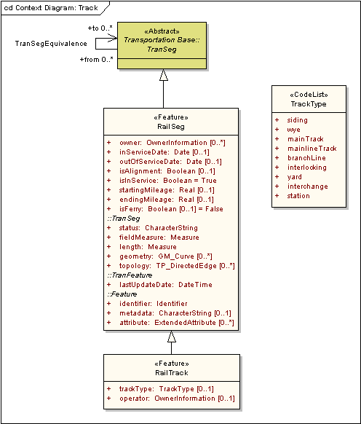
Figure 6 – RailTrack

Table 2 – Data dictionary for RailTrack
Line | Name/Role Name | Definition | Obligation  Condition | Maximum Occurrence | Data Type | Domain
 | RailSeg | Linear section of a physical transportation system designed for railroad movement |  |  | <<Feature>> | Lines 47-65
 | owner | Person(s) or organization(s) that possess RailSeg | O | * | <<DataType>>  OwnerInformation | Unrestricted
 | inServiceDate | Date the RailSeg was placed into service | O | 1 | Date | Valid historical or current date and time
 | outOfServiceDate | Date the RailSeg was taken out of service | O | 1 | Date | Valid historical or current date and time
 | isAlignment | Denotes whether or not the RailSeg is an Alignment | O | 1 | Boolean | True or False
 | isInService | Denotes whether or not the RailSeg is in service | M | 1 | Boolean | True or False
 | startingMileage | Mile at which the RailSeg begins | O | 1 | Number | Real Numbers
 | endingMileage | Mile at which the RailSeg ends | O | 1 | Number | Real Numbers
 | isFerry | Denotes whether or not the RailSeg represents a Ferry crossing | O | 1 | Boolean | True or False
 | Transportation Base::  TranSeg:status |  | M | 1 | CharacterString | Unrestricted
 | Transportation Base::  TranSeg::fieldMeasure |  | M | 1 | Measure
 | Transportation Base::  TranSeg::length |  | M | 1 | Measure
 | Transportation Base::  TranSeg::geometry | Shape and geolocation of a feature | O | * | <<Type>>  GM_Curve | Defined in ISO 19107
 | Transportation Base::  TranSeg::topology | Connectivity of the participating elements | O | * | <<Type>>  TP_DirectedEdge | Defined in ISO 19107
 | Transportation Base::  TranFeature::lastUpdateDate | Timestamp indicating when the RailSeg was last edited | M | 1 | DateTime | Valid historical or current date and time
 | Framework::Feature::Identifier | Feature identifier for the RailSeg | M | 1 | <<DataType>>  Framework::Identifier | Unrestricted
 | Framework::Feature::metadata | Structured or unstructured metadata as defined by the community of practice | O | 1 | CharacterString | May be text or structured metadata fragment
 | Framework::Feature::attribute | Producer-defined attribute for inclusion in transfer | O | * | <<DataType>>  ExtendedAttribute | Unrestricted
 | Role name: from | Source TranSeg in equivalency | C/part of equivalency? | * | <<Abstract>>  Transportation Base::  TranSeg | Whole or partial TranSegs
 | Role name: to | Destination TranSeg in equivalency | C/part of equivalency? | * | <<Abstract>>  Transportation Base::  TranSeg | Whole or partial TranSegs
 | RailTrack | Class used to represent the centerline of each pair of rails. In the case of a monorail, RailTrack is at the centerline of the monorail |  |  | <<Feature>> | Lines 67-68
 | trackType | Kind of track the feature represents | O | 1 | <<CodeList>>  TrackType | Unrestricted
 | operator | Person(s) or organization(s) that operate the track | O | 1 | <<DataType>>  OwnerInformation | Unrestricted

    - RailPath
A RailPath represents a route through the physical rail network. It is an ordered list of one or more, whole or partial RailSegs. A RailSeg is used to represent the physical railway itself, and so, can contain attributes about the physical railway. RailPath can be used to represent a connection between an origin and destination. An example of this is an Amtrak Route between Union Station in Washington, D.C. and Penn Station in New York.
RailPath extends TranPath and is shown in Figure 3. The geometry of RailPath can be explicitly defined by a GM_MultiCurve or implicitly defined by the sum of the geometries defined for the RailSegs it uses. It is also possible to use both geometry approaches. For example, the RailSeg geometries may be a more precise representation of the rail network, whereas the RailPath geometry may be a more generalized representation.
For a complete data dictionary of the RailPath feature, see Table 1.
  - Linear reference system
Linear reference systems (LRSs) are, in the strictest sense, not a central part of the Rail part and are also complex enough to warrant separate treatment. The Rail part references the linear reference scheme specified by ISO 19133. LRSs are used in this part to support the exchange of asset information, such as sign locations and project boundaries. In this part, assets are considered to be features. Features can have their own geometry, such as may be created through GPS data. A feature can also be given an LRS location that describes its linear location along a transportation segment or transportation path feature. In this case, a FeatureEvent is created to specify the feature’s linear location. Features can have their own geometry, such as may be created through GPS data, and they also can have an LRS location that describes their location along or near a transportation feature.
Another key use of LRS in this model allows the exchange of attribute information that describes transportation features, such as the speed limit of a track. In the Rail part, these attributes are called attribute events. Attribute events can apply to a single point along a segment or path feature; or an interval along a segment or path feature. This use of LRS may not be familiar to many readers of this document, but it has important implications for feature segmentation and attribution for data exchange.
  - Rail event model
Transportation events are the mechanism by which attributes or entities can be linearly located along either a RailSeg or RailPath feature. Refer to the transportation event model in the Transportation Base for a more detailed overview of the general model. Transportation events can be either attribute events or feature events. Within this subpart, events specific to the rail network are supported as specializations of transportation attributes and feature events. Attributes may be either rail characteristics, such as number of tracks, speed restrictions, or rail elements, such as bridges and intersections. Elements may be alternatively represented as feature events, which can include their own geometry. Attribute and feature events may take the form of point or linear phenomena.
Attribute and feature events are located on the applicable RailSeg or RailPath using a linear reference method (LRM). A linear referenced position expression specifies the applicable LRM, identifies the relevant RailSeg or RailPath feature on which the event occurs, a distance along the RailSeg or RailPath, an offset referent from which any lateral displacement should occur, the direction from the referent to the specified event location, and the lateral displacement distance, if any. Annex B of the Transportation Base provides additional information about linear referencing.
    - RailAttributeEvent
When an attribute always applies to an entire rail segment or path, it should be a property of the RailSeg or RailPath class, as applicable. However, when an attribute may apply to only a portion of a rail segment or path, attribute event classes should be utilized to store its occurrences and values. Each rail attribute event stores the value of a specified attribute and the location where that value applies. The difference between the two instantiable rail attribute event classes is how the location information is presented. The location of a point event is defined by a single linear reference (at). The location of a linear event is defined by a pair of endpoint linear references (start and end).
Figure 7 shows the RailAttributeEvent model. RailLinearAttributeEvent and RailPointAttributeEvent are subclasses of the class RailAttributeEvent from the general event model contained in the Transportation Base. At a minimum, a RailAttributeEvent class must include properties to indicate the attribute conveyed (event type), the attribute’s value (attributeValue), the source of the data (source), and the event’s location (atPosition or startPosition and endPosition).

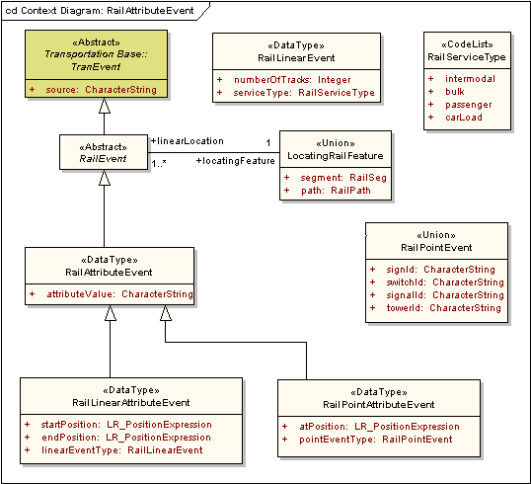
Figure 7 – RailAttributeEvent model

      - RailLinearAttributeEvent
RailLinearAttributeEvent provides the means of specifying the value and location of a single segment or path attribute that may apply to only part of the segment or path. The name of the attribute is specified by the linearEventType property. The value of the segment or path attribute is specified through the attributeValue property. The location interval along which the value applies is specified by start and end positions along the segment or path using linearly referenced position expressions, as explained in Annex B of the Transportation Base. RailLinearAttributeEvents have no geometry of their own but instead inherit any geometry that may have been defined for the applicable portion of the rail segment or path.
      - RailPointAttributeEvent
RailPointAttributeEvent provides the means of specifying the value and location of an attribute that has a particular value at only a single point along a rail segment or path. The name of the attribute is specified by the pointEventType property. The value of the segment or path attribute is specified as the attributeValue. The location at which the value applies is specified by a single linearly referenced position expression, as explained in Annex B of the Transportation Base. RailPointAttributeEvents have no geometry of their own but instead inherit any geometry that may have been defined for the applicable portion of the rail segment or path.
    - RailFeatureEvent
Features can have attributes, each with a single, constant value. One of these attributes can be its representative geometry. For example, a rail signal feature can have a height attribute and point geometry. Features can also have topology, identifier, metadata, lastUpdateDate, and extendedAttribute attributes. The feature can also be linearly located along a rail segment or path using a rail feature event. RailFeatureEvent have a location property and a data source.
FeatureEvents are subtyped into point and linear forms. A RailPointFeatureEvent occurs at a single location (at) on a rail segment or path. A RailLinearFeatureEvent occurs along a section (start and end) of the rail segment or path. The “at” or “start” and “end” positions used to locate an event are specified using a linearly referenced position expression. The form of these expressions is described in Annex B of the Transportation Base. As with attribute events, a feature need not contain its own geometry, but may utilize that of the linear rail segment or path on which it is located through the linearly referenced position expression. Thus, there are two potential sources of feature geometry: the feature class and the rail segment or path class.
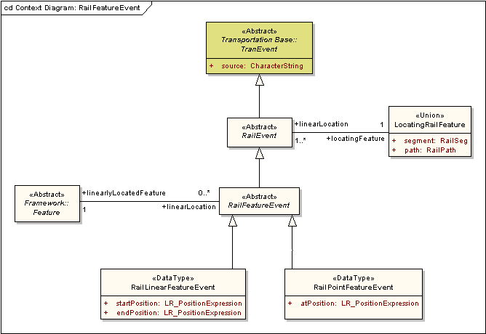
Figure 8 – RailFeatureEvent model

      - RailLinearFeatureEvent
RailLinearFeatureEvent provides the means for specifying a linear location for a feature located along a rail segment or path. All of the feature’s attributes, including optional geometry, are properties of the feature, which could be stored in a user-specified instantiable subclass of TranFeature. RailLinearFeatureEvent stores the location information tying the feature to the rail segment or path.
There are no restrictions on the type of feature being located. The feature can have a linear footprint, like a RailPlatform instantiated as a RailLinearFeatureEvent. Platform attributes, such as platformType or platformName, are kept with the platform feature, which could be a user-specified instantiable subclass of TranFeature. Features with area geometries, like a county, are also supported. In this case, a RailLinearFeatureEvent could depict what part of the rail segment or path is located within the county.
      - RailPointFeatureEvent
RailPointFeatureEvent provides the means for specifying a point location for a feature along a rail segment or path. All of the feature’s attributes, including optional geometry, are properties of the feature, which could be stored in a user-specified instantiable subclass of TranFeature. RailPointFeatureEvent stores the location information tying the feature to the rail segment or path.
There are no restrictions on the type of feature being located. The feature can have a point footprint, like a RailCommunicationTower. Railroad tower attributes, like tower type and height, are kept with the tower feature. Features with a linear geometry, such as a county boundary, are also supported. In this case, a RailPointFeatureEvent could be used to depict every location where a county boundary crosses a rail segment or path.
Table 3 – Data dictionary for Rail event model
Line | Name/Role Name | Definition | Obligation/  Condition | Maximum Occurrence | Data Type | Domain
 | Transportation Base::TranEvent | Mechanism for locating an attribute value or feature |  |  | <<Abstract>> | Line 70
 | source | Supplier of the event object | M | 1 | CharacterString | Unrestricted
 | RailEvent | Mechanism for locating an attribute value or feature along a railroad |  |  | <<Abstract>> | Line 72
 | Role name: locatingFeature |  | M | 1 | <<Union>>  LocatingRailFeature | Unrestricted
 | RailAttributeEvent | Mechanism for locating an attribute value along a railroad |  |  | <<DataType>> | Line 74
 | attributeValue | Value of the attribute at the specified location | M | 1 | CharacterString | Unrestricted
 | RailLinearAttributeEvent | Mechanism for locating an attribute value for an interval along a railroad |  |  | <<DataType>> | Lines 76-78
 | startPosition | Starting location along the railroad for the attribute value | M | 1 | <<Type>>  LR_PositionExpression | Defined in ISO 19133
 | endPosition | Ending location along the railroad for the attribute value | M | 1 | <<Type>>  LR_PositionExpression | Defined in ISO 19133
 | linearEventType | Name of the attribute | M | 1 | <<DataType>>  RailLinearEvent | Unrestricted
 | RailPointAttributeEvent | Mechanism for locating an attribute value at a single point along a railroad |  |  | <<DataType>> | Lines 80-81
 | atPosition | Point location along the railroad at which the attribute value applies | M | 1 | <<Type>>  LR_PositionExpression | Defined in ISO 19133
 | pointEventType | Name of the attribute | M | 1 | <<Union>>  RailPointEvent | Unrestricted
 | RailFeatureEvent | Mechanism for locating a feature along a railroad |  |  | <<Abstract>> | Line 83
 | Role name: linearlyLocatedFeature |  | M | 1 | <<Feature>>  Framework::Feature
 | RailLinearFeatureEvent | Mechanism for locating a feature along an interval along a railroad |  |  | <<DataType>> | Lines 85-86
 | startPosition | Starting location along the railroad for the feature | M | 1 | <<Type>>  LR_PositionExpression | Defined in ISO 19133
 | endPosition | Ending location along the railroad for the feature | M | 1 | <<Type>>  LR_PositionExpression | Defined in ISO 19133
 | RailPointFeatureEvent | Mechanism for locating a feature at a single point along a railroad |  |  | <<DataType>> | Line 88
 | atPosition | Point location along the railroad at which the feature is located | M | 1 | <<Type>>  LR_PositionExpression | Defined in ISO 19133
 | LocatingRailFeature | Railroad feature used to locate a railroad event |  |  | <<Union>> | Lines 90-92
 | segment | The RailSeg used to locate a railroad event | C/if path is not specified | 1 | RailSeg | Unrestricted
 | path | The RailPath used to locate a railroad event | C/if segment is not specified | 1 | RailPath | Unrestricted
 | Role name: event | Railroad event located by the feature | M | * | <<Abstract>>  RailEvent | Unrestricted
 | Framework::Feature | Feature from any framework part |  |  | <<Abstract>> | Line 94
 | Role name: linearLocation | Location of the Framework Feature along a RailSeg or RailPath | O | * | <<Abstract>>  RailFeatureEvent | Unrestricted
 | RailLinearEvent | Kind of rail linear event |  |  | <<DataType>> | Lines 96-97
 | numberOfTracks | Number of tracks represented by the RailSeg | C/if not serviceType | 1 | Integer | All positive integers
 | serviceType | Kind of service the RailSeg carries. | C/if not numberOfTracks | 1 | <<CodeList>>  RailServiceType | Unrestricted
 | RailPointEvent | Kind of rail point event |  |  | <<Union>> | Lines 99-102
 | signId | Identity of the RailSign | C/if not switchID, signalID, or towerID | 1 | CharacterString | Unrestricted
 | switchId | Identity of the RailSwitch | C/if not signID, signalId, or towerID | 1 | CharacterString | Unrestricted
 | signalId | Identity of the RailSignal | C/if not signID, switchID, or towerID | 1 | CharacterString | Unrestricted
 | towerId | Identity of the RailCommunicationTower | C/if not signID, switchID, or signalID | 1 | CharacterString | Unrestricted

  - Facilities and administrative areas model
This section deals with the supporting infrastructure that is used by the rail industry to conduct ongoing rail operations. These include designated areas for aggregating rail stock, shipping facilities, regulatory signage and signals, and other facilities necessary for the safe and efficient operation of the rail industry.
Figure 9 shows that the RailFacilityOrAdminFeature is a subclass of TranFeature. As shown in Figures 9 through 21, the features defined in this section are subtypes of the RailFacilityOrAdminFeature and therefore inherit all the attributes of RailFacilityOrAdminFeatures. These attributes are owner, lastUpdateDate, identifier, geometry, metadata, topology and attribute.

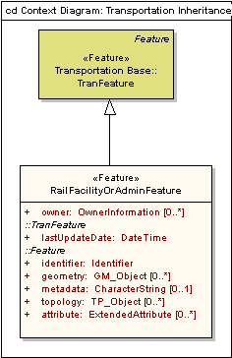
Figure 9 – RailFacilityOrAdminFeature

Table 4 – Data dictionary for RailFacilityOrAdminFeature
Line | Name/Role Name | Definition | Obligation/  Condition | Maximum Occurrence | Data Type | Domain
 | RailFacilityOrAdminFeature | Features for supporting the railroad infrastructure |  |  | <<Feature>> | Lines 104-110
 | owner | Person(s) or organization(s) that posses the station | O | * | <<DataType>>  OwnerInformation | Unrestricted
 | Transportation Base::  TranFeature::lastUpdateDate | Timestamp indicating when the RailFacilityOrAdminFeature object was last edited | M | 1 | DateTime | Valid historical or current date and time
 | Framework::Feature::identifier | Feature identifier for the RailFacilityOrAdminFeature | M | 1 | <<DataType>>  Framework::Identifier | Unrestricted
 | Framework::Feature::geometry | Shape and geolocation of a feature | O | * | <<Type>>  GM_Object | Defined in ISO 19107
 | Framework::Feature::metadata | Structured or unstructured metadata as defined by the community of practice | O | 1 | CharacterString | May be text or structured metadata fragment
 | Framework::Feature::topology | Connectivity of the participating elements | O | * | <<Interface>>  TP_Object | Defined in ISO 19107
 | Framework::Feature::attribute | Producer-defined attribute for inclusion in transfer | O | * | <<DataType>>  Framework::  ExtendedAttribute | Unrestricted

    - RailStation
The feature RailStation is shown in Figure 10. RailStation has optional character string attributes of type and FSAC (Freight Station Accounting Code) and mandatory character string attributes name and SPLC (Standards Point Location Codes). A RailPointFeatureEvent may be used to locate the RailStation along a RailSeg, a RailPath, or a RailTrack.

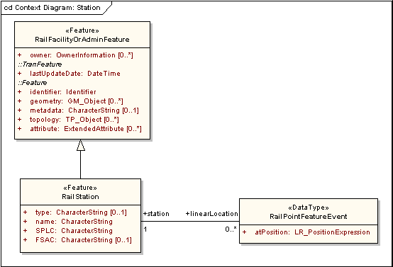
Figure 10 – RailStation

Table 5 – Data dictionary for RailStation
Line | Name/Role Name | Definition | Obligation/  Condition | Maximum Occurrence | Data Type | Domain
 | RailFacilityOrAdminFeature | Features for supporting the railroad infrastructure |  |  | <<Feature>> | Lines 112-118
 | owner | Person(s) or organization(s) that posses the station | O | * | <<DataType>>  OwnerInformation | Unrestricted
 | Transportation Base::  TranFeature::lastUpdateDate | Timestamp indicating when the RailFacilityOrAdminFeature object was last edited | M | 1 | DateTime | Valid historical or current date and time
 | Framework::Feature::identifier | Feature identifier for the RailFacilityOrAdminFeature | M | 1 | <<DataType>>  Framework::Identifier | Unrestricted
 | Framework::Feature::geometry | Shape and geolocation of a feature | O | * | <<Type>>  GM_Object | Defined in ISO 19107
 | Framework::Feature::metadata | Structured or unstructured metadata as defined by the community of practice | O | 1 | CharacterString | May be text or structured metadata fragment
 | Framework::Feature::topology | Connectivity of the participating elements | O | * | <<Interface>>  TP_Object | Defined in ISO 19107
 | Framework::Feature::attribute | Producer-defined attribute for inclusion in transfer | O | * | <<DataType>>  Framework::  ExtendedAttribute | Unrestricted
 | RailStation | Named location where railroad or non-railroad revenue and/or operating business occurs; it does not necessarily have to be a building |  |  | <<Feature>> | Lines 120-124
 | type | Kind of RailStaton | O | 1 | CharacterString | Unrestricted
 | name | Word or phrase that constitutes the distinctive designation of the rail station | M | 1 | CharacterString | Unrestricted
 | SPLC | Standard Point Location Codes | M | 1 | CharacterString | Unrestricted
 | FSAC | Freight Station Accounting Code | O | 1 | CharacterString | Unrestricted
 | Role name: linearLocation | Location of the RailStation along a RailSeg or Railpath | O | * | <<DataType>>  RailPointFeatureEvent | Unrestricted
 | RailPointFeatureEvent | Mechanism for locating a feature at a single point along a railroad |  |  | <<DataType>> | Lines 126-127
 | atPosition | Point location along the railroad at which the RailStation is located | M | 1 | <<Type>>  LR_PositionExpression | Defined in ISO 19133
 | Role name: station | Named location where railroad or non-railroad revenue and/or operating business occurs; it does not necessarily have to be a building | M | 1 | <<Feature>>  RailStation | Unrestricted

    - RailCommunicationTower
Figure 11 describes the feature RailCommunicationTower. RailCommunicationTower is a subclass of RailFacilityOrAdminFeature and inherits the attributes owner, lastUpdateDate, identifier, metadata, and attribute. As a feature, a RailCommunicationTower may have geometry and topology as specified in ISO 19107. RailCommunicationTower has one attribute, towerType, which is expressed as a character string. A RailPointFeatureEvent may be used to locate the RailCommunicationTower along a RailSeg, a RailPath, or a RailTrack.

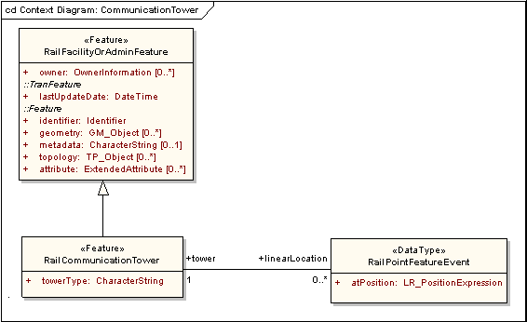
Figure 11 – RailCommunicationTower

Table 6 – Data dictionary for RailCommunicationTower
Line | Name/Role Name | Definition | Obligation/  Condition | Maximum Occurrence | Data Type | Domain
 | RailFacilityOrAdminFeature | Features for supporting the railroad infrastructure |  |  | <<Feature>> | Lines 129-135
 | owner | Person(s) or organization(s) that posses the station | O | * | <<DataType>>  OwnerInformation | Unrestricted
 | Transportation Base::  TranFeature::lastUpdateDate | Timestamp indicating when the RailFacilityOrAdminFeature object was last edited | M | 1 | DateTime | Valid historical or current date and time
 | Framework::Feature::identifier | Feature identifier for the RailFacilityOrAdminFeature | M | 1 | <<DataType>>  Framework::Identifier | Unrestricted
 | Framework::Feature::geometry | Shape and geolocation of a feature | O | * | <<Type>>  GM_Object | Defined in ISO 19107
 | Framework::Feature::metadata | Structured or unstructured metadata as defined by the community of practice | O | 1 | Characterstring | May be text or structured metadata fragment
 | Framework::Feature::topology | Connectivity of the participating elements | O | * | <<Interface>>  TP_Object | Defined in ISO 19107
 | Framework::Feature::attribute | Producer-defined attribute for inclusion in transfer | O | * | <<DataType>>  Framework::  ExtendedAttribute | Unrestricted
 | RailCommunicationTower | Railroad building or structure typically higher than its diameter and high relative to its surroundings that may stand apart, or be attached to a larger structure, that may be fully walled in or of skeleton framework and used for communications |  |  | <<Feature>> | Lines 137-138
 | towerType | Kind of RailCommunicationTower | M | 1 | CharacterString | Unrestricted
 | Role name: linearLocation | Location of the RaiCommunicationTower along a RailSeg or RailPath | O | * | <<DataType>>  RailPointFeatureEvent | Unrestricted
 | RailPointFeatureEvent | Mechanism for locating a feature at a single point along a railroad |  |  | <<DataType>> | Lines 140-141
 | atPosition | Point location along the railroad at which the RailCommunicationTower is located | M | 1 | <<Type>>  LR_PositionExpression | Defined in ISO 19133
 | Role name: tower | Railroad building or structure typically higher than its diameter and high relative to its surroundings that may stand apart, or be attached to a larger structure, that may be fully walled in or of skeleton framework and used for communications | M | 1 | <<Feature>>  RailCommunication  Tower | Unrestricted

    - RailPlatform
The feature RailPlatform, shown in Figure 12, is a subclass of RailFacilityOrAdminFeature and therefore can have geometry and topology as defined in ISO 19107. A RailPointFeatureEvent may be used to locate the RailPlatform along a RailSeg, a RailPath, or a RailTrack.
The code list PlatformType in Figure 12 provides the values for platformType. The other code list, PlatformHeightType, gives values for the height of the platform. Other attributes include stationServiced, measuredLength, owner, and platformName.

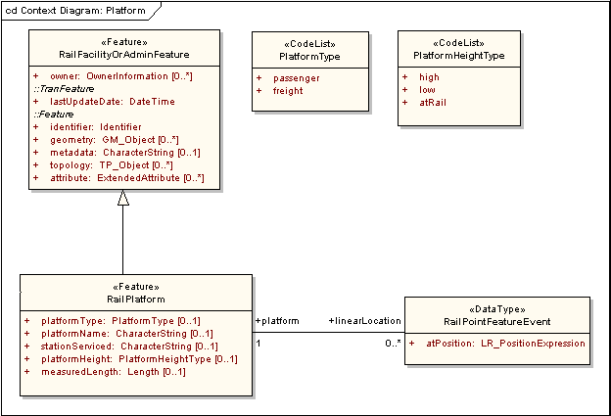
Figure 12 – RailPlatform

Table 7 – Data dictionary for RailPlatform
Line | Name/Role Name | Definition | Obligation/  Condition | Maximum Occurrence | Data Type | Domain
 | RailFacilityOrAdminFeature | Features for supporting the railroad infrastructure |  |  | <<Feature>> | Lines 143-149
 | owner | Person(s) or organization(s) that posses the station | O | * | <<DataType>>  OwnerInformation | Unrestricted
 | Transportation Base::  TranFeature::lastUpdateDate | Timestamp indicating when the RailFacilityOrAdminFeature object was last edited | M | 1 | DateTime | Valid historical or current date and time
 | Framework::Feature::identifier | Feature identifier for the RailFacilityOrAdminFeature | M | 1 | <<DataType>>  Framework::Identifier | Unrestricted
 | Framework::Feature::geometry | Shape and geolocation of a feature | O | * | <<Type>>  GM_Object | Defined in ISO 19107
 | Framework::Feature::metadata | Structured or unstructured metadata as defined by the community of practice | O | 1 | CharacterString | May be text or structured metadata fragment
 | Framework::Feature::topology | Connectivity of the participating elements | O | * | <<Interface>>  TP_Object | Defined in ISO 19107
 | Framework::Feature::attribute | Producer-defined attribute for inclusion in transfer | O | * | <<DataType>>  Framework::  ExtendedAttribute | Unrestricted
 | RailPlatform | Usually raised horizontal flat surface |  |  | <<Feature>> | Lines 151-156
 | platformType | Kind of platform | O | 1 | <<CodeList>>  PlatformType | Unrestricted
 | platformName | Word or phrase that constitutes the distinctive designation of the platform | O | 1 | CharacterString | Unrestricted
 | stationServiced | Kind of railStation serviced | O | 1 | CharacterString | Unrestricted
 | platformHeight | Height of the platform relative to the rail adjacent to it | O | 1 | <<CodeList>>  PlatformHeightType | Unrestricted
 | measuredLength | Length of the RailPlatform feature, which may differ from the field measured length due to differences in calculation | O | 1 | Measure | Defined in ISO 19103
 | Role name: linearLocation | Location of the RailPlatform along a RailSeg or RailPath | O | * | <<DataType>>  RailPointFeatureEvent | Unrestricted
 | RailPointFeatureEvent | Mechanism for locating a feature at a single point along a railroad |  |  | <<DataType>> | Lines 158-159
 | atPosition | Point location along the railroad at which the RailPlatform is located | M | 1 | <<Type>>  LR_PositionExpression | Defined in ISO 19133
 | Role name: platform | Usually raised horizontal flat surface | M | 1 | <<Feature>>  RailPlatform | Unrestricted

    - RailWaysideDetectionDevice
The RailWaysideDetectionDevice is depicted in Figure 13 and is shown to be a subtype of RailfacilityOrAdminFeature. RailWaysideDetectionDevice inherits the attributes owner, lastUpdateDate, identifier, metadata, attributes, and may have geometry and topology as defined in ISO 19107. It also has the attributes, deviceType, name and alarmType. A RailPointFeatureEvent may be used to locate the RailWaysideDectectionDevice along a RailSeg, a RailPath, or a RailTrack.

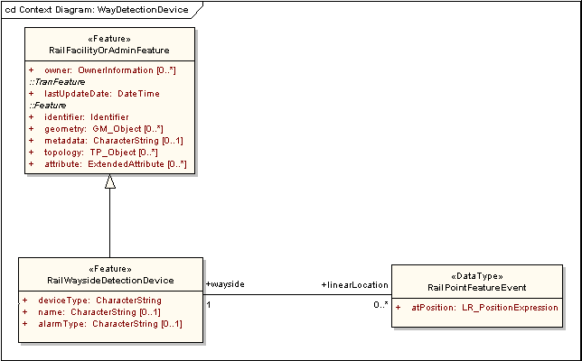
Figure 13 – RailWaysideDetectionDevice

Table 8 – Data dictionary for RailWaysideDetectionDevice
Line | Name/Role Name | Definition | Obligation/  Condition | Maximum Occurrence | Data Type | Domain
 | RailFacilityOrAdminFeature | Features for supporting the railroad infrastructure |  |  | <<Feature>> | Lines 161-167
 | owner | Person(s) or organization(s) that posses the station | O | * | <<DataType>>  OwnerInformation | Unrestricted
 | Transportation Base::  TranFeature::lastUpdateDate | Timestamp indicating when the RailFacilityOrAdminFeature object was last edited | M | 1 | DateTime | Valid historical or current date and time
 | Framework::Feature::identifier | Feature identifier for the RailFacilityOrAdminFeature | M | 1 | <<DataType>>  Framework::Identifier | Unrestricted
 | Framework::Feature::geometry | Shape and geolocation of a feature | O | * | <<Type>>  GM_Object | Defined in ISO 19107
 | Framework::Feature::metadata | Structured or unstructured metadata as defined by the community of practice | O | 1 | CharacterString | May be text or structured metadata fragment
 | Framework::Feature::topology | Connectivity of the participating elements | O | * | <<Interface>>  TP_Object | Defined in ISO 19107
 | Framework::Feature::attribute | Producer-defined attribute for inclusion in transfer | O | * | <<DataType>>  Framework::  ExtendedAttribute | Unrestricted
 | RailWaysideDetectionDevice | Piece of equipment or a mechanism, adjacent to the railroad, designed to detect characteristics of train movement |  |  | <<Feature>> | Lines 169-172
 | deviceType | Kind of wayside detection device | M | 1 | CharacterString | Unrestricted
 | name | Word or phrase that constitutes the distinctive designation of the wayside detection device | O | 1 | CharacterString | Unrestricted
 | alarmType | Kind of alarm the wayside detection device will activate | O | 1 | CharacterString | Unrestricted
 | Role name: linearLocation | Location of the RailWaysideDetectionDevice along a RailSeg or RailPath | O | * | <<DataType>>  RailPointFeatureEvent | Unrestricted
 | RailPointFeatureEvent | Mechanism for locating a feature at a single point along a railroad |  |  | <<DataType>> | Line 174-175
 | atPosition | Point location along the railroad at which the RailWaysideDetectionDevice is located | M | 1 | <<Type>>  LR_PositionExpression | Defined in ISO 19133
 | Role name: wayside | Piece of equipment or a mechanism, adjacent to the railroad, designed to detect characteristics of train movement | M | 1 | <<Feature>>  RailWaysideDetection  Device | Unrestricted

    - RailYard
Figure 14 shows the feature class RailYard and its relationship as a subtype of RailFacilityOrAdminFeature. It can have geometry and topology and inherits the attributes owner, lastUpdateDate, identifier, metadata, and attributes. It is further described by the attributes name, type, and capacity. The code list RailYardType gives the values for attribute “type”. Also, a RailLinearFeatureEvent may be used to locate the RailYard along a RailSeg, a RailPath, or a RailTrack.

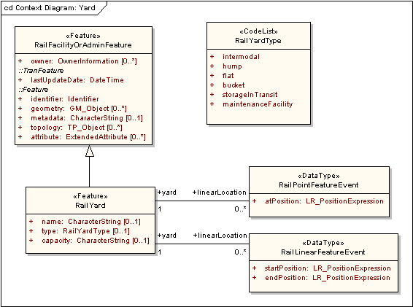
Figure 14 – RailYard

Table 9 – Data dictionary for RailYard
Line | Name/Role Name | Definition | Obligation/  Condition | Maximum Occurrence | Data Type | Domain
 | RailFacilityOrAdminFeature | Features for supporting the railroad infrastructure |  |  | <<Feature>> | Lines 177-183
 | owner | Person(s) or organization(s) that posses the station | O | * | <<DataType>>  OwnerInformation | Unrestricted
 | Transportation Base::  TranFeature::lastUpdateDate | Timestamp indicating when the RailFacilityOrAdminFeature object was last edited | M | 1 | DateTime | Valid historical or current date and time
 | Framework::Feature::identifier | Feature identifier for the RailFacilityOrAdminFeature | M | 1 | <<DataType>>  Framework::Identifier | Unrestricted
 | Framework::Feature::geometry | Shape and geolocation of a feature | O | * | <<Type>>  GM_Object | Defined in ISO 19107
 | Framework::Feature::metadata | Structured or unstructured metadata as defined by the community of practice | O | 1 | CharacterString | May be text or structured metadata fragment
 | Framework::Feature::topology | Connectivity of the participating elements | O | * | <<Interface>>  TP_Object | Defined in ISO 19107
 | Framework::Feature::attribute | Producer-defined attribute for inclusion in transfer | O | * | <<DataType>>  Framework::  ExtendedAttribute | Unrestricted
 | RailYard | System of tracks for storage and maintenance of cars and making up trains |  |  | <<Feature>> | Lines 185-189
 | name | Word or phrase that constitutes the distinctive designation of the RailYard | O | 1 | CharacterString | Unrestricted
 | type | Kind of RailYard | O | 1 | <<CodeList>>  RailYardType | Unrestricted
 | capacity | Maximum amount or number of rail cars that can be contained or accommodated | O | 1 | CharacterString | Unrestricted
 | Role name: linearLocation | Location of the RailYard along a RailSeg or RailPath | O | * | <<DataType>>  RailPointFeatureEvent | Unrestricted
 | Role name: linearLocation | Location of the RailYard along a RailSeg or RailPath | O | * | <<DataType>>  RailLinearFeatureEvent | Unrestricted
 | RailPointFeatureEvent | Mechanism for locating a feature at a single point along a railroad |  |  | <<DataType>> | Lines 191-192
 | atPosition | Point location along the railroad at which the RailYard is located | M | 1 | <<Type>>  LR_PositionExpression | Defined in ISO 19133
 | Role name: yard | System of tracks for storage and maintenance of cars and making up trains | M | 1 | <<Feature>>  RailYard | Unrestricted
 | RailLinearFeatureEvent | Mechanism for locating a feature along an interval along a railroad |  |  | <<DataType>> | Lines 194-196
 | startPosition | Starting location along the railroad for the attribute value | M | 1 | <<Type>>  LR_PositionExpression | Defined in ISO 19133
 | endPosition | Ending location along the railroad for the attribute value | M | 1 | <<Type>>  LR_PositionExpression | Defined in ISO 19133
 | Role name: yard | System of tracks for storage and maintenance of cars and making up trains | M | 1 | <<Feature>>  RailYard | Unrestricted

    - RailBridge
Figure 15 shows RailBridge to be a subclass of RailFacilityOrAdmenFeature and therefore can have geometry and topology as defined in ISO 19107. A RailLinearFeatureEvent may be used to locate the RailBridge feature along a RailSeg, a RailPath, or a RailTrack. Certain RailBridge attributes, bridgeName, bridgeType, isBallasted, and utilitiesCarried, are expressed as character strings.

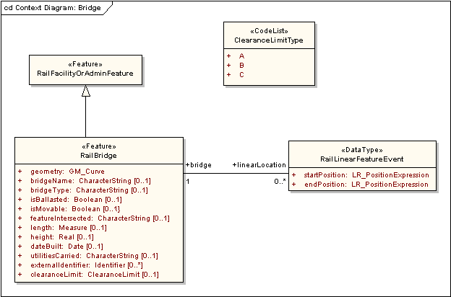
Figure 15 – RailBridge

Table 10 – Data dictionary for RailBridge
Line | Name/Role Name | Definition | Obligation/  Condition | Maximum Occurrence | Data Type | Domain
 | RailFacilityOrAdminFeature | Features for supporting the railroad infrastructure |  |  | <<Feature>> | Lines 198-204
 | owner | Person(s) or organization(s) that posses the station | O | * | <<DataType>>  OwnerInformation | Unrestricted
 | Transportation Base::  TranFeature::lastUpdateDate | Timestamp indicating when the RailFacilityOrAdminFeature object was last edited | M | 1 | DateTime | Valid historical or current date and time
 | Framework::Feature::identifier | Feature identifier for the RailFacilityOrAdminFeature | M | 1 | <<DataType>>  Framework::Identifier | Unrestricted
 | Framework::Feature::geometry | Shape and geolocation of a feature | O | * | <<Type>>  GM_Object | Defined in ISO 19107
 | Framework::Feature::metadata | Structured or unstructured metadata as defined by the community of practice | O | 1 | CharacterString | May be text or structured metadata fragment
 | Framework::Feature::topology | Connectivity of the participating elements | O | * | <<Interface>>  TP_Object | Defined in ISO 19107
 | Framework::Feature::attribute | Producer-defined attribute for inclusion in transfer | O | * | <<DataType>>  Framework::  ExtendedAttribute | Unrestricted
 | RailBridge | Structure carrying a railway over a depression or obstacle |  |  | <<Feature>> | Lines 206-218
 | geometry | Shape and geolocation of a feature | M | 1 | <<Type>>  GM_Curve | Defined in ISO 19107
 | bridgeName | Word or phrase that constitutes the distinctive designation of the RailBridge | O | 1 | CharacterString | Unrestricted
 | bridgeType | Kind of RailBridge | O | 1 | CharacterString | Unrestricted
 | isBallasted | Denotes whether or not there exist gravel or broken stone laid in the railroad | O | 1 | Boolean | True or False
 | isMovable | Denotes whether or not the bridge is movable | O | 1 | Boolean | True or False
 | featureIntersected | Obstruction being traversed | O | 1 | CharacterString | Unrestricted
 | length | Length of the RailBridge feature, which may differ from the field measured length due to differences in calculation | O | 1 | Measure | Defined in ISO 19103
 | height | Height of the bridge above the feature being traversed | O | 1 | Real | All real numbers
 | dateBuilt | Date the bridge construction was completed | O | 1 | Date | Valid historical or current date and time
 | utilitiesCarried | Public utility and the equipment used to carry that service across the railroad bridge | O | 1 | CharacterString | Unrestricted
 | externalIdentifier | Feature identifier for the feature being traversed | O | * | <<DataType>>  Framework::Identifier | Unrestricted
 | clearanceLimit | Minimum height and width the train must be to safely traverse the bridge | O | 1 | <<CodeList>>  ClearanceLimitType | Unrestricted
 | Role name: linearLocation | Location of the RailBridge along a RailSeg or RailPath | O | * | <<DataType>>  RailLinearFeatureEvent | Unrestricted
 | RailLinearFeatureEvent | Mechanism for locating a feature along an interval along a railroad |  |  | <<DataType>> | Lines 220-222
 | startPosition | Starting location along the railroad for the attribute value | M | 1 | <<Type>>  LR_PositionExpression | Defined in ISO 19133
 | endPosition | Ending location along the railroad for the attribute value | M | 1 | <<Type>>  LR_PositionExpression | Defined in ISO 19133
 | Role name: bridge | Structure carrying a railway over a depression or obstacle | M | 1 | <<Feature>>  RailBridge | Unrestricted

    - RailControlPoint
RailControlPoint is depicted in Figure 16, which shows that RailControlPoint is a subtype of RailFacilityOrAdminFeature. RailFacilityOrAdminFeature can have geometry and topology as defined in ISO 19107. A RailPointFeatureEvent can be used to define the location of the control point along a RailSeg, a RailPath or a RailTrack. The code list ControlPointType gives the values for attribute pointType. Attribute name is expressed as a character string.

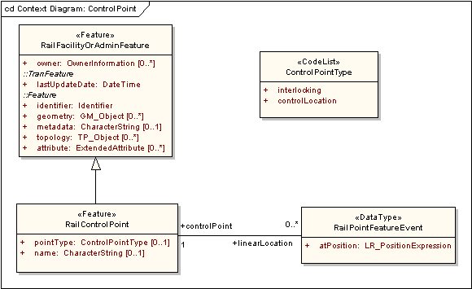
Figure 16 – RailControlPoint

Table 11 – Data dictionary for RailControlPoint
Line | Name/Role Name | Definition | Obligation/  Condition | Maximum Occurrence | Data Type | Domain
 | RailFacilityOrAdminFeature | Features for supporting the railroad infrastructure |  |  | <<Feature>> | Lines 224-230
 | owner | Person(s) or organization(s) that posses the station | O | * | <<DataType>>  OwnerInformation | Unrestricted
 | Transportation Base::  TranFeature::lastUpdateDate | Timestamp indicating when the RailFacilityOrAdminFeature object was last edited | M | 1 | DateTime | Valid historical or current date and time
 | Framework::Feature::identifier | Feature identifier for the RailFacilityOrAdminFeature | M | 1 | <<DataType>>  Framework::Identifier | Unrestricted
 | Framework::Feature::geometry | Shape and geolocation of a feature | O | * | <<Type>>  GM_Object | Defined in ISO 19107
 | Framework::Feature::metadata | Structured or unstructured metadata as defined by the community of practice | O | 1 | CharacterString | May be text or structured metadata fragment
 | Framework::Feature::topology | Connectivity of the participating elements | O | * | <<Interface>>  TP_Object | Defined in ISO 19107
 | Framework::Feature::attribute | Producer-defined attribute for inclusion in transfer | O | * | <<DataType>>  Framework::  ExtendedAttribute | Unrestricted
 | RailControlPoint |  |  |  | <<Feature>> | Lines 232-234
 | pointType | Kind of wayside detection device | O | 1 | <<CodeList>>  ControlPointType | Unrestricted
 | name | Word or phrase that constitutes the distinctive designation of the controlPoint | O | 1 | CharacterString | Unrestricted
 | Role name: linearLocation | Location of the RailControlPoint along a RailSeg or RailPath | O | * | <<DataType>>  RailPointFeatureEvent | Unrestricted
 | RailPointFeatureEvent | Mechanism for locating a feature at a single point along a railroad |  |  | <<DataType>> | Lines 236-237
 | atPosition | Point location along the railroad at which the RailControlPoint is located | M | 1 | <<Type>>  LR_PositionExpression | Defined in ISO 19133
 | Role name: controlPoint |  | M | 1 | <<Feature>>  RailControlPoint | Unrestricted

    - RailFuelingFacility
The feature class RailFuelingFacility is depicted in Figure 17. It is shown to be a subtype of RailFacilityOrAdminFeature and therefore can have geometry and topology as defined in ISO 19107. A RailPointFeatureEvent may be used to locate the RailFuelingFacility along a RailSeg, a RailPath, or a RailTrack. The attribute name is given as a character string and attributes isDTL (Direct to Locomotive) and isPipelineDelivery are Boolean expressions. Attribute capacity is given as a volume expression.

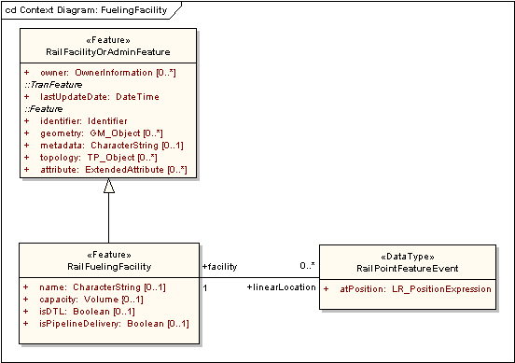
Figure 17 - RailFuelingFacility

Table 12 – Data dictionary for RailFuelingFacility
Line | Name/Role Name | Definition | Obligation/  Condition | Maximum Occurrence | Data Type | Domain
 | RailFacilityOrAdminFeature | Features for supporting the railroad infrastructure |  |  | <<Feature>> | Lines 239-245
 | owner | Person(s) or organization(s) that posses the station | O | * | <<DataType>>  OwnerInformation | Unrestricted
 | Transportation Base::  TranFeature::lastUpdateDate | Timestamp indicating when the RailFacilityOrAdminFeature object was last edited | M | 1 | DateTime | Valid historical or current date and time
 | Framework::Feature::identifier | Feature identifier for the RailFacilityOrAdminFeature | M | 1 | <<DataType>>  Framework::Identifier | Unrestricted
 | Framework::Feature::geometry | Shape and geolocation of a feature | O | * | <<Type>>  GM_Object | Defined in ISO 19107
 | Framework::Feature::metadata | Structured or unstructured metadata as defined by the community of practice | O | 1 | CharacterString | May be text or structured metadata fragment
 | Framework::Feature::topology | Connectivity of the participating elements | O | * | <<Interface>>  TP_Object | Defined in ISO 19107
 | Framework::Feature::attribute | Producer-defined attribute for inclusion in transfer | O | * | <<DataType>>  Framework::  ExtendedAttribute | Unrestricted
 | RailFuelingFacility | Structure established to transfer fuel onto locomotives |  |  | <<Feature>> | Lines 247-251
 | name | Word or phrase that constitutes the distinctive designation of the fueling facility | O | 1 | CharacterString | Unrestricted
 | capacity | Maximum amount of fuel that can be contained or accommodated at the facility | O | 1 | Volume | Defined in ISO 19103
 | isDTL | Denotes whether or not the fueling facility transfers the fuel direct to the locomotive | O | 1 | Boolean | True or False
 | isPipelineDelivery | Denotes whether or not the fueling facility is supplied by a pipeline | O | 1 | Boolean | True or False
 | Role name: linearLocation | Location of the RailFuelingFacility along a RailSeg or RailPath | O | * | <<DataType>>  RailPointFeatureEvent | Unrestricted
 | RailPointFeatureEvent | Mechanism for locating a feature at a single point along a railroad |  |  | <<DataType>> | Lines 253-254
 | atPosition | Point location along the railroad at which the RailFuelingFacility is located | M | 1 | <<Type>>  LR_PositionExpression | Defined in ISO 19133
 | Role name: facility | Structure established to transfer fuel onto locomotives | M | 1 | <<Feature>>  RailFuelingFacility | Unrestricted

    - RailLinearOccupancy
Figure 18 shows the RailLinearOccupancy feature class, which is shown to be a subclass of RailFacilityOrAdminFeature. RailLinearOccupancy therefore can have geometry and topology as defined in ISO 19107. A RailLinearFeatureEvent may be used to locate the RailLinearOccupancy along a RailSeg, a RailPath, or a RailTrack. The value for attribute utilityOwner is supplied by the data type OwnerInformation. Values for attribute levelOfGrade are supplied by the CrossingLevelKind enumeration. OccupancyTypes are expressed as characterStrings.

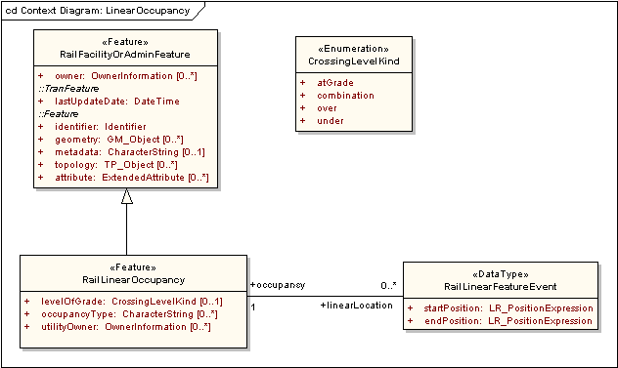
Figure 18 – RailLinearOccupancy

Table 13 – Data dictionary for RailLinearOccupancy
Line | Name/Role Name | Definition | Obligation/  Condition | Maximum Occurrence | Data Type | Domain
 | RailFacilityOrAdminFeature | Features for supporting the railroad infrastructure |  |  | <<Feature>> | Lines 256-262
 | owner | Person(s) or organization(s) that posses the station | O | * | <<DataType>>  OwnerInformation | Unrestricted
 | Transportation Base::  TranFeature::lastUpdateDate | Timestamp indicating when the RailFacilityOrAdminFeature object was last edited | M | 1 | DateTime | Valid historical or current date and time
 | Framework::Feature::identifier | Feature identifier for the RailFacilityOrAdminFeature | M | 1 | <<DataType>>  Framework::Identifier | Unrestricted
 | Framework::Feature::geometry | Shape and geolocation of a feature | O | * | <<Type>>  GM_Object | Defined in ISO 19107
 | Framework::Feature::metadata | Structured or unstructured metadata as defined by the community of practice | O | 1 | CharacterString | May be text or structured metadata fragment
 | Framework::Feature::topology | Connectivity of the participating elements | O | * | <<Interface>>  TP_Object | Defined in ISO 19107
 | Framework::Feature::attribute | Producer-defined attribute for inclusion in transfer | O | * | <<DataType>>  Framework::  ExtendedAttribute | Unrestricted
 | RailLinearOccupancy | Public utility or utilities that occupy the land adjacent to the railroad |  |  | <<Feature>> | Lines 264-267
 | levelOfGrade | Level at which the utility is carried in reference to the ground | O | 1 | <<Enumeration>>  CrossingLevelKind | over, under, atGrade, combination
 | occupancyType | Kind of public utility occupying the land adjacent to the rail tracks | O | * | CharacterString | Unrestricted
 | utilityOwner | Person(s) or organization(s) that posses the public utility | O | * | <<DataType>>  OwnerInformation | Unrestricted
 | Role name: linearLocation | Location of the RailLinearOccupancy along a RailSeg or RailPath | O | * | <<DataType>>  RailLinearFeatureEvent | Unrestricted
 | RailLinearFeatureEvent | Mechanism for locating a feature along an interval along a railroad |  |  | <<DataType>> | Lines 269-271
 | startPosition | Starting location along the railroad for the attribute value | M | 1 | <<Type>>  LR_PositionExpression | Defined in ISO 19133
 | endPosition | Ending location along the railroad for the attribute value | M | 1 | <<Type>>  LR_PositionExpression | Defined in ISO 19133
 | Role name: occupancy | Public utility that occupies the land adjacent to the train tracks | M | 1 | <<Feature>>  RailLinearOccupancy | Unrestricted

    - RailSignal
Figure 19 shows the RailSignal feature class. The RailSignal feature class is a subtype of RailFacilityOrAdminFeature and therefore can have geometry and topology as defined in ISO 19107. A RailPointFeatureEvent may be used to locate the RailSignal along a RailSeg, a RailPath, or a RailTrack. The attribute numberOfTracksServed is given as an integer and attribute description is given as a character string. The enumeration TravelDirectionKind supplies the values for the attribute travelDirection and the code list SignalType supplies values for the attribute signalType.

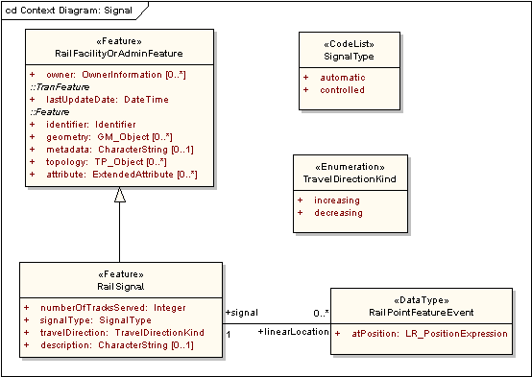
Figure 19 – RailSignal

Table 14 – Data dictionary for RailSignal
Line | Name/Role Name | Definition | Obligation/  Condition | Maximum Occurrence | Data Type | Domain
 | RailFacilityOrAdminFeature | Features for supporting the railroad infrastructure |  |  | <<Feature>> | Lines 273-279
 | owner | Person(s) or organization(s) that posses the station | O | * | <<DataType>>  OwnerInformation | Unrestricted
 | Transportation Base::  TranFeature::lastUpdateDate | Timestamp indicating when the RailFacilityOrAdminFeature object was last edited | M | 1 | <<Type>>  DateTime | Valid historical or current date and time
 | Framework::Feature::identifier | Feature identifier for the RailFacilityOrAdminFeature | M | 1 | <<DataType>>  Framework::Identifier | Unrestricted
 | Framework::Feature::geometry | Shape and geolocation of a feature | O | * | GM_Object | Defined in ISO 19107
 | Framework::Feature::metadata | Structured or unstructured metadata as defined by the community of practice | O | 1 | CharacterString | May be text or structured metadata fragment
 | Framework::Feature::topology | Connectivity of the participating elements | O | * | <<Interface>>  TP_Object | Defined in ISO 19107
 | Framework::Feature::attribute | Producer-defined attribute for inclusion in transfer | O | * | <<DataType>>  Framework::  ExtendedAttribute | Unrestricted
 | RailSignal | Structure established to transfer fuel onto locomotives |  |  | <<Feature>> | Lines 281-285
 | numberOfTracksServed | Number of railroad tracks served by the signal | M | 1 | Integer | Positive integers
 | signalType | Kind of signal | M | 1 | <<CodeList>>  SignalType | Unrestricted
 | travelDirection | Direction in which the train travels relative to the signal | M | 1 | <<Enumeration>>  TravelDirectionKind | increasing, decreasing
 | description | Description of the RailSignal | O | 1 | CharacterString | Unrestricted
 | Role name: linearLocation | Location of the RailSignal along a RailSeg or RailPath | O | * | <<DataType>>  RailPointFeatureEvent | Unrestricted
 | RailPointFeatureEvent | Mechanism for locating a feature at a single point along a railroad |  |  | <<DataType>> | Line 286-288
 | atPosition | Point location along the railroad at which the RailSignal is located | M | 1 | <<Type>>  LR_PositionExpression | Defined in ISO 19133
 | Role name: signal | Structure established to transfer fuel onto locomotives | M | 1 | <<Feature>>  RailSignal | Unrestricted

    - RailSwitch
The feature class RailSwitch is depicted in Figure 20. It is shown to be a subtype of RailFacilityorAdminFeature and therefore can have geometry and topology as defined in ISO 19107. A RailPointFeatureEvent may be used to locate the RailSwitch along a RailSeg, a RailPath, or a RailTrack. The value for switchAngle is given by the code list SwitchAngleType. The attribute isManual is a Boolean value.

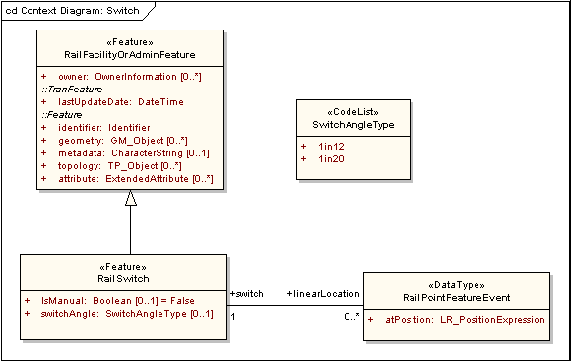
Figure 20 – RailSwitch

Table 15 – Data dictionary for RailSwitch
Line | Name/Role Name | Definition | Obligation/  Condition | Maximum Occurrence | Data Type | Domain
 | RailFacilityOrAdminFeature | Features for supporting the railroad infrastructure |  |  | <<Feature>> | Lines 290-296
 | owner | Person(s) or organization(s) that posses the station | O | * | <<DataType>>  OwnerInformation | Unrestricted
 | Transportation Base::  TranFeature::lastUpdateDate | Timestamp indicating when the RailFacilityOrAdminFeature object was last edited | M | 1 | DateTime | Valid historical or current date and time
 | Framework::Feature::identifier | Feature identifier for the RailFacilityOrAdminFeature | M | 1 | <<DataType>>  Framework::Identifier | Unrestricted
 | Framework::Feature::geometry | Shape and geolocation of a feature | O | * | <<Type>>  GM_Object | Defined in ISO 19107
 | Framework::Feature::metadata | Structured or unstructured metadata as defined by the community of practice | O | 1 | CharacterString | May be text or structured metadata fragment
 | Framework::Feature::topology | Connectivity of the participating elements | O | * | <<Interface>>  TP_Object | Defined in ISO 19107
 | Framework::Feature::attribute | Producer-defined attribute for inclusion in transfer | O | * | <<DataType>>  Framework::  ExtendedAttribute | Unrestricted
 | RailSwitch | Mechanism used to transfer railcars from one set of tracks to another |  |  | <<Feature>> | Lines 298-300
 | isManual | Denotes whether or not the railroad switch is manually operated | O | 1 | Boolean | True or False
 | switchAngle | Angle at which the switch diverts to the next track | O | 1 | <<CodeList>>  SwitchAngleType | Unrestricted
 | Role name: linearLocation | Location of the RailSwitch along a RailSeg or RailPath | O | * | <<DataType>>  RailPointFeatureEvent | Unrestricted
 | RailPointFeatureEvent | Mechanism for locating a feature at a single point along a railroad |  |  | <<DataType>> | Lines 302-303
 | atPosition | Point location along the railroad at which the RailSwitch is located | M | 1 | <<Type>>  LR_PositionExpression | Defined in ISO 19133
 | Role name: switch | Mechanism used to transfer railcars from one set of tracks to another | M | 1 | <<Feature>>  RailSwitch | Unrestricted

    - RailTransportationCrossing
Figure 21 depicts the feature class RailTransportationCrossing. It is a subtype of RailFacilityOrAdminFeature and therefore can have geometry and topology as defined by ISO 19107. A RailLinearFeatureEvent may be used to locate the RailTransportationCrossing along a RailSeg, a RailPath, or a RailTrack. The code list TransportationCrossingType supplies values for the attribute crossingType. The enumeration CrossingLevelKind supplies values for the attribute levelOfCrossing. Attributes name, nearestRoad, and nearestAddress are expressed as character strings.

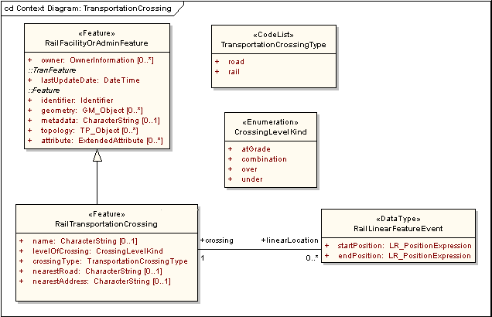
Figure 21 – RailTransportationCrossing

Table 16 – Data dictionary for RailTransportationCrossing
Line | Name/Role Name | Definition | Obligation/  Condition | Maximum Occurrence | Data Type | Domain
 | RailFacilityOrAdminFeature | Features for supporting the railroad infrastructure |  |  | <<Feature>> | Lines 305-311
 | owner | Person(s) or organization(s) that posses the station | O | * | <<DataType>>  OwnerInformation | Unrestricted
 | Transportation Base::  TranFeature::lastUpdateDate | Timestamp indicating when the RailFacilityOrAdminFeature object was last edited | M | 1 | DateTime | Valid historical or current date and time
 | Framework::Feature::identifier | Feature identifier for the RailFacilityOrAdminFeature | M | 1 | <<DataType>>  Framework::Identifier | Unrestricted
 | Framework::Feature::geometry | Shape and geolocation of a feature | O | * | <<Type>>  GM_Object | Defined in ISO 19107
 | Framework::Feature::metadata | Structured or unstructured metadata as defined by the community of practice | O | 1 | CharacterString | May be text or structured metadata fragment
 | Framework::Feature::topology | Connectivity of the participating elements | O | * | <<Interface>>  TP_Object | Defined in ISO 19107
 | Framework::Feature::attribute | Producer-defined attribute for inclusion in transfer | O | * | <<DataType>>  Framework::  ExtendedAttribute | Unrestricted
 | RailTransportationCrossing | Intersection between the railroad and another railroad or roadway |  |  | <<Feature>> | Lines 313-318
 | name | Word or phrase that constitutes the distinctive designation of the Transportation Crossing | O | 1 | Character String | Unrestricted
 | levelOfCrossing | Level at which the transportation crossing intersects the railroad | M | 1 | <<Enumeration>>  CrossingLevelKind | over, under, atGrade, combination
 | crossingType | Kind of crossing | M | 1 | <<CodeList>>  TransportationCrossingType | Unrestricted
 | nearestRoad | Closest road to the transportation crossing | O | 1 | CharacterString | Unrestricted
 | nearestAddress | Closest address to the transportation crossing | O | 1 | CharacterString | Unrestricted
 | Role name: linearLocation | Location of the RailTransportationCrossing along a RailSeg or RailPath | O | * | <<DataType>>  RailLinearFeatureEvent | Unrestricted
 | RailLinearFeatureEvent | Mechanism for locating a feature along an interval along a railroad |  |  | <<DataType>> | Lines 320-322
 | startPosition | Starting location along the railroad for the attribute value | M | 1 | <<Type>>  LR_PositionExpression | Defined in ISO 19133
 | endposition | Ending location along the railroad for the attribute value | M | 1 | <<Type>>  LR_PositionExpression | Defined in ISO 19133
 | Role name: crossing |  | M | 1 | <<Feature>>  RailTransportation  Crossing | Unrestricted

    - RailUtilityCrossing
Figure 22 depicts the feature class RailUtilityCrossing. It is a subtype of RailFacilityOrAdminFeature and therefore can have geometry and topology as defined by ISO 19107. A RailPointFeatureEvent may be used to locate the RailUtilityCrossing along a RailSeg, a RailPath, or a RailTrack. The code list UtilityCrossingType supplies values for the attribute crossingType. The enumeration CrossingLevelKind supplies values for the attribute crossingLevel. Attributes nearestRoad, and nearestAddress are expressed as character strings.

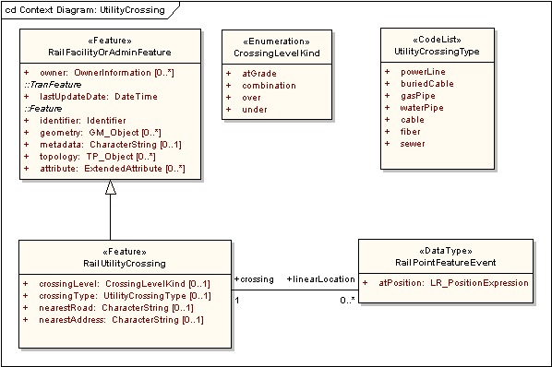
Figure 22 – RailUtilityCrossing

Table 17 – Data dictionary for RailUtilityCrossing
Line | Name/Role Name | Definition | Obligation/  Condition | Maximum Occurrence | Data Type | Domain
 | RailFacilityOrAdminFeature | Features for supporting the railroad infrastructure |  |  | <<Feature>> | Lines 324-330
 | owner | Person(s) or organization(s) that posses the station | O | * | <<DataType>>  OwnerInformation | Unrestricted
 | Transportation Base::  TranFeature::lastUpdateDate | Timestamp indicating when the RailFacilityOrAdminFeature object was last edited | M | 1 | DateTime | Valid historical or current date and time
 | Framework::Feature::identifier | Feature identifier for the RailFacilityOrAdminFeature | M | 1 | <<DataType>>  Framework::Identifier | Unrestricted
 | Framework::Feature::geometry | Shape and geolocation of a feature | O | * | <<Type>>  GM_Object | Defined in ISO 19107
 | Framework::Feature::metadata | Structured or unstructured metadata as defined by the community of practice | O | 1 | CharacterString | May be text or structured metadata fragment
 | Framework::Feature::topology | Connectivity of the participating elements | O | * | <<Interface>>  TP_Object | Defined in ISO 19107
 | Framework::Feature::attribute | Producer-defined attribute for inclusion in transfer | O | * | <<DataType>>  Framework::  ExtendedAttribute | Unrestricted
 | RailUtilityCrossing | Intersection between the railroad and public utility equipment |  |  | <<Feature>> | Lines 332-336
 | crossingLevel | Intersection between the railroad and public utility equipment | O | 1 | <<Enumeration>>  CrossingLevelKind | over, under, atGrade, combination
 | crossingType | Kind of crossing | O | 1 | <<CodeList>>  UtilityCrossingType | Unrestircted
 | nearestRoad | Closest road to the transportation crossing | O | 1 | CharacterString | Unrestricted
 | nearestAddress | Closest address to the transportation crossing | O | 1 | CharacterString | Unrestricted
 | Role name: linearLocation | Location of the RailUtilityCrossing along a RailSeg or RailPath | O | * | <<DataType>>  RailPointFeatureEvent | Unrestricted
 | RailPointFeatureEvent | Mechanism for locating a feature at a single point along a railroad |  |  | <<DataType>> | Lines 338-339
 | atPosition | Point location along the railroad at which the RailUtility is located | M | 1 | <<Type>>  LR_PositionExpression | Defined in ISO 19133
 | Role name: crossing |  | M | 1 | <<Feature>>  RailUtilityCrossing | Unrestricted

  - Code lists and enumerations
    - Code lists
      - ClearanceLimitType code list
ClearanceLimitType is a CodeList of values for the attribute clearanceLimit.

Table 18 – CodeList for ClearanceLimitType
Name | Definition
A
B
C

      - ControlPointType code list
ContolPointType is a CodeList of values for the attribute pointType.

Table 19 – CodeList for ControlPointType
Name | Definition
interlocking
controlLocation

      - OwnershipType code list
OwnershipType is a CodeList of values for the attribute ownershipType.

Table 20 – CodeList for OwnershipType
Name | Definition
joint
trackageRights
haulageRights
leased
owned
other
operated

      - PlatformHeightType code list
PlatformHeightType is a CodeList of values for the attribute platformHeight.

Table 21 – CodeList for PlatformHeightType
Name | Definition
high
low
atRail

      - PlatformType code list
PlatformType is a CodeList of values for the attribute platformType.

Table 22 – CodeList for PlatformType
Name | Definition
passenger
freight

      - RailServiceType code list
RailServiceType is a CodeList of values for the attribute serviceType.

Table 23 – CodeList for RailServiceType
Name | Definition
intermodal
bulk
passenger
carLoad

      - RailYardType code list
RailYardType is a CodeList of values for the RailYard attribute type.

Table 24 – CodeList for RailYardType
Name | Definition
intermodal
hump
flat
bucket
storageInTransit
maintenanceFacility

      - TrackType code list
TrackType is a CodeList of values for the attribute trackType.

Table 25 – CodeList for TrackType
Name | Definition
siding
wye
mainTrack
mainlineTrack
branchLine
interlocking
yard
interchange
station

      - TransportationCrossingType code list
TransportationCrossingType is a CodeList of values for the attribute crossingType.

Table 26 – CodeList for TransportationCrossingType
Name | Definition
road
rail

      - SignalType code list
SignalType is a CodeList of values for the attribute signalType.

Table 27 – CodeList for SignalType
Name | Definition
automatic
controlled

      - SwitchAngleType code list
SwitchAngleList is a CodeList of values for the attribute switchAngle.

Table 28 – CodeList for SwitchAngleType
Name | Definition
1in12
1in20

      - UtilityCrossingType code list
UtilityCrossingType is a CodeList of values for the attribute crossingType.

Table 29 – CodeList for UtilityCrossingType
Name | Definition
powerLine
buriedCable
gasPipe
waterPipe
cable
fiber
sewer

    - Enumerations
      - CrossingLevelKind enumeration
CrossingLevelKind is an enumeration of values for the attributes crossingLevel, levelOfCrossing, and levelOfGrade.

Table 30 – CrossingLevelKind enumeration
Name | Definition
atGrade
combination
over
under

      - TravelDirectionKind enumeration
TravelDirectionKind is an enumeration of values for the attribute travelDirection.

Table 31 – TravelDirectionKind enumeration
Name | Definition
increasing
decreasing

- (normative)
Normative references
This annex lists normative standards that support this part of the Framework Data Content Standard. Annex A of the Base Document (Part 0) lists normative references applicable to two or more parts of the standard, including those other than the transportation parts.
ANSI and ISO standards may be purchased through the ANSI eStandards Store at http://webstore.ansi.org/ansidocstore/default.asp, accessed October 2006.
ISO 19110:2005, Geographic information – Methodology for feature cataloguing

- (informative)
Railway use cases
  - Introduction
In developing the Rail part of the Framework Data Content Standard, a series of general use cases were developed to assist in defining the requirements for a rail model. While these use cases focus on scenarios common to a broad segment of the rail industry, they are not comprehensive in defining all the potential uses of rail data. They were critical in providing focus for the development team. In future versions of the part, more detailed and formalized use cases will be developed to facilitate expansion and refinement of the rail model.
    - Emergency response use case
This use case details an emergency response scenario involving the following user groups:
- Locomotive engineer
- Railroad dispatcher
An event, such as a derailment, occurs that requires the railroad to involve outside agencies. The locomotive engineer needs to summon non-railroad emergency response agencies, such as fire departments to control fires, rescue squads to provide injury assistance, environmental agencies to contain hazardous material spills, or law enforcement to assist the population in vicinity of the incident.
During this type of scenario, the engineer contacts the railroad dispatcher and describes the event location by track and milepost. In response, the dispatcher contacts outside agencies to relate the railroad location to a location reference understood by the outside agency. By having the GIS data layers for tracks and mileposts as well as for streets, highways, municipal boundaries, waterways, and other pertinent geospatial layers, the dispatcher can describe the location relative to an intersection or provide a distance from a road crossing, city, or river for the outside agency to direct them to the derailment.
    - Emergency stop use case
This use case details a scenario that requires the cessation of rail traffic along a specific section of track. This scenario involves the following user groups:
- Railroad customer service center representative
- Railroad dispatcher
- Locomotive engineer
- Local law enforcement officer
- Local law enforcement central dispatching
An event occurs that requires the railroad to stop a train, such as a car stuck on a crossing. In response, a local law enforcement officer needs to contact the railroad to ensure on-coming rail traffic is stopped.
In this scenario, the law enforcement officer contacts the central dispatcher who then calls the railroad thought to be the owner of the track using a 1-800 number for the railroad. The railroad customer service center representative receives the call and the law enforcement officer relays information regarding the incident and the location of the road crossing. This could include the following types of location information:
- Street or highway name
- Municipality and/or county name
- State, Province, or Territory
- Closest intersection (highways or streets)
- Closest town or municipality to the event
- Proximity to other landmarks such as a bridge or river
The service representative will use GIS data for the rail network, such as track and milepost, overlaid with other GIS data layers for streets, highways, municipal boundaries, and waterways to correlate the location received from the law enforcement officer with a track and mile post. The service representative contacts the dispatcher in control of the identified track and sends notification of the situation. The dispatcher will then radio the locomotive engineers on approaching trains to have them stop at a safe distance from the crossing.
Additionally, if there are multiple tracks at the crossing and there is the possibility that another railroad could be operating through the crossing, the first railroad customer representative can contact the other railroad in order to stop their trains.
    - Incident reporting use case
This use case details a scenario in which a member of the public contacts an “authority” to report an incident. This scenario involves the following user groups:
- The railroad's rail traffic control center
- The railroad’s law enforcement personnel
- Non-railroad emergency response agencies (911, fire departments, ambulance services, contractors, population in vicinity of incident)
A member of the general public witnesses an incident on a railroad and needs to contact the appropriate "authorities" to describe the incident and the location. The citizen may not know the railroad track owner, subdivision name, and mileage sign location. Other location information that may be provided is:
- Street or highway name
- Municipality and/or county name
- State, Province or Territory
- Closest intersection (highways or streets)
- Closest town or municipality
- GPS location
- Information found on the back of crossbucks
- Proximity to other landmarks such as a bridge or river
- Track configuration at incident (single track, multiple tracks)
- Whether incident is at a crossing
The "public" emergency responder would then dispatch appropriate services and would also try to identify and then contact the appropriate rail company. The "public" responder would also need to convey the location description to the railroad.

