xxxx-Part.3

Date: 2008-03-18

Information Technology – Geographic Information
Framework Data Content Standard
Part 3: Elevation

Contents
Introduction vi
1 Scope, purpose, and application 1
2 Conformance 1
3 Normative references 1
4 Maintenance authority 1
4.1 Level of responsibility 1
4.2 Contact information 1
5 Terms and definitions 2
6 Symbols, abbreviated terms, and notations 3
7 Requirements 4
7.1 General 4
7.2 Point 4
7.3 Grid 5
7.4 Contour 6
7.5 Triangulated irregular network (TIN) 6
7.6 Profile 7
Annex A (normative) UML model, Application schema for the exchange of framework elevation data 10
A.1 General 10
A.2 ElevationCollection 10
A.2.1 Semantics 10
A.2.2 extent 10
A.2.3 metadata 10
A.2.4 gridSet 11
A.2.5 pointSet 11
A.2.6 pointCoverage 11
A.2.7 contourSet 11
A.2.8 tin 11
A.2.9 profileSet 11
A.3 ElevationCoverage 11
A.3.1 Semantics 12
A.3.2 domainExtent 12
A.3.3 rangeType 12
A.3.4 commonPointRule 13
A.3.5 metadata 13
A.4 ElevationGridCoverage 13
A.4.1 Semantics 13
A.4.2 interpolationType 14
A.4.3 data 14
A.5 ElevationGrid 14
A.5.1 Semantics 14
A.5.2 dimension 14
A.5.3 axisNames 14
A.5.4 origin 14
A.5.5 offsetVectors 14
A.5.6 extent 14
A.5.7 sequencingRule 14
A.5.8 startSequence 14
A.5.9 values 15
A.6 ElevationPointCoverage 15
A.6.1 Semantics 15
A.6.2 element 15
A.7 MultiElevationPoint 15
A.7.1 Semantics 15
A.7.2 geometry 16
A.7.3 value 16
A.8 ElevationTinCoverage 16
A.8.1 Semantics 16
A.8.2 interpolationType 17
A.8.3 geometry 17
A.8.4 element 17
A.9 ElevationTriangle 17
A.9.1 geometry 17
A.9.2 collection 17
A.9.3 control value 17
A.9.4 MultiElevationPoint 17
A.10 ElevationContourCoverage 17
A.10.1 Semantics 18
A.10.2 element 18
A.11 ElevationContour 18
A.11.1 Semantics 18
A.11.2 geometry 18
A.11.3 value 18
A.12 ElevationPointSet 19
A.12.1 Semantics 19
A.12.2 domainExtent 19
A.12.3 point 19
A.12.4 metadata 19
A.13 ElevationPoint 19
A.13.1 Semantics 19
A.13.2 surfaceType 20
A.13.3 geometry 20
A.14 ElevationProfileCollection 20
A.14.1 Semantics 20
A.14.2 domainExtent 20
A.14.3 metadata 20
A.14.4 profile 20
A.15 ElevationProfile 21
A.15.1 Semantics 21
A.15.2 surfaceType 21
A.15.3 profileType 21
A.15.4 geometry 21
A.16 DirectPosition 21
A.16.1 Semantics 22
A.16.2 coordinate 22
A.16.3 dimension 22
A.16.4 coordinateReferenceSystem 22
A.17 Code lists 22
A.17.1 CV_CommonPointRule code list 22
A.17.2 CV_InterpolationMethod code list 23
A.17.3 CV_SequenceType code list 23
A.17.4 ProfileType code list 24
Annex B (normative) Elevation data UML object description, Data dictionaries for framework elevation data 25
B.1 ElevationCollection 25
B.2 ElevationCoverage 26
B.3 ElevationGridCoverage 27
B.4 ElevationPointCoverage 30
B.5 ElevationTinCoverage 31
B.6 ElevationContourCoverage 32
B.7 ElevationPointSet 33
B.8 ElevationProfileCollection 34
Annex C (informative) Bibliography 35
Figures
Figure 1 – Elevation 4
Figure 2 – Example: Point 5
Figure 3 – Example: Grid 6
Figure 4 – Example: Contours 6
Figure 5 – Example: Triangulated irregular network 7
Figure 6 – Example: Profile1 8
Figure 7 – Example: Profile2 8
Figure 8 – Example: Profile3 9
Figure A.1 – ElevationCollection 10
Figure A.2 – ElevationCoverage 12
Figure A.3 – ElevationGridCoverage 13
Figure A.4 – ElevationPointCoverage 15
Figure A.5 – ElevationTinCoverage 16
Figure A.6 – ElevationContourCoverage 18
Figure A.7 – ElevationPointSet 19
Figure A.8 – ElevationProfileCollection 20
Figure A.9 – DirectPosition 21
Figure A.10 – Code lists 22

Tables
Table A.1 – CodeList for CV_CommonPointRule 23
Table A.2 – CodeList for CV_InterpolationMethod 23
Table A.3 – CodeList for CV_SequenceType 23
Table A.4 – Codelist for ProfileType 24
Table B.1 – Data dictionary for ElevationCollection 25
Table B.2 – Data dictionary for ElevationCoverage 26
Table B.3 – Data dictionary for ElevationGridCoverage 27
Table B.4 – Data dictionary for ElevationPointCoverage 30
Table B.5 – Data dictionary for ElevationTinCoverage 31
Table B.6 – Data dictionary for ElevationContourCoverage 32
Table B.7 – Data dictionary for ElevationPointSet 33
Table B.8 – Data dictionary for ElevationProfileCollection 34

Foreword
Geographic information, also known as geospatial information, both underlies and is the subject of much of the political, economic, environmental, and security activities of the United States. In recognition of this, the United States Office of Management and Budget issued Circular A-16 (revised 2002), which established the Federal Geographic Data Committee (FGDC) as a coordinating organization.
Work on this standard started under the Geospatial One-Stop e-Government initiative. The standard was developed with the support of the member agencies and organizations of the FGDC and aids in fulfilling a primary objective of the National Spatial Data Infrastructure (NSDI), that is, creation of common geographic base data for seven critical data themes. The seven core data themes are considered framework data of critical importance to the spatial data infrastructure.
As the Geographic Information Framework Data Content Standard was developed using public funds, the U.S. Government will be free to publish and distribute its contents to the public, as provided through the Freedom of Information Act (FOIA), Part 5 United States Code, Section 552, as amended by Public Law No. 104-231, “Electronic Freedom of Information Act Amendments of 1996”.

Introduction
The primary purpose of this part of the Geospatial Information Framework Data Ccontent Standard is to describe content of geospatial elevation data models to support of the exchange of elevation information. This part seeks to establish a common baseline for the semantic content of elevation databases for public agencies and private enterprises. It also seeks to decrease the costs and simplify the exchange of elevation data among local, Tribal, State, and Federal users and producers. That, in turn, discourages duplicative data collection. Benefits of adopting this part of the standard also include the long-term improvement of the geospatial elevation data within the community.

Framework Data Content Standard – Elevation
- Scope, purpose, and application
The Elevation part of the Framework Data Content Standard defines the geospatial data model entities and attributes that permit the exchange of digital elevation data consistent with the National Spatial Data Infrastructure’s (NSDI) framework for elevation data. This part of the standard is consistent with ISO 19123 Geographic Information – Schema for Coverage Geometry and Functions and the OGC 03-065r6 Abstract Specification for Coverage Type and its Subtypes. The part includes an application schema expressed in the Unified Modeling Language (UML).
The Elevation part identifies the geospatial data model elements required for digital elevation data to be used for the NSDI framework. The part was written to be inclusive of the common geospatial elevation data models (point, grid, contour, triangulated irregular network, and profile) and to not restrict anyone wishing to contribute their elevation data to the NSDI. The part supports both topographic elevation data (above a reference datum) and bathymetric elevation data (below a reference datum). Collecting and sharing NSDI digital elevation data that are consistent with this part of the standard will assure a common understanding of the data throughout the user community. Furthermore, the principles described in this standard may be extended to other geographic entities to facilitate the exchange of other geospatial thematic data.
- Conformance
Each geospatial elevation model of the Elevation part includes a data dictionary based on the conceptual application schema presented in that model. To conform to this part of the Framework Data Content Standard, an elevation dataset shall satisfy the requirements of the data dictionary for that geospatial data model.
- Normative references
Annex A of the Base Document (Part 0) lists normative references applicable to two or more parts of the standard. Informative references applicable only to the Elevation part are listed in Annex C. Annex D of the Base Document lists informative references applicable to two or more of the parts.
- Maintenance authority
  - Level of responsibility
The FGDC is the responsible organization for coordinating work on all parts of the Geographic Information Framework Data Content Standard. The U.S. Department of the Interior, United States Geological Survey (USGS), National Geospatial Programs Office, working with the FGDC, is directly responsible for development and maintenance of the Geographic Information Framework Data Content Standard, Part 3: Elevation.
  - Contact information
Address questions concerning this part of the standard to:
Federal Geographic Data Committee Secretariat
c/o U.S. Geological Survey
590 National Center
Reston, Virginia 20192 USA
Telephone: (703) 648-5514
Facsimile: (703) 648-5755
Internet (electronic mail): gdc@fgdc.gov
WWW Home Page: http://fgdc.gov
Or
Associate Director for Geographic Information
United States Geological Survey, MS 108
12201 Sunrise Valley Drive
Reston, VA 20192
Telephone: (703) 648-5747
Facsimile: (703) 648-7031
- Terms and definitions
Definitions applicable to the Elevation part are listed below. More general terms and definitions can be found in the Base Document (Part 0). Users are advised to consult that part for a complete set of definitions.

5.1
coordinate reference system
coordinate system which is related to the real world by a datum [ISO 19111]

5.2
coverage
feature that acts as a function to return values from its range for any direct position within its spatial, temporal, or spatiotemporal domain [ISO 19123]
EXAMPLES A raster image, a polygon overlay, or a digital elevation matrix.

5.3
coverage geometry
configuration of the domain of a coverage described in terms of coordinates [ISO 19123]

5.4
direct position
position described by a single set of coordinates within a coordinate reference system [ISO 19107]

5.5
elevation
distance measured upward along a plumb line between a point and the geoid
NOTE The elevation of a point is normally the same as its orthometric height. This is the “official” geodesy definition of elevation, but the term “elevation” is also used more generally for height above a specific vertical reference, not always the geoid.

5.6
geometry value pair
ordered pair composed of a spatial object, a temporal object, or a spatiotemporal object and a record of feature attribute values [ISO 19123]

5.7
grid
network composed of two or more sets of curves in which the members of each set intersect the members of the other sets in an algorithmic way [ISO 19123]
NOTE The curves partition a space into grid cells.

5.8
line segment
straight line between two points

5.9
point coverage
coverage that has a domain composed of points [ISO 19123]

5.10
range
set of feature attribute values associated by a function with the elements of the domain of a coverage

5.11
record
finite, named collection of related items (objects or values) [ISO 19107]
NOTE Logically, a record is a set of pairs <name, item>.

5.12
spatial object
object used for representing a spatial characteristic of a feature [ISO 19107]

5.13
tessellation
partitioning of a space into a set of conterminous spatial object, temporal object, or spatiotemporal object having the same dimension as the space being partitioned [ISO 19123]
NOTE A tessellation composed of congruent regular polygons or polyhedra is a regular tessellation. One composed of regular, but non-congruent polygons or polyhedra is a semi-regular tessellation. Otherwise the tessellation is irregular.

5.14
triangulated irregular network
TIN
tessellation composed of triangles [ISO 19123]

5.15
vector
quantity having direction as well as magnitude [ISO 19123]
NOTE A directed line segment represents a vector if the length and direction of the line segment are equal to the magnitude and direction of the vector. The term vector data refers to data that represents the spatial configuration of features as a set of directed line segments.
- Symbols, abbreviated terms, and notations
The following symbols, abbreviations, and notations are applicable to the Elevation part. Symbols, abbreviated terms, and notations applicable to multiple parts are listed in the Base Document (Part 0).
3D – 3-dimensional
LIDAR – Light Detection and Ranging
TIN – Triangulated Irregular Network
- Requirements
  - General
This standard models elevation data as a geospatial data coverage within the context of five geospatial data models: Point, Grid, TIN, Contour, and Profile as shown in Figure 1. Specifications, defined in this standard, accommodate the level of content and relationships necessary for exchange of all forms and formats of these data in a predictable and repeatable manner.

Elevation

Point
(Section 7.2)

Grid
(Section 7.3)

Contour
(Section 7.4)

TIN
(Section 7.5)

Profile
(Section 7.6)

Figure 1 – Elevation

Definitions for, and characteristics of, digital elevation data may be specific to these individual data models, or they may apply to all five geospatial data models. Appendix B provides the application schema for each of these geospatial elevation data models. The National Digital Elevation Program (www.ndep.gov) has developed a set of Guidelines for Digital Elevation Data that describe and provide best practices and examples for each of these geospatial data models.
  - Point
Points are the most basic geospatial elevation data model used for modeling terrain and bathymetric elevation data. Points are usually represented by a collection of irregularly, or non-uniformly organized geometry coordinate sets as shown in Figure 2. Each point is identified by a horizontal coordinate geometry pair (X,Y) and an vertical coordinate elevation value (Z). The elevation value (Z) may be explicitly encoded as a triplet (X, Y, Z), known as an ElevationPointSet (see section A.12 for the ElevationPointSet UML application schema and B.7 for the ElevationPointSet UML object description) or as an attribute value to the X,Y geometry pair, known as an ElevationPointCoverage (see section A.6 for the ElevationPointCoverage UML application schema and B.4 for the ElevationPointCoverage UML object description). Point coverage attribution could include identification such as a control point reference, reference to the type of surface to which the point applies, or other characteristics specific to the point. The order (if applicable) and definition of these additional attributes shall be specified in the metadata. While points are not necessarily presented in a uniform or structured pattern, they often are acquired in a systematic distribution, which is intended to facilitate accurate representation of the surface or features the data are intended to model. When generated manually, points are ideally chosen so that subtle terrain characteristics, such as gradual variations in slope or aspect, or distinct features such as a levee or river embankment are adequately represented in the data. However, when generated automatically, such as through the use of an active sensing system (LIDAR), point distribution depends upon the characteristics of the sensor used to acquire the data, and its performance in different terrain and land cover types.

Point 2
Point 1
Point 5
Point 7
Point 4
Point 6
Point 8
Point 3

Figure 2 – Example: Point

  - Grid
Grids are the most common geospatial data model used for modeling terrain and bathymetric elevation data. Grids are represented by a collection of regularly or uniformly organized points as shown in Figure 3. There are several advantages to grids over other types of elevation geospatial data models. A regular spacing of elevations requires that only one point be referenced to a horizontal coordinate. From this point, in conjunction with coordinate referencing information supplied with the grid, the horizontal location of all other points can be determined. This eliminates the need to explicitly define the horizontal geometry coordinate pairs of each elevation and minimizes file size. The grid is also an efficient structure for data processing. See section A.4 for the ElevationGridCoverage UML application schema and B.3 for the ElevationGridCoverage UML object description.
The spacing within the grid can be chosen to most efficiently represent the size and frequency of terrain undulations to be modeled. For example, rough or dissected terrain may require small, narrow grid spacing, while gentle relief may be adequately modeled with fairly wide grid spacing. Grids may not model all terrain features smaller or narrower than the grid spacing when the feature lies between grid points.

Figure 3 – Example: Grid
  - Contour
Three-dimensional vector modeling supports the exchange of constant-elevation features, also referred to as hypsography or contours. See section A.10 for the ElevationContourCoverage UML application schema and B.6 for the ElevationContourCoverage UML object description.
Contours are vectors connecting points of equal elevation and are a common visual representation of topography and bathymetry in mapping applications as shown in Figure 4. The density of x, y coordinate geometry pairs (vertices) along a contour vector are dependent on the characteristics and complexity of the terrain.

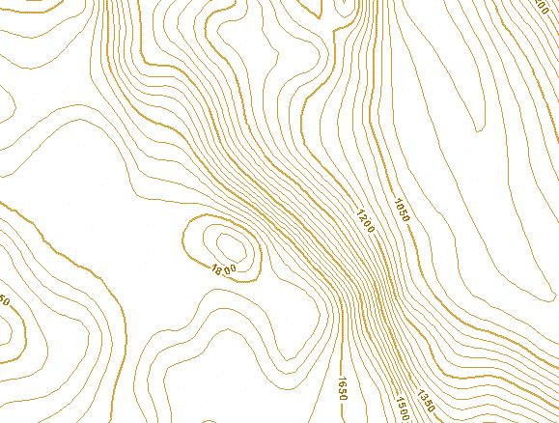

Figure 4 – Example: Contours

  - Triangulated irregular network (TIN)
A fundamental data structure frequently used to model points from photogrammetry and LIDAR collection is the triangulated irregular network (TIN). TINs are surface representations derived from irregularly spaced sample points and breakline features (surface discontinuities such as peaks, pits, ridges, and valleys). The main components of a TIN are nodes, edges, and triangles, which are linked by topological structure. TIN datasets include topological relationships between points and their neighboring triangles. Each sample point has an x,y coordinate geometry pair and a surface, or z-value. These points are connected by edges to form a set of non-overlapping triangles used to represent the surface as shown in Figure 5. See section A.8 for the ElevationTINCoverage UML application schema and B.5 for the ElevationTINCoverage UML object description.
TINs are used many times when it is necessary to capture or show complex topographic elevation surfaces. TINs allow for extra data in complex areas and less data in non-complex areas and enable the use of natural topographic features as breaklines. See Figure 5 for an example of a triangulated irregular network.

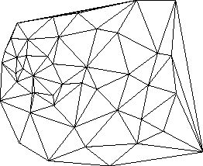

Figure 5 – Example: Triangulated irregular network

  - Profile
Profiles, also known as breaklines or cross sections (also referred to as transects), are lines that connect irregularly spaced points of varying elevation values as shown in Figure 6. Profiles are commonly used to model surface discontinuities such as peaks, pits, ridges, and valleys or may be used to model the elevation information of other linear features such as transportation or pipelines. See section A.15 for the ElevationProfile UML application schema and B.8 for the ElevationProfileCollection UML object description.
They are used for specialized applications to represent a string of elevations along a designated path. Cross sections, which are generally perpendicular to a linear terrain feature, are used for a variety of engineering applications. For example, a cross section of a stream will show the stream channel geometry above and below the water surface for hydraulic engineering purposes and a cross section of a road will show the shape of the road surface including its crown, shoulders, and ditches.
Breaklines are lines that are used to model a relatively abrupt change in the slope or continuity of a surface slope or aspect. Breaklines may represent surface breaks observed at a constant elevation or that trend up and down slope.

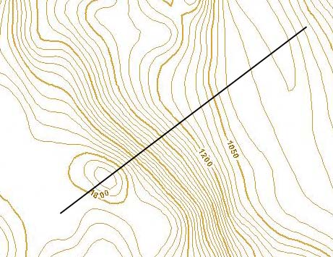
Point 1
Point 2
Point 3
Point 4
Point 5
Point 6
Point 7
Point 8

Figure 6 – Example: Profile1

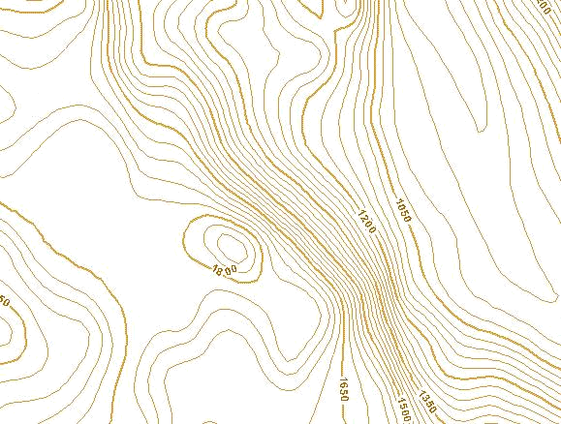
Point 4
Point 1
Point 2
Point 3
Point 5
Point 6

Figure 7 – Example: Profile2

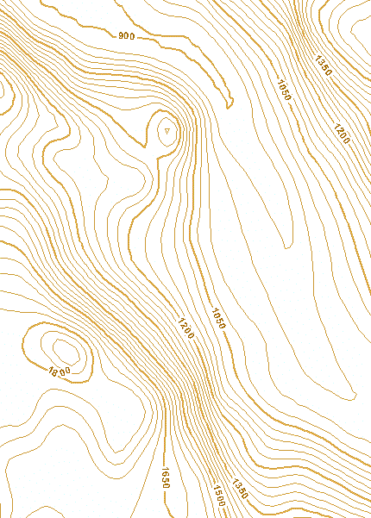
Point 4
Point 1
Point 2
Point 3
Point 5
Point 6
Point 6

Figure 8 – Example: Profile3
- (normative)
UML model,
Application schema for the exchange of framework elevation data
  - General
The model object names and notation conform to the names and notation used by ISO Technical Committee 211 - Geographic information/Geomatics.
  - ElevationCollection

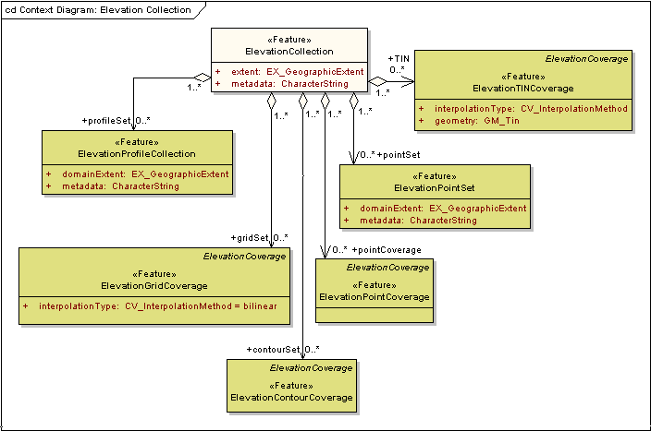
Figure A.1 – ElevationCollection

    - Semantics
The class ElevationCollection represents a collection of framework elevation data. It inherits the attribute metadata from the FeatureCollection class specified in the Base Document (Part 0).
    - extent
The attribute extent shall describe the geographic area to which the data in the ElevationCollection applies. The data type EX_GeographicExtent is specified in ISO 19115.
    - metadata
The attribute metadata shall provide a link to metadata that describes the ElevationCollection.
    - gridSet
The role name gridSet shall identify the set of ElevationGridCoverages contained in the ElevationCollection.
    - pointSet
The role name pointSet shall identify the set of ElevationPointSets contained in the ElevationCollection.
    - pointCoverage
The role name pointCoverage shall identify the set of ElevationPointCoverages contained in the ElevationCollection.
    - contourSet
The role name contourSet shall identify the set of ElevationContourCoverages contained in the ElevationCollection.
    - tin
The role name tin shall identify the set of ElevationTinCoverages contained in the ElevationCollection.
    - profileSet
The role name profileSet shall identify the set of ElevationProfileCollections contained in the ElevationCollection.
  - ElevationCoverage

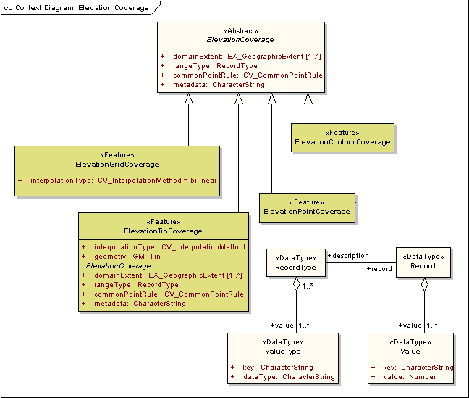
Figure A.2 – ElevationCoverage

    - Semantics
ElevationCoverage is an abstract class that specifies a set of attributes common to all the kinds of coverages that may be contained in an ElevationCollection. It is a realization of the Type CV_Coverage specified in ISO 19123 and implements attributes specified for that Type. It inherits an association to SC_CRS from CV_Coverage. SC_CRS provides a description of the coordinate reference system including horizontal and vertical datums and units of measure.
    - domainExtent
The attribute domainExtent shall describe the spatial extent of the domain of the ElevationCoverage.
    - rangeType
The attribute rangeType shall describe the range of the ElevationCoverage. It uses the data type RecordType specified in ISO/TS 19103. An instance of RecordType is a list of name:data type pairs each of which describes an attribute type included in the range of the coverage. The name field shall be used to identify the type of surface that each elevation value describes.
EXAMPLE The rangeType for an elevation coverage that includes values for bare earth surface elevation and for reflective surface elevation would have the value “bare earth surface elevation:Real, reflective surface elevation:Real”.
    - commonPointRule
The attribute commonPointRule shall identify the procedure recommended for evaluating the ElevationCoverage at a position that falls on a boundary between geometric objects in the domain of the coverage. It takes a value from the code list CV_CommonPointRule specified in ISO 19123. The rule shall be applied to the set of elevation values that results from evaluating the coverage with respect to each of the geometric objects that share a boundary. For elevation coverages, appropriate values of CV_CommonPointRule include “average”, “high”, and “low”.
    - metadata
The attribute metadata shall provide a link to metadata that describes the ElevationCoverage.
  - ElevationGridCoverage

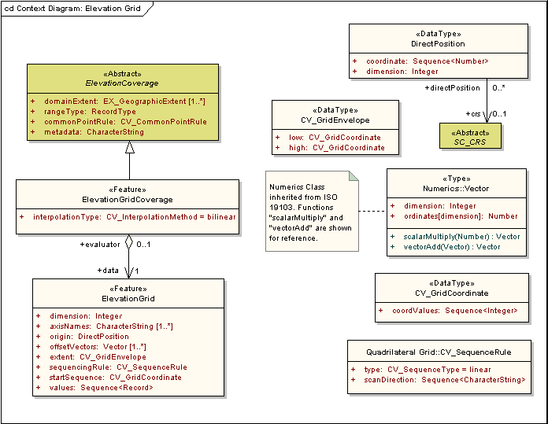
Figure A.3 – ElevationGridCoverage

    - Semantics
The class ElevationGridCoverage is a subclass of ElevationCoverage that represents a set of elevation values assigned to the points in a 2D grid. The class is a realization of the Type CV_ContinuousQuadrilateralGridCoverage specified in ISO 19123 and implements the attributes and associations specified for that Type as well as those inherited from ElevationCoverage.
    - interpolationType
The attribute interpolationType shall specify the interpolation method recommended for evaluation of the ElevationGridCoverage. The data type CV_InterpolationMethod is a code list specified in ISO 19123. For an ElevationGridCoverage, the value shall be either “bilinear” or “bicubic”.
    - data
The role name data shall identify the ElevationGrid that contains the values of the ElevationGridCoverage.
  - ElevationGrid
    - Semantics
The class ElevationGrid represents the data content of an ElevationGridCoverage. It is a realization of two Types specified in ISO 19123: CV_RectifiedGrid and CV_GridValuesMatrix. As such, it implements the attributes of both of these Types.
    - dimension
The attribute dimension shall specify the dimension of the ElevationGrid. Its value shall be two for all instances of ElevationGrid.
    - axisNames
The attribute axisNames shall list the names of the grid axes, one of each dimension of the grid.
EXAMPLES “north”, “east” or “latitude”, “longitude”.
    - origin
The attribute origin shall provide the coordinates of the grid origin with respect to an external coordinate reference system. The data type DirectPosition, specified in ISO 19107, has an association though the role name coordinateReferenceSystem to the class SC_CRS specified in ISO 19111. This association shall be used to identify the external coordinate reference system for the ElevationGrid. The external coordinate reference system for the ElevationGrid shall be the coordinate reference system identified by the association from ElevationCoverage to SC_CRS.
    - offsetVectors
The attribute offsetVectors shall specify both the spacing between grid points and the orientation of the grid axes with respect to the external coordinate reference system identified through the attribute origin. It uses the data type Vector specified in ISO/TS 19103.
    - extent
The attribute extent shall identify the area of the grid for which elevation data are provided. It uses the data type CV_GridEnvelope specified in ISO 19123 to provide both the CV_GridCoordinates of the corner of that area having the lowest grid coordinate values and the CV_GridCoordinates of the corner of that area having the highest grid coordinate values. CV_GridCoordinate is also specified in ISO 19123.
    - sequencingRule
The attribute sequencingRule shall identify the method to be used to assign values from the sequence of elevation values to grid coordinates. It uses the data type CV_SequenceRule specified in ISO 19123.
    - startSequence
The attribute startSequence shall use a value of CV_GridCoordinate to specify the grid coordinates of the grid point to which the first in the sequence of elevation values is to be assigned.
    - values
The role name values shall identify a sequence of Records each containing one or more elevation values to be assigned to a single grid point. Each Record shall conform to the RecordType specified by the rangeType attribute of the ElevationGridCoverage with which the ElevationGrid is associated.
  - ElevationPointCoverage

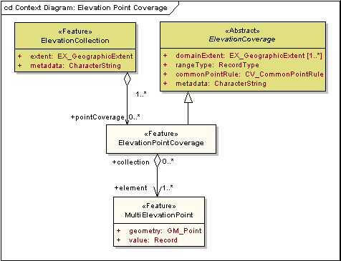
Figure A.4 – ElevationPointCoverage

    - Semantics
The class ElevationPointCoverage is a subclass of ElevationCoverage and a realization of the Type CV_DiscretePointCoverage specified in ISO 19123. It is an aggregation of points, each of which is associated with one or more elevation values carried as attributes rather than as coordinates. It implements the attributes and associations inherited from ElevationCoverage as well as those specified for CV_DiscretePointCoverage in ISO 19123.
    - element
The role name element shall identify the set of MultiElevationPoints contained in the ElevationPointCoverage.
  - MultiElevationPoint
    - Semantics
The class MultiElevationPoint is a realization of the Type CV_PointValuePair specified in ISO 19123. It represents a point that has a Record of one or more elevation values associated with it.
    - geometry
The attribute geometry shall contain an instance of GM_Point as specified in ISO 19107. The position of the GM_Point shall be stated with reference to a 2-dimensional coordinate reference system.
NOTE Elevation values are carried as attributes of the point rather than as coordinate values.
    - value
The attribute value shall be a Record that contains one or more elevation values as specified by the rangeType attribute inherited from ElevationCoverage.
  - ElevationTinCoverage

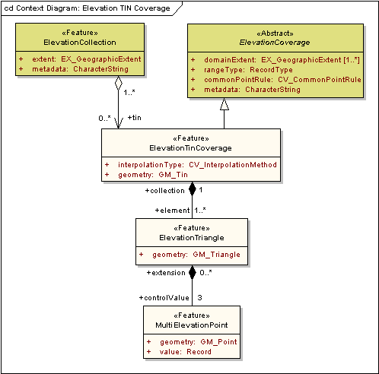
Figure A.5 – ElevationTinCoverage

    - Semantics
The class ElevationTinCoverage is a realization of the Type CV_TinCoverage specified in ISO 19123. It is an aggregation of ElevationTriangles that represents a triangulated irregular network in which the points of known elevation fall on the vertices of the triangles. It is also a subclass of ElevationCoverage that inherits the attributes specified for that class.
    - interpolationType
The attribute interpolationType shall specify the interpolation method recommended for evaluation of the ElevationTinCoverage. The data type CV_InterpolationMethod is a code list specified in ISO 19123. For an ElevationTinCoverage, the value shall be “barycentric”.
    - geometry
The attribute geometry shall contain the network of triangles that form the basis of the TIN. The class GM_Tin is specified in ISO 19107. The triangles shall lie on a 2-dimensional surface; the elevation values at the vertices are treated as attributes of the points, not as coordinate values.
    - element
The role name element shall identify the set of ElevationTriangles contained in the ElevationTinCoverage.
  - ElevationTriangle
The class ElevationTriangle is a realization of the Type CV_ValueTriangle specified in ISO 19123. It represents one of the triangles of the TIN and the elevation values associated with the vertices of that triangle.
    - geometry
The attribute geometry shall contain the GM_Triangle that is the basis of the ElevationTriangle. The class GM_Triangle is specified in ISO 19107. Each instance of geometry is an instance of GM_Triangle identified by the patch attribute of the GM_Tin that is the value of the geometry attribute of ElevationTinCoverage.
    - collection
The role name collection shall identify the ElevationTinCoverage to which the ElevationTriangle belongs.
    - control value
The role name controlValue shall identify the set of ElevationPoints at the vertices of the ElevationTriangle.
    - MultiElevationPoint
The class MultiElevationPoint is described in A.6. The value of the geometry attribute of ElevationPoint equals one of the values of the attribute controlPoint of the GM_Tin that is the value of the geometry attribute of the ElevationTinCoverage to which the ElevationTriangle belongs.
  - ElevationContourCoverage

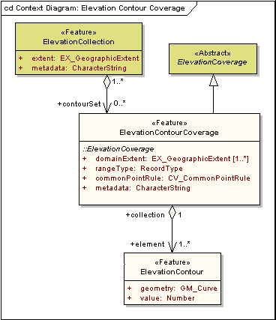
Figure A.6 – ElevationContourCoverage

    - Semantics
The class ElevationContourCoverage is a realization of the Type CV_DiscreteCoverage specified in ISO 19123 that represents a set of elevation contours. It is also a subclass of ElevationCoverage that inherits the attributes specified for that class.
    - element
The role name element identifies the set of ElevationContours contained in the ElevationContourCoverage.
  - ElevationContour
    - Semantics
The class ElevationContour is a realization of the Type CV_CurveValuePair specified in ISO 19123. It has two attributes.
    - geometry
The attribute geometry shall contain the instance of GM_Curve that describes the shape of the contour. The position of the curve is stated with respect to a 2D coordinate reference3 system.
    - value
The attribute value shall contain a Record consisting of the elevation value associated with the curve.
  - ElevationPointSet

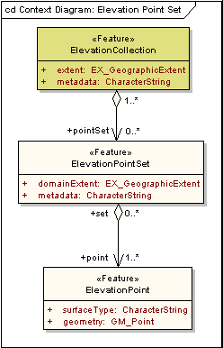
Figure A.7 – ElevationPointSet

    - Semantics
The class ElevationPointSet represents a collection pf points each related to a 3D coordinate reference system such that the elevation value is carried as one of the coordinates rather than as a distinct attribute of the point.
    - domainExtent
The attribute domainExtent shall specify the spatial extent of the area to which the ElevationPointSet applies.
    - point
The role name point shall identify the ElevationPoints contained in the ElevationPointSet.
    - metadata
The attribute metadata shall provide a link to metadata that describes the ElevationPointSet.
  - ElevationPoint
    - Semantics
The class ElevationPoint represents a point associated with a single elevation surface. Unlike the MultiElevationPoints of an ElevationPointCoverage, each ElevationPoint in an ElevationPointSet has only one elevation value and represents only one elevation surface type.
    - surfaceType
The attribute surfaceType shall identify the type of surface that is described by the ElevationPoint.
    - geometry
The attribute geometry shall contain an instance of GM_Point. The position of the point shall be described in terms of a 3D coordinate reference system. One of the coordinates shall be the value for the elevation.
  - ElevationProfileCollection

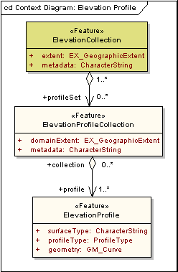
Figure A.8 – ElevationProfileCollection

    - Semantics
The class ElevationProfileCollection is an aggregation of ElevationProfiles.
    - domainExtent
The attribute domainExtent shall specify the spatial extent of the area to which the ElevationProfileCollection applies.
    - metadata
The attribute metadata shall provide a link to metadata that describes the ElevationProfileCollection.
    - profile
The role name profile shall identify the set of ElevationProfiles that is contained in the ElevationProfileCollection.
  - ElevationProfile
    - Semantics
The class ElevationProfile represents a curve lying on an elevation surface. It is a realization of the Type GM_Curve specified in ISO 19107, which is an aggregation of GM_CurveSegments.
    - surfaceType
The attribute surfaceType shall identify the type of surface that the elevation values describe. The data type CharacterString is specified in ISO/TS 19103.
    - profileType
The attribute profileType shall identify the kind of profile from the code list ProfileType.
    - geometry
The attribute geometry shall contain an instance of GM_Curve. Positions of the control points for that curve shall be described in terms of a 3D coordinate reference system. One of the coordinates shall be a value for elevation.
  - DirectPosition

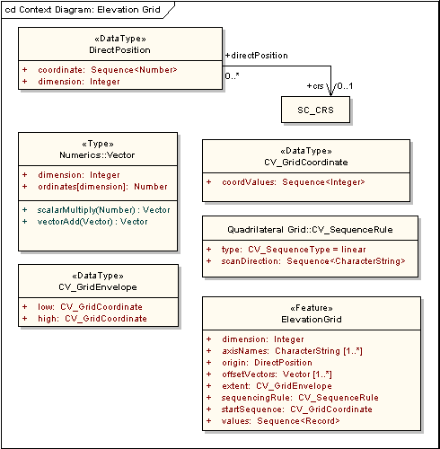
Figure A.9 – DirectPosition

    - Semantics
The data type DirectPosition, specified in ISO 19107, is used to provide position information for all elevation values in an ElevationCollection.
    - coordinate
The attribute coordinate shall contain the coordinates that identify the spatial position of a point.
    - dimension
The attribute dimension is derived from the dimension of the coordinate reference system and specifies the number of ordinates included in each coordinate value.
    - coordinateReferenceSystem
The role name coordinateReferenceSystem shall identify the SC_CRS to which the position is referred. SC_CRS is specified in ISO 19111 as an abstract class. The appropriate subclass from ISO 19111 shall be used to describe the coordinate reference system used with any framework elevation data set.
  - Code lists

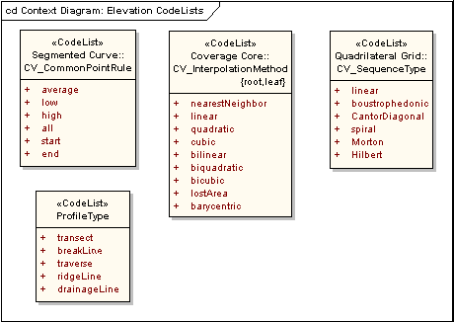
Figure A.10 – Code lists

    - CV_CommonPointRule code list
CV_CommonPointRule is a CodeList of values for the attribute commonPointRule.
Table A.1 – CodeList for CV_CommonPointRule
Name | Definition
average
low
high
all
start
end

    - CV_InterpolationMethod code list
CV_InterpolationMethod is a CodeList of values for the attribute interpolationType.

Table A.2 – CodeList for CV_InterpolationMethod
Name | Definition
nearestNeighbor
linear
quadratic
cubic
bilinear
biquadratic
bicubic
lostArea
barycentric

    - CV_SequenceType code list
CV_SequenceType is a CodeList of values for the attribute type.

Table A.3 – CodeList for CV_SequenceType
Name | Definition
linear
boustrophedonic
CantorDiagonal
spiral
Morton
Hilbert

    - ProfileType code list
ProfileType is a CodeList of values for the attribute profileType.

Table A.4 – Codelist for ProfileType
Name | Definition
transect
breakLine
traverse
ridgeLine
drainageLine

- (normative)
Elevation data UML object description,
Data dictionaries for framework elevation data
  - ElevationCollection

Table B.1 – Data dictionary for ElevationCollection
Line | Name/Role Name | Definition | Obligation/  Condition | Maximum Occurrence | Data Type | Domain
 | ElevationCollection |  |  |  | <<Feature>> | Lines 2-9
 | extent | Spatial extent of the collection | M | 1 | EX_GeographicExtent | Unrestricted
 | metadata | Data about the ElevationCollection | M | 1 | CharacterString | Unrestricted
 | Role name: profileSet | Set of elevation profile sets | O | * | <<Feature>>  ElevationProfileCollection | Unrestricted
 | Role name: gridSet | Set of elevation grid coverages | O | * | <<Feature>>  ElevationGridCoverage | Unrestricted
 | Role name: contourSet | Set of elevation contour coverages | O | * | <<Feature>>  ElevationContourCoverage | Unrestricted
 | Role name: pointCoverage | Set of elevation point coverages | O | * | <<Feature>>  ElevationPointCoverage | Unrestricted
 | Role name: pointSet | Set of elevation point sets. | O | * | <<Feature>>  ElevationPointSet | Unrestricted
 | Role name: tin | Set of elevation TIN coverages | O | * | <<Feature>>  ElevationTinCoverage | Unrestricted
 | ElevationProfileCollection |  |  |  | <<Feature>>
 | ElevationGridCoverage |  |  |  | <<Feature>>
 | ElevationContourCoverage |  |  |  | <<Feature>>
 | ElevationPointCoverage |  |  |  | <<Feature>>
 | ElevationPointSet |  |  |  | <<Feature>>
 | ElevationTinCoverage |  |  |  | <<Feature>>

  - ElevationCoverage

Table B.2 – Data dictionary for ElevationCoverage
 | ElevationCoverage |  |  |  | <<Abstract>> | Lines 17-20
 | domainExtent | Spatial extent of the elevation coverage | M | * | EX_GeographicExtent | Unrestricted
 | rangeType | Description of the elevation values provided by the elevation coverage | M | 1 | RecordType | Unrestricted
 | commonPointRule | Rule to follow in interpolating a value at a point that falls on the boundary between two domain objects | M | 1 | <<CodeList>>  CV_CommonPointRule | Average, low, high
 | metadata | Data about the ElevationCoverage | M | 1 | CharacterString | Unrestricted
 | ElevationGridCoverage |  |  |  | <<Feature>>
 | ElevationTinCoverage |  |  |  | <<Feature>>
 | ElevationPointCoverage |  |  |  | <<Feature>>
 | ElevationContourCoverage |  |  |  | <<Feature>>
 | RecordType |  |  |  | <<DataType>> | Lines 26-27
 | Role name: value |  | M | * | <<DataType>>  ValueType
 | Role name: record |  | M | 1 | <<DataType>>  Record
 | ValueType |  |  |  | <<DataType>> | Lines 29-30
 | key |  | M | 1 | CharacterString
 | dataType |  | M | 1 | CharacterString
 | Record |  |  |  | <<DataType>> | Lines 32-33
 | Role name: value |  | M | * | <<DataType>>  Value
 | Role name: description |  | M | 1 | <<DataType>>  RecordType
 | Value |  |  |  | <<DataType>> | Lines 35-36
 | key |  | M | 1 | CharacterString
 | value |  | M | 1 | Number

  - ElevationGridCoverage

Table B.3 – Data dictionary for ElevationGridCoverage
Line | Name/Role Name | Definition | Obligation/  Condition | Maximum Occurrence | Data Type | Domain
 | ElevationCoverage |  |  |  | <<Abstract>>
 | ElevationGridCoverage |  |  |  | <<Feature>> | Lines 39-40
 | interpolationType | Recommended method for interpolating elevation values at positions between grid points | M | 1 | <<CodeList>>  CV_InterpolationMethod = bilinear | Bilinear, bicubic
 | Role name: data | Sequence of elevation values | M | 1 | <<Feature>>  ElevationGrid | Unrestricted
 | ElevationGrid |  |  |  | <<Feature>> | Lines 42-50
 | dimension | Dimension of the elevation grid | M | 1 | Integer | 2
 | axisNames | Names of the axes of the elevation grid | M | * | CharacterString | Unrestricted
 | origin | Coordinates, in an external coordinate system, that map to grid coordinates 0, 0 | M | 1 | <<DataType>>  DirectPosition | Unrestricted
 | offsetVectors | Vectors that specify the orientation of the grid axes and the dimensions of the grid cells in directions parallel to the axes | M | * | <<Type>>  Vector | Unrestricted
 | extent | Limits of the set of grid points included in the elevation grid | M | 1 | <<DataType>>  CV_GridEnvelope | Unrestricted
 | sequencingRule | Rule for assigning values to grid points | M | 1 | <<DataType>>  CV_SequenceRule | Unrestricted
 | startSequence | Grid point associated with the first record in the values sequence | M | 1 | <<DataType>>  CV_GridCoordinate | Unrestricted
 | values | Recorded elevation values | M | 1 | Sequence<Record> | Unrestricted
 | Role name: evaluator |  | O | 1 | <<Feature>>  ElevationGridCoverage
 | CV_GridEnvelope | Grid coordinates for the diametrically opposed corners of the elevation grid |  |  | <<DataType>> | Lines 52-53
 | low | Minimal grid coordinate values of the part of the grid that contains elevation values | M | 1 | <<DataType>>  CV_GridCoordinate | Unrestricted
 | high | Maximal grid coordinate values of the part of the grid that contains elevation values | M | 1 | <<DataType>>  CV_GridCoordinate | Unrestricted
 | CV_GridCoordinate | Data type for holding the coordinates of a grid point |  |  | <<DataType>> | Line 55
 | coordValues | Number of grid cell offsets from the origin of the grid parallel to each axis | M | 1 | Sequence<Integer> | Unrestricted
 | Quadrilateral Grid::  CV_SequenceRule | Description of how grid points are ordered for association to the elements of the sequence values |  |  | <<DataType>> | Lines 57-58
 | type | Identifier of the type of sequencing method | M | 1 | <<CodeList>>  CV_SequenceType = linear | Unrestricted
 | scanDirection | List of signed axisNames that indicates the order in which grid points shall be mapped to position within the sequence of values | M | 1 | Sequence<CharacterString> | Unrestricted
 | Numerics::Vector |  |  |  | <<Type>> | Lines 60-61
 | dimension |  | M | 1 | Integer
 | ordinates[dimension] |  | M | 1 | Number
 | DirectPosition |  |  |  | <<DataType>> | Lines 63-65
 | coordinate | Numerical description of the spatial position | M | 1 | Sequence<Number> | Unrestricted
 | dimension | Dimension of the coordinate space | M | 1 | Integer | Context dependent
 | Role name: crs | Spatial reference system to which the positions is associated | O | 1 | <<Abstract>>  SC_CRS | Unrestricted
 | SC_CRS |  |  |  | <<Abstract>> | Line 67
 | Role name: directPosition |  | O | * | <<DataType>>  DirectPosition

  - ElevationPointCoverage

Table B.4 – Data dictionary for ElevationPointCoverage
Line | Name/Role Name | Definition | Obligation/  Condition | Maximum Occurrence | Data Type | Domain
 | ElevationCollection |  |  |  | <<Feature>>
 | ElevationCoverage |  |  |  | <<Abstract>>
 | ElevationPointCoverage |  |  |  | <<Feature>> | Line 71
 | Role name: element | Point included in the coverage | M | * | <<Feature>>  MultiElevationPoint | Unrestricted
 | MultiElevationPoint |  |  |  | <<Feature>> | Lines 73-74
 | geometry | Geometric description of the elevation point | M | 1 | <<Type>>  GM_Point | Defined in ISO 19107
 | value | Elevation at the point | M | 1 | Record | Unrestricted

  - ElevationTinCoverage

Table B.5 – Data dictionary for ElevationTinCoverage
Line | Name/Role Name | Definition | Obligation/  Condition | Maximum Occurrence | Data Type | Domain
 | ElevationCollection |  |  |  | <<Feature>>
 | ElevationCoverage |  |  |  | <<Abstract>>
 | ElevationTinCoverage |  |  |  | <<Feature>> | Lines 78-80
 | interpolationType | Recommended method for interpolating values at points within triangles | M | 1 | <<CodeList>>  CV_InterpolationMethod | Barycentric
 | geometry |  | M | 1 | <<Type>>  GM_Tin | Defined in ISO 19107
 | Role name: element |  | M | * | <<Feature>>  ElevationTriangle | Unrestricted
 | ElevationTriangle |  |  |  | <<Feature>> | Lines 82-84
 | geometry | Geometric description of the elevation triangle | M | 1 | <<Type>>  GM_Triangle | Defined in ISO 19107
 | Role name: collection |  | M | 1 | <<Feature>>  ElevationTinCoverage
 | Role name: controlValue | Elevation point at one of the vertices of the elevation triangle | M | 3 | <<Feature>>  MultiElevationPoint | Unrestricted
 | MultiElevationPoint |  |  |  | <<Feature>> | Lines 86-88
 | geometry | Geometric description of the elevation point | M | 1 | <<Type>>  GM_Point | Defined in ISO 19107
 | value | Set of elevations at the point | M | 1 | Record | Unrestricted
 | Role name: extension |  | O | * | <<Feature>>  ElevationTriangle

  - ElevationContourCoverage

Table B.6 – Data dictionary for ElevationContourCoverage
Line | Name/Role Name | Definition | Obligation/  Condition | Maximum Occurrence | Data Type | Domain
 | ElevationCollection |  |  |  | <<Feature>>
 | ElevationCoverage |  |  |  | <<Abstract>>
 | ElevationContourCoverage |  |  |  | <<Feature>> | Line 92
 | Role name: element | Contour included in the coverage | M | * | <<Feature>>  ElevationContour | Unrestricted
 | ElevationContour |  |  |  | <<Feature>> | Lines 94-96
 | geometry | Geometric description of the contour | M | 1 | <<Type>>  GM_Curve | Defined in ISO 19107
 | value | Elevation value associated with the contour | M | 1 | Number | Unrestricted
 | Role name: collection |  | M | 1 | <<Feature>>  ElevationContourCoverage

  - ElevationPointSet

Table B.7 – Data dictionary for ElevationPointSet
Line | Name/Role Name | Definition | Obligation/  Condition | Maximum Occurrence | Data Type | Domain
 | ElevationCollection |  |  |  | <<Feature>>
 | ElevationPointSet |  |  |  | <<Feature>> | Lines 99-101
 | domainExtent | Spatial extent of the elevation point set | O | * | EX_GeographicExtent | Unrestricted
 | metadata | Data about the ElevationPointSet | M | 1 | CharacterString | Unrestricted
 | Role name: point | ElevationPoint contained in the ElevationPointSet | M | * | <<Feature>>  ElevationPoint | Unrestricted
 | ElevationPoint |  |  |  | <<Feature>> | Lines 103-105
 | surfaceType | Type of surface with which the ElevationPoint is associated | M | 1 | CharacterString | Unrestricted
 | geometry | Geometric representation of the ElevationPoint | M | 1 | <<Type>>  GM_Point | Defined in ISO 19107
 | Role name: set |  | O | * | <<Feature>>  ElevationPointSet

  - ElevationProfileCollection

Table B.8 – Data dictionary for ElevationProfileCollection
Line | Name/Role Name | Definition | Obligation/  Condition | Maximum Occurrence | Data Type | Domain
 | ElevationCollection |  |  |  | <<Feature>>
 | ElevationProfileCollection |  |  |  | <<Feature>> | Lines 108-110
 | domainExtent | Extent of the elevation profile collection | M | 1 | EX_GeographicalExtent | Unrestricted
 | metadata | Data about the ElevationProfileCollection | M | 1 | CharacterString
 | Role name: profile | Profile included in the collection | M | * | <<Feature>>  ElevationProfile | Unrestricted
 | ElevationProfile |  |  |  | <<Feature>> | Lines 112-115
 | surfaceType | Type of surface with which the elevation profile is associated | M | 1 | CharacterString | Unrestricted
 | profileType | Code identifying a description of what the profile represents | M | 1 | ProfileType | Unrestricted
 | geometry | Geometric description of the profile | M | 1 | <<Type>>  GM_Curve | Defined in ISO 19107
 | Role name: collection |  | O | * | <<Feature>>  ElevationProfileCollection

- (informative)
Bibliography
ANSI and ISO standards may be purchased through the ANSI eStandards Store at http://webstore.ansi.org/ansidocstore/default.asp, accessed October 2006.
American Society for Photogrammetry and Remote Sensing, 2001, Digital elevation model technologies and applications: The DEM users manual
National digital elevation guidelines, Version 1.0, 2004
OGC 03-065r6, Abstract specification for coverage type and its subtypes Open Geospatial Consortium, Version 1.0.0, Open GIS Consortium, Inc.

