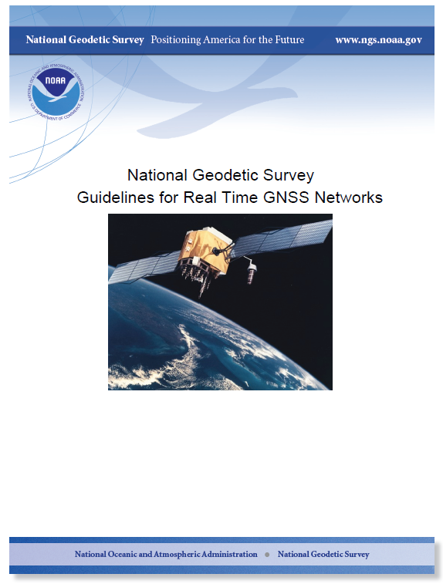
February 2011
v. 1.6



The RTN Guideline Work Group Leaders

William Henning, team leader, editor

Dan Martin, Site Considerations group leader

Gavin Schrock, Planning and Design group leader

Gary Thompson, Administration group leader
Dr. Richard Snay, Aligning RTN to the NSRS

William Henning, Users group leader

Version History;
Draft v. 1.0, November 2009
v. 1.3 – edits from first comments from team, September, 2010
v 1.5-1.6 – reformats and edits. February 2011

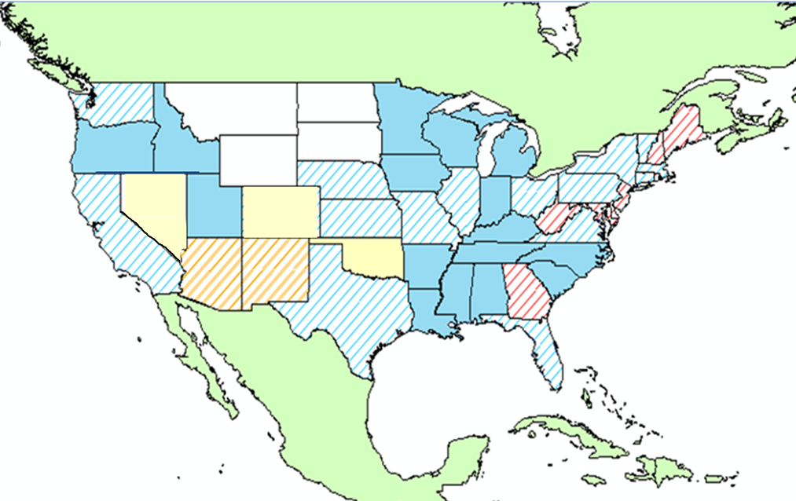

Municipal, Public Statewide and Private Statewide RTN in the USA

 Public and Private Statewide

 Public Statewide – Planned or Operating
 Private Statewide

Public and Private Municipal – No Statewide

 Private Municipal - No Statewide
W.Henning 12/2010
Table of Contents

Acronyms & Abbreviations

Preface

- Introduction

- Site Considerations

- Planning & Design
IV. Administration
V. Obtaining Station Coordinates
Consistent with NAD 83 and ITRS
VI. Users Best Methods
References
ACRONYMS & ABBREVIATIONS

ARP – Antenna Reference Point
CORS – Continuously Operating Reference Station(s)
DOP – Dilution of Precision
ECEF – Earth Centered, Earth Fixed
FKP – Flächen Korrektur Parameter
GPS – Global Positioning System
GLN – Global'naya Navigatsionnaya Sputnikovaya Sistema / Global Orbiting Navigation Satellite System (GLONASS)
IGS – International GNSS Service
ITRF – International Terrestrial Reference Frame
MAC – Master Auxiliary Concept
NAVD 88 – North American Vertical Datum of 1988
NGS – National Geodetic Survey
NOAA – National Oceanic and Atmospheric Administration
NSRS – National Spatial Reference System
NTRIP – Networked Transport of RTCM via Internet Protocol
OPUS – Online Positioning Users Service
NAD 83 – North American Datum of 1983
RT – Real Time Positioning
RTCM – Radio Technical Commission for Maritime Services
RTCM SC-104 – RTCM Special Committee 104 for Differential GNSS Positioning
RTK – Real Time Kinematic
RTN – Real Time GNSS Network(s)
SWPC – Space Weather Prediction Center (NOAA)
TEQC – Translation, Editing, Quality Checking (UNAVCO software)
PREFACE

NOAA’s National Geodetic Survey (NGS) is committed to continued support of accurate real time global navigation satellite system (GNSS) positioning across the USA and its territories. Users of GNSS technology show greater dependence on this methodology every day for important coordinates in their projects as well as for academic and scientific studies. Real time networks (RTN) of active reference stations streaming GNSS data in various formats, with or without correctors, are rapidly becoming a nationwide infrastructure operated by both public and private sectors alike. It is important that these RTN provide accurate, homogeneous, repeatable coordinates based on our national datums for many reasons. Geographic Information Systems (GIS), emergency management, national security, engineering projects, cartographic work, environmental studies, geophysical research, deformation modeling, cadastral data, municipal infrastructure and many other applications require that data are based on a common foundation as consistently maintained by NGS in our National Spatial Reference System (NSRS).
For over 200 years, NGS has endeavored to provide this geodetic foundation for all positioning applications. To further that end, NGS has assembled a team of over 60 individuals from the public and geodetic communities, as well as a small number of GNSS manufacturers who are currently operating RTN in the US. Individuals from State Geodetic Surveys, Spatial Reference Centers, State Departments of Transportation, as well as NGS Geodetic Advisors and headquarters personnel have all contributed to this effort.
The goal is to provide a much needed basis of general information for real time GNSS positioning in networks of active reference stations . This would include recommending procedures and approaches for aligning a RTN at acceptable levels to the NSRS and best methods to use the RTN with maximum precision and confidence. NGS is working in the real time (RT) positioning field to support RTN administrators and will not compete with RTN services supplied by any private or public RTN. NGS offers these guidelines as a dynamic document which will endeavor to keep pace with the rapid changes in satellite constellations, satellite signals and the increased capabilities of the GNSS manufacturers hardware, firmware and software.

- INTRODUCTION
NGS support for RT positioning can be categorized into four areas:
A. Streaming of specified Radio Technical Commission for Maritime Services (RTCM) format messages via the freely available Networked Transport of RTCM via Internet Protocol (NTRIP) application from selected federally owned and/or operated CORS.
RTCM format data and the NTRIP software suites are open, generic industry standards and are included in most major GNSS manufacturers’ firmware and software. Currently, NGS wishes to only support federal agencies and international near real time data streaming efforts such as through the International Global Navigation Satellite Systems (GNSS) Service noted as IGS.
B. Providing education and outreach to the geospatial GNSS positioning community.
Workshops, presentations and papers will continue in all geodetic topics, but will include new content on real time GNSS positioning. NGS maintains an interactive presence with many local, regional, national and international organizations involved with RT, including the American Congress for Surveying and Mapping (ACSM), the International Federation of Surveyors (FIG), RTCM SC-104 (special committee for differential GNSS positioning), Federal Geodetic Control Subcommittee (FGCS), Environmental Systems Research Institute (ESRI), the Transportation Research Board (TRB), and state surveying societies.
C. Continuing scientific research. Study areas for RT include geoid models, antenna model calibrations, geophysical studies such as time dependent positioning (TDP), multipath, and GNSS orbits.
D. Developing guidelines for RTN administrators and users.
GNSS RT positioning guidelines must be amenable to change as new signals, satellite constellations and GNSS hardware and software come on line.
While not acting as a standard or a set of specifications, these RTN guidelines are therefore the response of NGS to the evident needs of the GNSS positioning community for a set of consistent recommendations to produce precise RTN derived data aligned with high accuracy to the NSRS. This document will be a companion document to the recently released “NGS User Guidelines for Single Base Real Time GNSS Positioning” dealing with single base GNSS positioning.
- CORS/RTN MONUMENT CONSTRUCTION GUIDELINES

The installation of continuously operating reference stations (CORS) as part of a Real-Time Network (RTN) has significantly increased over the last few years. Likewise, many different types of installation techniques have been employed. The National Geodetic Survey has produced a set of guidelines that addresses the basic requirements for most mounting types http://www.ngs.noaa.gov/PUBS_LIB/CORS_guidelines.pdf
however more often than not; the installers of these sites are left to their own imagination when it comes to the design of a particular type of monument based on their specific site characteristics. This document provides some specific recommendations and examples for various types of CORS mounts.

General Provisions

Electrical Supply
  - Receivers should be supplied with continuous power via a reliable source. NGS suggests that a dedicated circuit be supplied for the receiver and its associated equipment. The dedicated circuit should be located within 6 feet or less of the receiver to eliminate the need for extension cords or power strips as these are likely to become unplugged or switched off unintentionally.
  - Sharing of a circuit with other uses should be avoided if possible. Circuits that serve welders or other intermittent high current draw loads are subject to voltage swings that may affect the receiver.
  - In the event that voltage swings exist throughout an entire building’s electrical service, some form of voltage regulating equipment should be considered. The use of an Uninterrupted Power Supply (UPS) is highly recommended.

Receiver Mounting
  - The receiver should be mounted in such a way that it will be accessible for maintenance activities.
  - The receiver should be mounted in such a location as to prevent accidental damage caused by persons moving nearby.
  - Physical disturbances, such as earthquakes, high winds, or flooding should be anticipated and mitigated.

Security
  - The CORS system serves as a trusted source of data for many uses. Good security starts with prevention. The receiver and antenna should be located and secured to discourage tampering or theft.

Monument Types
Most CORS installations can generally categorized into two groups, building mounts and ground mounts. Within these two categories, there are a number of different sub-types that have been designed to address specific site characteristics.

As is pointed out in the existing CORS Site Guidelines, stability of the mount and the mounting structure is of the upmost importance. However, economics certainly plays a role in the design and installation of a CORS station.

Building Mounts
Building mounts are often the most appealing installation for a number of reasons:
- Accessibility of power and communications
- Site security
- Increased elevation to help overcome local obstructions
- Receiver environmental factors (temperature, humidity)
- Existing structure (implied long-term stability)
- Often reduced installation cost due reasons listed above

Though building mounts are often the most economical and convenient, they often pose the greatest challenge relative to the mount design since every building has its own characteristics. Additionally there are challenges that relate to the relationship of where the receiver is to reside within the building to the desired location of the antenna. Most standard antenna cables are 30 meters in length (LMR400), which means that the separation between the antenna and receiver locations is no more than 30 meters. It is not uncommon that the best antenna location is more than 30 meters away from the ideal location of the receiver. In this case there are a number of options:

- Purchase a longer, low impedance antenna cable, LMR600 for example
  - Creates a longer run but the cable is thicker and stiffer, making the installation more difficult.
- Purchase and install an in-line amplifier and add another length of standard cable.
  - Creates a longer run but also creates another potential point of failure
- Change the location of the antenna to be closer to the final location of the receiver
  - Reduces the cable run but alternate suitable locations not always available
- Change the location of the receiver to be closer to the final location of the antenna.
  - Often the best solution but not always practical. Additional security (locked cabinet) may be necessary if receiver is in a remote, non secure location within the building.

As indicated above, the building characteristics often present a significant challenge, usually related to the type of roof and the amount of overhang. There are three general types of building mounts that can be used and adapted to most situations.

Flush Mount
A flush mount can be used if the roof overhang (eve) is small. This is the most desired type of building mount as it provides the best stability. See figure 1.
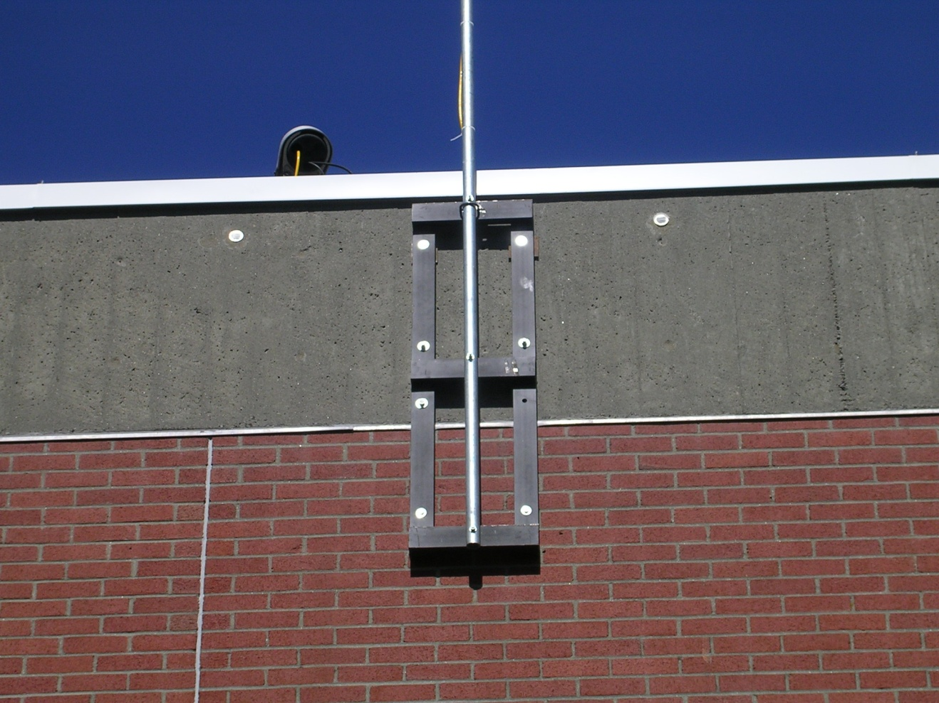

Figure 1 - Flush Mount used on buildings with small roof overhang

Outrigger and Corner Mount
In cases where the roof overhang is large or there is a decorative cornice, two types of mounts are commonly used. These are the Outrigger Mount and the Corner Mount. See figures 2 and 3.
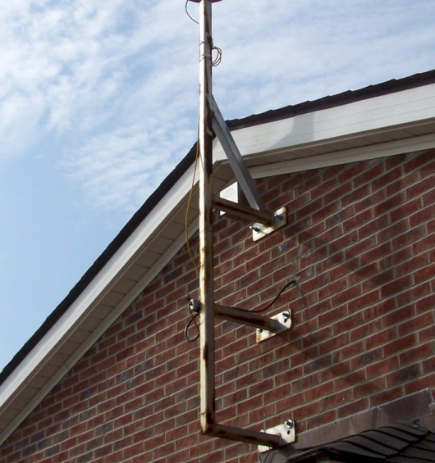
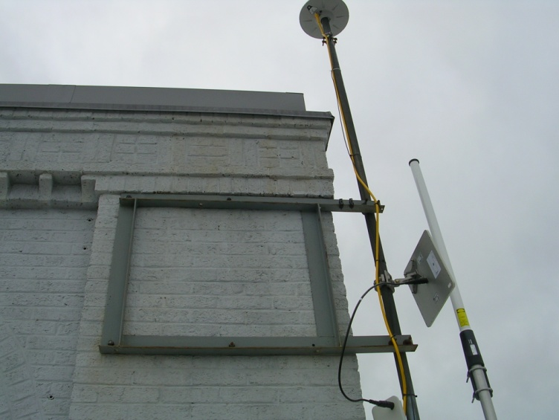
Figure 2 - Outrigger Mount Figure 3 - Corner Mount

The following link is a collection of various building mount designs. www.ngs.noaa.gov/realtime/buildingmounts (whatever the actual link would be)

When attaching mounts to a building, it is most desirable that the mount be attached with through bolts whenever possible. This may not always be possible if the through-bolt would be visually exposed in the finished space of a building; however, the top bolts will often be above a suspended ceiling where they can be hidden. When through-bolting, a steal backing plate should be used to distribute the compressive force. This is especially true when attaching to block walls. See figure 4.

Careful site reconnaissance and planning will go a long way to making any building mount installation a success. Here are some important points to consider when generating your installation plan.

- Select the best location for antenna first, and then determine a suitable location for the receiver.
- Determine where the power for the receiver will come from. It is also a good idea to have the receiver on a dedicated circuit if possible so determine the location of the nearest electrical breaker box to determine if a dedicated circuit can be run.
- If the receiver is not to be located in a room that has internet access, determine where the nearest access is and plan the route for the internet cable.
- Once the mount location and type is determined, determine where the antenna cable will enter the building and make a list of materials and tools that will be needed for the installation.
- Determine what will be needed (inside and outside) to access the installation site.
  - Ladders or mechanical lifts
  - Ropes
  - Fall protection
  - Is there access to the roof by means other than a ladder or lift?
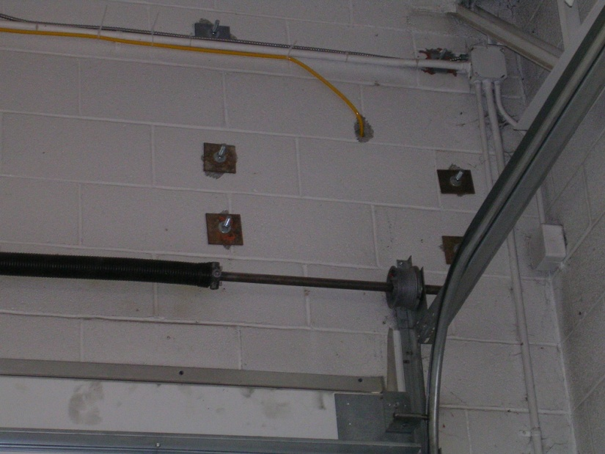
Figure 4 – Through-bolts with backing plates

Ground Mounts
Though ground mounts will generally be more expensive due to the cost of excavation, concrete, installation, and cabling, they do offer some advantages as they can be installed in almost any location that provides a good view to the sky. Ground mounts are well suited to locations that have (or can have) all required infrastructure (power, communications, etc…) but lack a building or the proper building type to facilitate a building mount. Ground mounts generally fall into three categories: Braced, Pillar, and Tower. One disadvantage to ground mounts is a lack of security since the antenna could be accessed from the ground or a short ladder. Also since the monument is on the ground, it is in potential danger of being disturbed (hit) by motor vehicles or maintenance equipment. Other things to consider when choosing a location for ground monuments are:
- Future use of the area, i.e., construction of new buildings or improvements and installation of underground utilities
- Multi-path from nearby objects
- Soil type
- Access to power and communications

Braced Mount
A braced mount, typical of stations installed by the Plate Boundary Observatory (PBO) are the most stable of the ground mounts. See http://www.unavco.org/facility/project_support/permanent/monumentation/deepdrilled.html and http://www.unavco.org/facility/project_support/permanent/monumentation/sdbm.html

Pillar Mount
A pillar mount generally consists of a concrete monument that extends at least 1.5 meters (2 – 2.5 meters is recommended) above ground and is poured to a depth of 4 meters or poured to a depth of less than 4 meters and pinned to bedrock. These mounts have been used in a number of states that have co-located their CORS stations with their Road Weather Information Systems (RWIS). In this case, the RWIS site contains the required power and communications that will support the CORS and a pillar is constructed near the site.

The general construction guidelines that are contained within the links below describe the process well. One item that should be cautioned against though is the use of Delrin tubes in the monument as well as the placement of electrical conduit (for the antenna cable) in the monument. Some who have manufactured these monuments have experienced cracking of the monument when a large Delrin tube was inserted to attach the antenna and when the conduit was installed inside the monument. It is unknown what the exact cause of the cracking is, but it is suggested that those constructing these monuments err on the side of caution and refrain from these practices. See figure 5.
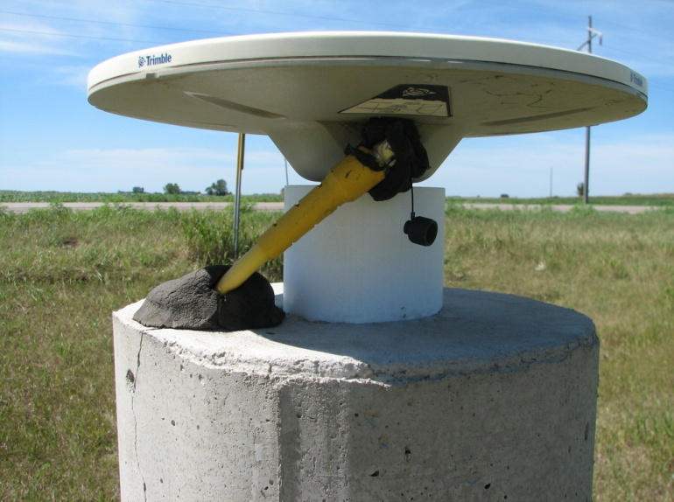
Figure 5 – view of pillar monument (note the crack that has developed near conduit location)
The following is a link to the resource page for pillar monuments that shows photos and schematics for a number of different pillar designs. www.ngs.noaa.gog/real-time/pillar

Tower Mounts
The last type of ground monument is the Tower Mount. A Tower Mount can be used in locations with conditions that are similar to those for a pillar, but have some local obstructions that require elevating the antenna more than would be accomplished with a pillar. See figures 6 and 7.

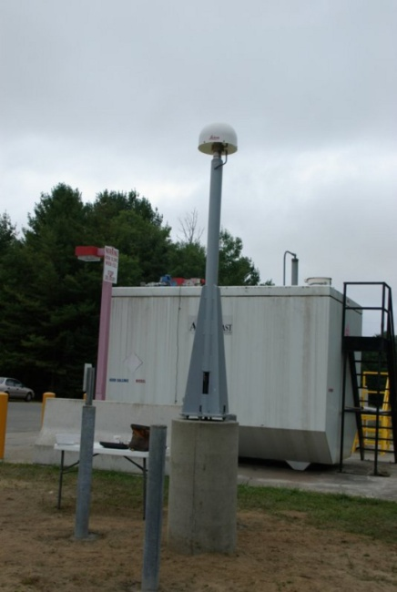
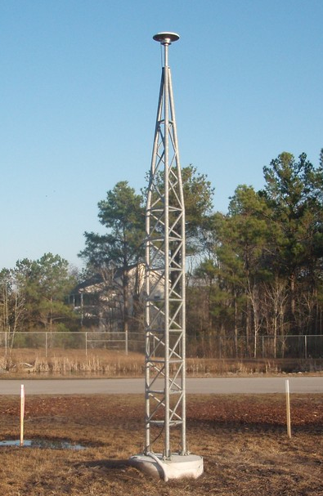

Figure 6 Figure 7
Examples of Tower Mounts

If constructing a Tower Mount, the foundation should be poured to the same depth as that of a Pillar Mount. Also depending on the height of the tower, a system of guy wires may be needed to ensure stability against wind loading. The following is the link to the Tower Mount resource page www.ngs.noaa.gov/realtime/tower.html

- PLANNING AND DESIGN

  - Introduction
As with any project or business undertaking, a thoughtful planning process is essential. A planning phase will inform the design, and operations parameters, as well as govern performance and the ultimate success of the network.

The planning for a new Real-Time Network (RTN) or for the adaptation of existing infrastructure to form an RTN may be approached with fundamental engineering project management principles and tools. There are also elements that would have been considered when undertaking conventional GPS network style campaigns, the development of base-rover style RTK, or the development of CORS for purely static work. But it is the unique nature of an RTN that requires consideration of many more elements.

An RTN, consisting of permanent infrastructure and by the seemingly endless possibilities to serve multiple user segments with any number of services, is by nature a utility. Whether the RTN is designed to serve a single client or user segment, or has been designed to serve as wide a range of user segments as possible, there are certain core considerations that speak to quality and reliability.

Though many early RTN evolved from varied and disparate infrastructure elements in times when RTN resources were limited, over time the related technologies have advanced. This together with improved commercial, governmental, and scientific resources; these resources now offer reliable design elements that may readily be adopted to suit nearly all stakeholder goals.

Though the goals of the immediate stakeholders govern the planning process, it is in the nature of RTN that they may possibly or eventually serve a broader range of uses than originally envisioned. Designs should not preclude possible future accommodation of additional user segments unless such exclusions are a specific goal of the stakeholders.

  - Prior to Planning
RTN stakeholders should clearly state their goals prior to any planning. It is recommended that a simple “needs analysis” be performed, and that goals are prioritized. The following questions should be posed to stakeholders:

    - Type of RTN. There are nearly as many variations as there are in number: Private for Profit, private as a value added service to equipment purchases, public no-fee, public closed-use, public cost-recovery, public-private partnership variations, amalgam (multiple networks with joint operating agreements, standards, and common reference frameworks). Depending on the type of RTN, some potential partners (and users) may be subject to certain restrictions on their possible participation. Example: do not count on utilizing existing or future infrastructure until you have evaluated such restrictions.

    - Needs Analysis. Both in immediate stakeholders and potential stakeholders. There are generic templates commercially available for how to develop “use case analysis” questionnaires (though none specifically for RTN).

    - Cost-benefit Analysis. Boilerplates for such analyses do not exist at this time. The vendors may assist, but it is also recommended that you seek advice from existing RTN operators.

    - Performance expectations and risk. Set goals for RTN service availability and quality. These govern such design elements as station spacing, server configuration, operations model, power, and communications redundancies (specifics under subsequent sections on respective design elements). What are the tradeoffs between cost and possible hazards (e.g. weather, power interruptions, site security, etc)

    - RTN Service types. RTN can provide dozens of real-time and static-file services of varied approach and data type (regardless of brand). These fall into three main categories:

      - Single Base Correctors. You may choose to offer multiple broadcast formats for each RTN CORS (e.g. RTCM1.0, 2.3, 3.1, CMR+, etc). Single Base may be offered in auto-select and/or user select modes.
      - Network Corrections. These may include (but are not limited to) Non-Physical Reference (e.g. VRS, Master-Auxiliary aka “MAC” using RTCM3.1 Network Message, FKP, and others). See the ‘Users’ section of this document for a brief explanation of the most-used types of RTN in the USA.
      - Server-Side Real-Time Processing. “Reverse RTK” and numerous motion engines (e.g. used for monitoring structural integrity).
      - Static Files for Post-Processing. Which formats will you offer and at what rates? Will there be a custom request system? Are there archiving requirements (or is it up to the user to store the files that they may need at some later time)?

    - Operations Model. Who will be responsible for operations? Will there be on-call service? Can you avoid single-point of failure in operations staffing?

    - Support Liabilities. Is your RTN purely a provider of corrections/data or (unless otherwise specified) will you become the troubleshooter of all matters RTN for the users? (E.g. troubleshooting all brands and configurations of user equipment, troubleshooting user cellular connections, establishing field procedures for users). Set realistic expectations and even codify these expectations in user agreements if needed.

    - Product delivery goals. Will the real-time correctors be authorized services (subject to authentication and metering). Do you intend to provide interactive service access systems (e.g. single-point access, multi-point, internet casting like NTRIP) or broadcast service (e.g. open radio, encrypted radio, etc), or a mix of methods? [more in subsequent sections]

  - Spacing
This section is provided as a source of considerations to be entertained when planning with no specified RTN spacing.

RTN infrastructure is by no means inexpensive to establish. Cost to establish a new RTN reference station may range from thousands to tens of thousands of dollars (depending on design criteria and resources). It can be costly to establish a number of reference stations only to find out after-the fact that the reference station, its siting, and/or interstation spacing are inadequate to meet the goals of the RTN.

One element that is most readily associated with planning and design of an RTN is the station spacing and geometry. As with any network of sensors or emitters; to cover as broad an area with as evenly and with as few nodes as possible, an array of stations in a pattern forming equilateral triangles is best. While an RTN is not simply “solving triangles” as is mistakenly assumed by looking at a map of an RTN, a pattern of equilateral triangles does also provide an optimal geometry for certain types of network modeling and for post-processing services and users.

Spacing is a fundamental cost variable. There are many factors governing optimal spacing (per your RTN goals for performance/risks)

    - Theoretical Spacing Exercise.
A good exercise to perform in a CAD program is to take an outline of the geometric region desired for coverage by your proposed RTN and to overlay a pattern of equilateral triangles of progressing lengths. For example a 200km x 200km area (40,000km²) area would require:

46 stations at 30km spacing
39 stations at 40km spacing
22 stations at 50km spacing
14 station s at 70km spacing (See Figure III-1)

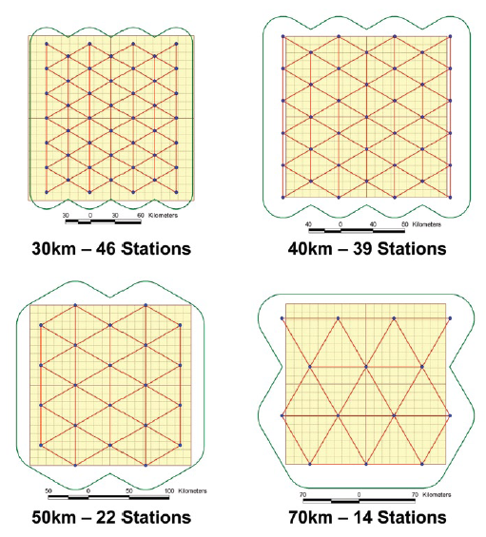

Figure III-1 – Example of the Importance of Planning in RTN Reference Station Spacing

    - RTN processing limitations.
Manufacturers of RTN software suites will recommend station spacing for each of the network service types offered. There is no general rule of thumb as these lengths have increased over time, but at this time you may often hear spacing numbers of 50km to 70km. An RTN software suite may offer multiple network correction styles and it may be that there is different recommended spacing for each type (e.g. VRS, MAC, FKP).
In addition to the recommended spacing, you may wish to consider:

      - Single-base limitations. If it is a goal to provide consistent single-base service over the entire network area, an effective single-base length would be the limiting factor. The impetus for development of network style corrections was to extend the baseline lengths, because single-base is subject to more pronounced performance degradation (increasing error) over distance. Mixing multiple single base observations beyond recommended lengths will likely yield inconsistent results, particularly in periods or conditions of high solar activity.

At this time a network correction over an example 70km spacing would yield more consistent results along the entire length than a comparison of respective single base observations from each base.

A network of stations serving only single-base corrections is often called an “RTK Cluster”, and if the spacing is close enough such a network may serve perfectly well all real-time needs. While great strides have been made in the increase of single-base lengths, the ability of network corrections to provide consistency over a region is generally accepted. Times of increased solar activity which results in elevated ionospheric affect on the GNSS signals may bear this out.

It may be a goal of an RTN that will serve primarily network corrections to have single-base as a fall back should individual or multiple stations become unavailable and then users would revert to single-base; if the risks are high for such situations, then a closer spacing may be recommended.

      - Long-baseline risks. Certain trade-offs may be considered. One of the hazards of longer baselines is possible poor network performance during high solar events (or at the peak of solar cycles). To save costs the spacing may be deliberately placed at or beyond the manufacturers recommended spacing with the understanding that there will be periods where network use may be compromised, or impossible. Be sure all stakeholders are aware of this and be sure to have a notification plan for such events.

Another long baseline length hazard lies in station failures. In a dense network, the failure of an individual station may not necessarily compromise network correction services for a particular region of an RTN. At longer spacing, you may lose a particular region should key stations fail.

      - Mixed baseline lengths. There may be areas within your network that represent higher usage than others (e.g. high population areas) where many RTN will place CORS closer together than in less used areas of the network. This is often to provide some assurance of service in the event of individual or multiple CORS outages.

Other reasons for varied spacing can be in networks that cover large geographically disparate regions. For example, an entire state may have coastal regions, mountainous, arid, and/or areas of varied tectonic activity. One area may be subject to greater variations in tropospheric (weather). While the signal delays due to troposphere may not be as great as those due to the ionosphere, it is not insignificant, and you may find that stations need to be closer in say a coastal rain forest area than in an arid grassland on the other side of the network.

Closer spacing is also recommended to help mitigate tectonic movement effects (through a comprehensive monitoring program), and for ocean tide loading (OTL) [more later]

      - Phased implementation. Phased implementation is often a function of funding, but also a phased construction schedule for stations propagating over a varied geographic area provides a great option to test results before commitment of expensive CORS. Some RTN will place new stations on temporary mounts to test conditions and network results in advance.

    - Reference Station Spacing – Siting Limitations:
(See more on this in the Site Evaluation and Construction Sections)

Even the best planned theoretical spacing will be subject to site specific considerations. The regular equilateral triangle pattern will in reality be unlikely to achieve. Finding suitable sites near your desired locations can be challenging. It is not always a direct trade-off between compromised site conditions and optimal geometry as there are many options to mitigate for less than optimal site conditions (see construction) as well as some flexibility in geometry (perhaps through slightly closer spacing).

A brief summary of site conditions that may directly influence options for spacing:
- Secure site availability
- Availability of real-time communications
- Availability of reliable power
- Local surface and sub-surface conditions (geology)
- Sky view
- Localized multipath or radio interference hazards

    - Fiducial Station Spacing With repect to these guidelines, the term “fiducial station” would refer to those that are a subset of the CORS program. Designation of a subset of the stations of an RTN as “fiducial stations” assumes that there are sufficient CORS to meet the guidelines presented in Section V: Obtaining Station Coordinates Consistent with NAD 83 and ITRS, or that a subset (or all) stations of an RTN may be submitted for acceptance into the CORS program. The purpose of these stations is to promote the use of RTN station coordinates that are consistent with the National Spatial Reference System and to serve as fiducuial stations in the subsequent coordination and integrity monitoring of all other RTN stations in the network (see Section III, H). In achieving optimal fiducial station spacing (per Section V) the following should also be considered:
      - Reference to CORS external to the RTN. Should the availability of national CORS located wholly within the area of a proposed RTN be limited or nonexistent, use of CORS external to the RTN should be chosen to provide as even a spacing as possible and as equidistant as possible, but that otherwise all guidelines of Section V should be followed
      - Adoption of a subset of RTN CORS as CORS. Should there be insufficient national CORS available to meet the recommendations of Section V to act as fiducial stations, then it is recommended that a subset (or all) of the RTN stations be submitted for consideration as CORS. It is not necessary to have all stations in an RTN as CORS, and in some instances doing so would limit the options for integrity monitoring and mitigation of localize movements due to such factors as plate tectonics. Only those that meet the NGS requirements for submission should be considered. While an RTN should only contain the very best in site and mount qualities, hard choices and trade-offs may need to be made in such selections; the probability that a particular station may be submitted as a CORS should be considered in advance.
      - Reference to IGS stations. For most RTN this may not apply, but it may be that an RTN will serve multiple roles, and the RTN stations may be utilized for scientific or academic purposes and it may also be desired to establish a direct tie and/or integrity monitoring holding IGS (International GNSS Service, www.igs.org) registered stations. Typically for such purposes it is optimal to have two or more IGS stations within the bounds of the RTN, or three or more evenly spaced and as equidistant as possible external to the RTN, or that submission of a subset of the RTN stations as IGS stations should be considered.
      - Fiducial – Other. It may be that for purposes other than coordination or registration to the NSRS (National Spatial Reference System) other station in the RTN are designated by respective RTN administrator(s) as “fiducial stations”. This may be a function of integrity monitoring needs and capabilities, the practicalities of submission as CORS, or perhaps specific end use needs and applications

    - Existing Infrastructure. A developing RTN may be able to take advantage of existing infrastructure, typically in the form of existing reference stations, CORS, and communications links, provided that these elements of existing infrastructure meet recommended specifications or are easily upgraded or adapted for inclusion in the RTN. Successful inclusion of existing infrastructure can represent substantial cost savings and it is recommended that these resources be researched prior to the design phase. Stations adjacent to the RTN in development, whether they are a stand-alone CORS, part of an existing RTN, or a station in an “RTK Cluster” (a network of stations that provide only single-base RTK) may be considered for inclusion. Station quality, data availability and reliability are key considerations. It is irrelevant what reference system the owners/operators of these external stations establish for their own use as you will only be concerned with observation data, and you will be establishing reference positions for the purposes of your own RTN.
      - Peer Networks. A peer network would be another RTN, and likely such stations would have had to meet the requirements to be functional as RTN stations, and would already be streaming raw observations at a standard rate required by an RTN (typically 1 Hz). As RTN stations typically stream to one or more CPC (Central Processing Centers) of an RTN, such CPC’s have software suites with stream management utilities or NTRIP casters (See Section III, D, 2, e) and a split (copy) of a stream can be directed to or accessed by your CPC with ease, low security risk, and minimal throughput. This minimizes impact on the respective RTN. For redundancy purposes it may be desirable to split the data stream at each respective receiver (most modern RTN-capable receivers are set up for multiple outgoing streams).
      - Fostering partnerships. A common scenario for use of streaming data from peer networks is to establish a ‘quid pro quo’ type of agreement; exchange of a stream from one of your stations for one of theirs, but there can also be for-fee agreements if there are streaming needs for only one party.
      - CORS. The NGS has proposed streaming GNSS data from a subset of the CORS in that such data may be used freely for all and RTN. See Section I. A.
      - Scientific CORS networks. There are many CORS established by scientific and academic organizations, from the national arrays like the Plate Boundary Observatory (PBO) to regional arrays, to individual stations at universities and schools. Typically these are high quality sites and mounts, but may not have real-time streaming capabilities. The current trend is that such entities are rapidly establishing stations with live communications or upgrading existing stations. Many are open to the RTN establishing separate communications, with access to the station data from an existing serial port (most receivers have multiple) provided there is no negative impact on current operational needs.
      - Upgrade of L1-only bases. There are many existing L1-(single frequency) only base station set up to serve lower-precision needs; DGPS, mapping, asset inventory, etc. While many were not mounted to the standards required by an RTN or otherwise higher-precision needs, but they are often a good candidate to offer to partner on an upgrade to dual –frequency receivers (and respective antennas).Such a station would still be serving the original needs, but an RTN as well. There may also need to be an upgrade in mount, and communications, but the site has been established and tested.
      - Pitfalls of external CORS. While using existing infrastructure may speed the development of an RTN and represent a cost savings, there can be a downside. The biggest challenge is data availability and reliability. If the owners/operators of an external station do not have the same operational goals as your RTN, they may not go to the same lengths to keep the station running and streaming. You may be waiting days or weeks before a failed station is fixed. An external station may not be as rigorously monitored or upgraded to the same specifications or schedule as your own.

      - Multi-Constellation CORS Spacing. Multi-station capabilities may be a goal of your RTN, in that added tracked constellations will provide end users with data and corrections from more satellites than a single constellation system. Multi-constellation capability is referred to as Global Navigation Satellite Systems (GNSS), whereas the widely used term Global Positioning System (GPS) correctly refers to the Navstar System of the United States alone. At this time, GLONASS of the Russian Federation is the only other functional GNSS constellation. While additional satellites may not result in higher precisions, what is gained foremost is visibility of more satellites in limited view conditions. There is typically a cost increase associated with adding multi-constellation capability to receivers, antennas, and RTN software. There are several approaches to establish a GNSS capable network, upgrade to, or do a phased upgrade.
- All GNSS Network. If all receivers and antenna’s utilized for the RTN stations, and if the RTN software used in the Central Processing Center(s) is GNSS capable, then the spacing considerations are the same as those for GPS-only RTN’s. This does not require all end-users to have GNSS capable equipment; they can still take advantage of the GPS-side and their equipment will simply ignore that which it cannot track.
- Mixed Network. Typically for financial reasons, an RTN may have GNSS capable subnetworks and GPS-only subnetworks. In such a scenario, subnets, or clusters of GNSS capable stations would provide the additional functionality to the correctors developed by and used within said GNSS subnet. GPS-only users would be able to work in any subnet, and GNSS capable end-users would simply default back to GPS-only when not in a GNSS subnet. Depending on the RTN CPC software used, a GNSS subnet would need a minimum of 3 stations to add such functionality. Consult with your software vendor for specifics.
- Isolated GNSS Stations. If there are individual or isolated GNSS capable stations within the RTN, they will support the GPS-only network corrections but can also be made available for single base GNSS use.
- GNSS Sparse Network Solutions. There are options in some RTN CPC software suites to add GNSS capabilities to network corrections that do not require all stations in the RTN to be GNSS capable. Typically it would require that “every-other” station have GNSS and that there may be specific spacing limitations to enable this functionality. Consult with your software vendor for specifics.
- RTCM3.1-Network Message. At this time, the message format has been completed and interoperability testing has been successfully completed. Currently, at this writing (03Dec2010), the committee is voting on amendment 5 to the 3.1 standard which contains revisions and additions for GLONASS MAC and FKP.

  - Central Processing Center Design
    - Primary design considerations. The design of the Central Processing Center (CPC) of an RTN is key to the success of an RTN; whether it can fully utilize and manage all of the infrastructure, and deliver services reliably in real-time. There are a few critical consideration to address before a CPC should be designed or built

a) Hosting policies. It is important to establish a good working relationship with the Information Technology interests of the proposed host site and of the respective RTN partners. IT policies will govern not only the physical aspects of the CPC design like servers, but what will be required for firewalls, operating systems, systems monitoring, and end user access (e.g. proxy servers, NTRIP, modem banks, broadcast radios, etc). Get the respective IT interests together with your CPC software vendor early (and even better before any evaluations, pilots, or tenders)

b) Power and Environment. Consult with the proposed host site IT staff. A typical CPC is essentially a set of applications and services installed and running on commercially available servers, which have specifications for power and environment.

c) Server Array. Consult with your CPC software vendor and IT staff for options in utilizing multiple servers. Many CPC suites can be run in a distributed environment, either on multiple physical servers, or on virtual servers; giving many more options for security, load balancing and redundancy.

d) Static data archiving strategies. When decisions have been made on what types of static data files (for post-processing) are desired to be stored both in short term and for archiving, then consult with IT staff for storage options. 24hrs of static data for a GPS-only station collected at1Hz will require around 90MB, and as much as 170MB for a GNSS enabled station. Most CPC suites offer the option of generating the static files at the CPC (if only a raw stream is capable from the stations) as well as pulling files generated at the stations (with a fill-in option if connectivity is lost for short periods). The impacts on the design of the CPC vary depending on what post-processing-file services you plan to offer (e.g. customized time-decimation requests, file types, compressions), and your long-term archiving requirements. A distributed environment can separate the file generation load from the real-time processing load, and enable a scalable storage array.
    - Station to CPC Connectivity Strategies. The stations of a RTN serve primarily as sensors providing raw observation data to the CPC in real-time, typically at 1Hz. There are several approaches to getting the observation data cleanly and with low-latency to the CPC. It is recommended to involve the IT staff for the CPC host, remote sites host IT staff, and the CPC software vendor technical staff in early planning for connectivity.
      - Unidirectional. It will suffice for most stations in an RTN to simply push the observation data to the CPC. While this provides the raw materials with which the CPC can generate corrections and server-side static files, this one-direction-only connection does not enable remote operation of the station, requests for file fill-in of static files generated locally on the receiver, or ad hoc updates of almanacs from the receiver. (For the latter it is recommended that a subset of RTN stations have bi-directional communications capabilities.) A unidirectional connection may be desirable to overcome certain security (typically firewall) restrictions. If the receiver acts as a client to the CPC server and simply “pushes” the data then security is much easier to control.
      - Bi-Directional. It is much more typical for two-way communications to be established between the CPC server and the GNSS receivers. Most modern base receivers have web based interfaces for setup and remote operations. Also, the CPC server can directly request static file updates as needed and ad hoc requests for almanacs. While most base receivers have built-in filtering for incoming/ outgoing connections, IT staff of the CPC hosts and remote sites may require additional security measures (more filtering, firewall rules).
      - NTRIP. Network Transport of RTCM for Internet Protocol is a widely accepted international standard for raw and correction data formats. See http://igs.bkg.bund.de/index_ntrip.htm. It is an HTTP compliant protocol that enables authenticated access for transmission and reception of data streams while limiting the number of Internet addresses involved, making security management easier. It is not uncommon for RTN stations to send raw observations by NTRIP to an NTRIP caster running on the CPC servers. Note that some of the bi-directional functionality (as noted in the preceding item) would be limited, and a subset of stations would need bi-directional connectivity by other means.

d) Proxy servers, modem banks, or dedicated authentication servers. Not widely utilized anymore, but consult with the IT staff on these options.
      - Mode of Data Transportation. What is desired is essentially an Internet Protocol (IP) connection of some kind. Most stations are too far from the CPC for a hard wired LAN connection; typically the connection needs to run through a wider network, and intranet, or the public Internet in some fashion. The raw observations represent a data stream of roughly 500BPS (Bytes Per Second). While this is not a large throughput, even handled in some cases by a 56K capacity, it is the latency that is of key concern. For the RTN software to successfully synchronize the epochs of data from multiple stations a latency in transmission from a station to the CPC of under 1 second is desired; with an upper, highly undesirable limit of 2.5 seconds. Some of the more common modes of low latency connectivity include:
        - WAN/LAN. Be this with a fiber backbone or not, it is highly likely that low latency is possible. The only drawbacks may be in that dealing with a single entity, there is a single point of possible comms failure. Potential quality of service issues should be explored; a WAN/LAN may be shared by other uses and may experience load issues.
        - Commercial DSL/Cable. These may all perform quite well latency and reliability-wise. The security controls may be limited to those available on the GNSS receivers and for security reasons you may have to employ a unidirectional connection.
        - Broadband Wireless/Cellular. The options are changing fast. While there have been successful deployments of such technologies, this is mostly achieved on a case-by-case basis. It is recommended that you involve the IT staff, as well as tech support from the respective carriers of such service to fully explore the feasibility (and a pilot ) before you make design decisions that would rely on such connections.

iv. Satellite. This technology has improved rapidly, but it is still susceptible to high latencies. The quality can vary by carrier and by the quality of installation. In some remote sites this may be the only option available. Involve the IT staff, and tech support from the respective carrier in explorations and testing of such options.

v. Radio. Typically radio is used for the last link from the station to the nearest source of IP, what is referred to as “last mile radios”. These can send serial or ethernet data. Although there are solutions that can employ spread spectrum and unlicensed radio options, there can be security concerns and licensed frequency concerns. There are some instances where a radio pair can be used for such purposes up to 20 miles, but more practically and reliably. Consult IT staff and radio comms specialists for these options.
    - CPC to User Connectivity Strategies. The CPC of an RTN is essentially providing corrections developed server-side, or relaying the observations from a subset of a group of station to the user in the field for rover-side corrections. Whether the comms be bi-directional (or casted) or unidirectional (broadcasted), the data is most commonly served up via an Internet Protocol (IP) type connection as it leaves the CPC, and then a number of approaches are employed by end users to retrieve the data:
      - Radio. In a broadcast-only mode, if there were enough radios to cover the region of an RTN, then all users could use rover radios to receive the corrections. Broadcast (unidirectional) limits the corrections to single base, preset master style Master-Auxiliary (MAC), preset virtual base styles, radio relays and repeaters or variations of these. These are not commonly employed as there can be licensing issues, compatibilities with multiple types of rovers, and costs. There are other variations that employ low band radio options for relaying observation data or correction data to specialized radios. Involve IT staff and radio comms specialists in early explorations and testing
      - NTRIP. As previously examined in the Station-to-CPC section above, NTRIP is a commonly used method for accessing the CPC services once a source of connectivity is established. Essentially anywhere one can “get IP” (or connect to the Internet) one can access authorized “casters” for bi-directional requests of correctors or observations from an RTN. Most rover software packages have an NTRIP client included.
      - Mobile sources of IP. The options are rapidly changing . These may include but are not limited to:
        - Cellular – the most commonly used for RTN connectivity; dedicated modems, cellular phones,
        - Wi-Fi,- limited to the range of the nearest Wi-Fi sources, sometimes other mobile IP sources are used to set up a portable Wi-Fi hotspot.
        - Satellite – portable self-aiming satellite Internet should be tested as there may be latency issues.
        - Wireless Broadband. Essentially a cellular technology, the options and speed are changing rapidly. A rover does not need high capacity, but it does need a reliable connection,
        - Passive and active cellular boosters. Wjile often improving range, if a signal is bad or nearly non-existent, one may simply beboosting a bad signal.
        - Radio Relay. A broader range beyond that of an existing source of IP (e.g. at the far edge of a cellular coverage area) users can employ a relay radio for the last few miles

      - Redundant Communications – Stations to CPC. Failures of stations are far less common than drops in communications between individual stations and the CPC. It is recommended that two or more streams be established from each station to the CPC. Or as many stations as possible to ensure continued operations if communications is lost to one or a few. If for instance an RTN relies most heavily on one communications approach for most stations (e.g. Internal WAN/LAN) then this could represent a single point of widespread failure), the best type of redundant comms is that of a completely different approach (e.g. WAN/LAN bidirectional primary – commercial DSL unidirectional secondary). Most services can accommodate a split stream also feeding a mirror CPC as well. So an RTN station may have four or more discrete connections (two to primary CPC , and two to a mirror CPC). Involve IT staff, RTN CPC software vendor tech support, and communications specialists in early design.
      - Mirror Central Processing Center(s). A mirror of the CPC is highly recommended. Often for the cost of a few extra servers, the RTN can be mirrored at another physical location to ensure continued service should there be failures of a primary CPC. Sometimes a mirror CPC is utilize for load balancing and archiving redundancy strategies as well. Both sites can easily be maintained by the same staff remotely and there are strategies for synchronization of settings. With some RTN CPC software suites capable of working in distributed environments, mirror CPCs are much easier to manage. Involve IT staff, RTN CPC software vendor tech support, and communications specialists in early design.

      - Remote Operations. Unless the RTN CPC is hosted at a facility with round-the-clock staff trained to manage an RTN, remote administration is recommended. For the most part, RTN run unattended, and only need intervention for upgrades, configuration, accounts management, and upon failures. With remote alarming (e.g. email or SMS alerts) the operators can access from secure web interfaces or VPN connections. Involve IT staff, and communications specialists in early design.

      - Alarm and Notification Systems. These are not only desirable for RTN operators and administrators. Most RTN CPC software suites enable the configuration of numerous alarm states (e.g. stations down, quality thresholds, services offline) and can be delivered by web alerts, email, SMS, and other automated methods. Involve IT staff, RTN CPC software vendor tech support, and communications specialists in early design.

      - Accounting and Accounts Management. Most RTN require some form of authentication for use of services. This is not only for commercial RTN, but also for load management purposes. Usage data and resultant metrics can be an invaluable tool for administrators and operators. It is a good idea to run administrative tools like accounting and related databases on servers separate from those processing corrections or static data, and the databases should be archived on separate servers as well.

      - Web Interfaces. The RTN CPC suites generate a wealth of data on the quality and health of the RTN which is not only useful for the RTN administrators and operators, but a subset is invaluable for the end user as well. Many RTN CPC software suites have web interfaces or modules that can be added to display both standard and custom data.

  - Design for Operational Levels.
There is broad difference between an RTN that is “capable” of producing real-time services, like an ad hoc tool, and one that runs seamlessly and continuously like a utility.

If it is a goal of your RTN offer at least minimal services year round, and round the clock, then each element of the design needs to reflect that goal. Will any day-to-day operational or administrative activities (e.g. accounts management, station configurations, reports generation, etc) impact the seamless flow of services and data for the end users? Are redundancy measures employed? Are there sufficient staff trained to administer and operate the RTN, are their contingencies for after-hours operations and support? Could the operational model be upgraded or redesigned easily in the future if the operational needs were to change, or are there restrictions inherent to the original design that might otherwise prohibit changes or scaling (e.g. proprietary software limitations, limited agreements, IT restrictions, no accommodation for further training, etc).

But the stakeholders for an RTN may decide it is only necessary to run at minimal operational levels
    - Typical Design for Minimal Operations:

a. Receivers – simple sensors; no remote operational interfaces, outgoing streaming only, no local logging, older units OK, often utilize an external serial-to-IP device for connectivity, no redundant comms.

b. CPC – single server or small server array, no mirror, basic corrections generating software, lowest cost software, no web interface, no remote operations, basic integrity monitoring.

c. Operations – only during business hour, minimal staff trained.
    - Optimal Design for Full Operations:

a. Receivers – designed for RTN, remote operational interface, accommodate redundant comms, ethernet ready, local logging, accommodate external sensors.

b. CPC – full suite; corrections generation, web interface, remote operations capabilities, multi-tiered integrity monitoring, multiple servers and/or distributed environment, mirrored,

Operations – on-call and/or shift staffing, multiple staff, remote access 24/7, support request and response system.

  - Design for Maintenance, Repair, and Replacement (MR&R).
As in the preceding section on operations, the design should be appropriate to support the maintenance, repair, and replacement levels desired by the stakeholders, or accommodate a redesigned elements. Designing for maximum uptime of infrastructure elements is a function of risk management. Certain elements can run seamlessly with little wear and tear from day-to-day operations, like receivers; often running for many years (until possible obsolescence) with little intervention. But all elements are susceptible to catastrophic failure, some more than others.

Typical MR&R Strategy for full operational levels:

Receivers – all new, full maintenance contract, some spares (to swap out while others are in for repair), replacement schedule (expected lifespan and accommodation of additional features/constellations), on-site custodians.

CPC – New servers’ w/maintenance contracts, operating system upgrade schedule, on-call maintenance, top-end CPC software w/upgrade subscription. On-call/contract IT and communications specialists.

Stock items for repair/replacement.

  - Peer Support.
It is recommended that RTN administrators and operators develop open communications channels with peers running similar RTN. There are some groups of administrators and operators already formed (though mostly along brand lines) but other more generic RTN groups are in the works. It is a goal of the NGS RTN working group to continue the guidelines team activities and to foster perhaps a group of peer networks (of any brand) to exchange ideas, research, standards, tips, and solutions. Peer groups are also an invaluable tool for developers to gather feedback and best respond to user needs.

  - Integrity Monitoring.
The underlying value of a RTN lies in the ability to provide real-time correctors that yield consistent high precision positioning services. If an RTN is expected to produce coordinates of a given precision at any given time, anywhere in the RTN, the relative positional integrity of each and every station to each and every other station in the RTN must be equal to or better than the desired field results. Typically RTN processing may achieve optimal results only if the relative integrity of any given station is better than 1cm 3D at any given time. If the field results are expected in real-time, then the relative integrity of stations used in the solution must be monitored in real-time.

    - The single biggest contributing factor to poor field results (within the control RTN operations) is poor coordinate values. Without specific integrity monitoring, the results may only be verifiable through repeated observations, or through heightened levels of predicted geometric error in field and RTN CPC software quality indicators. This is a poor strategy for identifying bad coordinate values.

Section V provides guidelines for obtaining starting station coordinates consistent with NAD 83 and ITRS, and how to utilize the same methods for ensuring that station coordinates continue to hold fidelity to these systems. But unless all stations in the RTN are part of the CORS system, and therefore monitored for you by the NGS (albeit only periodically) then you must put in place a strategy for maintaining the positional integrity of each station both purely relative to the other RTN stations and to fiducial stations (NGS or other).

What is being sought is a detection of episodic movement of each inclusive antenna, and to track chronic (longer term) movement and trends. Episodic movement would have an immediate effect on field results, while the long term trending will inform strategies for re-establishing and re-publishing coordinates. Examples of episodic movement might be localized geophysical movements (landslides, shifting strata), earthquakes, storm damage, deliberate acts of malfeasance, accidents, etc. Chronic movement usually results from plate tectonic movements, and may be tracked and expressed as velocities
    - Periodic Monitoring– Post Processing. Although only representing a snapshot in time, all monitoring strategies should include at least some element of periodic post-processed evaluations of station relative integrity to fiducial stations. Periodic monitoring will reveal general trends in chronic movement (depending on frequency) and may be used to verify the magnitude of any episodic movement if performed immediately following a known incidence of episodic movement.

Post-Processing may be automated. As most RTN CPC software suites provide for the automated storage of high-rate (and decimated) static files, and some provide automated post-processing tools (for monitoring purposes), pre-designed tasks of baseline processing, reporting, weighting strategies, and even adjustments can be established to run monthly, weekly , or even daily if needed.

There are also a number of third party post-processing packages that can be set up to run automatically with periodically exported static files.
    - Basic Network Integrity – Near Real-Time. Most commercial RTN CPC software suites come with a standard network integrity monitoring engine; some run a never-ending series of closed loops from each station through each and every other station in the RTN, it provides comparison offsets to pre-designated fiducial stations. The solution does take some time to converge, depending on the size of the RTN and number of stations being checked, episodicmovement might not show up for hours.
    - Episodic motion detection. Some RTN CPC suites offer add-on motion engines that can produce more rapid results than standard network motion engines, with certain trade-offs between precision, speed of results, or baseline lengths that can be tested: RTK-based motion detection. Some very high precision options for detecting episodic movement utilize RTK engines, either initializing on the station being monitored, or server-side initialization (the latter having the advantage of being able to process many baselines simultaneously). The way one would check all stations would be to set up a monitoring subset for each station using its nearest surrounding stations, each in turn checked against fiducial stations shared between each subnet. Alarm thresholds can be set to notify operators.
    - Long baseline solutions. Conventional long-baseline processing can be achieved at high rates 1Hz -15Hz but with less precision, but if the motion engine can “learn” the normal pattern of such undulations then rapid changes can be detected and alarms triggered. A scenario where long-baseline detection may be desired is for that of earthquake prone areas. If an earthquake occurs then it would likely not only affect an individual station but those surrounding it as well. With long-baseline rapid motion detection, coordinates can be constrained to be fixed for stations located many hundreds of miles away, in areas that might not be affected by the same quake.
    - External Sensors. Tilt meters are a good addition to an antenna mount, and a good way to determine if detected movement is the physical mount or something systematic. There are relatively inexpensive 2-axis tilt meters (sensitive to hundredths of a degree) that can be connected directly to many types of base receivers.
    - Cameras. Inexpensive Ethernet cameras can share the same connection as your base receiver and give you a remote visual inspection tool.

    - Long-Term Trending. Both periodic and real-time monitoring can feed databases (and many commercial packages are designed in this manner).From the data, very detailed velocity data can be derived.

The NGS provides velocities for all CORS and generalized velocity models for all regions, but the typically tighter spaced RTN stations and often automated round-the-clock monitoring may produce more refined velocity models.

Velocity data can help predict when certain stations may go out of tolerance, and help you design strategies and schedules for updating coordinates. A calendar of predicted updates will help end users plan to update localized calibrations. Another use for velocity data is the development of transformation databases; collections of transformations that may be accessed in the future by such methods as activating the transformation parameter options of some correction formats like RTCM3.1.

- ADMINISTRATION

- Introduction
The administration of a Real-Time Network (RTN) is a critical component of the network’s usefulness. After successfully completing the planning, design, and installation phase of setting-up an RTN, the administration of the network is the critical element that
- Efficiently operates the various components of the network (e.g. receivers, servers, and communication networks, etc.) to work as a system and distributes the Global Navigation Satellite Systems (GNSS) data
- Provides the users with the information needed to utilize the network

There are several definitions for “administration”, but the two most applicable definitions are the following:
- Performance or management of a business operation
- Process of organizing resources and people

Similarly, administering an RTN consists of organizing the following framework of resources and people to work together as a system:
Resources:  - Hardware infrastructure  - Communication networks  - Global Navigation Satellite Systems (GNSS) | People:  - Users  - Administration staff to provide:  - Helpful support to users  - Partnerships with IT professionals

Consequently, the key component of the administration staff is the system administrator who:
- Operates the computer network that receives the data from the remote GNSS receivers
- Distributes the GNSS information to the network’s users in an efficient manner

Therefore, the requirements of an RTN system administrator must include the following abilities:
- Ability to support and maintain computer servers and communication links
- Ability to respond to service outages and other problems reported by either personnel at GNSS station sites or users in the field

In addition, it would be very helpful for the RTN system administrator to have a background in geodesy and satellite positioning.

- Key Components of an RTN Administration
      - System Administrator
      - Communication
      - IT Partners
Depending on the size of the RTN, the requirement to include GNSS CORS at sites will require the interaction (i.e. forming partnerships) with different IT partners in order to coordinate such issues as:
- IT security  - Firewall issues | - Lightning protection  - Power system backup

      - Latency
Latency is the delay in the packet of data traveling from one site to another site, which can be generated by:
- Bandwidth at a GNSS CORS location using wire or wireless network
- Bandwidth at the RTN server
- Transmission medium (fiber optical, wireless, etc,)
- Router and switch performance
- Firewall (can cause latency or loss of data flow)
- Voice/data traffic on wireless network used by rover GNSS receiver
- Capability of wireless network used by rover GNSS receiver

In addition, latency can also occur with the data flow from a rover GNSS receiver to the RTN server or from the server to a rover GNSS receiver. Both latency sources can reduce the ability to efficiently utilize the RTN or in some cases render the RTN unusable.

      - Reference Station Datums

The benefits of using a reference datum that is consistent with the datum utilized by the National Geodetic Survey are:
- Easy to verify
- Can use OPUS to position RTN CORS
- Fits with local passive monuments

The ramifications of using a datum that differs from the datum utilized by the National Geodetic Survey are:
- OPUS and RTN solutions are based on different reference datums
- OPUS can not be used to check RTN solutions
- RTN can not be used to check OPUS solutions
- Could create confusion with users
      - Coordinates
The reference positional information of the RTN CORS should be of the highest accuracy and precision. Determining the reference coordinates of the RTN CORS can be determined from a variety of sources:
        - OPUS
- The advantage of using OPUS to determine the reference coordinates of the RTN CORS is the ability to rapidly provide a solution
- Use a minimum of ten (10) days of twenty-four (24) data sets
- Only use OPUS if a minimum of three (3) CORS sites are within 250 km of your RTN.
- Review the 60-day solution of the CORS sites used by OPUS to ensure that those CORS sites used in the solution are stable and operating within network accuracy tolerances
- Carefully analyze the OPUS results to insure that results are within the recommended NGS tolerances

        - Adjustments
Observations collected at the proposed RTN CORS sites can be used in a least square adjustment. As with the OPUS technique, a minimum of five (5) days of twenty-four (24) data sets should be used in the adjustment. Along with the commercial adjustment packages, NGS ADJUST can be used to perform the adjustment. Also, if the “extended output” option is enabled when submitting files to OPUS, the G-file can be extracted from the extended OPUS output and utilized in ADJUST. Please note the following advantages and disadvantages of performing a least square adjustment:
Advantages  - Evenly distributes errors  - Includes connection to NSRS and NAVD88 if passive monuments are included in the observations | Disadvantages  - Takes more time

      - Connection to NAD 83
It is recommended that as a minimum, the larger number of 3 or 10% of CORS sites in the RTN be CORS sites. This will provide the RTN a connection to the CORS Network- which is the basis of “truth” of our national NAD 83 datum. Local static surveys should be performed to connect the RTN CORS with the local NSRS passive stations. This will provide information that will assist you in developing local accuracies between the RTN CORS and passive monuments in the RTN coverage area. For a complete discussion of NGS recommendations for obtaining RTN station coordinates see Chapter V. Obtaining Station Coordinates Consistent with NSRS and ITRS.

      - Connection to NAVD88

In height modernization surveys (NGS 59) a geodetically-leveled bench mark in the NGS Integrated Database (NGS IDB) can have a GPS receiver set over it for use as a reference bench mark. Although tempting, and sometimes done in practice, the use of a CORS in this fashion is not endorsed by NGS. The reasons for this are multiple, including (a) desire to keep CORS antennas untouched except during their installation and decommissioning (b) inaccessibility of many CORS antennas to geodetic leveling (c) general inability to re-check the leveling over time, especially with regard to points “a” and “b” above which leads to (d) an inconsistency between a monitored and changed ellipsoid height and an unchecked, unchanged leveled orthometric height. Finally, despite anecdotal statements to the contrary, NGS does not use, nor seek to use, such data in geoid modeling.

NGS strongly endorses the establishment of passive control near CORS for many reasons, just one of which is its potential use as a height modernization reference station, and which addresses all of the issues above.

Despite all this, NGS is cognizant that some users have chosen to treat CORS as height modernization reference marks, albeit not accepted into the NGS integrated database with 1st, 2nd or even 3rd vertical order because the methodology might not follow the required standards and specifications. Even so, some station ARP are capable of being leveled to geodetically following the full standards and specifications (in the case of pillar mounts for example). It should be noted that any position obtained from an active reference station using real time GNSS positioning will still rely on the NGS hybrid geoid model to produce NAVD 88 orthometric heights from the NAD 83 ellipsoid heights. The RTN administrator must weigh the advantage of the time and effort involved to obtain geodetically leveled heights on RTN ARP versus providing more accessible passive marks to the user.

In spite of the lack of NGS endorsement for the practice of leveling to an ARP, the following is included to aid the RTN operator in the case where leveling does transpire and to help avoid unacceptable errors:

The NAVD 88 orthometric height of the ARP should be determined before the CORS antenna is installed or may be done afterwards if an ARP offset leveling plate had been installed immediately below the antenna (Figure 1). Such a re-leveling does involve touching the CORS during operation, which NGS does not endorse.

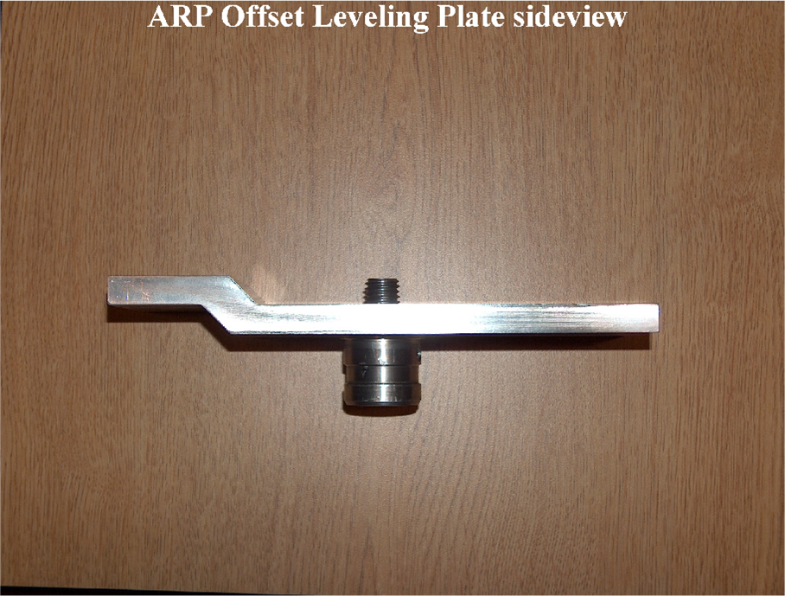
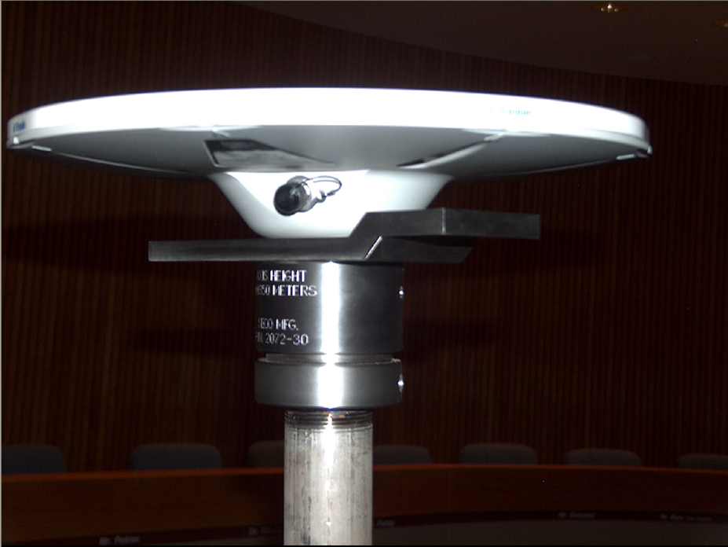

Figure 1. Left image: An offset leveling plate. Right image: The correct installation position of an offset leveling plate (immediately below the antenna) so that the ARP may be determined while attempting to minimize disturbances to the antenna.

The following field techniques can be used to determine the NAVD88 elevation of an ARP depending on the antenna’s location, accessibility, and mounting. For more information on different leveling techniques, please visit the following URL:

http://www.ngs.noaa.gov/heightmod/Leveling/leveling_index.html

        - Geodetic leveling
If the ARP is accessible to perform geodetic leveling and the antenna mount is on either a ground based tower or pier, differential leveling can be conducted to determine the NAVD 88 height of the ARP in most cases.

NGS and NCGS have experimented with using digital levels to determine the NAVD 88 height of the ARP by reading an upside down level rod that is attached to a horizontal rod that is attached the antenna mounting plate (Figure 2).


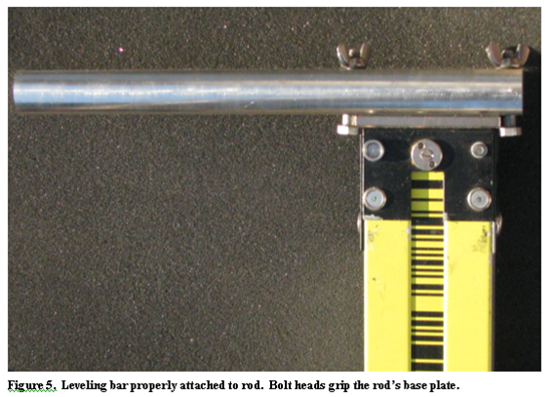
Figure 2.Left image: The backside view of an upside down invar rod bolted to a rod that is connected to (and level with) the antenna mount so that the NAVD 88 height of the ARP may be determined by geodetic leveling. Right image: A close-up of the upside down invar rod bolted to the horizontal rod.

        - Trigonometric leveling
Trigonometric leveling can be used if:
- The CORS ARP is not accessible for geodetic leveling.
- The antenna is on a structure that does not exceed two stories.

Proper trigonometric leveling procedures must be followed in order to obtain an accurate elevation of the CORS ARP. For more information, please read the following NGS report on trigonometric leveling:

http://www.ngs.noaa.gov/PROJECTS/bridge/report.htm

        - NGS-59
A GPS derived elevation of the CORS ARP can be obtained by including the CORS ARP into an NGS-59 project that adheres to the following guidelines:
- The two CORS reference monuments are placed near the CORS ARP.
- Geodetic leveling is performed to the CORS reference monuments and these monuments along with the CORS ARP are included in the NGS-project.

- Obtaining Station Coordinates Consistent with NSRS and ITRS
Richard Snay, Chief (Retired), NGS Spatial Reference System Division

  - Introduction

The purpose of this document is to provide guidelines for operating a Real-Time Network (RTN); that is, a network of terrestrial-based Global Navigation Satellite System (GNSS) tracking stations for enabling clients to obtain accurate positional coordinates for points of interest to them in the United States and its territories, and to do so with a latency of less than a few seconds (once integer ambiguities have been resolved). These guidelines do not address the operation of a RTN for navigational applications.

NOAA’s National Geodetic Survey (NGS) encourages the use of both NAD 83 and ITRS for geometric positioning (geodetic latitude, geodetic longitude, ellipsoid height; or equivalently, geocentric 3-dimensional Cartesian coordinates). Indeed, NAD 83 is the official spatial reference system for geometric positioning in the United States for all federal civil survey and mapping agencies, as well as for 48 of the 50 states. While this chapter presents guidelines for promoting the consistency of the generated positional coordinates with current realizations of the North American Datum of 1983 (NAD 83) as well as with current realizations of the International Terrestrial Reference System (ITRS), an official, more rigorous policy is forthcoming on compliance of RTN to the National Spatial Reference System (NSRS). On that note, over the next year NGS will work with RTN operators on acceptable procedures to ensure NSRS compliance with the actual customer-received RTN-based coordinates.
At present (February 2011), NGS endorses the use of the ITRS realization known as the International Terrestrial Reference Frame of 2000 (ITRF2000) [see Altamimi, Sillard, and Boucher, 2002] for use throughout the United States and its territories. Also, NGS endorses the use of the following NAD 83 realizations:
- NAD 83(CORS96) in CONUS, Alaska, Puerto Rico, and the AmericanVirgin Islands;
- NAD 83(PACP00) in Hawaii, the Marshall Islands, American Samoa and other islands residing on the Pacific tectonic plate; and
- NAD 83(MARP00) in the Mariana Islands (Guam, Saipan, etc.) and other islands residing on the Mariana tectonic plate.
Note that these three realizations of NAD 83 are each related mathematically to ITRF2000 by a 14-parameter Helmert transformation. Hence, if the 3-dimensional ITRF2000 positional coordinates and velocity for a point are known, then its equivalent positional coordinates and velocity can be exactly computed for any of the above three realizations of NAD 83. Conversely, if the positional coordinates and velocity are known for any of the above three realizations of NAD 83, then the corresponding ITRF2000 positional coordinates and velocity can be exactly computed. The transformation between NAD 83(CORS96) and ITRF2000 was published by Soler and Snay [2004]. The transformation between NAD 83(PACP00) and ITRF2000, as well as that between NAD 83(MARP00) and ITRF2000 were published by Snay [2003]. All three transformations are encoded in the Web-based utility known as HTDP at http://www.ngs.noaa.gov/TOOLS/Htdp/Htdp.shtml . The fact that these three NAD 83 realizations are each mathematically equivalent to ITRF2000 implies that RTN operators can work interchangeably in either the the ITRS or the NAD 83 reference system. At NGS, all CORS computations are performed in ITRF2000 and the resulting positional coordinates and velocities are transformed to an appropriate NAD 83 realization, if needed, at the end of the process.

NGS has also adopted a realization of NAD 83 called NAD 83(NSRS2007) for use in CONUS, Alaska, and Puerto Rico. This latter realization approximates NAD 83(CORS96). It was obtained by adjusting Global Positioning System (GPS) data collected during various campaign-style geodetic surveys performed between the mid-1980’s and 2005. For this adjustment, NAD 83(CORS96) positional coordinates for several continuously operating reference stations (CORS) were held essentially fixed to obtain consistent positional coordinates for about 70,000 passive geodetic reference stations, as described by Vorhauer [2007] and Pursell and Potterfield [2008]. Hence, derived NAD 83(NSRS2007) positional coordinates should be consistent with corresponding NAD 83(CORS96) positional coordinates to within the accuracy of the GPS data involved in the adjustment and the accuracy of the corrections applied to these data for crustal motion, atmospheric refraction, etc. Note that NGS did not compute NAD 83(NSRS2007) velocities for the 70,000 reference stations involved in this adjustment, but the horizontal components of their velocities may be predicted using the aforementioned HTDP utility. The vertical velocities of these passive reference stations are essentially unknown.

NGS recommends that RTN reference station coordinates and velocities be referred to NAD 83 (CORS96) rather than NAD 83 (NSRS2007) in CONUS, Alaska and Puerto Rico because the former NAD 83 realization is more rigorously defined, especially in terms of 3-dimensional velocities. More specifically. coordinates and velocities for reference stations should be derived directly from reference stations contained in the CORS network and not from passive reference stations.

The positional coordinates of a reference station should be referred to a “reference date”. This term corresponds to the date for which the positional coordinates are considered valid. A station’s positional coordinates referred to one reference date can be compared with those referred to another reference date, only if the station’s motion between the two reference dates is known. This motion includes the station’s (3-dimensional) velocity. Appendix IV.A presents a procedure for predicting a station’s positional coordinates at a specified reference date by using its positional coordinates for a different reference date together with the station’s velocity.

  - Summary of Recommended Procedures

NGS recommends that the administrator of a RTN follow three procedures so that his/her clients will obtain positional coordinates that are consistent with the NGS-adopted realizations of ITRS and NAD 83.

Recommendation 1. Some RTN reference stations should also be contained in the CORS network.

Recommendation 2. For each reference station contained in the RTN, adopt values for its 3-dimensional positional coordinates (at a selected reference date) and a velocity that are consistent, with corresponding values adopted by NGS for reference stations in the CORS network, to within 2 cm in each horizontal dimension (north-south and east-west) and 4 cm in ellipsoid height.

Recommendation 3. For each reference station in the RTN, use the Online Positioning User Service (OPUS) at http://www.ngs.noaa.gov/OPUS/ or some similar utility, on a daily basis, to test for the continued consistency of the station’s positional coordinates and velocity, as adopted by the RTN administrator, with the coordinates computed by the utility; and revise the station’s adopted coordinates and/or velocity if coordinate differences in excess of 2 cm in either horizontal dimension and/or 4 cm in ellipsoid height persist over a period of several days.

  - Implementing Recommendation 1: Some RTN stations should also be contained in the CORS network

If the RTN contains at least 30 reference stations, then NGS recommends at least 10% of these reference stations be also contained in the CORS network. If the RTN contains less than 30 reference stations, then NGS recommends that at least three of them should also be contained in the CORS network. In either case, the RTN administrator and NGS may agree that the CORS network contain more than the recommended number of RTN stations. Also, the RTN stations contained in the CORS network should be well distributed throughout the RTN.

For each station contained in the CORS network, NGS will determine its positional coordinates and velocity for each pertinent realization of NAD 83 and ITRS. Moreover, NGS will monitor the accuracy of these positional coordinates and velocities on a daily basis. NGS will also make available all GNSS data collected at these stations to the public for post-processing activities. NGS will NOT distribute these data in real time to individuals and/or organizations unless NGS has received permission to do so from the RTN administrator. Even with permission, current NGS policy is to broadcast only the GNSS data without correctors.

Some RTN stations may already be contained in the CORS network. If not, the RTN administrator may contact NGS to add one or more of his/her RTN stations into the CORS network. Information about adding a reference station into the CORS network and guidelines for establishing and operating these stations may be found at http://www.ngs.noaa.gov/CORS/ .

As will be addressed later, one advantage of having RTN stations contained in the CORS network is to allow RTN administrators to easily test for the consistency of the positional coordinates that they have adopted for their RTN reference stations via OPUS and in such a way that OPUS uses only reference stations from this RTN as control stations.

A second advantage of having some RTN stations contained in the CORS network is that it allows prospective RTN users and others to easily compare the coordinates adopted by the RTN administrator with coordinates adopted by NGS for at least this set of reference stations. As discussed in Section D of this chapter, these two sets of coordinates need only agree within some prespecified tolerance. For RTN stations contained in the CORS network, prospective RTN users and others can determine if the two sets of coordinates are indeed within the tolerances without performing complicated computations.

  - Implementing Recommendation 2: Adopt RTN station coordinates and velocities that are consistent with CORS coordinates and velocities

For each RTN reference station contained in the CORS network, NGS encourages the RTN administrator to adopt values for the station’s 3-dimensional positional coordinates (at an administrator-selected reference date) and velocity which will agree with the corresponding NGS-adopted values for this station’s positional coordinates (at the NGS-selected reference date) and velocity in the following sense:

The reference station’s coordinates for any given day of RTN operation, as computed from administrator-adopted values, should differ by no more than 2 cm in each horizontal dimension (north-south and east-west) and/or by no more than 4 cm in ellipsoid height from corresponding coordinates computed from NGS-adopted values.

As mentioned previously, a procedure for computing positional coordinates at one reference date using positional coordinates for a different reference date is presented in Appendix IV.A.

It would be convenient if the administrator-adopted values were identical to the NGS-adopted values, but the administrator may have more available resources than NGS to monitor the positional coordinates of his/her RTN reference stations. Hence, the administrator may be the first to detect when positional coordinates and/or velocities need to be revised. The administrator should then advise NGS at ngs.cors@noaa.gov as to the discrepancy, for it may be the case that the administrator-adopted values are more accurate than the NGS-adopted values, whereupon NGS would consider revising its adopted values.

The RTN administrator may want to adopt values that differ (within the above tolerances) from the NGS-adopted values because RTN technology requires a higher level of internal consistency among positional coordinates than what is required for standard CORS applications. This internal consistency enhances the ability to determine accurate corrections to the GNSS data for the systematic errors associated with orbits, clocks, atmospheric refraction, and other phenomena. These accurate corrections will better enable rapid and reliable resolution of the integer ambiguities, as is needed for cm-level positioning. In many cases, due to the different scale of their respective missions, the RTN administrator will have more available resources than NGS to determine internally consistent positional coordinates for his/her RTN reference stations.

The RTN administrator may use any procedure that he/she deems appropriate to determine positional coordinates (at a selected reference date) and velocities for all reference stations contained in his/her RTN. For RTN reference stations that are not contained in the CORS network, the administrator-adopted values should be consistent with those yielded by OPUS in the following sense:

If--for any period of time spanning 60 consecutive days--a person submits daily (24-hour) GPS data files from a RTN reference station to OPUS, then the average coordinates from these 60 OPUS solutions should differ by no more than 2 cm in each horizontal dimension nor by no more than 4 cm in ellipsoid height from the average positional coordinates for these 60 days, as computed using administrator-adopted values.

Appendices IV.B and IV.C provide some suggestions as to how a RTN administrator may determine positional coordinates (at a selected reference date) and velocities for his/her RTN reference stations.

  - Implementing Recommendation 3: Use OPUS or some similar utility to test for the continued consistency of RTN coordinates and velocities over time

For each reference station contained in his/her RTN, the administrator may submit a 24-hour GPS data set (spanning the time from UTC midnight to the following UTC midnight) to OPUS for each day of operation. Moreover, the administrator should submit these data to OPUS no sooner than 24 hours after the end of the UTC day so that OPUS will use the Rapid Precise Orbits provided by the International GNSS Service (IGS), when processing these GPS data. (Otherwise, OPUS may use the IGS Ultra-Rapid Orbits whose accuracy is less reliable than that of the IGS Rapid Orbits.) Note that RTN operators do not need to wait until the IGS Final Precise orbits become available, about 14 days after the end of the UTC day, because the Rapid orbits are essentially as good as the Final orbits.

For each day, the administrator should then compare the OPUS-generated positional coordinates for the station with the positional coordinates computed by the administrator for that day, updated from the RTN reference date by using the adopted velocity. If the two sets of positional coordinates differ in a consistent manner over a period of several days by more than 2 cm in either horizontal dimension and/or by more than 4 cm in ellipsoid height, then the RTN administrator may want to contact NGS at ngs.cors@noaa.gov to help him/her determine the cause of the discrepancy. For example, the discrepancy may be caused by
- an error in the administrator-adopted values for the RTN station’s coordinates and/or velocity,
- an error in the NGS-adopted values for the coordinates and/or velocities of the CORS being used by OPUS, and/or
- an error in the OPUS software.

In some cases, the cause of the discrepancy may be rather obvious; for example, the reference station’s antenna was displaced by an earthquake or by vandals. In such cases, the administrator need only determine new values for the reference station’s coordinates. In other cases, the cause may be extremely subtle; for example, gradual subsidence due to sediment compaction or seasonal variations in the station’s location due to hydrological effects. In such cases, the motion of the station may need to be modeled more accurately or perhaps the station should be replaced with another station whose crustal motion would be better understood.

Note that OPUS allows its users to select one or more of the three CORS that this software will use in processing the user-submitted GPS data. Hence, a RTN administrator may instruct OPUS to use any of the three or more reference stations that he/she opted to include in the CORS network in accordance with Recommendation 1. This action would promote internal consistency among the station coordinates in this RTN.

As an alternative to using OPUS, the RTN administrator may use any other utility that allows him/her to verify the consistency of RTN coordinates and velocities over time. Such utilities are available from several software vendors as well as some public institutions.

Appendix V.A – Transforming positional coordinates from one reference date to another.

Let [x(t₁), y(t₁), z(t₁)] denote the geocentric Cartesian coordinates of a specified terrestrial point at time t₁ relative to a specified reference frame, for example, some realization of NAD 83 or some realization of ITRS.

Furthermore, let [x(t₂), y(t₂), z(t₂)] denote the geocentric Cartesian coordinates of this same point at time t₂ relative to the same reference frame.

Then
x(t₂) = x(t₁) + v_{x}•(t₂ – t₁)
y(t₂) = y(t₁) + v_{y}•(t₂ – t₁)
z(t₂) = z(t₁) + v_{z}•(t₂ – t₁) (IV.1)
where [v_{x}, v_{y}, v_{z}] denotes the x-, y-, and z-components of the point’s velocity relative to the specified reference frame.

The above equations assume that the motion of the specified terrestrial point between times t₁ and t₂ is adequately characterized by a constant velocity. In particular, the point has not been suddenly displaced by an earthquake or by a bulldozer; nor has the point’s location fluctuated significantly due to thermal or hydrological effects, nor has any other motion occurred which is better represented by a non-constant velocity.

Equations similar to (IV.1) can also be formulated to update given geodetic coordinates (latitude, longitude, and ellipsoid height) at time t₁ to corresponding geodetic coordinates at time t₂, if the velocity components [v_{north}, v_{east}, v_{up}] are available. Alternatively, the geodetic coordinates at time t₁ can be converted to their equivalent geocentric Cartesian coordinates and the north-east-up velocity can be converted to its equivalent geocentric Cartesian velocity, so that Equations A1 may be used to compute the geocentric Cartesian coordinates at time t₂. These Cartesian coordinates can then be converted into their equivalent geodetic coordinates at time t₂.

It should be noted that the HTDP Web-based utility residing at
http://www.ngs.noaa.gov/TOOLS/Htdp/Htdp.shtml
enables its users to update given positional coordinates at time t₁ to corresponding positional coordinates at time t₂ in any of several popular reference frames. The user simply needs to enter either the geocentric Cartesian coordinates or the geodetic coordinates at time t₁ and the velocity. If the user does not know the velocity, then HTDP will predict a velocity based on numerical models encoded into this utility and this utility will allow the user to use this predicted velocity. Finally, HTDP also incorporates numerical models for several major earthquakes, and this utility can apply these models to determine the positional coordinates at time t₂ given the corresponding positional coordinates at time t_{1,} if the point has been displaced by one of the modeled earthquakes occurring between these times.

Appendix V.B – Suggestions for determining positional coordinates and velocities for RTN reference stations.

Two approaches are considered: (1) using multiple OPUS solutions, one solution for each of several days and (2) using a network adjustment. NGS prefers the second option.

Option 1. The positional coordinates for a RTN reference station may be obtained by processing some of the station’s GPS data with the OPUS utility at
http://www.ngs.noaa.gov/OPUS/ .
NGS recommends that the RTN administrator submit to OPUS 24 hours of the station’s GPS data for at least 10 separate days and then computes the arithmetic mean of all these solutions (after editing out any anomalous results).

The problem with using OPUS to determine positional coordinates for a reference station is that the accuracy of an OPUS solution depends on the accuracy of the positional coordinates of the three CORS being used in the OPUS solution. Because of the breadth and variety of its stations and partners, NGS has seen CORS coordinates to be in error by as much as 1 cm in each horizontal dimension and/or by as much as 2 cm in ellipsoid height. NGS monitors the values of all CORS coordinates on a daily basis by performing an adjustment of all CORS data collected during the given day. Using these daily values for the coordinates, NGS will revise the adopted CORS coordinates of a particular station only if the daily values differ consistently over a period of several days from the station’s adopted coordinates by more than 1 cm in one of the horizontal dimensions and/or by more than 2 cm in ellipsoid height. Daily differences for each station in the CORS network are publicly displayed, for the past 60 days, at http://www.ngs.noaa.gov/CORS/.

Option 2. As an alternative to using multiple OPUS solutions for determining coordinates for a reference station, NGS recommends that the RTN administrator use a network adjustment involving GPS data for at least 10 days and from several RTN reference stations, including as many CORS sites in this adjustment as is reasonable. Appropriate adjustment software may be obtained from any of several commercial vendors. Also, the ADJUST software is available for this purpose from NGS at
http://www.ngs.noaa.gov/PC_PROD/ADJUST/ .

In the network adjustment, the RTN administrator should constrain the coordinates of all CORS sites, contained in the RTN, to the values that are currently adopted by NGS, as updated to the epoch date selected by the RTN administrator. For convenience, the RTN administrator may want to select an epoch date that is reasonably close (less than one year) from the time period spanned by the GPS data included in the adjustment. NGS recommends that the RTN administrator weight the constraints on the CORS coordinates to allow them to adjust by as much as 1 cm in each horizontal dimension and by as much as 2 cm in ellipsoid height. (Constraints on CORS coordinates should be eliminated whenever the adjusted residuals of these coordinates significantly exceed these tolerances, because this would indicate that the NGS-adopted CORS coordinates may be in error. Please contact NGS at ngs.cors@noaa.gov, if this is the case.) Weighted constraints are preferred rather than absolute constraints that hold the CORS coordinates rigidly fixed. With weighted constraints, small errors in the CORS coordinates will not significantly distort the computed coordinates for the other RTN reference stations involved in the adjustment.

The advantage of using a network adjustment, as opposed to using multiple OPUS solutions, is that the resulting positional coordinates will be consistent among all reference stations contained in the RTN. Such internal consistency is important because any coordinate discrepancies among the RTN stations would corrupt the GPS correctors being distributed to RTN users. For the sake of internal network consistency, the RTN administrator may choose to adopt his/her adjusted values for the CORS coordinates rather than use the NGS-adopted values. This is okay, as long as Recommendation 2 is satisfied.

In summary, NGS recommends a network adjustment, rather than averaged OPUS daily solutions, to achieve good local accuracy among the RTN reference stations. Furthermore, the adjustment should be constrained so that the resulting coordinates of all included CORS stations agree with the corresponding coordinates adopted by NGS to within 2 cm in each horizontal dimension and 4 cm in ellipsoid height. Consequently, the adjusted coordinates should exhibit good network accuracy with respect to the National Spatial Reference System.

Appendix V.C—Suggestions for determining velocities for RTN reference stations.

As discussed throughout this chapter, terrestrial points move. The dominant motion is often associated with a constant velocity, but other types of motion also exist. To address possible motion, NGS recommends that RTN administrators adopt a constant velocity for each reference station in their network. The HTDP software at
http://www.ngs.noaa.gov/TOOLS/Htdp/Htdp.shtml
may be used to predict such a velocity in any of several popular reference frames. After a reference station has been in operation for several years, NGS recommends that its velocity be computed from the GPS data that has been collected over the lifespan of this reference station. Such a computed velocity is likely to be more accurate than the HTDP-predicted velocity, if the station’s GPS data span more than three years. This is particularly true for the vertical component of velocity which is not predicted in HTDP. Computing such velocities is not an easy task, even for NGS. If an accurate velocity for a moving reference station can not be obtained, then the RTN administrator will need to update the station’s positional coordinates relatively frequently.

References:

Altamimi, Z., P. Sillard, and C. Boucher (2002) “ITRF2000: A new release of the International Terrestrial Reference Frame for Earth science applications”, J. Geophysical Research, 107(B10), ETG2/1-19.

Pursell, D., and M. Potterfield (2008) “NAD 83(NSRS2007) National Readjustment Final Report”, NOAA Technical Report NOS NGS 60, 75pp, NOAA’s National Geodetic Survey, Silver Spring, MD 20910.

Snay, R.A. (2003) “Introducing two spatial reference frames for regions of the Pacific Ocean”, Surveying and Land Information Science, 63(1), 5-12.

Soler, T. and R. A. Snay (2004) “Transforming positions and velocities between the International Terrestrial Reference Frame of 2000 and the North American Datum of 1983”, J. Surveying Engineering, 130(2), 49-55.

Vorhauer, M.L. (2007) “National readjustment of 2007”, The American Surveyor, May 2007, 48-54.

VI. RTN User Guidelines

A. Benefits to the user of an RTN over single-base Real Time (RT) positioning include:
1. No user base station is necessary. Therefore, there are no security issues with the base, no control recovery is necessary to establish its position, and the user needs only half the equipment to produce RT work (or, conversely, one can double productivity). Additionally, there is no lost time setting up and breaking down the base station equipment and radio.
2. The first order ppm (part per million) error is eliminated (or drastically reduced) because ionospheric, tropospheric and orbital errors are interpolated to the site of the rover. This enables centimeter level positioning at extended ranges over 10 km from a reference station.
3. The network can be aligned with the NSRS with high accuracy. The users will then be collecting positional data that will fit together seamlessly across the RTN coverage. This is important to all users of geospatial data, such as GIS professionals who by using good RT practices may deal with such regional issues as emergency management and security issues.
4. Datum readjustments or changes can be done transparently to the user with no post campaign work. New datum adjustments to NAD 83 or even transformations to another geodetic datum such as the International Terrestrial Reference Frame (ITRF) or the forthcoming replacement for NAD 83 (NGS, 2008) are done at the network level and are broadcast to the users.
5. With some business models, the user can share in the network profits by installing a network reference station and getting a share of the subscription fees imposed upon other network users.
6. Different formats and accuracies are readily available. GIS data, environmental resource data, mapping grade data, etc. can be collected with 30 to 60 centimeter accuracy while surveyors and engineers can access the network with one centimeter level accuracy. RTCM, CMR+ and other binary formats can be user selected.
7. The RTN can be quality checked and monitored in relation to the NSRS using utilities such as OPUS from NGS (http://www.ngs.noaa.gov/OPUS/) and TEQC from UNAVCO (http://facility.unavco.org/software/teqc/teqc.html) .

B. Drawbacks to the user of an RTN compared to classical RT positioning include:
1. Network subscription fees. These may be prohibitive for small companies – even though there are considerable savings in time, labor or equipment .
2. Limited wireless data access. Some RTN are addressing this issue by offering their own broadcast solutions.
3. Interpolation issues. Network spacing, communication and error modeling must be handled optimally for best results.
4. Work outside the network envelope (extrapolation of corrections) degrades accuracy for RT work. This may actually be worse than single base accuracy because of the extended range from the nearest reference station.
5. The network solution may not fit to local passive control. Calibration may be necessary, though errors in local passive control should be eliminated prior to calibrating against them.
6. The network datum may not be the user’s required datum.

C. Types of RTN
Although there are several RTN solution models available to the user from the major GNSS manufacturers, the results from all are of consistent accuracy and can provide survey grade precision. It should be noted that it is more important for the user to decide on the business model that best suits his needs than to pick a certain brand equipment.

The RTNs in the USA at this writing can be found in a multitude of sizes, from a multitude of providers, and for a multitude of applications. Of the 80 or so RTN in the USA at this writing, there are both public and private, scientific and academic, GPS and GLONASS, agriculture and machine control, surveying precision and GIS mapping accuracy, and a combination of all of these somewhere in the country. Currently, the RTN interpolation solutions used in the U.S. fall into primarily three categories:
- Non-physical (virtual) reference station. Duplex communication (two-way) is necessary. The network server creates a virtual base station near the rover and sends interpolated correction data and position for this station to the rover (See Figure 1). These error corrections may be combined into a total correction for each signal of a satellite or it may employ a State Space model, where the error corrections are input by their individual contribution. This could mean separate input for the ionospheric, tropospheric, and orbit errors as well as message types that give correction residuals to aid the rover in weighting its solution. The rover then computes a differential baseline from the virtual base to its position. Roaming limits from this base are preset by the RTN administrator. When the rover ranges beyond this limit, it will reinitialize a new virtual base coordinate.
Figure 1. A non-physical (virtual) base RTN
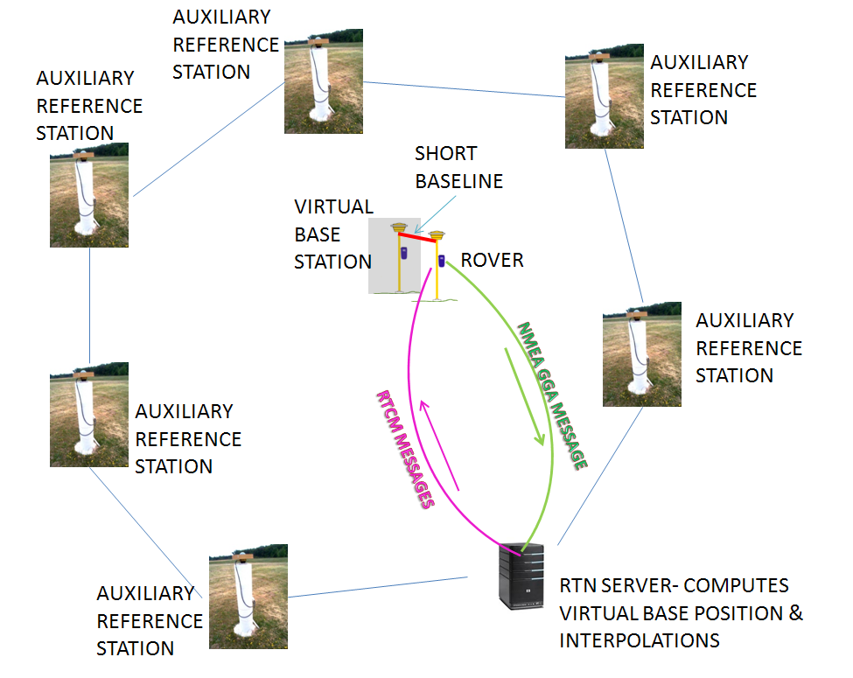
- Master-Auxiliary. Duplex or simplex (received by the rover only) communication can be used. The network server sends position and correction data for the closest active station in a cell of 5 or 6 stations surrounding the rover (duplex communication) or from a preselected master station (simplex communication). Additionally, the server sends position differences and correction differences for the other reference stations in the cell. The rover computes the interpolations for its position and then computes a baseline to the master reference station to obtain its position coordinates (See Figure 2).
.
Figure 2. A Master-Auxiliary base RTN (duplex communication)
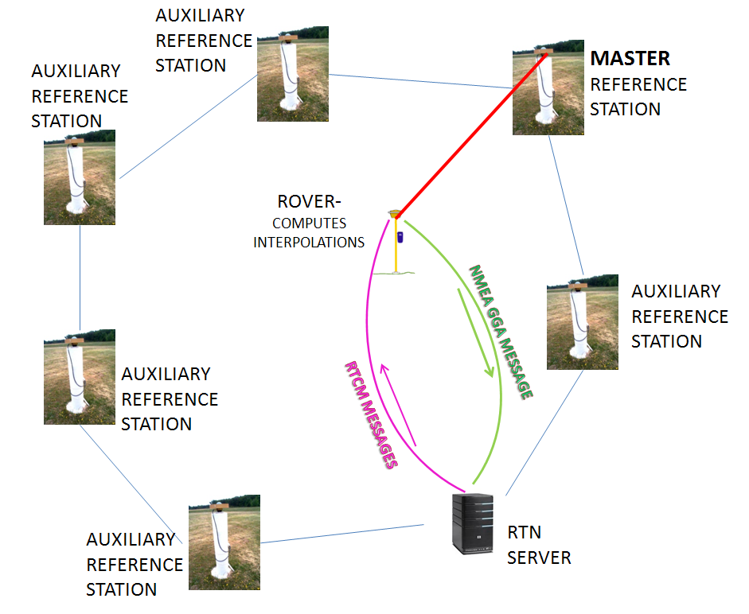
- Reverse processing. Duplex (two-way) communication is necessary. The rover sends its GNSS observables to the network server which computes the interpolations and position and sends the position to the rover (See Figure 3).
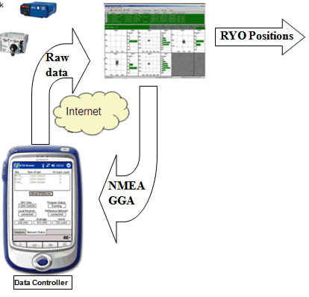
Figure 3. Server selected base(s) and processing (graphic courtesy of Geodetics, Inc.)
Regardless of the RTN interpolation methodology used, the rover position is always the result of a differential baseline from a physical or non-physical reference station whose coordinate is held fixed. It should be noted that many reference station networks start their operation as a closest base network. In this case, a network server manages a group of reference stations and the communication with registered users. The user would select a reference station for a baseline computation (usually the closest station) and corrections at the reference station are streamed to the user –similar to classical single base RT positioning operated by a user. This method allows precise survey grade RT positioning perhaps up to 25 km depending on field conditions, but adds the part per million (ppm) error factor because of the atmospheric correction decorrelation. Additionally, an all-in-rover solution is possible where the rover would receive all observables, position, antenna and atmospheric data from a cell of reference stations surrounding it and compute all the interpolated correction factors and the position.
For an extensive discussion of factors affecting RT positioning, general principles for rover processing of RT observables, proper field procedures, a glossary of real time positioning terms, and additional references, the user is referred to the NGS document (Henning, 2010) “National Geodetic Survey User Guidelines for Single Base Real Time GNSS Positioning” found on the NGS web site:
http://www.ngs.noaa.gov/PUBS_LIB/NGSRealTimeUserGuidelines.v3.0.0.pdf
That document is intended to be a companion document to these RTN user guidelines and the contents will not be reproduced herein. It is necessary, however, to augment them for the particular concerns of positioning within a RTN. Best methods that are currently employed by the majority of the RTN users in the U.S. geospatial community that are either unique to RTN positioning or of paramount importance to successful RTN positioning are briefly discussed in this chapter.

D. Metadata

Because coordinates and little else are the typical output of RT positioning, it is imperative that the user record in any manner the associated metadata of each session.
Certain metadata to keep on record might be:
- Datum, adjustment and epoch used by the RTN. (When were the reference station coordinates last changed?)
- If and how well, the RTN is in alignment with the National Spatial Reference System (NSRS)
- Was a project localization to passive marks performed? If so, what passive monuments were held? What are the quality, source, reliability and general usefulness of these coordinates as a constrained point? What were the best fit residuals on the monuments?
- What hardware (especially antenna model), firmware and software were used? What versions of the firmware were used in the data collector?
- Were any guidelines or standards adhered to for collection? How many data collection epochs were collected to produce the coordinates? What collection interval was used? Were important points observed redundantly at staggered times, etc?
- What were the field conditions during data collection? This would include PDOP (or GDOP, RDOP, etc.), number of satellites, satellite constellation(s) used, local weather, space weather, RMS of the solution(s), horizontal and vertical precisions (give at 95% confidence).
- What were the multipath conditions? (benign or list potential problem conditions)
- Note any communication issues and possible interference conditions (high tension wires nearby, intermittent or problem communication, vibration on bridge platform, battery failure, etc.).
E. Comments on the Accuracy and Precision of RTN Derived Positions
All RT positioning within a RTN is a differential 3-D vector or baseline expressed in Earth-centered, Earth- fixed, Cartesian coordinates (ECEF X,Y,Z) from a known point (base) to the rover position. For our GPS constellation, this Cartesian coordinate system is realized by the U.S. Department of Defense (DoD) NavStar GPS system in the WGS 84 datum. The DoD has migrated WGS 84 so that its current realization is essentially equivalent to a recent realization of the International Terrestrial Reference System (ITRS) for RT positioning. While baseline vectors are originally computed from the broadcast ephemerides in the WGS 84 datum, other datums (such as NAD 83) are usually used in the RTN reference station coordinates, and established transformations mathematically related to WGS 84 are performed . In the coming years when autonomous positioning will yield sub meter or even less than two decimeter accuracy, the difference between NAD 83 and WGS 84 (and hence the ITRS) will be very evident. Additional translations to common projection coordinates (such as the State Plane Coordinate system) are then accomplished. As mentioned above, the baseline can originate at a true physical point, such as the antenna reference point (ARP) of a fixed active reference station or from a virtual station close to the rover. Additionally, when working within the NAD 83 datum, a hybrid geoid model developed by NGS, and sometimes augmented locally, can be added into the data collector to convert NAD 83 ellipsoid heights into NAVD 88 orthometric heights. Alternatively, to use existing passive monuments’ orthometric heights as project “truth”, a localization to the passive bench marks or 3D monuments can be performed to lock the coordinates to the user’s datum of choice as realized by these monuments. Coordinates produced from transformations to a local datum from the baseline vector computed in the WGS 84 datum (and as transformed from the PZ 90.02 datum of the GLONASS system) are not adversely affected by axes rotations for a user project area when using these least squares localization algorithms, unless the area is more than around 200 km in extent.

Since RTN positioning is a differential solution from a base station to a point of interest, the results are displayed in the data collector as measures of the precision, or repeatability, of the solution. On the other hand, the alignment of the base station to the user-selected datum (as part of the NSRS or otherwise) can be considered the level of accuracy. Many data collectors will show a position precision from the base station (whether non-physical or master) at the 68% confidence level (or “1 sigma”), although some actually do show a 95% or even 99% confidence level. Typically this is shown as horizontal, vertical (orthometric), and root-mean-square (RMS) values resulting from the baseline solution . It would be wise for the user to ascertain which confidence level is indeed displayed to have a realistic sense of the precision. Current empirical results suggest:
Typical RTN precisions at the 95% confidence level are: horizontal 2-3 cm , vertical (ellipsoid) 3-5 cm, orthometric heights 5-7 cm (typical-using the NGS hybrid geoid model).
Exceptional RTN derived precisions are at the current limit of the RT technology: horizontal : ≤ 1 cm, vertical (ellipsoid) ≤ 1 cm, possible orthometric height ≤ 2 cm.
Accuracy is a measure of how the positions are aligned to “truth”. NGS wishes to encourage all RTN to provide users with alignment to the NSRS as the representation of truth. Therefore, accuracy would be relative to the alignment to our national datums of NAD 83 (horizontal and ellipsoid height) and NAVD 88 (orthometric height). Initial NGS guidelines espouse this alignment to the NSRS as : within 2 cm latitude and longitude, and within 4 cm ellipsoid height (95% confidence) using the CORS network as truth.
Note: It is interesting to see that RT precision/accuracy can be extremely good in a relative sense. In benign conditions with the proper equipment, in measurements taken with the same initialization, RTN surveys conducted in common sessions on passive monuments in a local area can yield sub centimeter relative vertical precisions when compared to published values produced from high order geodetic leveling (Lapine, et al., 2008).
Because of the extended distances a rover receiver can be separated from any particular reference station of the RTN, the angle and azimuth views of the same satellites can be different. It has been shown that additional improvement of rover positioning can be obtained in some RTN by the application of an Individualized Absolute Antenna Calibration and the proper north orientation of the antenna. This procedure has shown to improve RT positioning by over 5 mm horizontally and vertically (Schmitz, et al., 2008).

F. Best Methods for RTN Users – The “Seven C’s” of NOAA’s NGS
This section in conjunction with the information and recommendations contained in the existing NGS guidelines for RT single base positioning (Henning, 2008), is given as a means to produce accurate, repeatable, homogenous positions at the 95% confidence level. It is understood that other methodology may produce similar results; however, these guidelines are given as a confident path that will lead to the stated precision and accuracy.

- Check Equipment, Data Collector Parameters & Site information
a) Measure the actual height of the antenna reference point (ARP) on the rover pole at the start of a campaign.
b) Ensure that all necessary and correct projection parameters are in the data collector.
c) Ensure that all project data are in the data collector. It is critical that the correct project calibration (a.k.a.localization), if any, is being used. Project control coordinates must be current.
d) Adjust the rover pole bubble before every campaign.
(see http://www.surveying.com/tech_tips/details.asp?techTipNo=19 “Adjustment of the Circular Vial”) (SECO, 2009a)
(see http://www.surveying.com/tech_tips/details.asp?techTipNo=13
for pole bubble calibration). (SECO, 2009b)
e) Test wireless data communications (cell/CDMA/SIM card/etc.) for Internet connectivity at the project site.
f) Make sure the GNSS unit and the communication device batteries are fully charged and that there are backups.
g) For orthometric heights, be sure to preload the current geoid model supplied by the NGS. To obtain a reasonably sized file for upload, a regional section of the national model can be extracted in all major GNSS manufacturers’ software packages.

- Conditions
a) Use mission planning in the GNSS manufacturer’s software to assess approximate times of poor DOP and/or low number of satellites. The Russian GLONASS constellation is on track to have full operational capability by the end of 2010. While there is little improved accuracy at the present time using the GLONASS constellation, it does enable RT positioning where GPS alone would not permit because of an inadequate number of satellites. Allowing one GLONASS (shortened to GLN in the following) satellite for the GLN/GPS system time parameter resolution, a minimum combination of these two constellations for RT positioning is given as:
GPS ≥ 5, GLN = 0
GPS = 4, GLN = 2
GPS = 3, GLN = 3
GPS = 2, GLN = 4 (Can't initialize with only GLN sats.) (Gakstetter, 2009)
While RTK methods require a minimum of 5 GPS satellites (or 3 GPS plus 3 GLONASS), at this writing it is recommended for highest accuracy to perform RTN locations with at least 7 GPS satellites. This enables faster ambiguity resolution at longer distances and has shown better integrity than using 5 or 6 GPS satellites. This is an empirical recommendation and not the result of scientific research.
b) If at all possible, try to work in uniform weather conditions between the closest RTN reference stations and the rover. This can help minimize local tropospheric differences.
c) Perform a daily check on NOAA’s Space Weather Prediction Center (SWPC) Web Site (http://www.swpc.noaa.gov ) to note predicted or current atmospheric disturbances that could affect communications, data quality or even cause the inability to obtain a fixed solution. Subscribers to the SWPC can receive alerts and updates by e-mail.
d) Always be aware of multipath conditions. The reflected GNSS signal from objects near the rover antenna can dramatically lower data quality and can not be modeled as well (or at all) as in static GNSS sessions. In some cases the point of interest must be collected regardless of these conditions. In those instances, extra care should be taken by allowing more time on point and additional redundancy with different satellite geometry. Some multipath conditions result from reflected signals from : buildings, structures, vehicles, metal poles, signs, water surfaces, tree canopy, and even the ground ( See Figure 4 ).

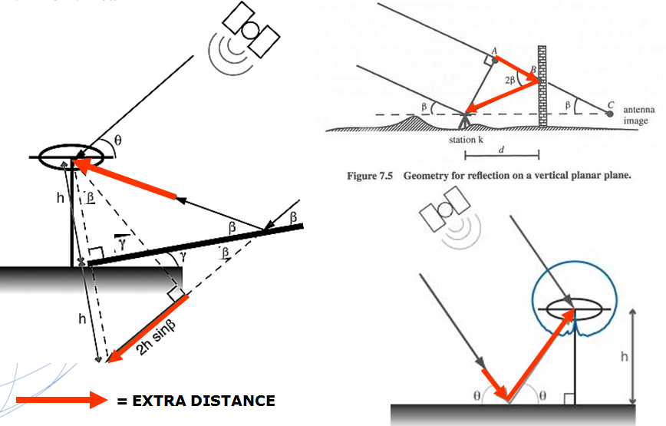

Figure 4. Some multipath reflected signal conditions showing the error in time/distance travel.
e) Be aware of possible electrical interference from sources such as high tension transmission lines or broadcast antennas. These can affect both communication and data quality. This interference may be present with high wattage transmission lines but absent in lower wattage ones.
- Coordinates
a) Know what datum, adjustment and epoch is needed for the coordinate data produced.
b) Know what datum, adjustment and epoch coordinates are supplied by the RTN. Be aware that if the RTN administrator is maintaining reference station coordinates in 4-D, that is, the reference station coordinates are also tagged with velocities, then the reference coordinates might at some point change. Conversely, be aware that the RTN coordinates may be maintained at a certain snapshot in time or “epoch”, which may not be the position epoch needed for the project. These coordinates may be updated periodically by the administrator, albeit given at the same epoch. Adding new stations to the network could change the network adjusted coordinates. Maintain good communication with the RTN administrator to be sure it is known when or if the RTN reference station coordinates change.
c) NGS guidelines encourage RTN operators to align their RTN to the NSRS at accuracies of 2 cm horizontally and 4 cm ellipsoid height or better ( see Chapter 4). It should be emphasized that passive monumentation values are a snapshot in time. Because everything is moving (albeit slowly in the NAD 83 datum for most of the U.S.), and susceptible to disturbance, subsidence, tectonic movement, uplift and seasonal variations, RTN that may be adjusted across several states and regions may not give consistent results with monumentation from GPS campaigns done in different years and in various areas. Even within local areas conditions such as subsidence may adversely impact the accuracy of the passive monuments. With the readjustment of NAD 83 in 2007, the HARN and all passive monumentation values derived from GNSS positioning adjustments should show better alignment with the CORS network, but this readjustment was done utilizing the original campaign data rather than reobservations, and the published coordinates alone may not account for any disturbance or movement of the geodetic monuments. Most RTN in the U.S. maintain their reference station ARP coordinates in the NAD 83 datum, albeit with varying adjustments and epochs. Recall that our national “horizontal” datum of NAD 83 has had several adjustments:
- NAD 83 (1986) – the original adjustment that included mostly triangulation and trilateration data. This was essentially a horizontal only datum.
- NAD 83 (HARN) – several state-by-state readjustments including GPS satellite derived data. Mostly pre-CORS. Added ellipsoid heights to now become a three dimensional datum.
- NAD 83 (FBN-CBN) – several state-by-state readjustments to remove ellipsoid height distortions and to align to the CORS system.
- NAD 83 (CORS 96)\ epoch 2002.0– a nationwide readjustment of the CORS data as truth. Did not include passive marks. “2002.0” epoch reflects active monumentation velocities rather than a snapshot in time as in the past.
- NAD 83 (NSRS 2007)\ epoch 2007.0 – a nationwide readjustment constraining of GPS campaign data on 70,000 passive reference stations in the NGSIDB. No classically derived data included. CORS coordinates were constrained to their estimated values for January 1, 2007 (i.e., 2007.0), and therefore the vertical motions of CORS through time were accounted for to get their 2007.0 coordinates. No vertical motion model for the observational data on passive marks was included, however.

In addition to selecting which of these datum adjustments and epochs the RTN will use, the RTN may also perform its own local adjustment which may change from time to time and hence may vary from the national datum to a small degree.
d) Remember that the data is being collected on the ground not on the datum surface nor on a projection grid such as the State Plane. Scale and height factors must be applied to go between these surfaces, either post campaign or as parameters in the data collector.
- Communication

a) Robust communication is the key to an effective RTN. Information technology (IT) resources must be properly allocated to ensure that the RTN infrastructure can maintain the integrity of the data streams to the end user with no more than one or two seconds total latency.

The benefits of a RTN over classical single base RTK include being able to roam for many tens of kilometers within the umbrella of the network and still obtain high precision positioning. This is most easily accomplished using cellular data modems transporting data packets via wireless IP (Internet protocol) from cellular communication providers across distances greater than possible using UHF or VHF radios. A plethora of options, and configurations of the communication hardware and firmware exist for this technology. For the most part, cellular data modems, SIM (Subscriber Identity Module) cards inserted into Internet capable data collectors, or cell phones with digital data service linked with blue tooth or a tether, are the hardware used in the field.
b) The user must research the available wireless service providers and select the one that meets his or her coverage needs and service costs for the project area. There are many areas of the USA with limited , sporadic or unavailable cellular communcationcoverage. This is the reason that UHF, VHF or spread spectrum radios are still an important tool to have available while in the field. Work can proceed from a local user base station using radio communication and traditional single base techniques rather than being completely halted because of the lack or poor quality of cell coverage which precludes RTN work. This emphasizes the need to have a RTN aligned with the NSRS. Using the NGS utility OPUS (Online Positioning User Service), the user can establish a working point compatible with the NSRS (and the compliant RTN) anywhere within the conterminous USA, possibly with as little as two 15 minute (OPUS-RS) static set ups or one 2 hour (OPUS-S) static set up over a point to be used as the local base station with unknown coordinates. See the links to OPUS from the NGS home page for additional information. It should be reiterated that single base RT work can be performed over a project area from a base station with autonomous coordinates. Once the base position is derived either through OPUS, differential GNSS post processing by the user, or from conventional optical means, the relative 3-D vectors from base to rover can simply be translated to the correct coordinates in the manufacturer’s software – either in the field or in the office.
c) Using one of the data service options of hardware and firmware, the user will typically connect to the RTN using an IP address, select a “mount point” (data stream corrector format- such as RTCM 3.1 or CMR+) from a source table, and enter a log in ID and password. Each rover will typically have a unique ID and password.
d) NGS endorses the use of the RTCM 3.x data format through the use of NTRIP server, caster and client software. RTCM is an open source, generic, world-wide standard for GNSS data dissemination and, starting with version 3.1, is built specifically for RTN use. NTRIP is designed as a variety of hyper text transfer protocol (http) application overlaying TCP/IP data transmission protocol and used to send GNSS RTCM format data in real time over the Internet. NTRIP is freely available for server, broadcaster and client applications.
For a good summary on the use of the NTRIP client in the field, see:
http://www.amerisurv.com/content/view/4466/153/ (Schrock, 2007).
The RTN user is referred to the following web site for specific NTRIP information and to download the NTRIP client software:
http://igs.bkg.bund.de/index_ntrip_down.htm (BKG, 2009).
e) To collect important positional data, the GNSS solution should become fixed in a “normal” amount of time and should remain fixed for the duration of the actual data collection at a point of interest. The “fixed” solution symbol or word will appear on the data collector screen when the carrier phase integer ambiguities have been solved. A “normal” time period is one which has been seen by the user to produce a reliable ambiguity resolution from the RTN in past data collection campaigns using proper conditions and procedures.
f) Save all communication configuration information for hardware, firmware, user names, passwords, serial numbers, and Bluetooth connections.

- Constraining to passive monuments (a.k.a. Calibrations or Localizations)
a) Currently, for the best orthometric height precision results using a RTN, a localization to at least four trusted benchmark monuments should be performed in addition to configuring the rovers to use the current NGS hybrid geoid model (GEOID09 at this writing). Current RTN technology utilizing the existing satellite constellations and signals has shown that while RTN derived horizontal precisions are usually of survey grade caliber, it benefits the user to perform a calibration to existing trusted passive bench marks surrounding and within a project area for optimal orthometric heights. For constraining horizontal values, please see the NGS User Guidelines for Single Base Real Time GNSS Positioning for a discussion of applying a 3D geodetic-based transformation to a projection surface for project work. (Henning, 2008)
b) These benchmarks should form a rectangle on the outside of the project area to the best extent possible. Additional monuments with trusted orthometric heights are beneficial- especially if these can be distributed throughout the project area (See Figure 5).
c) Calibrations have the additional benefit of giving the user a picture of how the existing vertical control monuments fit together and which monuments may be outliers. Care should be exercised when constraining certain monuments or removing them from the localization. Remember that an apparent outlier can in actuality be the monument closer to the project “truth” than the other ones that are homogenous. Ideally, the benchmark monuments can be combined with trusted horizontal values on the same or supplemental monuments as a check on the 2D values used as well.
d) Remember: Positioning within the umbrella of the RTN, but outside of a calibration envelope removes the precision of the calibration. Positioning outside the envelope of the RTN removes the interpolation correction accuracy and turns it into an extrapolation correction. Just as going beyond the limits of a state plane coordinate projection rapidly reduces position accuracy, going outside of a calibration envelope will likewise rapidly deteriorate the positional accuracy in reference to the control used.
e) If this recommended method is not possible, a sub-optimal approach can be taken for heights if there are only two trusted bench marks at the project site. Users report success with a two point vertical calibration, with one point used to move the hybrid geoid model up or down to align to a local vertical datum and the second point used as a check. This then reduces the orthometric “truth” to one monument, so it must be a trusted, verified mark of high integrity to have reasonable confidence in the results.

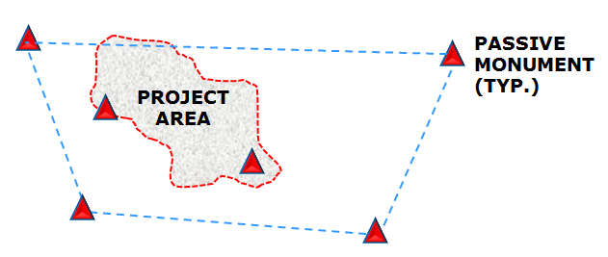

Figure 5. Working within a orthometric height constraint rectangle (quadrilateral, in this case)
- Collection

a) Check a known coordinate point before, during and at the end of data collection. This should provide a method of detecting rover configuration blunders, such as incorrect antenna heights, incorrect projection parameters or faulty calibrations. It also provides a check on the initialization or ambiguity resolution. Periodic checks on known points should also be done as work progresses- perhaps every 3 hours to utilize different satellite geometry and certainly if communication to the RTN or initialization is lost and reacquired. The user should decide what points in their project area are suitable for checks. For work in the higher accuracy classes (see Henning 2010) it is recommended to check known and trusted high stability monuments such as those of high integrity and accuracy found in the NGS data base. If none are available near a particular project, perhaps a check could be done from a semi-permanent point previously located from such a monument could be used as verification that the RT set up is of the desired accuracy. If it is impractical to visit a high accuracy control point after reinitializing, a check should at least be done to a previously located point. These ongoing checks give a sense of confidence in the positions obtained while in the field and prevent many inaccurate data being collected from a faulty session.
b) Set an elevation cut-off or mask of between 10° and 15°. This allows adequate satellite data through while blocking noisy low altitude data from the rising and setting satellites. Noisy or unhealthy satellites can also be turned off in the data collector. With sufficiently many GPS satellites overhead (see no. 2. Conditions above) but partial obstruction at the rover, the elevation cut off can be raised to 20° or so and still be able to use a statistically sound amount of observables to produce a solution.
c) Current recommendations for RTN data collection correspond to the single base guideline summary table for accuracy class RT2 (0.025 m horizontal and 0.045 m vertical) as shown in the existing RT single base guideline document (Henning, 2008). For important points, the NGS RTN guidelines currently recommend:
GDOP ≤ 3 (or PDOP ≤ 2.5)
Number of GPS satellites ≥7
Time on point = 5 second record intervals for 1 minute
Position RMS ≤ 0.02 m horizontal, 0.04 vertical (ellipsoidal).
Redundancy ≥ 2 locations staggered by 4 hours. Redundant locations must differ no more than the desired point accuracy from the average of the coordinates as located.
Note: The NGS utility OPUS can provide a good check of accuracy to the NSRS for important project control points. As little as two 15 minute static GPS sessions can provide redundant solutions and thus a measure of confidence against possible blunders in the RT produced data if those solutions have shown good statistics in the OPUS output report. Therefore, if a RTN is aligned to the NSRS at high accuracy, as NGS is promoting, the RTN derived coordinates can be verified by OPUS. See http://www.ngs.noaa.gov/OPUS/What_is_OPUS-RS.html for further information
EXAMPLE: Desired accuracy = 0.025 m horizontal, 0.045 m vertical (95% confidence)
location #1= 1000.025 m northing, 2000.111 m easting, 50.567 m vertical
location #2 = 1000.045 m northing, 2000.144 m easting, 50.678 m vertical
Avg. = 1000.035 m northing, 2000.128 m easting, 50.623 m vertical
difference location #1 & location #2 to Avg. = √0.010² + 0.017² = 0.020 horizontal,
0.056 vertical
Results show the horizontal position within the accuracy requirements, but the vertical outside of the requirements. The position should be reobserved. All positions may be averaged or two of the three locations may be selected to produce the required accuracy, discarding the outlier (all other conditions being good).

- Confidence
With the plethora of variables associated with RT positioning, collecting accurate, repeatable data depends on four main things: redundancy, good wireless communication links, checking known points, and an awareness of multipath conditions.
a) Redundancy is the king of RT GNSS positioning. Two or more locations on important points give validity, show repeatability with different satellite configurations and field conditions, and enable position refinement within the software. While coordinates computed on the same point, but whose observations are separated by as little as 20 minutes have been shown to give adequate redundancy to produce accurate data using RTN solutions (Edwards, et al., 2008), it is still recommended that differing conditions be used to produce the most compatible results over time for the highest level of data accuracy. Different satellite geometry (typically 4 hours separation), different tropospheric conditions (e.g. wet/dry, cold/hot, high pressure/low pressure, etc.), different ionospheric conditions (e.g. mid afternoon versus early morning) witnessed in TEC quantities (total electron content – usually measured in free electrons per square meter along a line between satellite and receiver) and different GNSS firmware and equipment would cover most of the foreseeable users’ collection parameters. Simply put, the more observations the better. Redundancy gives confidence and refines the precision of the data.
b) Robust wireless Internet connectivity ensures low latency data are transmitted to the rover. Coordinate accuracy will suffer if latencies rise above 2 seconds or if communication is intermittent during data capture. Obviously, wide cellular coverage areas provide the best use of RTN infrastructure – both to the user from the central server as well as interstation data transmittal. In addition to cell technology, satellite communication links from remote active stations to the server or even to the rover are now on the cusp of good usability and seem to be on the way to reducing their latencies.
c) Checks on known points before, during and at the end of the data collection session show the precisions with which the whole system is still working and that no blunders such as an incorrect antenna height or incorrect ambiguity resolutions have occurred. Additionally, if communication to the RTN or initialization is lost and reacquired, a check should be performed, even if just to a recently located point. These checks prevent incorrect data from being propagated into new positions’ errors.
      - Obvious Multipath conditions should be avoided for data collection on important points. Any point that will be used to generate other data collection (as a site control point or base station for example) must be established with the most confidence possible. While redundancy with different satellite geometry will help to mitigate some of the multipath error, the user should always avoid data collection on such new points under or very near tree canopy, metal structures, water surfaces, signs, vehicles above antenna height or other objects very close to the collection point.
Employing these four criteria will give the most confidence possible in RT positioning with the minimum of necessary work.

- Summary
As stated, the RTN user should always remember four basic elements to achieve reliability with their GNSS positions: Communication, Checks on known points, Redundancy, and Multipath. If the data are produced by following the coordinate and collection recommendations in this document, a high degree of confidence in the accuracy and repeatability of the measurements may be thus obtained.
Due to the dynamic nature of this rapidly growing technology, these user guidelines are expected to be updated regularly as new GNSS constellations and additional code and carrier phase signals come on line. Additionally, the GNSS manufacturers’ hardware and software continue to improve repeatability over longer distances and with higher integrity, and wireless communication capabilities continue to become wider and more robust.

Good GNSS gear, good field conditions and good field procedures will yield good RT positions. NGS hopes to encourage the latter with these guidelines.

References

Edwards S., Clarke P., Goebell S., Penna N., 2008, “An Examination of Commercial Network RTK GPS Services in Great Britain”, Report from Newcastle University to The Survey Association of the United Kingdom, web page: http://www.tsa-uk.org.uk/guidance.php

Lapine L., Wellslager M., 2007, A GPS + GLONASS for Precision, South Carolina’s GNSS Virtual Reference Station Network, Inside GNSS Magazine, July/August 2007, volume 2, number 5.

National Geodetic Survey, 2008, “The National Geodetic Survey 10 year plan, Mission, Vision and Strategy 2008-2018”, http://www.ngs.noaa.gov/INFO/NGS10yearplan.pdf

Schmitz M., G. Wübbena, M. Propp, 2008, “Absolute Robot-Based GNSS Antenna Calibration– Features and Findings”, PowerPoint presentation International Symposium on GNSS, Space-based and Ground-based Augmentation Systems and Applications, November 11-14, 2008, Berlin, Germany, web link: http://www.geopp.de/media/docs/pdf/gpp_gnss08_antenna_f.pdf

SECOa, SECO Mfg. Co., Redding CA., 2009, web page:
http://www.surveying.com/tech_tips/details.asp?techTipNo=19

SECOb, SECO Mfg. Co., Redding CA., 2009, web page:
http://www.surveying.com/tech_tips/details.asp?techTipNo=13

Schrock, G., 2007, “RTN101: NTRIP - The Essential RTN Interface (Part 10)”, American Surveyor magazine, volume 4, number 8, October 2007, web link:
http://www.amerisurv.com/content/view/4466/153/
Gakstetter, Eric, 2009, e-mail exchange on GNSS satellite requirements.

BKG, Bundesamt für Kartographie und Geodäsie (Federal Agency for Cartography and Geodesy) GNSS Data Center, web page accessed July, 2009:
http://igs.bkg.bund.de/index_ntrip_down.htm

Henning, W., NGS, 2008, NGS User Guidelines for Single Base Real Time GNSS Positioning, National Geodetic Survey. Web page: http://www.ngs.noaa.gov/PUBS_LIB/NGSRealTimeUserGuidelines.v3.1.1.pdf

Zilkoski, D.B., Carlson, E.E., & Smith, C., March 26, 2008, Guidelines for Establishing GPS-derived Orthometric Heights (Standards: 2 cm and 5 cm) NOAA TM NOS NGS-59. Web page:
http://www.ngs.noaa.gov/PUBS_LIB/NGS592008069FINAL2.pdf

Note that ITRF2008 will likely be available (and endorsed by NGS) before this document is finalized
Note that NAD 83(CORS96A) will likely be available before this document is finalized
See footnote 2
See footnote 2

