Advancing Statewide Spatial Data Infrastructures in Support of the National Spatial Data Infrastructure (NSDI)

Strategic Planning Process Map

For use by all Stakeholders in the Geospatial Community



Produced for the Federal Geographic Data Committee (FGDC) to Support the Cooperative Agreements Program (CAP), Category 3: Fifty States Initiative

Revised: May 2009


This page intentionally left blank.

Advancing Statewide Spatial Data Infrastructures in Support of the National Spatial Data Infrastructure (NSDI)

Strategic Planning Process Map

For use by all Stakeholders in the Geospatial Community

This document replaces the “Strategic Plan Process Map” (March 2006) that was produced by the National States Geographic Information Council (NSGIC) under contract (05HQCN0034) to the Federal Geographic Data Committee (FGDC). This replacement version was produced under a contract: issued by the U.S. Geological Survey (USGS), FGDC Secretariat

Contract Number: 08HQCN0024

Prime Contractor:

Subcontractors:







This page intentionally left blank.
Foreword
Strategic planning is a critical process for articulating a shared vision, and for building the partnerships that are necessary for disparate organizations to work together on common goals. The key is to identify the business needs for geospatial data and services that are shared by many stakeholder groups. For instance, it is easy to envision that statewide orthoimagery acquired on a routine basis would be useful to almost all stakeholders in the geospatial community, as might be a widely accessible geocoding service. Effective planning is essential for moving collaborative programs forward and for gaining the required support for investments in your statewide spatial data infrastructure (SSDI).
This project is part of the Fifty States initiative from the Federal Geographic Data Committee (FGDC), in close cooperation with the National States Geographic Information Council (NSGIC) and other stakeholders in the geospatial community. A core component of this Initiative is establishing more formal statewide geospatial coordination councils that will help to govern and complete the National Spatial Data Infrastructure (NSDI) by enabling all stakeholders. The principal goals of this project are to:

- Encourage implementation of statewide spatial data infrastructures through effective strategic and business planning efforts
- Provide guidance on planning activities
- Encourage the formation of partnerships and alliances that will improve planning process
- Provide a uniform national framework for strategic and business plans, for comparative analysis to reveal national trends

Several documents have been created to support the geospatial community in these planning efforts, and can be found on both the NSGIC and FGDC websites, including:

- Strategic Plan Guidelines that provides a structure for “mapping” a clear path from present conditions to a vision for the future into a plan document.
- Strategic Planning Process Map that divides the process of creating the strategic plan into five simple steps or phases that are each characterized by certain activities, tasks, and accomplishments.
- Business Plan Guidelines that provides a detailed description of how goals and objectives will be achieved, along with the necessary justification for action.

The Strategic and Business Plan Guidelines each include major section headings with key information and a series of questions that should be considered. Your planning team will determine which questions are applicable for their activities and use the answers to these questions to help draft an effective plan. This approach was developed, because “one size does not fit all” for these plans. However, the organizational structure of the main sections can and should be consistent with the Guidelines, even though the specific content of each section will vary for a variety of reasons, reflecting the differences in the organizations undertaking the plans.

For Fifty States Agreements, the main section topics of the Strategic Plan Guidelines are considered “mandatory.” This does not make everything within each section mandatory, but rather, requires that each of the main sections be addressed in an appropriate manner. These “mandatory” sections should be planned for in the early stages of the strategic planning process.

Using these Guidelines will help you navigate through the entire process of preparing high quality and effective strategic and business plans. By simply substituting terms such as “countywide” and “citywide” for “statewide,” the Guidelines should work well for most stakeholder groups.

Over the past three years, the states using these Guidelines have discovered that the “process” of working with people to create these plans, including the partnerships that are formed, may be more valuable than the actual plans. Please make the process a valuable learning experience that leads to trust and new partnership opportunities.

Table of Contents

Introduction 9
Phase 1 - Getting Started 11
Phase 2 - Preliminary Planning 12
Logistics 12
Resource Planning 12
Approach 12
Schedule 12
Organization 12
Phase 3 - Strategizing 13
Scoping 13
Goal Assessment 13
Generating Support 13
Phase 4 - Authoring 14
Phase 5 – Monitoring and Marketing 15

This page intentionally left blank.

Introduction

By using the Fifty States Strategic Plan Guidelines any group of stakeholders in the geospatial community can develop a comprehensive Strategic Plan that will help them to implement their vision of a shared statewide spatial data infrastructure (SSDI). The Guidelines provide an organized approach and process for creating a Strategic Plan. The guidelines have a comprehensive list of subjects to be discussed, debated, and decided on by the group of stakeholders that is tasked with developing a Strategic Plan (i.e. your Planning Committee). During the strategic planning process, this Committee will meet and work together to plan your approach, strategize, and author the plan. Once a plan has been formally adopted by the Committee, its members will need to market the plan’s adoption and monitor progress on its implementation.

For Fifty States Agreements, the “Strategic Plan Guidelines” include main section topics that are mandatory. This does not make everything within each section mandatory, but rather, requires that each of the main sections be addressed. Plan for the mandatory sections in the early stages of the strategic planning process, to make sure they are adequately covered. Refer to the “Strategic Plan Guidelines” for details on mandatory elements.

This Strategic Planning Process Map (SPP Map) has been developed to help the Committee author a Strategic Plan. The SPP Map divides up the process of creating a strategic plan into five simple steps or phases. Each phase is characterized by certain activities, tasks, and accomplishments. Your Committee is encouraged to use the SPP Map to help get organized, focused, and productive. Its simple format will help you get the job done quickly and efficiently.

As with the Strategic Plan Guidelines, the SPP Map offers a structure and approach that should be appropriately modified to suit the needs of your situation as you undertake the strategic planning task.

Good Luck!
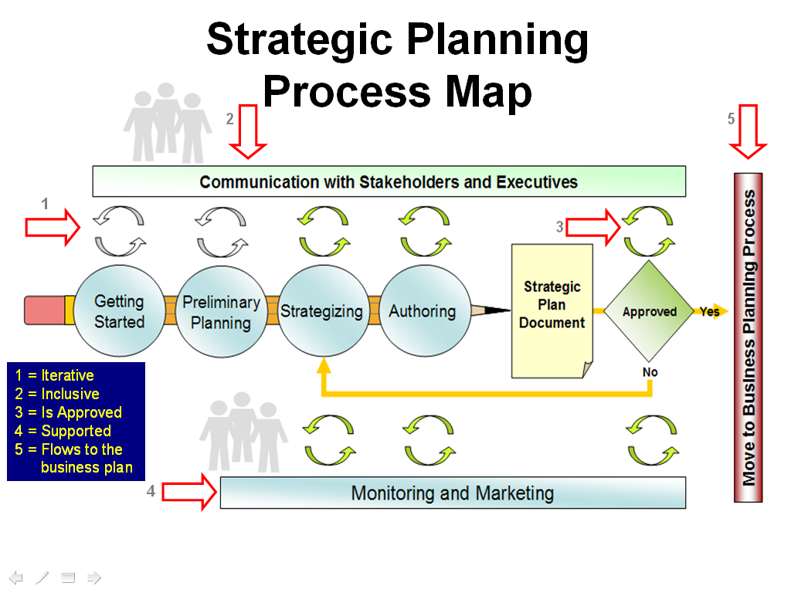

The Figure above shows the five phases of creating a strategic plan and managing the process. A feedback loop ensures that progress towards achieving plan goals is being monitored and that appropriate strategy adjustments are made to account for changing conditions. This diagram is intentionally meant to be a simplified view of the process. It is essential that you seek and incorporate management and stakeholder feedback during every phase of the planning process. Working through the planning process with all of the stakeholders can be a valuable bonding experience that leads to trust and improved cooperation. Try to create an environment that encourages mutual trust between the stakeholders.

Phase 1 - Getting Started
- Identify likely Planning Committee participants and determine their willingness to participate
- Establish a Strategic Planning Committee that is able to effectively identify the issues, develop practical solutions, and create clear objectives
- Define roles and responsibilities for completing the strategic planning process
- Assign roles and responsibilities
- Assign the role of Facilitator for the planning process
- Nominate a Committee Chair
- Specify the target audience for the Strategic Plan
- Determine the plan approval process
- Identify and engage the appropriate people who need to participate in the Strategic Plan development effort (e.g., Federal, state, tribal, regional and local government agencies, regional utility companies, private sector, academia, etc)

Phase 2 - Preliminary Planning

Logistics
- Schedule a kick-off meeting
- Determine future meeting frequency and dates of planning committee
- Determine the venue(s) for meetings and if there is an appropriate budget for amenities such as food service
- Establish Strategic Planning Committee tools for communication exchange
- Define locations and dates for stakeholder informational gathering sessions

Resource Planning
- Determine what resources are needed to complete the effort
- Assess what resources are available and how any existing gaps can be bridged
- Document and understand the impact of any relevant constraints to the planning process itself (time, money, people availability)

Approach
- Define the overall planning approach (e.g., are we going to complete the exercise internally, or use consultants?)
- Define brainstorming approaches that will be used
- Determine whether a survey mechanism will be used to gather input from stakeholders
- Identify exemplary strategic plans completed by other organizations that can be used as reference material
- For Fifty States Agreements, review “mandatory” sections of the Strategic Plan Guidelines

Schedule
- Identify any timing considerations, such as grant application deadlines, or other planning efforts (such as statewide IT plans)
- Develop a schedule and establish milestone dates for completing the plan

Organization
- Establish a Strategic Planning Committee Charter
- Establish sub-committees as necessary and ensure that subcommittee chairs understand what is expected of them
- Identify factors that will ensure a successful planning process

Phase 3 - Strategizing

Scoping
- Review any existing Strategic Plan(s)
- Review Primary Strategic Goals
- Review other intra-organizational mandates and mission statements that impact the current activity
- Identify political initiatives that the Strategic Goals can support
- Indentify roadblocks or political barriers that may inhibit the Strategic Goals
- Review other documents and materials that are relevant to this effort
- Understand the breadth and scope of the Strategic Plan
- Determine period covered by the new Strategic Plan
- Review Strategic Plan Guidelines Questions and tailor as appropriate (Facilitator)

Goal Assessment
- Develop templates for capturing information in a structured manner, for example, develop a form for the Planning Committee to list strengths and weaknesses
- Identify preliminary programmatic sub-goals
- Itemize, prioritize, refine, and validate programmatic sub-goals
- Validate objectives with stakeholders, management, and executives
- Identify programmatic goals with a ‘quick win’ potential and use them to show early progress
- Develop strategies for realizing each programmatic sub-goal
- Identify any roadblocks or barriers and tactics for overcoming them
- Analyze Strengths, Weaknesses, Opportunities, and Threats (SWOT)
- Iterate with stakeholders to establish consensus view

Generating Support
- Enlist political champion(s)
- Identify and generate consensus among involved stakeholders and executives to become advocates for the plan objectives
- Develop a marketing strategy to promote the plan’s objectives

Phase 4 - Authoring
- Develop content aimed at the target readership in terms of style and presentation
- Draft a preliminary plan
- Identify external reviewers
- Solicit feedback from external reviewers
- Parse and incorporate feedback as appropriate
- As necessary, complete further review iterations
- Publish the Strategic Plan

Phase 5 – Monitoring and Marketing
- Determine the level of progress monitoring required for this planning activity and how feedback will be incorporated into the process
- Develop metrics to assess progress over time
- Identify those responsible for overseeing the status review process
- Determine the frequency of status review meetings
- Review emerging Opportunities and Threats and apply course corrections as necessary
- Identify and market to specific individuals whose support can further guarantee a successful planning outcome
- Identify appropriate forums for the active and broad marketing of the strategic plan goals and objectives, (these could be conferences, user group meetings or other similar gatherings)
- Determine how feedback from marketing efforts will be incorporated into the process

