Information Technology Solutions
Iowa Geospatial Infrastructure
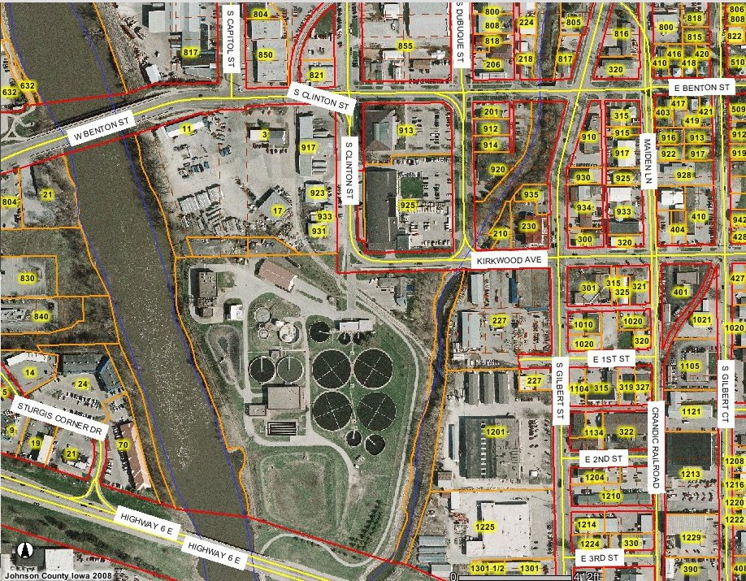

Framework GIS Data Layers

- Benchmarks

- Aerial Ortho-photography

- City and County Boundaries

- Parcels

- Transportation

- Elevation

- Water Features

- Address points

- Structures

During the historic flooding of 2008, geographic information systems (GIS) technology and data were used as an effective tool to predict and track the areas of flooding, allocate resources for rescue and sandbagging, assess the damage and plan for the future. GIS was and is essential for many government agencies to efficiently carry out these public service duties.

However there remains much work to be done in Iowa for all its citizens to enjoy all the benefits of GIS. While GIS is used by many local, state, federal and private entities, in some areas data is missing or not readily available, resources are lacking, or users need training to use GIS effectively. Sometimes there are institutional barriers that limit the use of GIS data when and where it’s needed. During the floods, some local agencies worked quite closely with state and federal disaster agencies to quickly share data to fight the flood, while other local agencies required payment of usage fees before accessing data needed during the emergency. The floods of 2008 had both good and bad examples of inter-agency cooperation.
In 2007-2008, the Iowa Geographic Information Council (IGIC) received a grant from the Federal Geographic Data Committee (FGDC) to create a business plan for a statewide spatial data infrastructure. IGIC developed a plan for the Iowa Geospatial Infrastructure (IGI), which included ideas on how to address missing basic data coverage for the state, the lack of resources to build and maintain those layers, and removing institutional impediments to sharing and integrating GIS data from various jurisdictions. Using the FGDC grant, IGIC contracted with the Geographic Information Technology Association (GITA) to study the return on investment for the IGI, including the costs to build it, and the benefits of using it. GITA's ROI study clearly shows that the IGI is a good investment and will return good value to the citizens of Iowa.
BENEFITS OF IGI
Counties without a GIS
IGI will help coordinate regional GIS projects that leverage joint acquisitions, shared resources, training and access to framework data layers to get counties without GIS into the action.

Counties with GIS
IGI will provide access to and training for lidar-derived elevation needed for infrastructure projects. IGI will help coordinate and acquire new data, manage contracts and disseminate data from large regional or statewide ortho-imagery projects. IGI will develop web applications and training for county staff to realize more benefits in economic development, emergency management and other areas.

State Agencies
IGI will help assist state agencies to use GIS in daily efforts, to share data and distribute public information on the Internet. IGI will develop a geocoding service to help all state organizations to accurately locate and map their program databases.
A Spatial Data Infrastructure for Iowa – Why It’s Needed
Fact sheet No. 1
July 23, 2008
During the course of the ROI study a new way of thinking about GIS cooperation emerged: data producers (county and state agencies) will voluntarily give their basic framework GIS layers to two central GIS service bureaus (one for counties, one for state agencies), which transform, merge and load the data into statewide GIS data layers, which in turn are made available in various Internet accessible forms to be used by anyone for any purpose. In return the data producers receive benefits in the form of coordination, data acquisition/creation, data storage and training services also provided by the service bureaus. The ROI study readily shows that the benefits far exceed the cost of providing the data - in fact the more the data gets used by others, the greater the overall benefits to citizens, government, businesses. In this community of cooperation, GIS has greater potential for expanded economic development, better emergency preparedness, protection of the environment and delivery of safety, human, health and educational services.
STRATEGIC BENEFITS OF IGI TO
ECONOMIC DEVELOPMENT

Story County
Benefits from a statewide GIS: “useful when negotiating to buy land. Often there are absentee owners who don’t want to sell outright because that would create a tax occurrence, so they are looking for an exchange. Often there is nothing available in the county that meets their specifications. There’s a need to search the state for properties, equate by CSRs, etc. to make comparisons. The county could bring in a multi-million dollar project where only one property will suit.”
Marshall County
“…. without GIS we would not be getting shots at projects. Without this capability, counties don’t even know what they are missing out on. GIS is turning into a must have rather than a nice to have. Maps get the clients to come to town and then the economic development staff must make the sale. We always start with a picture. If you can get them to visit your town and the property, you are already on the short list.”

On-going Costs Paid by the State
- State GIS Service Bureau – 4 persons, travel and equipment - $385,000/yr.
- State contribution to ortho and lidar programs - $600,000/yr.
- County GIS Service Bureau – 4 persons, travel, and equipment - $385,000/yr.
- County GIS framework data modernization and maintenance program $300,000/yr.
One-time Costs Paid by the State
- Create hydrography, address and structures GIS layers - $400,000/yr. for 5 years
Costs for Counties to Participate
- About $5000/yr. per county for coordinated statewide 1’ ortho-imagery
- For a county without a GIS, average yearly cost about $50,000 to create and maintain a GIS system (about 20 counties in the state)

Total Average Costs/Year ~$3 million

IGI – How It Works
IGI – Costs and Benefits

Benefits to Counties and State
- Counties without GIS participating in IGI can break even in 10 years instead of not at all, through regional coordination, data hosting and technical assistance
- Counties with GIS have benefits up to $165,000 through access to lidar, data acquisition assistance and training
- State agencies benefit through better coordination, access to county GIS data, technical assistance and training, web applications and geocoding services
- 20 year ROI analysis for IGI shows a Net Present Value of $271 million, a Present Value of Costs at $56 million and an annualized Return on Investment of 24%. For every dollar spent on IGI, $5 are generated in benefits.

Total Average Benefits/Year ~$16 million
Contact Person:
Jim Giglierano
Iowa DNR/Geological Survey
109 Trowbridge Hall
Iowa City, IA 52242-1319
Tel: 319-335-1594
james.giglierano@dnr.iowa.gov
The full IGI report can be downloaded from http://www.iowagic.org/

