FGDC Document Number XX


Federal Trail Data Standards (Draft)

Standards Development Group
Federal Geographic Data Committee

November 29, 2007

Federal Geographic Data Committee

Established by Office of Management and Budget Circular A-16, the Federal Geographic Data Committee (FGDC) promotes the coordinated development, use, sharing, and dissemination of geographic data.

The FGDC is composed of representatives from the Departments of Agriculture, Commerce, Defense, Energy, Housing and Urban Development, the Interior, State, and Transportation; the Environmental Protection Agency; the Federal Emergency Management Agency; the Library of Congress; the National Aeronautics and Space Administration; the National Archives and Records Administration; and the Tennessee Valley Authority. Additional Federal agencies participate on FGDC subcommittees and working groups. The Department of the Interior chairs the committee.

FGDC subcommittees work on issues related to data categories coordinated under the circular. Subcommittees establish and implement standards for data content, quality, and transfer; encourage the exchange of information and the transfer of data; and organize the collection of geographic data to reduce duplication of effort. Working groups are established for issues that transcend data categories.

For more information about the Committee, or to be added to the Committee's newsletter mailing list, please contact:

Federal Geographic Data Committee Secretariat
c/o U.S. Geological Survey
590 National Center
Reston, Virginia 22092

Telephone: (703) 648-5514
Facsimile: (703) 648-5755
Internet (electronic mail): gdc@usgs.gov
Anonymous FTP: ftp://fgdc.er.usgs.gov/pub/gdc/
World Wide Web: http://fgdc.er.usgs.gov/fgdc.html

CONTENTS
Page
1 Introduction 1
1.1 Objective of Standard 1
1.2 Scope of Standard 3
1.3 Applicability 3
1.4 Related Standards 3
1.5 Standard Development Procedures 4
1.6 Maintenance Authority 5
2 Rationale for the Design 5
2.1 Key Points 5
2.2 Legal Underpinnings of the Interagency Trail Data Standards Project 6
2.3 Underlying Premises for Development of Trail Data Standards 6
2.3.1 Interagency Definition of a Trail 6
2.3.2 Which Trails? 7
2.3.3 Factors Considered 8
2.3.4 ITDS Selection Criteria 9
2.3.5 ITDS Core Questions 10
3 Data Standard 12
3.1 ITDS Attribute Overview 13
3.2 ITDS Data Requirements and Data Parameters 20
3.2.1 ITDS Requirements and Quality Components 20
3.2.2 ITDS Data Parameters 23
3.3 ITDS Attributes 29
APPENDICES 61
Appendix A 62
Interagency Trail Data Standards (ITDS) Version 2, Trail Planning and Management Fundamentals 62
Interagency Trail Data Standards (ITDS) Version 2, National Trail Management Classes 66
Appendix B 73
National Historic Trail (NHT) Corridor Concept 73
NHT Condition Categories 75
Appendix C 94
Frequently Asked ITDS Questions 94
Appendix D 102
Core Questions and Attributes Considered, but Dropped or Deferred for Further Consideration 102
Appendix E 113
Chronology of the Project 113
Appendix F 117
Acronyms and Abbreviations 117

Introduction

Objective of Standard

Trails of all kinds, including Congressionally and secretarially-designated trails, are strongly recognized by the public and governmental agencies as important recreational and cultural resource corridors. The National Park Service (NPS), the Bureau of Land Management (BLM), the United States Fish and Wildlife Service (FWS), and the United States Forest Service (USFS) have worked for many years with each other and with States, local governments and trail organizations to promote and develop trails for the benefit of the public.

Universal trail data standards will enable national, regional, state, and trail-level managers and the public to use mutually understood terminology for recording, retrieving and applying spatial and tabular information. Data standards will make it easier for trail information to be accessed, exchanged and used by more than one individual, agency or group. Ease in sharing data increases the capability for enhanced and consistent mapping, inventory, monitoring, condition assessment, maintenance, costing, budgeting, information retrieval, and summary reporting for most internal and external needs.

The collection, storage, and management of trail-related data are important components of everyday business activities in many Federal and State land-managing agencies, trail organizations, and businesses. From a management perspective, trails data must often mesh closely with other types of infrastructure, resource, and facility enterprise data. For the public using paper maps, the internet, GPS or other instrumentation, standard data formats enable users to consistently and predictably identify specific trails and a core set of corresponding information. Today, digital trail data are a necessity throughout a trail data management life-cycle, from trail planning through design, construction, operation, and maintenance. Automating, sharing, and leveraging trail data through a widely-accepted standard can provide a variety of important benefits:
- Efficiency – creating and gathering trail data that are standardized and readily usable.
- Compatibility – compiling data from one project or discipline that can be compatible with other applications;
- Consistency – using the same standards, meshing data produced by one organization with that developed by another;
- Speed – hastening the availability of data through a reduction in duplicative efforts and lowered production costs (Applications can be developed more quickly and with more interoperability by using existing standards-compliant data);
- Conflict resolution – resolving conflicting trail data more easily if compliant to the same standards;
- Reliability – improving the quality of shared trail data by increasing the number of individuals who find and correct errors; and
- Reuseability – allow maximum reuse across agencies and support objectives of the Presidential E-Government Initiatives (E-Gov) and enterprise architecture.

Scope of Standard
The functional scope of the standard includes the definition of a core set of trail data attributes, corresponding values, and definitions. These standards reflect tabular and spatial trail data applicable only to trails within the United States, including all U.S. territories and outlying possessions.

Applicability
Trail data are used for many purposes including planning and management, mapping and condition assessment, routing and navigation, public information, emergency response, and research. These standards cover the core set of questions and data attributes identified in the Interagency Trail Data Standards (ITDS) Version 2 and are applicable to trails of all kinds, including National Historic Trails and National Scenic Trails. They do not cover all possible trail data or agency-specific data needs, but concentrate on a core set of inter-jurisdictional management and administrative trail data needs.

Related Standards
Basic Federal trail authorities are found in the National Trails System Act of 1968, as amended (16 USC 1241-1251). Heretofore, there have been no universal standards within the United States for trail terminology and data attributes. However, inter-jurisdictional trails, management and corresponding public information all suggest the need for universal data standards.

Standard Development Procedures
In 2001, the Federal Interagency Council on Trails, based on a provision in the January, 2001, Memorandum of Understanding for the Administration and Management of National Historic and National Scenic Trails, set in motion the development of national-level interagency trail data standards. This action stemmed from a collective need to inventory, assess and map trail locations and trail resources across multiple jurisdictions throughout the United States. An interagency team of trail, data, and subject-matter specialists was assembled. Over the following six years, the team developed the Interagency Trail Data Standards (ITDS) for trails of all kinds. The ITDS Version 1 underwent internal and external review in 2003 and 2004, followed by refinement and development of ITDS Version 2 which comprises the current set of proposed FGDC trail standards. The following steps are still to be completed:
- Standards Working Group (SWG) review and evaluation of the draft (1 month)
- FGDC Coordination Group reviews SWG recommendation; announcement for public comment in Federal Register (about 2 months)
- Public review (about 1 month)
- Standards Development Group (SDG) reviews public comments, prepares revisions to the draft standard, and produces the Public Response Document (6 months)
- SWG reviews revisions to draft and public response document (about 1 month)
- FGDC Coordination Group reviews SWG recommendation (about 1 month)
- FGDC Steering Committee reviews Coordination Group recommendation; standard approved and submitted for final publication and public release (about 3 months).

The ITDS Team is responsible for the subsequent validation, revision and refinement of the ITDS to reflect current and potentially expanded interagency data needs (e.g. additional National Scenic Trail-specific data, visitor information, etc.). Any revisions proposed by the ITDS Team will be subject to review, comment and publication through the FGDC data standard publication process.

Maintenance Authority
The maintenance authority for this standard remains to be determined.

Rationale for the Design

Key Points
- The Interagency Trail Data Standards (ITDS) identify a common set of standardized terminology that can be consistently applied to a core set of trails information.
- The ITDS are not a database.
- The ITDS can be incorporated into existing databases and/or used to crosswalk existing agency data to provide combined or shared information at an interagency/multi-jurisdictional level.
- The ITDS are the foundation for these FGDC-published Trail Data Standards.
- This is one step in the Federal Government's ongoing process of data standards definition and adoption.

Legal Underpinnings of the Interagency Trail Data Standards Project
The following mandates and directives recognize the need for the development of data standards. These are relevant for the FGDC standards as well.
- The Paperwork Reduction Act of 1995 (P. L. 104-13)
- The Government Performance and Results Act of 1993 (GPRA) (P. L. 103-62)
- The Presidential E-Government Initiatives (including Recreation One-Stop)
- The National Trails System Memorandum of Understanding (for 2006-2016)
- Executive Order 13195, Trails for America in the 21st Century
- "GIS for the National Trails System - An Action Plan", NPS, 2001, as requested by Congress

Underlying Premises for Development of Trail Data Standards

Interagency Definition of a Trail
Before attempting to identify and apply Interagency Trail Data Standards, it is essential to have a clear definition of the term “trail” as used in this interagency context.

Trail: A linear route managed for human-powered, stock, or off-highway vehicle (OHV) forms of transportation or for historic or heritage values.

Trails provide public access for opportunities of outdoor recreation as well as access to many significant prehistoric and historic sites.

Some portions of historic trails are accessible today, and provide recreational and other benefits, while others, more “virtual” in nature, provide a cultural and/or historic experience, but are not physically capable of being traversed or accessed. Historic trails can consist of a path, a route, a corridor, a road, a river/stream, etc.
See Appendix B for more details.
(Refer to individual agency trail definitions for further agency-specific guidance or direction on defining a trail.)

The interagency definition is based on and encompasses individual agency definitions of a trail. This includes “standard” trails, National Scenic Trails (NSTs) and National Historic Trails (NHTs). The definition was adopted by the interagency trail data standards team in July 2002.

Which Trails?
The ITDS core questions (Section 3 below) and ITDS data attributes (Section 2.3.5 below) can be applied to trails of all kinds, including National Scenic Trails and National Historic Trails. However, not every core question and attribute is applicable in every situation. The following trail categories have been incorporated in ITDS documentation to help clarify which core questions and data attributes are potentially applicable in various situations:
Trail Code Trail Category
Reg. Trail Regular Trail: any agency-managed trail not designated NST or NHT
NST National Scenic Trail (Congressionally Designated)
NHT¹(Desig) Route(s) congressionally designated as the National Historic Trail
NHT² (HR) NHT associated heritage resources (routes and/or sites)
NHT³ (Rec) NHT associated recreation or interpretive route and/or site

Factors Considered
Listed below are a few of the basic premises that were incorporated into development of the ITDS. They are also relevant for review of the ITDS as FGDC standards.
- Interagency Core Data Set: Represents the minimum set of data that the agencies agree to provide for all agency-managed or administered trails (i.e. System Trails and/or Designated Trails).
- Data Collection and Management: Data are not cheap! Each piece of data that is collected and recorded represents a cost in terms of time, database capability and available space. The subsequent and ongoing need to update certain data attributes represents an additional expense. The decision to collect, record and manage specific data should always be done considering the benefits and value of the data versus the initial and future cost.
- Standardized Terminology: Strive to establish and/or use the same terminology among agencies for interagency trail data standards. When this is not possible, provide crosswalk translation between the ITDS attribute terminology and definitions and those of the individual agency.
- Existing Data Attributes: If an identified ITDS attribute already exists as a standard attribute within one agency, but is not yet standardized and/or used by other agencies, consider adopting the attribute terminology and/or definition that is already in use to maximize efficiencies and minimize confusion or data re-work.
- Field Verification: To the extent possible, and when applicable, trail data should be based on field verification/inventory. Formal trail inventory and condition assessments should be performed, if they do not already exist.
- Implementation: The core standards will be implemented and data provided based on current agency priorities and budgets.

ITDS Selection Criteria
To focus on the most common trail data needs, eight criteria were used to choose the core set of questions and data attributes that are in the Interagency Trail Data Standards.
Does the Question or Data Attribute…
- Apply to all affected agencies?
- Directly relate to a Core Interagency Question (data output)?
- Have national, regional or state-wide significance?
- Contribute to the minimum data needed to provide a programmatic (heritage, maintenance, natural resources) snapshot of the trail (i.e. inventory, public information)?
- Include the minimum data needed to comply with and reflect applicable laws, regulations, and/or policies?
- Addresses key congressional, Office of Management and Budget (OMB), and department-wide reporting requirements?
- (Is the Data Attribute…) Currently available or obtainable?
- Include those attributes that would set national precedence or affect nation-wide trail management?

ITDS Core Questions
The following set of core questions, common to all participating agencies and reflecting the ITDS Selection Criteria, were identified to help narrow the scope and identify the core set of Interagency Trail Data Standards.
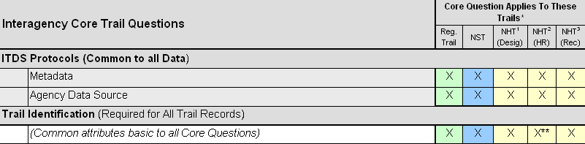
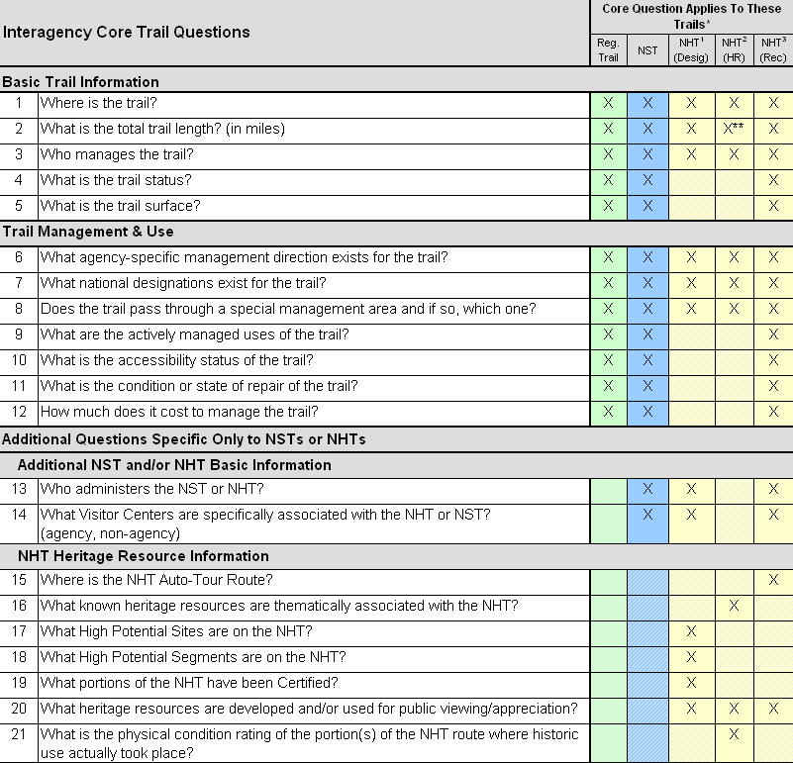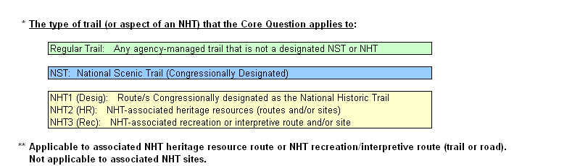

Data Standard
The metadata must be in a FGDC-compliant format (for both spatial and non-spatial data) as documented at http://www.fgdc.gov/metadata/geospatial-metadata-standards.

ITDS Attribute Overview
The table below provides a summarized overview of the ITDS attributes, grouped by functional category.

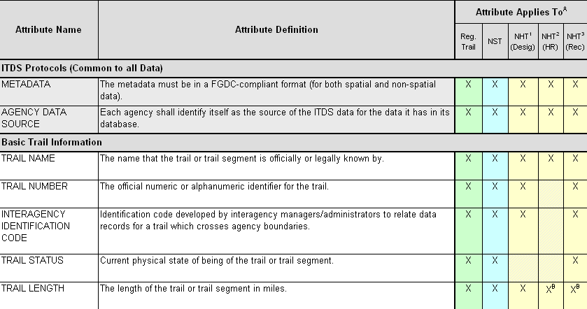
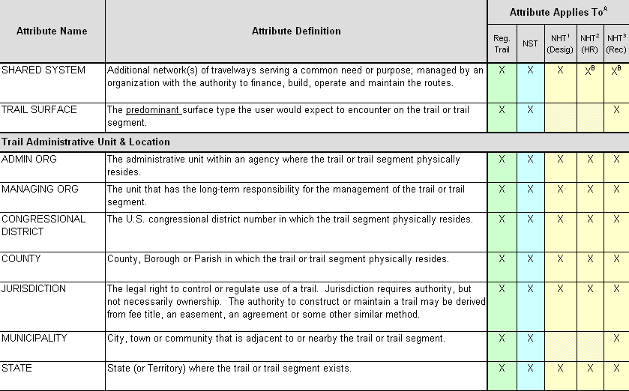
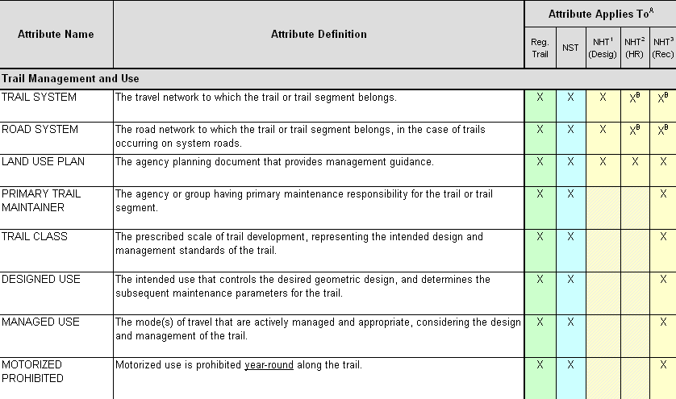
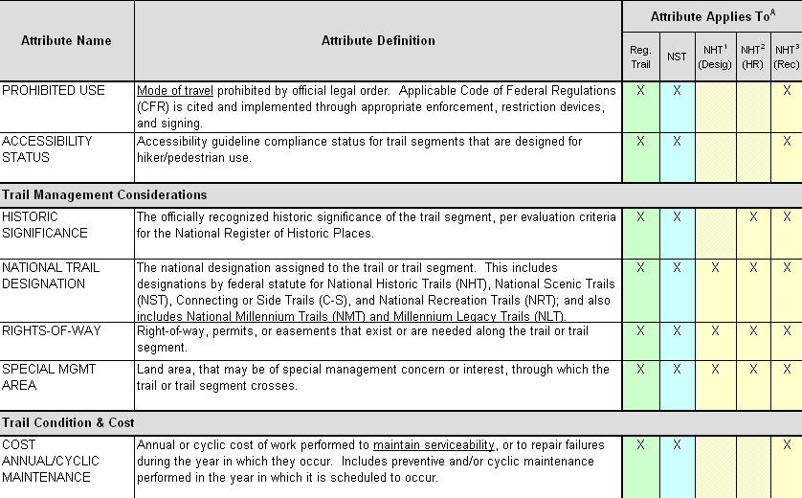
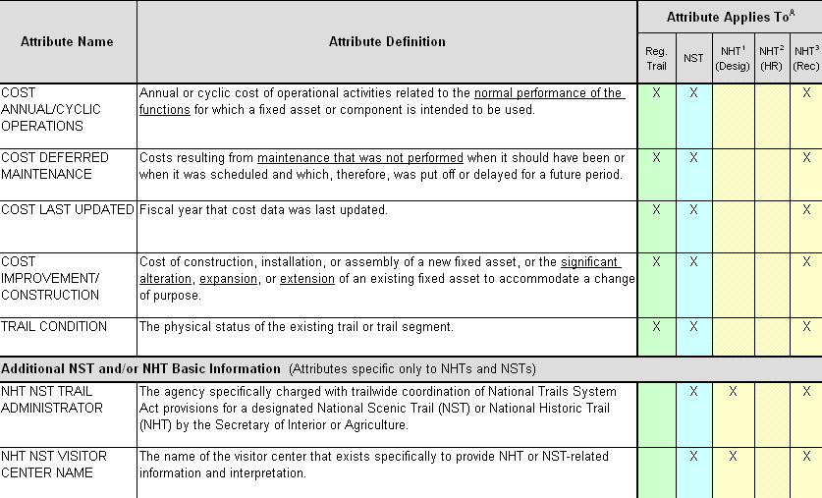
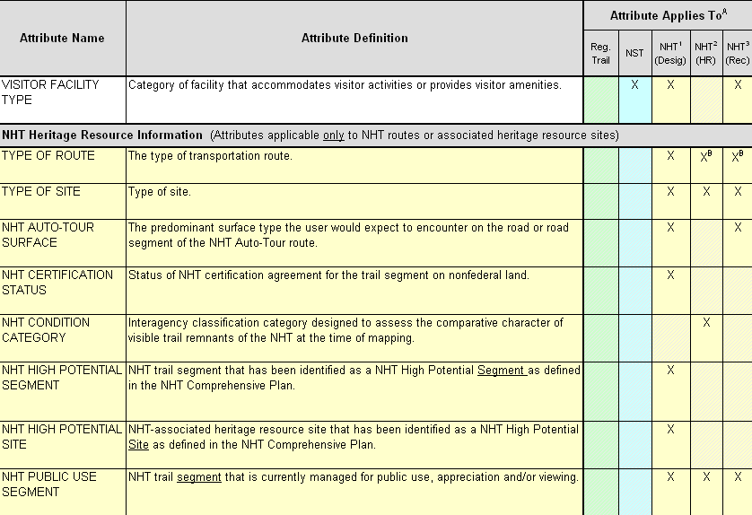
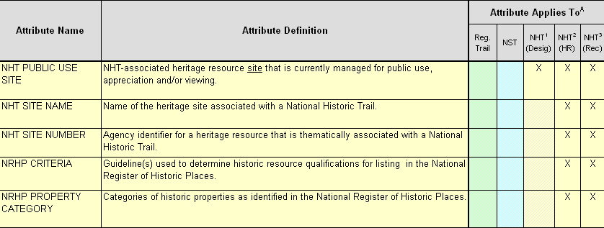

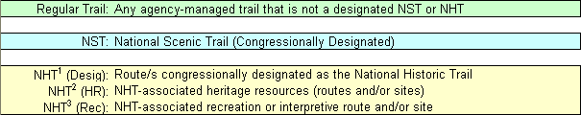

ITDS Data Requirements and Data Parameters

ITDS Requirements and Quality Components

Generally Applicable Data Parameters
The following data parameters are generally applicable to all Interagency Trail Data Standards.
Spatial Data Source: | Best available source with a target source scale of at least 1:24,000 for continental U.S., Puerto Rico, and Hawaii and 1:63,360 for Alaska.
Horizontal Accuracy: | Accuracy testing must use National Standards for Spatial Data Accuracy (NSSDA) testing guidelines or be reported based on compiled, published test reports appropriate for the data collection method and equipment.  The method of determining accuracy should be documented in the process step of the dataset metadata record. If published accuracy results are used, use the statement ‘Compiled to meet ___ (meters, feet) horizontal accuracy at 95% confidence interval’ in the metadata record, and identify the testing source used. If accuracy is locally tested to NSSDA standards, the statement ‘Tested to meet ___ (meters, feet) horizontal accuracy at 95% confidence interval’ should be added to the metadata record.  Accuracy for legacy data may be reported according to the accuracy standard in place at the time of data collection (typically National Map Accuracy Standards). Document the standard used in the metadata record.  (For more information, see: http://www.fgdc.gov/standards/projects/FGDC-standards-projects/accuracy/part3/chapter3)
Spatial Reference Information: | Agency appropriate. A complete projection description in FGDC format is required including horizontal coordinate system, datum, and units of measure. Include vertical coordinate system information where necessary.
Feature Type: | Line (route and arc topology)
Precision: | Double precision

Attribute-Specific Data Parameters
The data variables, defined below by the ITDS Team, are subsequently specified as applicable for each ITDS attribute.
Data Parameter | Data Parameter Definition / Criteria
GIS Item Name | The name the attribute is called in the GIS layer (10 characters or less).
GIS Alternate Name  (If Applicable) | If applicable, the GIS alias or crosswalk name for the ITDS attribute (not limited to 10 characters).
Width | Field width (excluding decimal point, as would be defined in Oracle database.)
Type | Text, Integer, Numeric (decimal), Date
Number of Decimals | Number of decimal places displayed when Type = Numeric.
Null / Not Null | Identification of whether a Null value or Not Null value is allowed:  Null: The data field may have a null value (be left blank with no data recorded).  Not Null: The data field must have a value entered for this attribute.
Unique / Not Unique | Identification of whether a data value is Unique or Not Unique:  Unique: The values recorded for this attribute would be unique for every entry (row) in the database. This includes all participating agencies or entities that collect trails data.  Not Unique: The values recorded for this attribute would not be unique for every entry (row) in the database.

Additional Attributes Considered
Below is a listing of the FGDC Attributes considered, and the corresponding ITDS disposition as identified by the ITDS Team.
FGDC Attribute | Related ITDS Data Parameter or Disposition
Attribute Label | ITDS Data Parameter: GIS Item Name
Attribute Definition | ITDS: Attribution Definition
Attribute Definition Source | ITDS Attributes Definitions were developed by ITDS Team (2003-2004)
Code List | ITDS: List of Values (LOV)
Vertical Accuracy | Not included in ITDS Data Parameters at this time because line features are not currently being modeled as 3D features. May be revisited if needed in the future.

Below is a listing of additional ESRI Profile Attributes considered, and the corresponding disposition as identified by the ITDS Team.
ESRI Profile Attribute | Related ITDS Data Parameter or Disposition
Attribute Alias | ITDS Data Parameter: GIS Alternate Name
Attribute Type | ITDS Data Parameter: Type
Attribute Width | ITDS Data Parameter: Width
Attribute Precision | Double Precision (as identified under ITDS Generally Applicable Data Parameters)
Attribute Scale | Pre-defined under ITDS Spatial Data Source
Attribute Output Width | Not included in ITDS since this attribute is software specific and/or reflects outdated technology
Attribute Number of Decimals | ITDS Data Parameter: Number of Decimals
Attribute Indexed | Not included in ITDS since this attribute is software-specific
Sub-Type Information | Not included in ITDS since this attribute is software-specific
Relationship Class | Not included in ITDS since this is software-specific and does not apply to basic GIS layers

ITDS Data Parameters
The table below provides a summarized listing of each ITDS attribute, with corresponding data parameters.

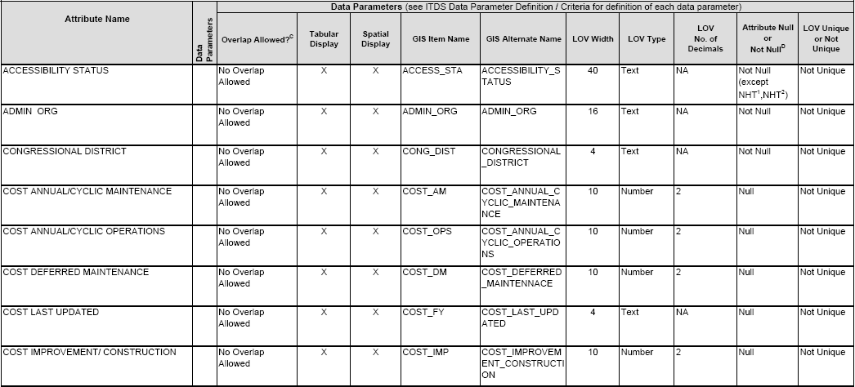
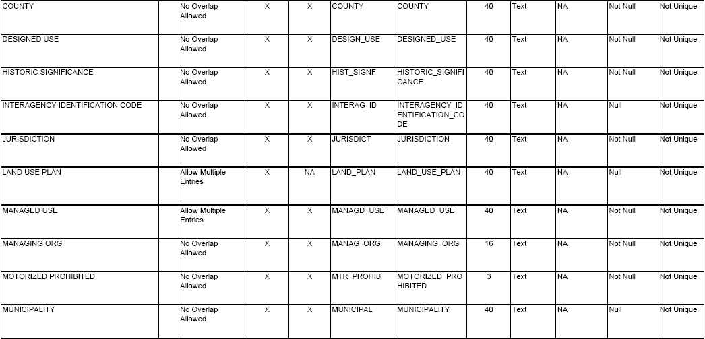

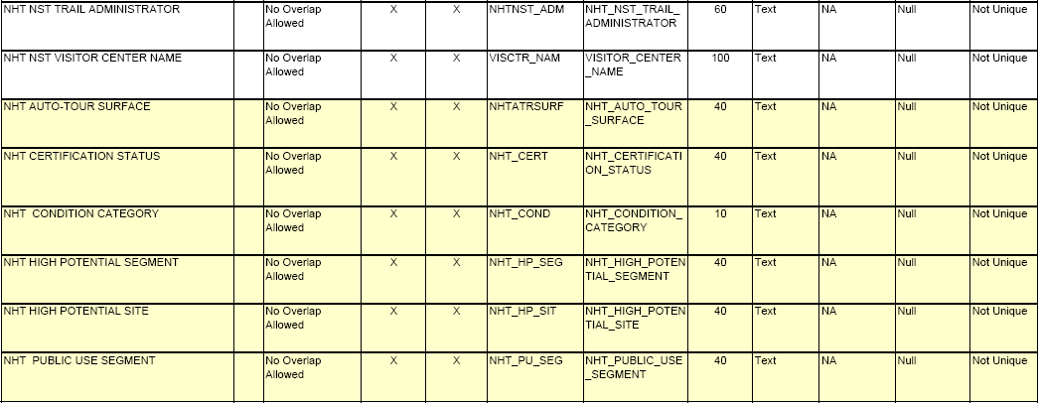

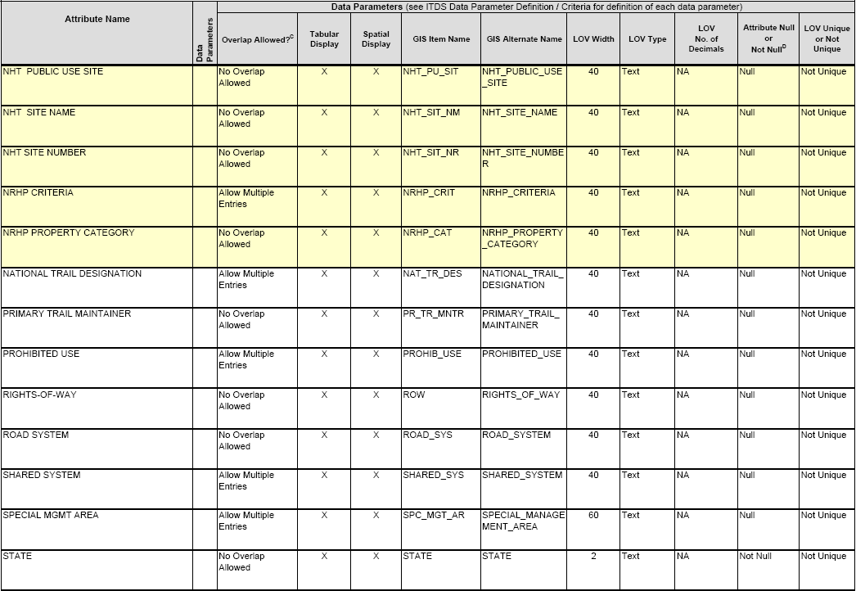
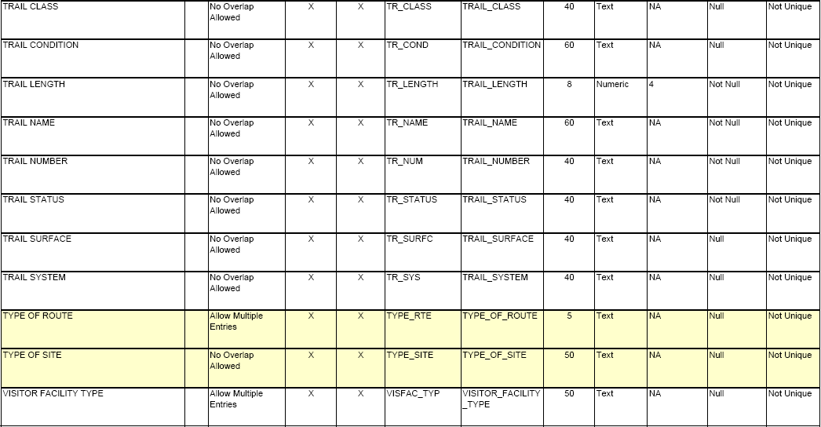

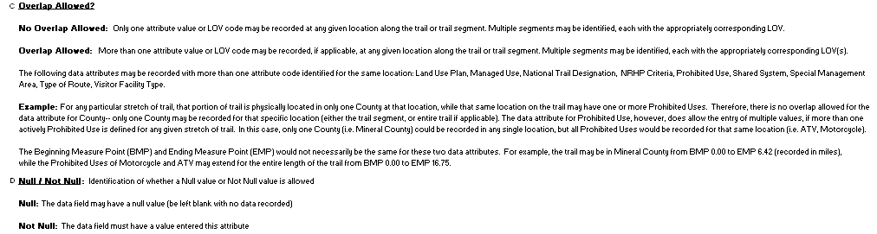
Attribute Color Coding:
Attribute applicable only to National Historic Trails (NHT)

ITDS Attributes
The section below lists each ITDS attribute alphabetically, with the corresponding attribute definition, list of values, value definitions, and corresponding business rules/clarifiers.


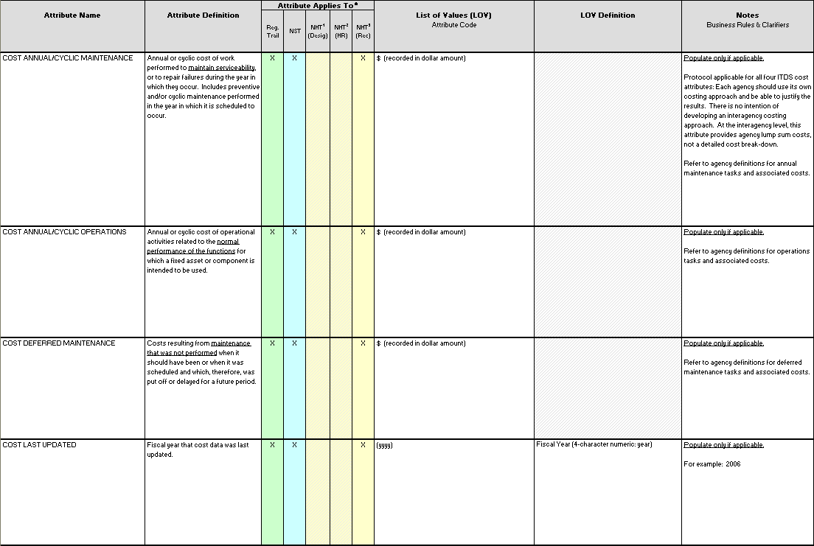

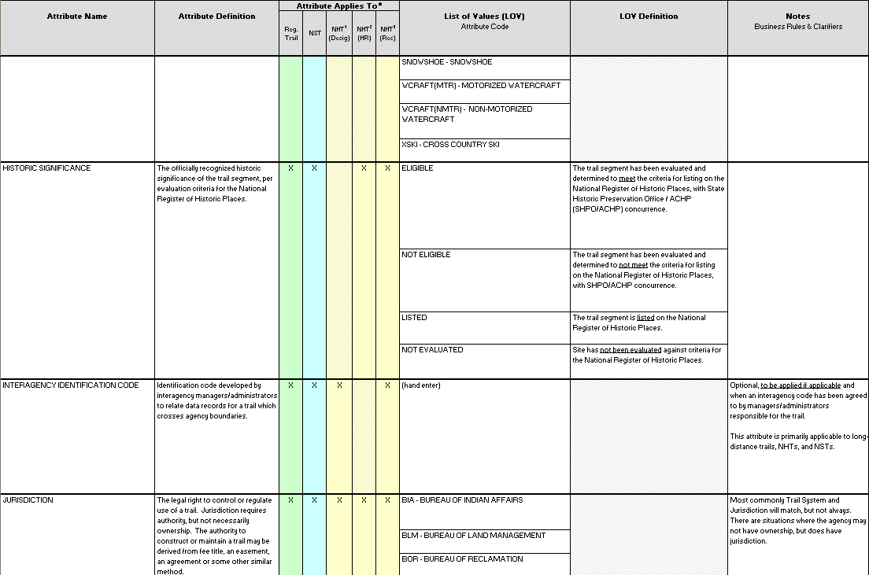
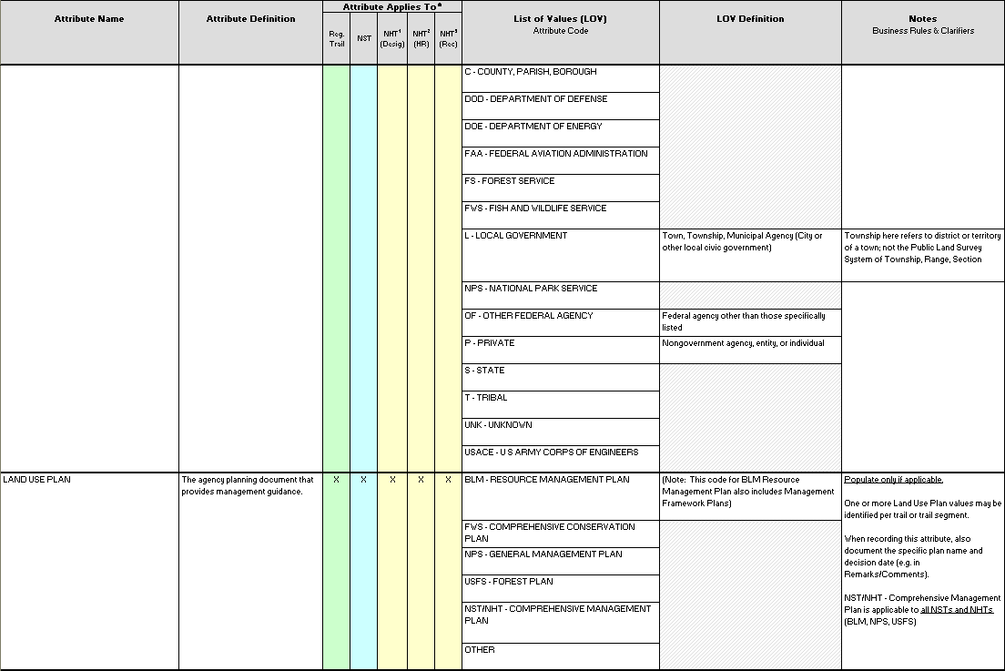
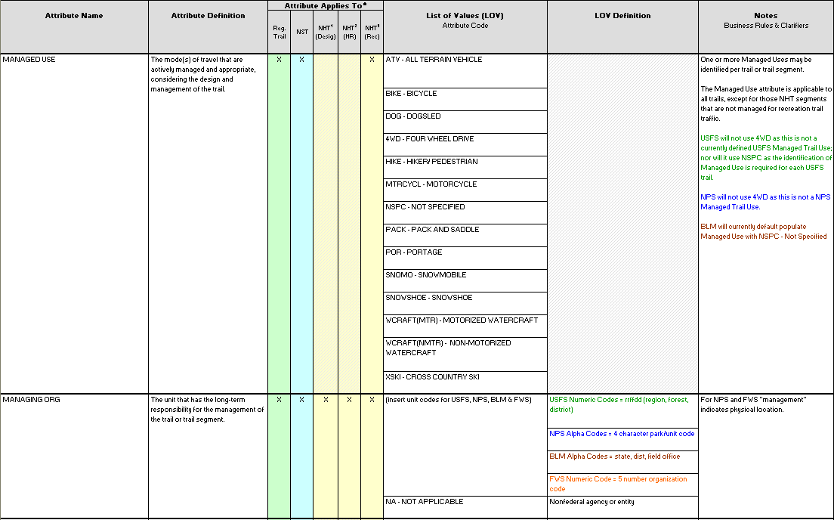
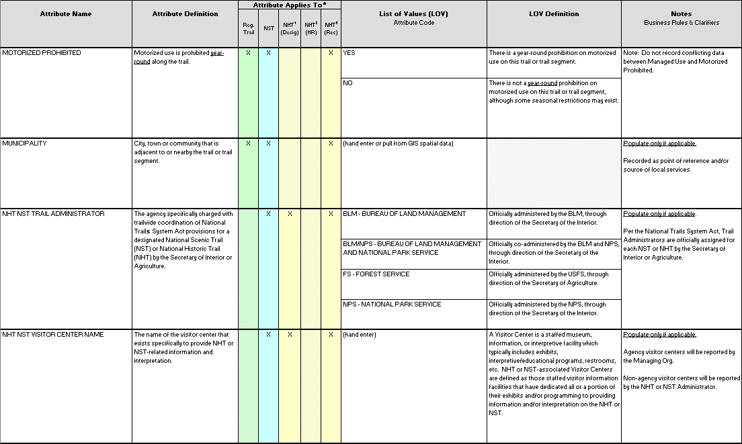
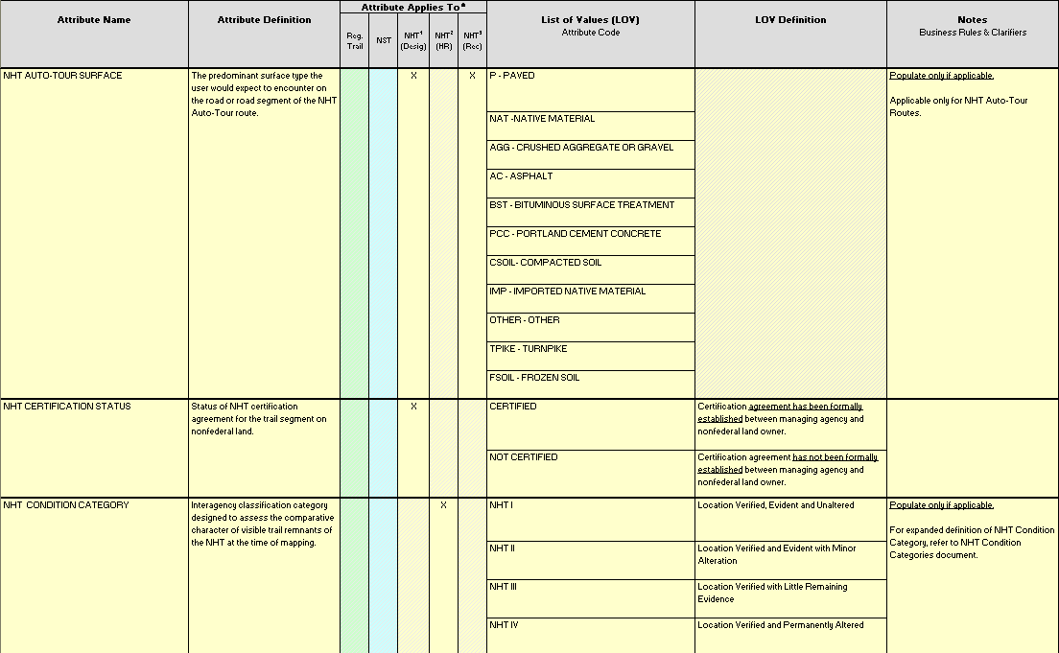
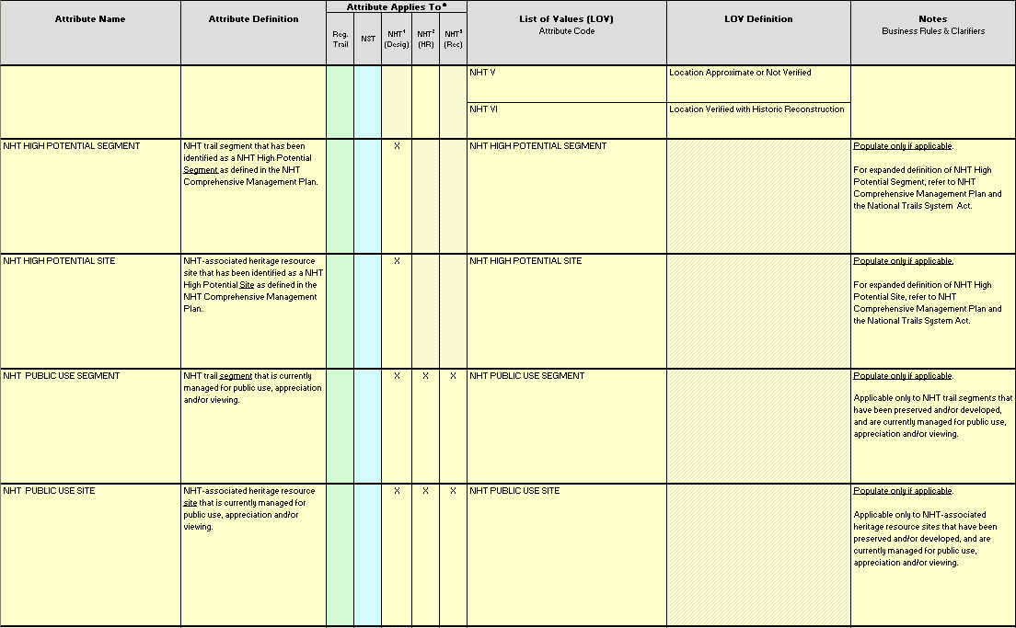

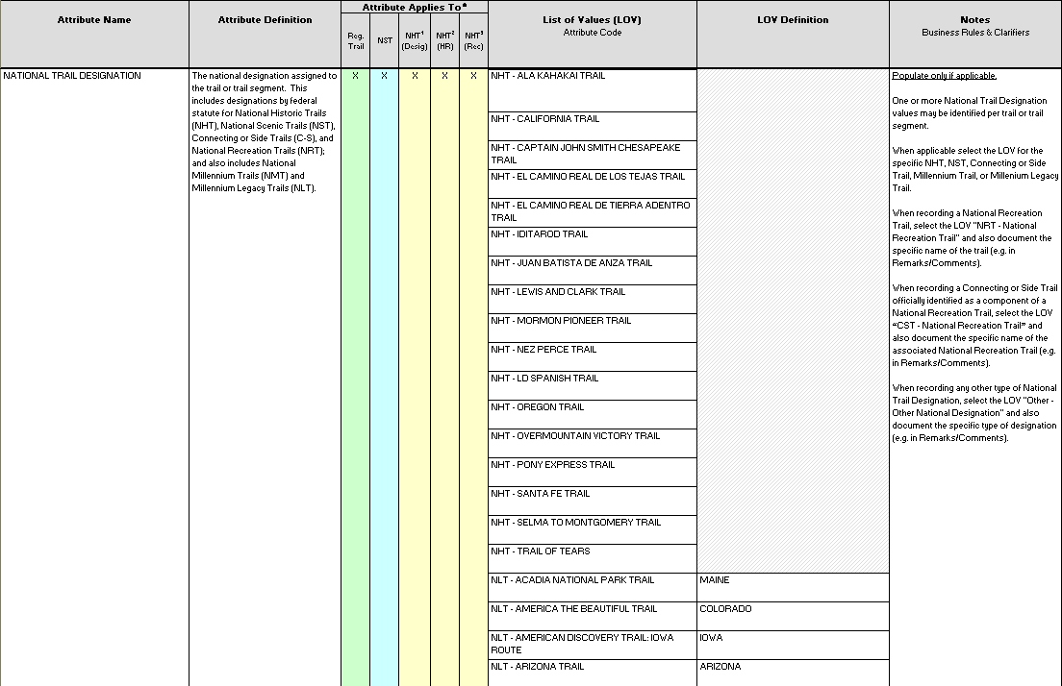
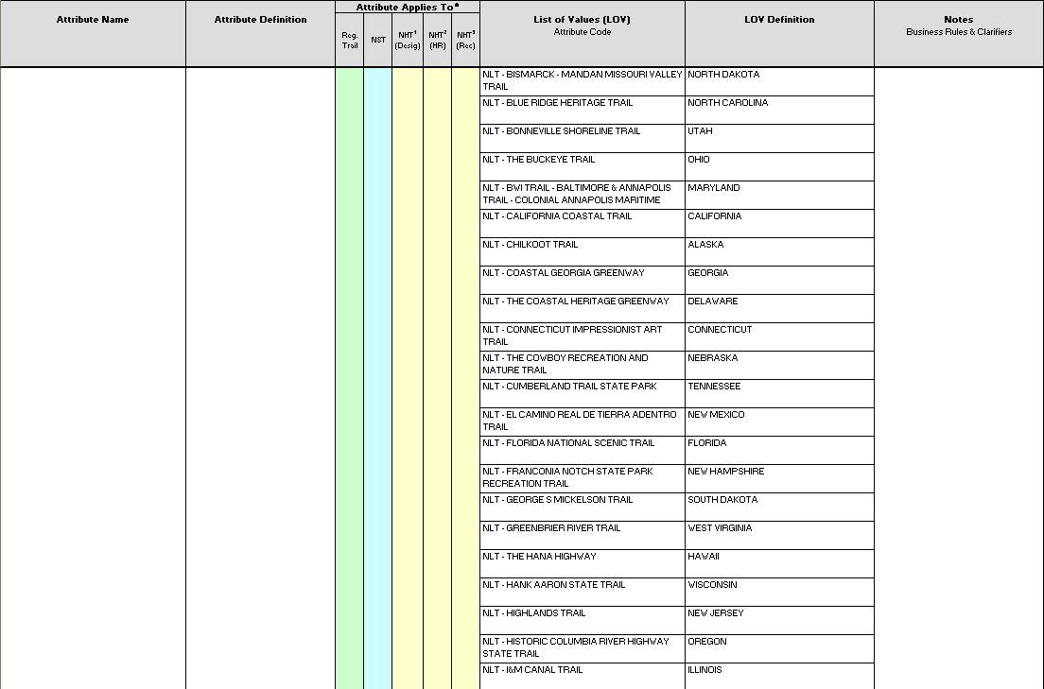
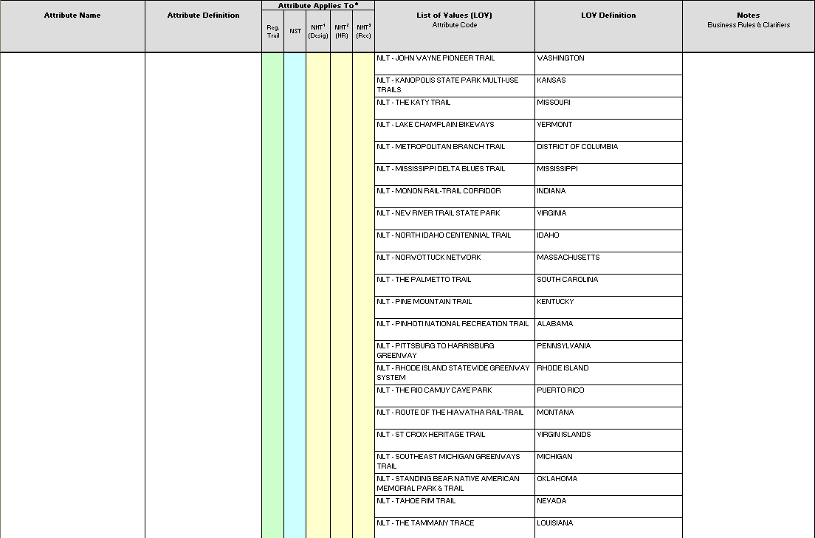
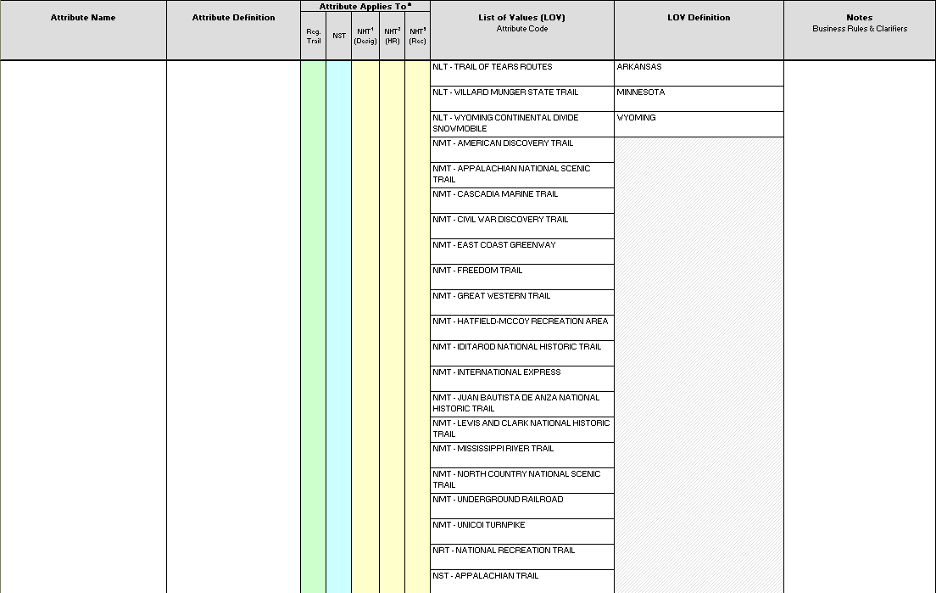

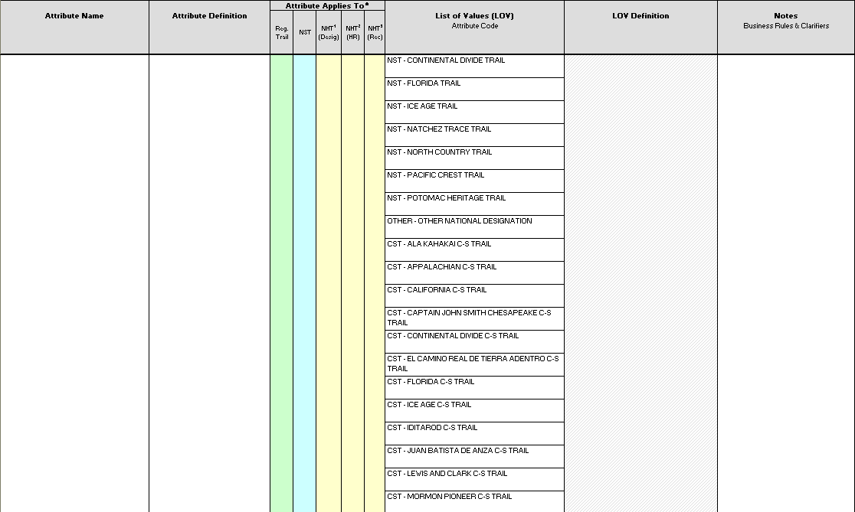
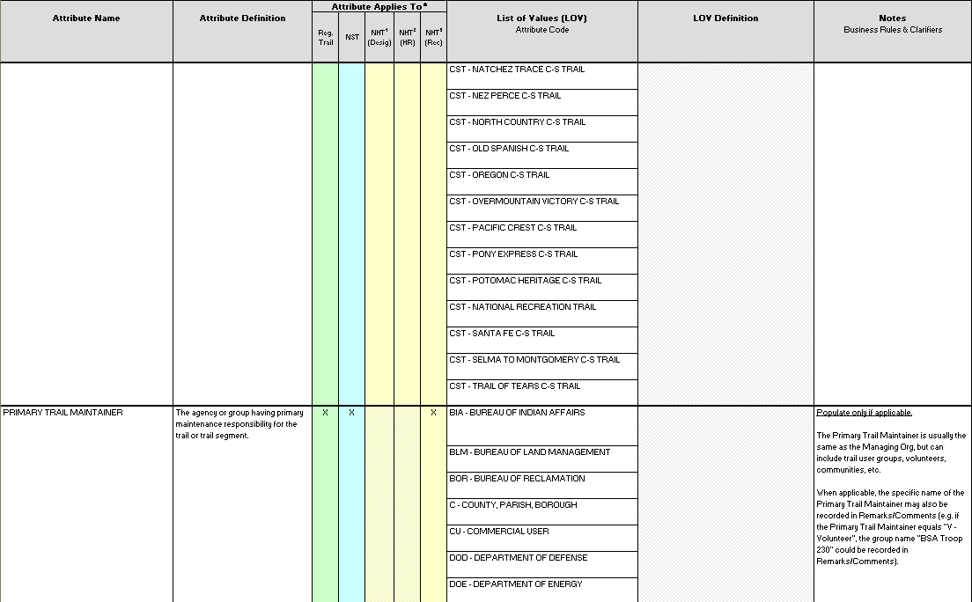

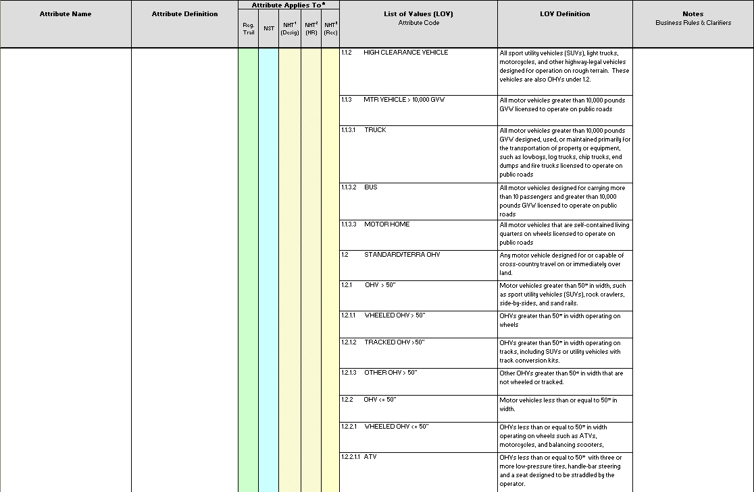
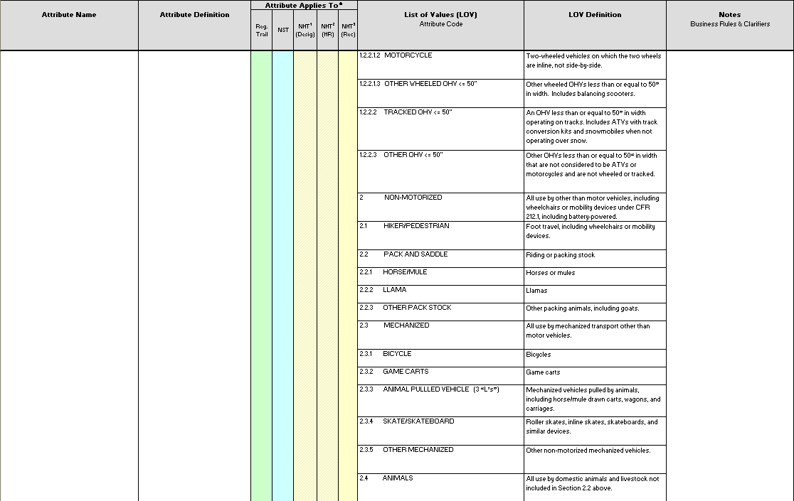
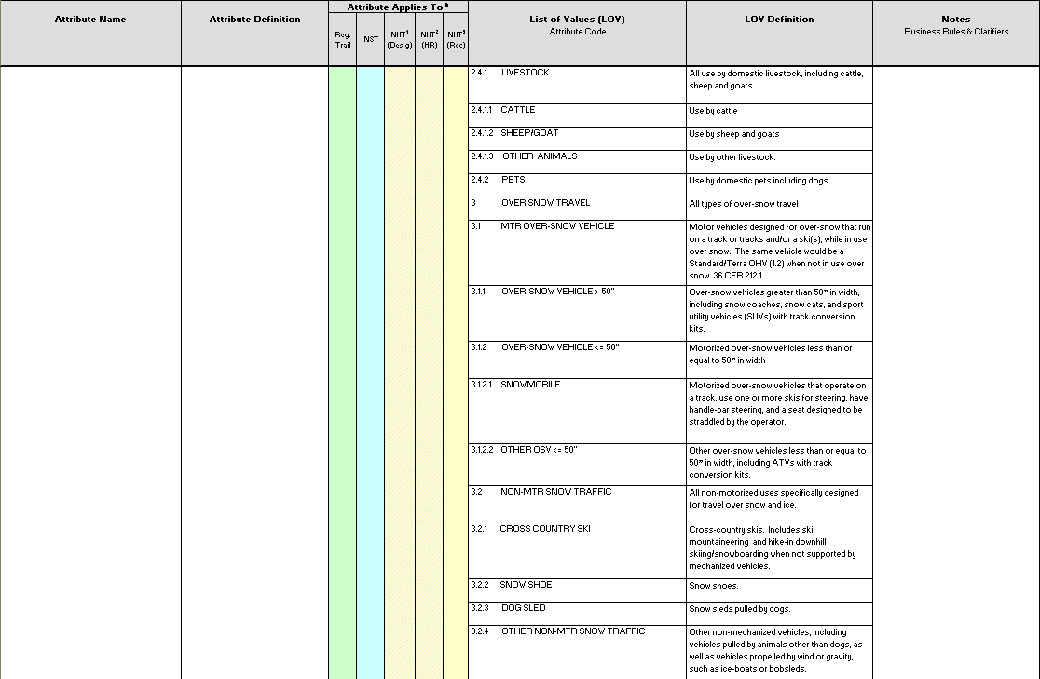
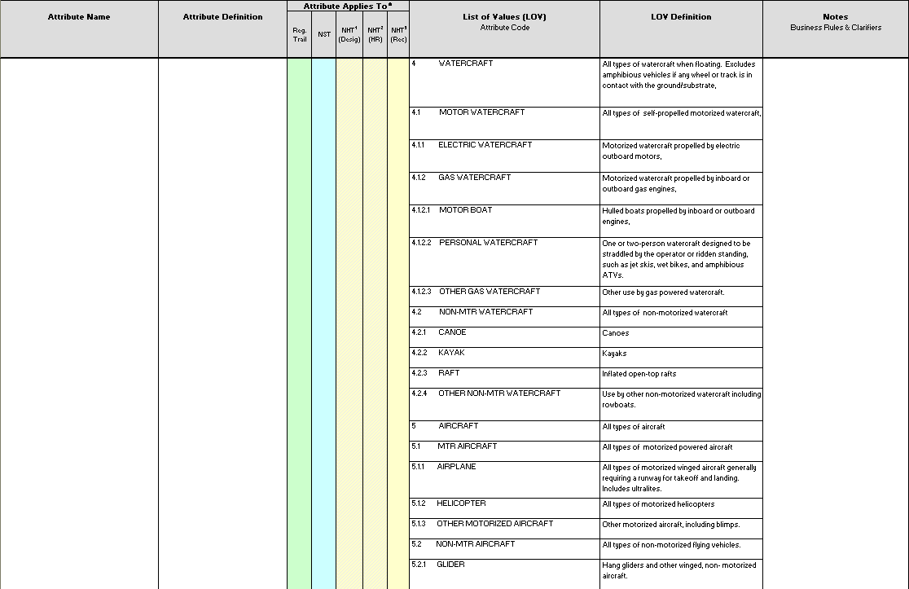
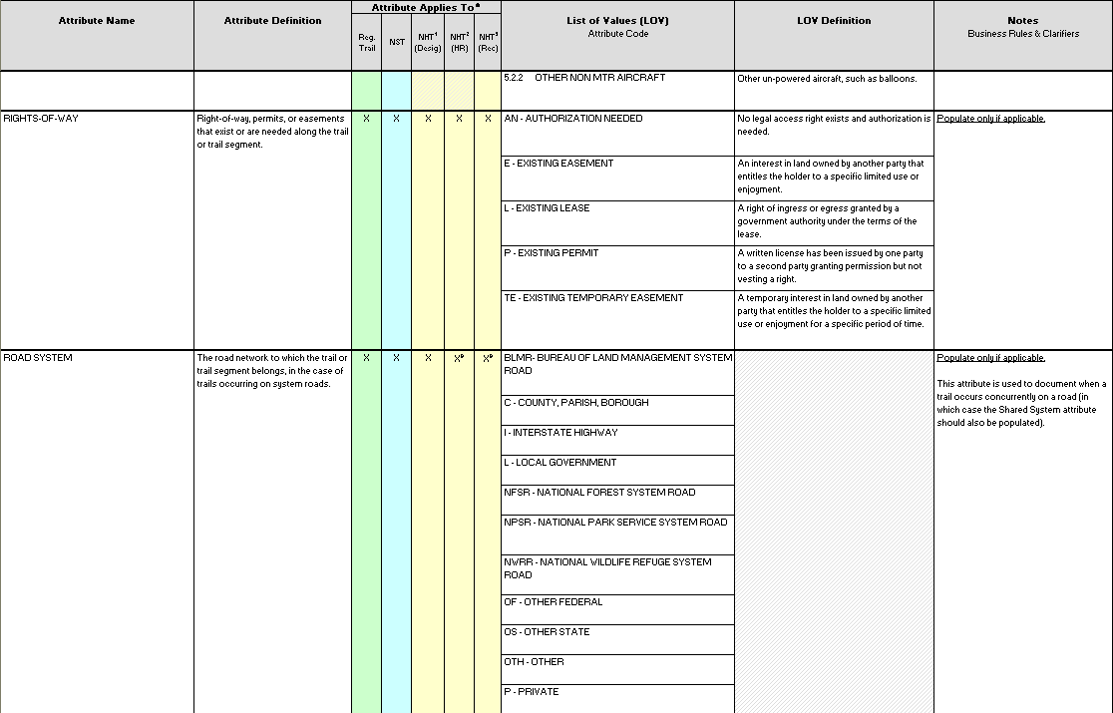
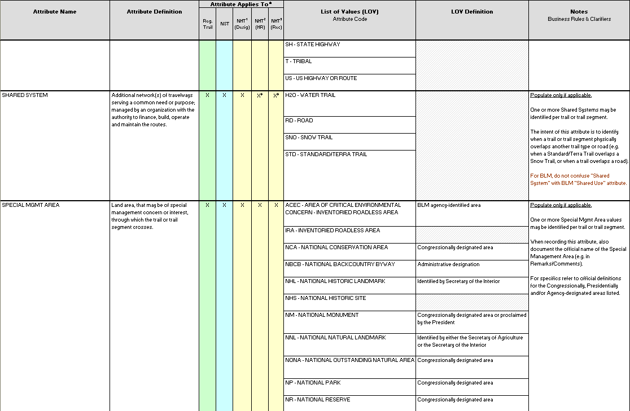
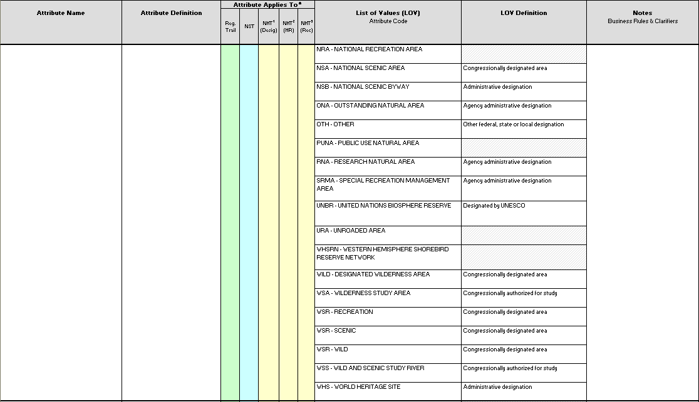
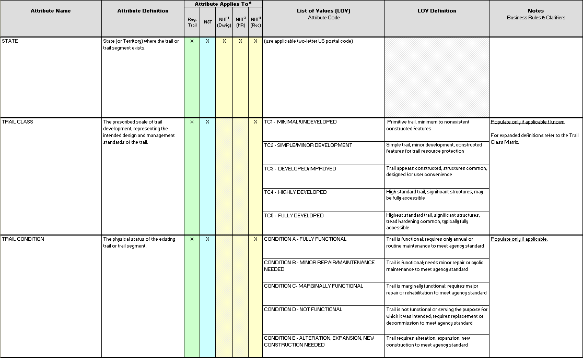
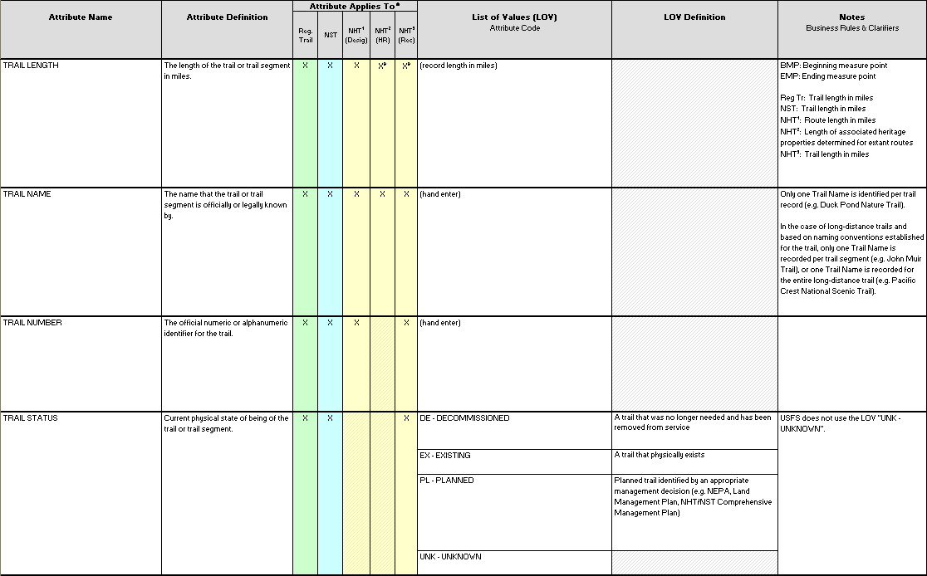
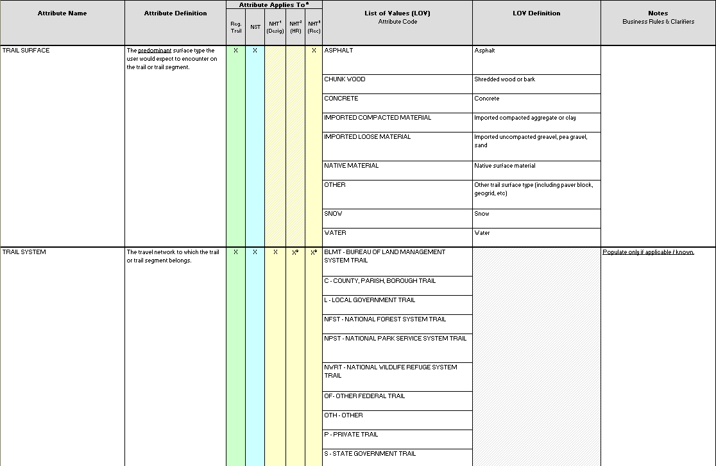


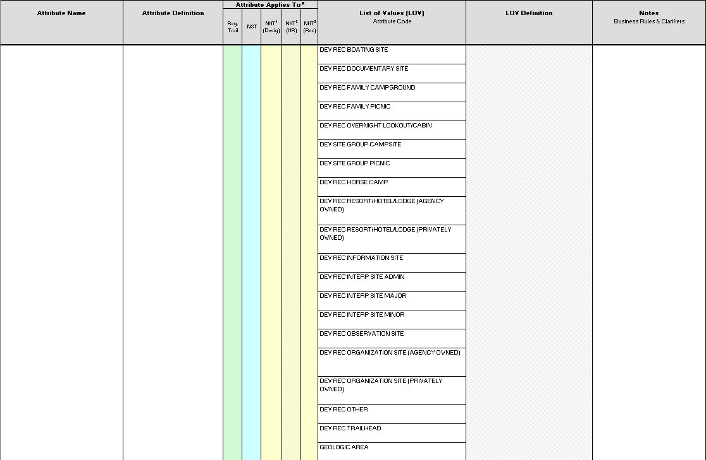


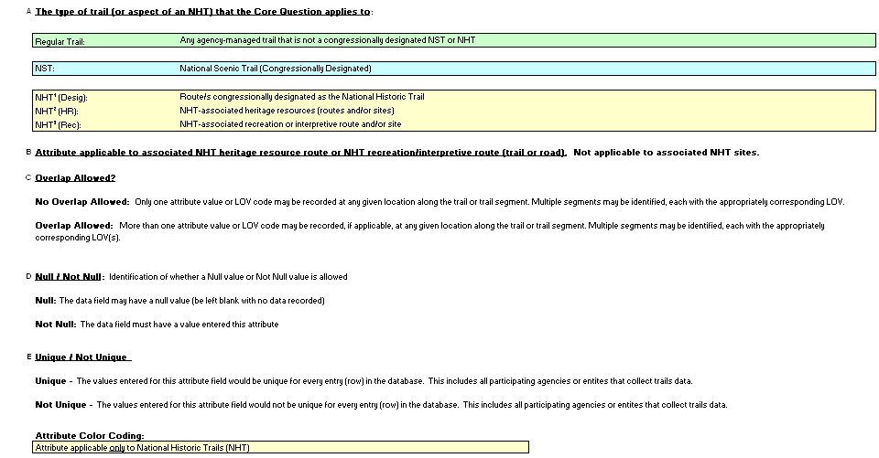

APPENDICES

Appendix A

Interagency Trail Data Standards (ITDS) Version 2, Trail Planning and Management Fundamentals
Trail Type ▪ Trail Class ▪ Managed Use ▪ Designed Use
Updated: 1/2004

Note: The management concepts incorporated in the ITDS Trail Fundamentals are currently undergoing public notice and comment via the Federal Register under the leadership of the US Forest Service. Once this is complete and the final version published in the Federal Register, the ITDS Trail Planning and Management Fundamentals will be revised as needed to reflect the final published version of these management concepts (August 2007)

The Interagency Trail Fundamentals include four fundamental concepts that are cornerstones of effective trail planning and management:
Trail Type
Trail Class
Managed Use
Designed Use
Although not entirely new, these interagency concepts provide an integrated means to consistently record and communicate the intended design and management guidelines for trail design, construction, maintenance and use.

Trail Type
A fundamental trail category that indicates the predominant trail surface or trail foundation, and the general mode of travel the trail accommodates.

Trail Types are exclusive, that is there can only be one Trail Type assigned per trail or trail segment. This allows managers to identify specific trail Design Parameters (technical specifications), management needs and the cost of managing the trail for particular uses and/or seasons by trail or trail segment.

When one Trail Type “overlaps” another, identify each trail or trail segment with its respective Trail Type as a separate route, with its own Trail Name and Trail Number. The ITDS “Shared System” data attribute will allow you to flag the route as also being used as a different type of route or Trail Type, (presumably during a different time of the year). For example, Canyon Ridge Trail 106 may be categorized as a Standard/Terra Trail from MP 0.0 to its end termini at MP 7.4. The first three miles of that same route may also function as a Snow Trail during the winter, in which case a separate record would be established for Canyon Creek Snow Trail #206 from MP 0.0 to MP 3.0. The actual naming and numbering of trails (i.e. Standard/Terra Trails versus Snow Trails) should be consistent with local unit identification protocols.

The three fundamental Trails Types include:

Standard/Terra Trail: The predominant foundation of the trail is ground (as opposed to snow or water); and that is designed and managed to accommodate ground-based trail use.
Snow Trail: The predominant foundation of the trail is snow (as opposed to ground or water); and that is designed and managed to accommodate snow-based trail use.
Water Trail: The predominant foundation of the trail is water (as opposed to ground or snow); and that is designed and managed to accommodate trail use by water craft. There may be ground-based Portage segments of Water Trails.

Trail Class
The prescribed scale of trail development, representing the intended design and management standards of the trail.

There is only one Trail Class identified per trail or trail segment.

The National Trail Classes provide a chronological classification of trail development on a scale ranging from Trail Class 1 to Trail Class 5:
Trail Class 1: Minimal/Undeveloped Trail
Trail Class 2: Simple/Minor Development Trail
Trail Class 3: Developed/Improved Trail
Trail Class 4: Highly Developed Trail
Trail Class 5: Fully Developed Trail

Each Trail Class is defined in terms of applicable Tread and Traffic Flow, Obstacles, Constructed Feature and Trail Elements, Signs, Typical Recreation Environment and Experience.

Trail Class descriptions define “typical” scenarios or combined factors, and exceptions may occur for any factor. In applying Trail Classes, choose the one that most closely matches the managed objective of the trail.

Trail prescriptions describe the desired management of each trail, based on land management plan direction. These prescriptions take into account actively managed trail uses, user preferences, setting, protection of sensitive resources, and other management activities. To meet prescription, each trail is assigned an appropriate Trail Class.

There is a direct relationship between Trail Class and Managed Use (defined below), and one cannot be determined without consideration of the other.

These general categories are used to identify applicable Trail Design Parameters (defined below) and to identify basic indicators used for determining the cost to meet national quality standards.

Managed Use
Modes of travel that are actively managed and appropriate, considering the design and management of the trail.

There may be more than one Managed Use per trail or trail segment.

Managed Use indicates a management decision or intent to accommodate and/or encourage a specified type of trail use.

Designed Use
The intended use that controls the desired geometric design of the trail, and determines the subsequent maintenance parameters for the trail.

There is only one Designed Use per trail or trail segment.

Although the trail may be actively managed for more than one use, and numerous uses may be allowed, only one use is identified as the critical design driver. The Designed Use determines the technical specifications for the design, construction and maintenance of the trail or trail segment. For each Designed Use and applicable Trail Class, a corresponding set of standardized construction and maintenance technical specifications or Design Parameters can be identified and applied.

Of the actively Managed Uses that the trail is developed and managed for, the Designed Use is the single design driver that determines the technical specifications for the trail. This is somewhat subjective, but the Designed Use is most often the Managed Use that requires the highest level of development. (i.e.: Pack & Saddle stock require higher and wider clearance than a trail designed for Hikers). In addition to Designed Use, managers must also determine the desired development scale or Trail Class, with Trail Class 1 being the lowest level of development and Trail Class 5 the highest. On a Trail Class 1 Hiker trail, the trail is basically a deer path and in places may disappear and be reacquired later. Trail Class 5 is most often paved, or at least hardened, and is associated with a highly developed Recreation Opportunity Spectrum classification (ROS).

Designed Use / Managed Use Types
All Terrain Vehicle
Snow All Terrain Vehicle
Bicycle
Dogsled
Hiker / Pedestrian
Motorcycle
Pack and Saddle
Snowmobile
Snowshoe
Watercraft
Motorized Watercraft
Non-Motorized Watercraft
Cross Country Ski

Interagency Trail Data Standards (ITDS) Version 2, National Trail Management Classes
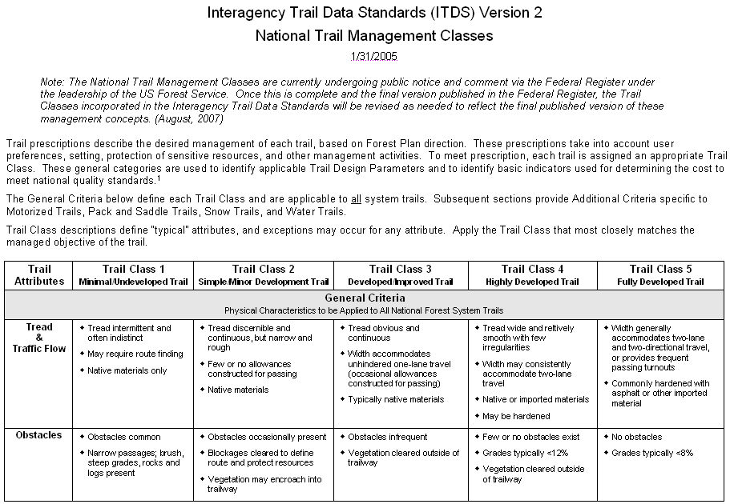
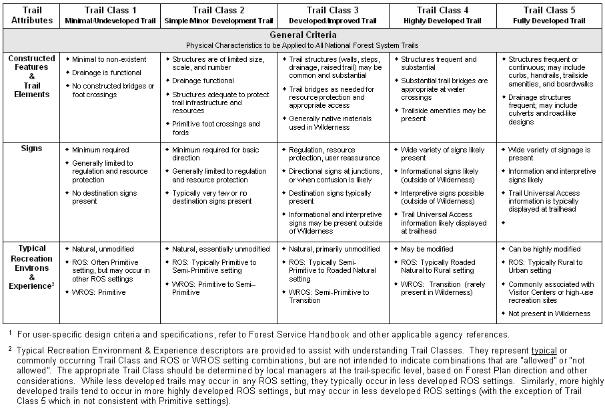
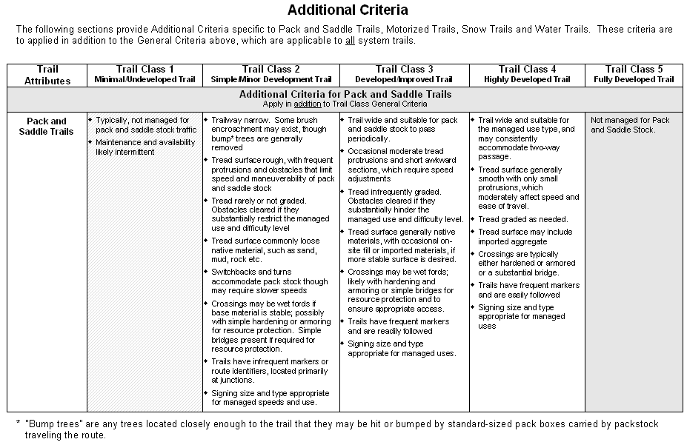
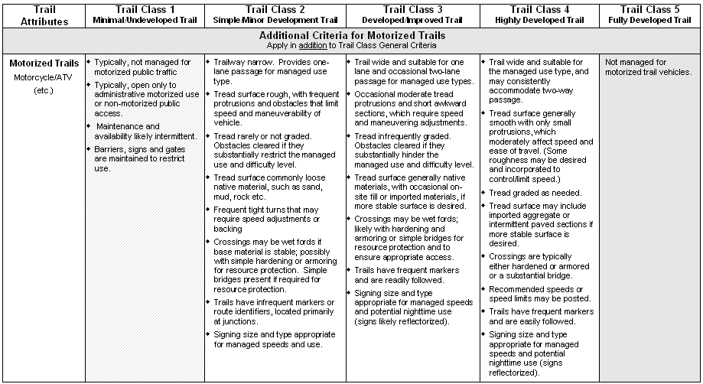
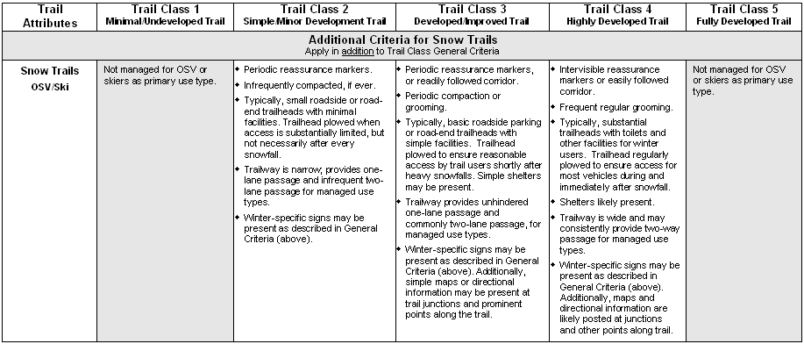
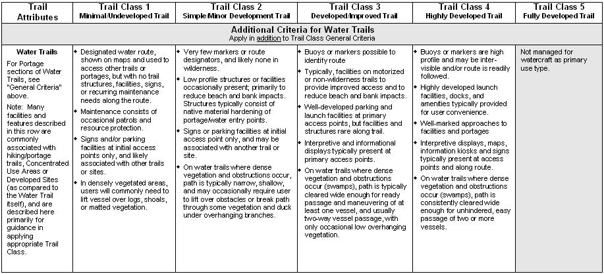

Appendix B

National Historic Trail (NHT) Corridor Concept
National Historic Trails (NHTs) differ from "regular" trails, which can generally be described, inventoried and managed as one linear route. This is not usually the case with NHTs. To better understand the inventory and management of NHTs, it is helpful to consider each NHT as an unofficial, informal "corridor", rather than a single line on a map. Each “NHT corridor” is comprised of two and often three aspects:

NHT¹ Designated Route: What and where is the congressionally designated NHT route and associated NHT heritage sites? [NHT¹ is identified for all NHTs.]

NHT² Heritage Resources: What and where is the route and sites where history actually occurred? [NHT² occurs on all NHTs, although physical evidence and/or remnants may no longer be present. Location may be other than the congressionally designated route.]

NHT³ Recreation and/or Interpretive Trail/Road/Sites: Where/what is the route and associated sites that people can use (i.e. trail/road/site used for recreation or interpretation)? [May or may not be present. NHT³ location may vary from the congressionally designated route and/or original, historically used route.]

To be effective, NHT administrators and managers rely on data representing two to three of these various components that can occur within an NHT corridor. It is important to note that “corridor” is used here as an unofficial descriptive concept, and not intended to imply the existence of actual area boundaries.

The Interagency NHT Data Standards Team recommends this concept be adopted and used internally to better communicate and explain the management and data needs related to NHTs.

NHT Condition Categories
The National Historic Trail (NHT) Condition Categories are interagency standard classifications designed to assess the comparative character of visible trail remnants observed at the time of mapping for all NHTs. National Historic Trail Condition Categories are applicable to the heritage resource component of the NHT, and not to the recreation or interpretive components. NHT Condition Categories do not reflect the character or integrity of the NHT setting or surrounding landscape.
The six NHT Condition Categories include:
NHT Condition Category | Title/Descriptor
NHT I | Location Verified, Evident, and Unaltered
NHT II | Location Verified and Evident with Minor Alteration
NHT III | Location Verified with Little Remaining Evidence
NHT IV | Location Verified and Permanently Altered
NHT V | Location Approximate or Not Verified
NHT VI | Location Verified with Historic Reconstruction

Because NHTs are designated for historic events spanning more than two centuries, NHT segments are classified based on their condition at the time of documentation, compared to their condition at the time of historic significance – be that undeveloped route, trail, primitive road or surfaced transportation route.

The Interagency NHT Condition Categories reflect broad standardized categories that can generally be applied to all NHTs, and will be used to communicate condition status among all NHTs. Since the character of each NHT differs, however, the NHT Condition Categories may be further refined to reflect specific NHTs if needed and appropriate. Any such trail-specific refinements or sub-categories must still fall within the general logic and generally equate to the national NHT Condition Categories, and should be clearly documented with examples.

NHT Condition Categories Encompass:
- Documentation of the historic location; and
- Presence (or lack) of visible trail remnants and/or artifacts that provide evidence of the historic route.

Reference Terminology:

Archaeological Evidence: Physical manifestations (e.g. artifacts and features) of historical use or events related to the significant period of trail use.

Condition: A descriptor of the current trail appearance, including the look and feel of the trail, in comparison to the probable appearance of the trail during its period of significant historic use. In other words, to what degree does the trail still look like it did during its period of maximum historic importance?

Location Verification: The combination of written records (e.g. journals or letters), cartographic information, terrain limitations, visible trail remnants, and artifacts used to precisely locate a land or water based historic route. Location verification is an important part of the definition of condition categories.

Historic Reconstruction: The deliberate re-creation or simulation of an NHT segment based on the accurate duplication of historic location, features and materials. Historic reconstruction re-creates the original appearance of the NHT segment.

Routes, Braids and Swales:

Route(s): Well-defined major variants of a historic trail. Most historic trails have various routes. They may be caused by divergent starting and destination points; changes in water, feed, and weather conditions; or the simple human desire to find a better, faster, and easier route. Routes are generally well defined, will be mapped at all scales, and should be reported to the interagency level for all historic trails. An example of routes for the California National Historic Trail are the Independence Road and St. Joe Road routes, which begin in different cities on the Missouri River and come together in Marysville, Kansas.

Braid: Routes frequently divide into braids. Trail braiding occurred when travelers found different routes around obstacles. One braid may go north of a butte and another south. At creek and river crossings braids spread out to find the best ford. If one braid was wet and marshy, a new braid was formed on higher, drier ground. Braids generally run more-or-less parallel to one another and are usually within a couple or miles of one another. Most braids are well known and are mapped at most scales. Whenever possible braids should be reported at the interagency level.

Swale: If trail data is recorded at the on-the-ground/GPS level, a third type of trail becomes visible. Physical evidence of the passage of historic travelers on the ground is often still visible. There may be many parallel swales running very close to one another. There are locations where 10-15 separate swales run parallel up a single ridge. Multiple swales occurred because travelers didn’t like to eat one another’s dust and would spread out whenever possible and also because old swales were often deeply rutted and muddy, making travel easier a few feet away. Although agencies may be documenting these swales at the GPS level of accuracy and detail, this information should not be reported at an interagency level.

Trace: A term normally associated with wagon and horse trails, that reflects visible, on-the-ground evidence of the travel along the route.

Visible Trail Remnant: The readily visible, remaining physical evidence of a trail or route that was established or made significant by historic use. For example trail trace, ruts, swales, rust marks, bridges, blazes, retaining wall, sidewalk, etc. Visible trail remnants do not include associated archaeological sites or features that are not directly part of the trail.

NHT Condition Category Definitions

Each NHT Condition Category is defined below, along with brief examples intended to illustrate the underlying logic of each category and to assist with the application of the categories to individual National Historic Trails.

NHT I: Location Verified, Evident and Unaltered
Description: The trail route is accurately located and verified from written and cartographic records, terrain limitations, and/or archaeological evidence.

The visible trail remnant retains the essence of its original character that relates to the historic period for which the trail was designated and shows no evidence of having been either impacted by subsequent uses or altered by other improvements.
For example, in the case of wagon trails, there is visible evidence of the original trail in the form of depressions, ruts, swales, tracks, or other scars, including vegetative differences and hand-placed rock alignments along the trailside. In the case of more contemporary historic trails, evidence may include constructed road features, sidewalks, railroad grades, etc. if significant to the historic events for which the trail was designated.

NHT II: Documented and Evident with Minor Alteration
Description: The trail route is accurately located and verified from written and cartographic records, terrain limitations, and/or archaeological evidence.

The visible trail remnant retains the essence of its character that relates to the historic period for which the trail was designated, but shows minor evidence of alteration by subsequent use, development, or natural events.

For example, in the case of wagon roads, there is little or no evidence of having been altered permanently by more modern road improvements, such as widening, blading, grading, crowning or graveling. In forested areas, the trail may have been used for logging but still retains elements of its original character during the significant historic period.

NHT III: Documented with Little Remaining Evidence
Description: The trail route is accurately located and verified from written and cartographic records, terrain limitations, and/or some archaeological evidence.

Due to weathering, erosion, vegetative succession, development, etc., trail traces are insignificant, although some evidence remains (e.g. wagon wheel impact evidence such as rust, grooved, or polished rocks).

For example, this category includes trail segments that once passed through forests and meadows, across excessively hard surfaces or bedrock (such as on ridges), over alkali flats and sandy soils, through ravines or washes or other environments not conducive to trace preservation.

NHT IV: Documented and Permanently Altered
Description: The trail route’s location is verified from written and cartographic records, or by terrain limitations, although little or no archaeological evidence remains.

The trail has been permanently altered or obliterated by human-caused or natural events, leaving no evidence of its original appearance.

For example, the original trail may have been permanently altered by road construction through widening, blading, grading, etc. Other above or below-ground developments include pipeline installation, utility corridor development, building construction, etc.

NHT V: Approximate Trail
Description: The trail route’s location cannot be accurately verified from written or cartographic records, or archaeological evidence.

The trail is either so obliterated or unverifiable that its location is only approximately known.

In many cases, the trail has been destroyed entirely by development, such as highways, structures, agriculture, or utility corridors. In others, it has been inundated beneath reservoirs. In some, there is not enough historical or topographic evidence by which to locate the trail accurately.

NHT VI Historic Reconstruction
Description: The trail route is accurately located and verified from written and cartographic records, terrain limitations, and/or archaeological evidence.

The trail segment has been deliberately reconstructed, at its original location, to appear as it did during the period of maximum historic importance.

For example, the reconstruction of a tow path or lock along an historic canal to simulate trail’s original character and use.

Note: Reconstructed trail segments or associated features, not in the original location do not meet the definition of NHT VI Historic Reconstruction, and are considered as recreation, interpretive or other developments.

NHT Condition Categories: Comparison Summary and Classification Tree

The tables below provide summarized comparisons of the NHT Condition Categories and are intended for general comparative purposes only. Refer to the specific NHT Condition Category definitions and, if applicable, the supplemental discussion when attempting to assign the Condition Categories to a particular NHT.

NHT Condition Category Comparison Summary
NHT Characteristics | NHT Condition Categories
NHT Characteristics | NHT I | NHT II | NHT III | NHT IV | NHT V | NHT VI
Location Verified | Yes | Yes | Yes | Yes | No | Yes
Historic Reconstruction | No | No | No | No | No | Yes
Trail Remnant Visible and Unaltered | Yes | No | No | No | No | No
Trail Remnant Visible and Altered | No | Yes | No | No | No | No
Trail Remnant Not Visible, but Archaeological Evidence Visible | No | No | Yes | No | No | No

NHT Condition Category Classification Tree
NHT Condition Categories: Classification Tree
To classify an NHT trail segment, ask the following questions in order shown:
1. | Is location verified? | if | No | then segment is: | NHT V
2. | Is location verified and historic reconstruction present? | if | Yes | then segment is: | NHT VI
3. | Is location verified, but the trail tread is permanently altered? | if | Yes | then segment is: | NHT IV
4. | Is location verified and original physical trail remnant visible and unaltered? | if | Yes | then segment is: | NHT I
5 | Is location verified and original physical trail remnant visible, but altered? | if | Yes | then segment is: | NHT II
6 | All remaining segments are: |  |  |  | NHT III

Application of NHT Condition Categories: Supplemental Discussion

This section provides additional examples and discussion to assist with the application of NHT Condition Categories to some common and/or potentially problematic situations. The examples provided below are not comprehensive and should be further refined as needed to reflect specific National Historic Trails, while remaining within the general context of the standardized NHT Condition Categories.

No trail categorization scheme can cover all situations with equal uniformity. In most situations, applicability of one of the six NHT Condition Categories is fairly straight-forward. Inevitably, however, there will be situations where more than one category might apply. In such cases, where there is no clear determination, the trail classifier will have to make a subjective decision based on a thorough observation and assessment to determine which NHT Condition Category best fits the NHT trail or NHT trail segment.

Origin of the Categories

The NHT Condition Categories were inspired by the Oregon-California Trails Association (OCTA) “Mapping Emigrant Trails” (OCTA 2002:13-15). The OCTA categories were devised for the emigrant trails across the western United States to describe, in particular, wagon and livestock trails. When developing NHT Condition Categories for interagency use, the OCTA categories were used as a starting point and were revised to be more broadly applicable to all NHTs, using the logic of trail location and trail appearance today relative to appearance during the period of the trail’s use.

Relationship to National Register of Historic Places

The NHT Condition Categories do not incorporate the National Register of Historic Places concepts of integrity, or even significance. These National Register concepts are derived through analysis and consideration of the context of an historic resource. The NHT Condition Categories, by contrast, are descriptive. Specifically, “setting”, as defined in the National Register of Historic Places, is not a consideration in assessing NHT condition: NHT Condition Categories describe the comparative condition of the route actually traveled, and not the condition of the overall landscape in which the route currently exists.

The National Register concept of associative qualities is not incorporated into the condition categories. The associative qualities of an NHT are already incorporated into its designation and management.

Eligibility to the National Register of Historic Places is not part of NHT condition categories because the condition categories are independent of the National Register criteria. For instance, a trail segment may not be significant but still be in NHT I Condition Category; another trail segment may be significant due to its association with some important event but be in NHT IV.

Effects of Modern Intrusions and Changes Around the NHT

Modern intrusions, such as freeways, power lines or buildings situated near trails normally do not affect trail categorization, because the NHT Condition Categories describe the route’s surface, not the landscape in which the NHT segment lies presently. Only the presence (or absence) of visible trail remnants, archaeological evidence, and/or knowledge of the trail’s location affect categorization.

Logging, forest fires, or vegetation changes since the period of the NHT’s maximum importance may have altered the trail corridor temporarily. However, over time, new growth has, or will have, restored the natural condition of the trail corridor. As long as the trail route is accurately known and the trail itself has not been physically altered, there will be no effect upon the Condition Category.

Often, the physical remains of a long NHT trail segment will be intermittently indistinct during certain conditions (e.g., in different seasons). In these cases, determining an appropriate NHT Condition Category requires multiple observations of the trail segment.

Application of NHT Condition Categories: Examples
Wagon and Livestock Trails
NHT I: Most emigrant trails still retaining evidence of original wagon use – in the form of ruts, swales, scaring or tracks – probably have undergone later 19th century wagon use due to freighting, mining, stage, or ranching activity. Therefore, rarely will visible trail remains be the result solely of emigrant wagon use. Also because these wagon trails have had little or no use in the 20th century, either erosion or restoration have often changed their appearance where they no longer look like they did during use by the emigrants. Nonetheless, these trail segments still retain their emigrant wagon-use character and qualify as NHT I.

NHT II: Many times, historic wagon roads have continued to be used as unimproved roads since their period of historic importance. In these cases, even though the historic road is overlain by an unimproved two-track road, it still retains the essence of its historic appearance and is an NHT II Condition Category trail.

Occasionally, a superimposed, two-track road will have been abandoned and the NHT will have reverted in appearance to an “unaltered trail.” However, if, through research of historic documents, oral histories, or soil conditions, it can be demonstrated that the trail was once used as a road for motor vehicles, then it is classified as a NHT II Condition Category. Agency documentation for the trail segment should note that the segment is an abandoned road that spuriously seems “unaltered trail.”

NHT III: Trails passing over soils and surfaces that did not easily take the imprint of a wagon wheel, or where erosion and other subsequent changes have obliterated the original trail tread, may still retain some evidence of the passage of emigrant wagons. Rust marks, grooves, and polish on rocks; rope burns on trees; and hub scrapes on rocks or trees allow verification of emigrant wagon travel even in areas where the trail tread itself may no longer be evident. The trail may also be verified in these areas by terrain limitations or archaeological evidence. Sections of trail that can be verified from these limited remains, but where no visible trail remnant remains should be classified as NHT III.

NHT IV: The trail condition has been permanently altered by subsequent development. Where improved roads, such as crowned and ditched roads, have been built over historic trails, the historic appearance is no longer retained and the trail Condition Category is NHT IV.

NHT V: In most cases, NHT V trails have been so obliterated by development that exact trail locations are impossible to determine. However, there will be situations where additional research and field verification may reveal the exact location of a trail segment which presently is known only approximately. Thus where trail location has not been determined due to insufficient research and field verification, a trail corridor should be protected from disturbance until it has been confirmed that physical or other evidence of a trail segment no longer exists.

NHT VI: NHT VI seldom exists for wagon and livestock trails. In rare cases trail tread may be reestablished in an area where the original trail has been completely obliterated. This reconstruction is usually done for interpretive purposes. For example: the pavement was removed from a section of the abandoned county road at Whitman Mission NHS and the trail returned to a more 19th century appearance.

“Urban” Trails
Examples of NHT Condition Categories applied to trails that originally occurred along roadways, sidewalks, railroads, or other developed travel ways:

NHT I: The NHT will have a Condition Category of NHT I if, for example, the original sidewalks that were used historically are unaltered in design, materials, construction method, and appearance along the original, verified, historical route. So, the concrete sidewalks of a block along a historic trail would be NHT I if they had been replaced with similar concrete slabs of the same dimensions and appearance.

NHT II: The NHT will have a Condition Category of NHT II if, for example, the original sidewalks that were used historically have been altered in design, materials, construction, method, but still retain much of their historical appearance along the original, verified, historical route. So, the concrete sidewalks of a block along a historic trail would be NHT II if they had been replaced with asphalt sidewalks of similar dimensions, replaced with somewhat larger poured slabs, or modified in places by cut-ins for driveway ramps or wheeled vehicles. Another example of an NHT II condition class is a block with much of its original sidewalk still similar in appearance to its period of historic significance but with minor areas of very different sidewalk.

NHT III: The NHT will have a Condition Category of NHT III if, for example, the original sidewalks that were used historically are substantially altered in appearance as well as design, materials, and construction but one can still tell that it was the originally used location and one could still traverse the trail in a similar way. So, the concrete sidewalks of a block along a historic trail would be NHT III if the sidewalks were rebuilt completely with different materials, or very different dimensions, or of very different materials (e.g., paving stones instead of cement slabs). Another NHT III condition is a stretch of former sidewalk that has now decayed to rubble, or on which the paving slabs have been wholly removed.

NHT IV: The NHT will have a Condition Category of NHT IV if, for example, the original sidewalks that were used have been paved over by conversion of a street to a highway and removal of all sidewalk. So, the concrete sidewalks of a block along a historic trail would be NHT IV if they were covered over by buildings, parking areas, roadways, or in some other way obliterated, yet the original location of the trail is known.

NHT V: The NHT will have a Condition Category of NHT V if, for example, the original location of the trail cannot be verified. For example, the trail is known to have occurred from Point A to Point B, but no exact location for the route traversed is known.

NHT VI: The NHT will have a Condition Category of NHT VI if, for example, the trail has been completely replicated by reconstruction intended to restore the trail to a facsimile of its original appearance. Or, for instance, a bridge that was once present, but has then been removed and replaced with a new bridge designed to appear the same as the historic bridge.

Snow Trails
Examples of NHT Condition Categories applied to trails that originally occurred across snow, ice, or water:
[Note: Field assessment of snow and water routes often necessitates observation during periods when snow and ice are not covering the ground.]

NHT I: Trail is in a verified location. Evidence of previous use including primitive bridges, culverts, corduroy road surfaces, and blazes may be evident in the same manner and degree as existed during the trail’s period of primary use.

NHT II: Trail is in a verified location. Some evidence of original use patterns including ruts, blazes, and dirtwork (ditches) are evident. Subsequent modern use by vehicles following the period of historic significance is evident.

NHT III: Trail is in a verified location. Original evidence of historic travel modes (sled trails, horse-drawn wagons, or sledges) are absent. Modern use (snowmachines, ATVs) patterns are apparent. Old blazes on trees are found occasionally.

NHT IV: Trail is in a verified location. No evidence of historic use can be found. The trail surface has been modified or obliterated by subsequent use or construction.

NHT V: The trail location cannot be verified.

NHT VI: Trail is in a verified location. The trail has been rebuilt on its original location with a replica representation of the trail’s historic appearance during its period of significant historic use.

Appendix C

Frequently Asked ITDS Questions
(Updated 10/3/2007)

Several frequently asked questions and answers about the Interagency Trail Data Standards (ITDS) are listed below.

- Why are you creating a new data base?
This effort does not create any new databases. For the first time, four federal land management agencies have collaborated to standardize their definitions of commonly used trail terminology.

- What are your ultimate goals?
Develop universal standards for core trail terminology and data attributes: Interagency Trail Data Standards (ITDS). These standards will enable national, regional, state, and trail-level managers AND the public to use mutually understood terminology for recording, retrieving and applying spatial and tabular information.

- Why are you creating more work for the field?
The Interagency Trail Data Standards Team (Team) is developing commonality amongst the three agencies. The Team is NOT creating a new data base, but is merely defining and standardizing terms that we have all used for decades. Existing data bases may adapt these standards throughout the four agencies. Data exchange amongst managing units will be more efficient. Most importantly, there will be less confusion on the public’s part as they access information about the trails they use.

- How will GIS layers fit into this data model?
The ITDS outline common definitions, terminology and core set of data attributes to be used by the BLM, FWS, NPS and USFS for communicating and sharing trails information. There is no attempt here to develop data models or Geographic Information Systems (GIS). Rather, the standards will define the data that is displayed in your particular GIS.

- How and who will maintain this system? How will we maintain and mesh this effort with existing databases?
Maintenance of your particular GIS and/or database will continue as before in your unit. This is not a GIS or a data model. The standards will not lead to the creation of new databases but allow existing data to be described in a manner that will clearly understood and utilized by the four agencies.

- How could such an effort foresee unique local situations?
No attempt was made to do so. The attributes that have been defined here are those that should be common to most databases nationwide. This does not prevent any unit from identifying its own data attributes and values to reflect the trail or agency-specific situation or information need.

- Are there any standards, descriptors that could be used to ground-truth road, two-track and/or trails?
These standards are for trails (see interagency “trail” definition). While these trail data standards may have some applicability in the future development or refinement of road data standards, these standards focus on trails.

- Has the ITDS Team reviewed the current Federal Geographic Data Committee (FGDC) Framework Standards as a basis for establishing these standards? Does this effort need approval by the Federal Geographic Data Committee?
The ITDS Team is working with representatives of FGDC to publish the ITDS as FGDC trail standards.

- Is this a data request?
No, data collection and implementation schedules will be determined by each agency. The ITDS simply provide common definitions and terminology for a core set of trail information.

- Do these standards deal with trail difficulty?
No, this level of detail is beyond the scope of the ITDS (see Interagency Core Questions), and is up to the agency and/or specific managing unit.

- Do these standards deal with facilities along the trail?
In general, the ITDS do not include standardized data definitions for facilities or “things along the trail” (i.e. constructed features, etc.). This level of detail is beyond the scope of the ITDS and more appropriate for individual agencies or entities to define, depending on their specific data needs (see ITDS Selection Criteria). In the case of NHT/NSTs, however, basic data on NHT/NST-related visitor centers and visitor facility type, and NHT-related historic sites are included in the standards.

- Who is the audience for this information?
The audience that will benefit from the Interagency Trail Data Standards includes:
  - Interagency counterparts
  - Congress
  - Partner organizations
  - General public (Media, trail users, info seekers, educators, researchers)
  - Travel and Recreation Industry (service providers)
  - Advisory boards
  - Intra-agency Specialists (GIS, budget, facilities, resource specialists, cultural and natural, related biologists, etc.).

- What units of measure shall we use? What projection shall we use?
The ITDS will be provided in miles (and/or feet when applicable). Most ITDS will be recorded with a beginning and ending measure point, allowing total miles/feet to be available at the interagency level, per ITDS attribute and attribute LOV. Databases and GIS have the capability of quick conversion to metric, if desired. Feet and miles are still the US national standards for measurement. Projection: WGS 84 is the national standard.

- What is the format in which this information should be reported?
The ITDS Team did not address database and presentation formats. The Team only addressed data standards – attribute definitions. It is up to the individual agency and/or user to decide which format to display data.

- Why should we use these standards since they are not found in MAXIMO (FMSS in Park Service, FAMS in BLM, SAMMS in FWS)?
  - BLM: BLM is adapting these standards into FAMS.
  - FWS: FWS has incorporated these standards into its SAMMS database and into the trail inventory of all National Wildlife Refuges being conducted by the Federal Highway Administration and due to be completed by the end of CY 2007.
  - NPS: NPS is incorporating some of these standards into FMSS. The remaining standards will be incorporated into other appropriate systems.
  - USFS: USFS has incorporated the majority of these standards into Infra Trails. The remaining standards have been through internal review and are planned for incorporation into Infra Trails and/or Infra Heritage (for certain NHT data fields).

- Why is financial data addressed in these standards? Isn’t this an unnecessary duplication of databases?
The ITDS define four very general categories of Annual/Cyclic Operations and Maintenance, Deferred Maintenance, and Capital Improvement Costs to facilitate apples-to-apples summation of costs between agencies and for long-distance trails crossing multiple agency boundaries (see Core Questions 11 and 12). The ITDS do not address financial details of trail assessment and condition surveys. It is up to the managing unit to compute and store its own detailed trail maintenance and construction costs.

- Why is it necessary to collect and assess detailed trails data in a multi-agency setting?
Each agency determines the specifics and extent of its data needs. This effort is in keeping with a government-wide effort (known as “E-Government”) to store, classify and efficiently share important data that is useful to the general public.

- How do we implement these standards?
Implementation is up to the individual agencies. The ITDS should be incorporated as each agency data management system is developed or refined.

- How do these standards deal with “segmentation” of trails (especially long-distance trails)?
- Trail Segment: “Trail segment", as used in the ITDS attribute definitions, is used as an informal term to identify that portion of trail that corresponds to the attribute "answer" or value selected for that attribute. It is not used in the ITDS definitions to identify or indicate officially recognized portions of trail, but rather to define the portion or entire section of trail to which a particular attribute value corresponds. The "segment" identified depends on the question being asked, or the data attribute and attribute value being recorded.

For example, the data attribute State may be recorded for Trail ABC as "Montana" from mile 0.0 to mile 24.55, Idaho from mile 24.55 to mile 54.70, and Utah from mile 54.70 to mile 61.22. In this case, the attribute State is recorded by using three different attribute values that correspond to three different "segments" of trail. Another example for the attribute State could be recorded as "Florida" for Trail QRS which lies entirely within the state of Florida, from mile 0.0 to mile 9.75. Hence the reference to "trail or trail segment" in several ITDS attribute definitions.
For those same trails, the data attribute Trail Class may be recorded for Trail ABC as Trail Class 3 from mile 0.0 to mile 35.50, and as Trail Class 2 from mile 35.50 to mile 54.70. Trail Class may be recorded for Trail QRS as Trail Class 4 from mile 0.0 to mile 1.74, and as Trail Class 3 from mile 1.74 to mile 9.75. Again, in these examples the "segment" refers only to the portion of trail where the recorded attribute value is applicable.
In these examples, there is no correlation between the informally identified "segments" recorded for State and the "segments" recorded for Trail Class, as the attribute values usually change at locations independent of other data attributes.
- GIS Segmentation: Resolution of detailed spatial segmentation at the agency or trail-specific level is currently possible within various agency databases, depending on database capabilities, protocols, and data structure.

In the case of the USFS' Infra Trails, for example, all ITDS attributes are recorded as linear events, each with its own beginning and ending measure point (i.e. length). Most of these can also be displayed spatially, by trail or identified attribute segment. Depending on the question being asked, a lump sum total can be queried to answer the question (i.e. Miles of Trail Class 2), or a "slice" or snapshot taken at any given point on a trail to display the entire combination of attributes and values recorded for that location (i.e. Attributes values for Trail Class, Managed Use, and Designed Use at mile 6.5). While the intent of the ITDS is not to go to this level of trail-specific detail, this example is provided to illustrate the possibility of incorporating the ITDS and the utility of identifying data attributes by informal or dynamic "segments".

- What does “No Overlap Allowed” and “Allow Multiple Entries” on the List of Values (LOV) table mean?
The “Overlap Allowed” is used to indicate whether, for any one data attribute along a particular portion of trail, more than one value or LOV code can be concurrently assigned that attribute.
  - No Overlap Allowed: Only one attribute value or LOV code may be recorded at any given location along the trail or trail segment. Multiple segments may be identified, each with the appropriately corresponding LOV.
  - Overlap Allowed: More than one attribute value or LOV code may be recorded, if applicable, at any given location along the trail or trail segment. Multiple segments may be identified, each with the appropriately corresponding LOV(s).

The following data attributes may be recorded with more than one attribute code identified for the same location: Land Use Plan, Managed Use, National Trail Designation, Prohibited Use, NHRP Criteria, Prohibited Use, Shared System, Special Mgmt Area, Type of Route, and Visitor Facility Type.
- Example: For any particular stretch of trail, that portion of trail is physically located in only one County at that location, while that same location on the trail may have one or more Prohibited Uses. Therefore, there is no overlap allowed for the data attribute for County – only one County may be recorded for that specific location (either the trail segment, or the entire trail if applicable). The data attribute for Prohibited Use, however, does allow the entry of multiple values, if more than one actively Prohibited Use is defined for any given stretch of trail. In this case, only one County (i.e. Mineral County) could be recorded in any single location, but all Prohibited Uses would be recorded for that same location (i.e. ATV, Motorcycle).

The Beginning Measure Point (BMP) and Ending Measure Point (EMP) would not necessarily be the same for these two data attributes. For example, the trail may be in Mineral County from BMP 0.00 to EMP 6.42 (recorded in miles), while the Prohibited Uses of Motorcycle and ATV may extend for the entire length of the trail from BMP 0.00 to EMP 16.75.

Appendix D

Core Questions and Attributes Considered, but Dropped or Deferred for Further Consideration
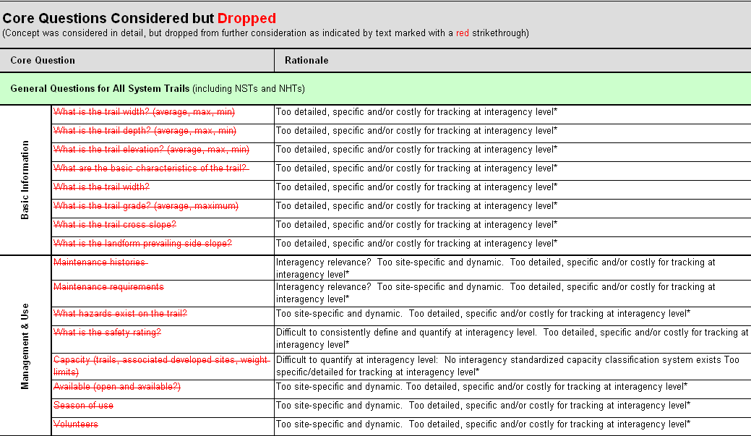

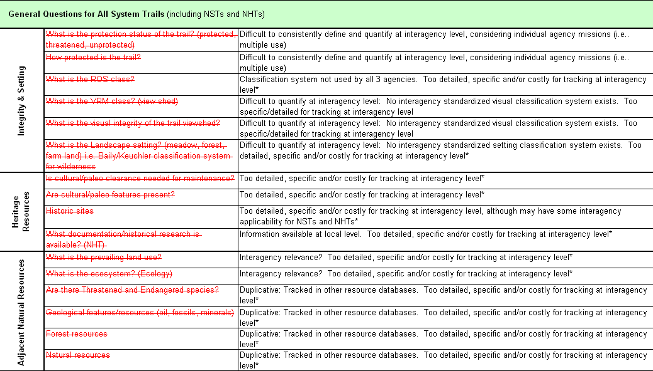
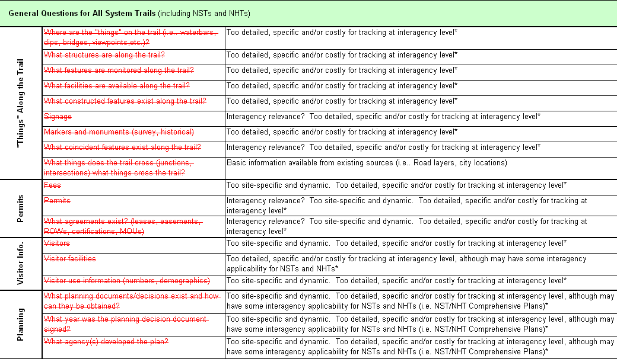
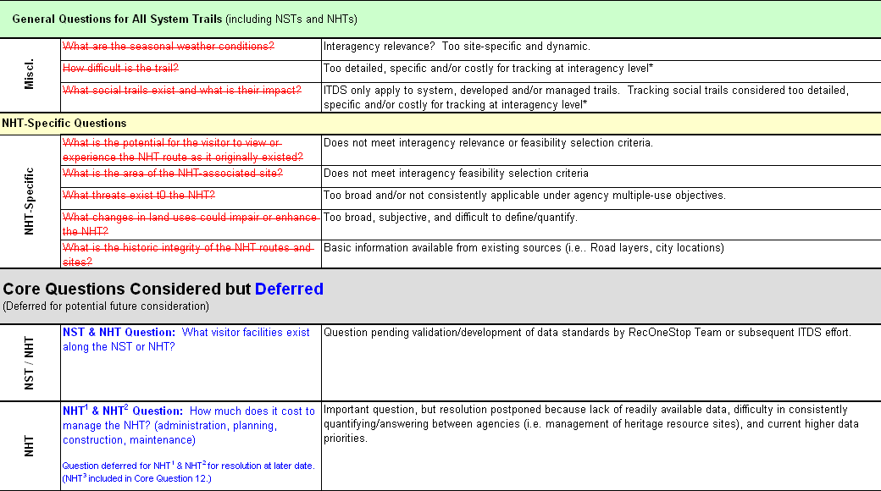
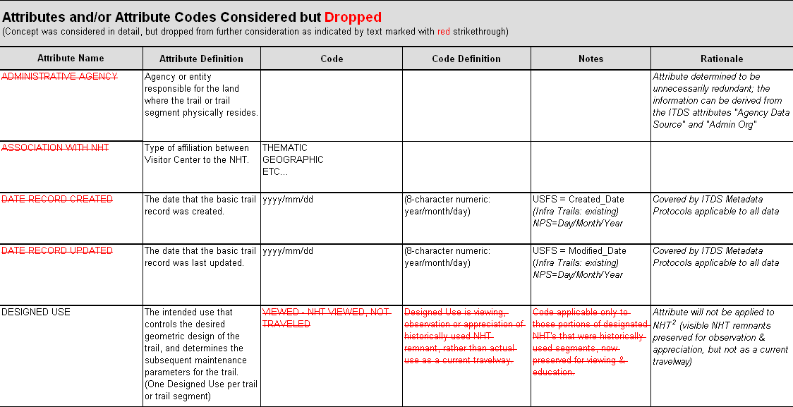
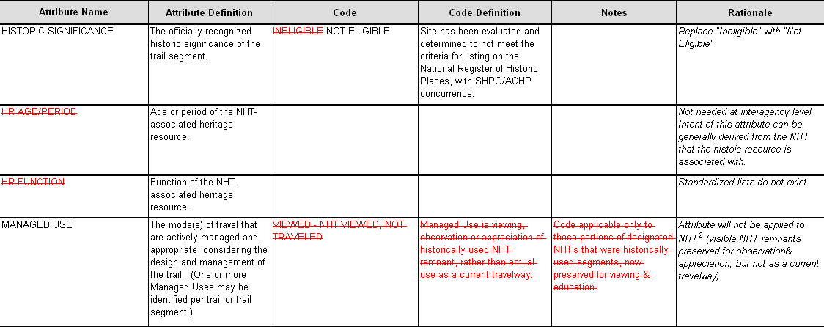
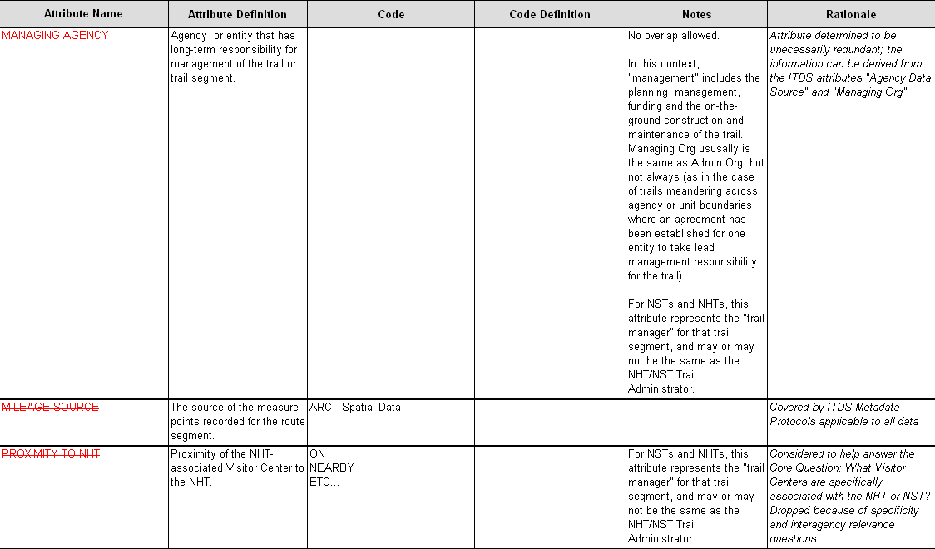
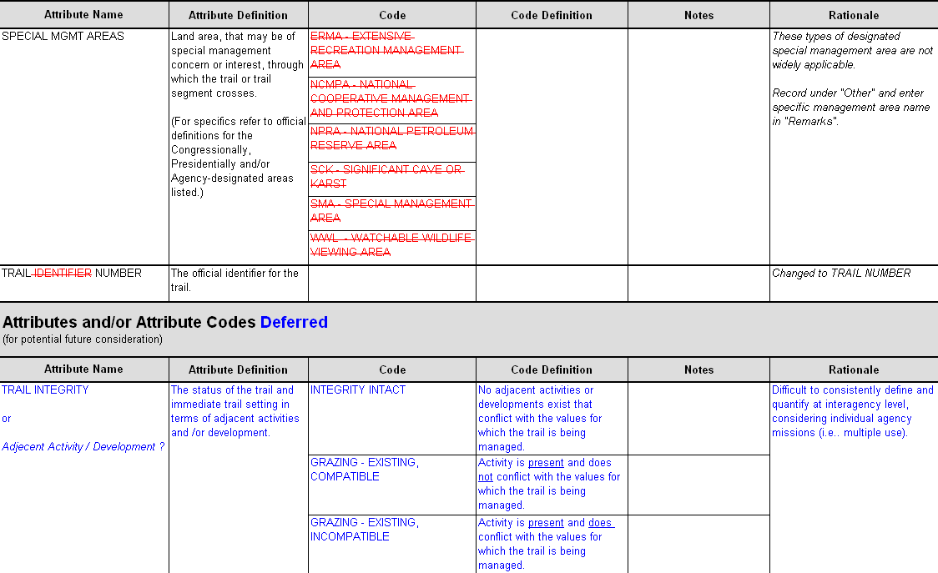
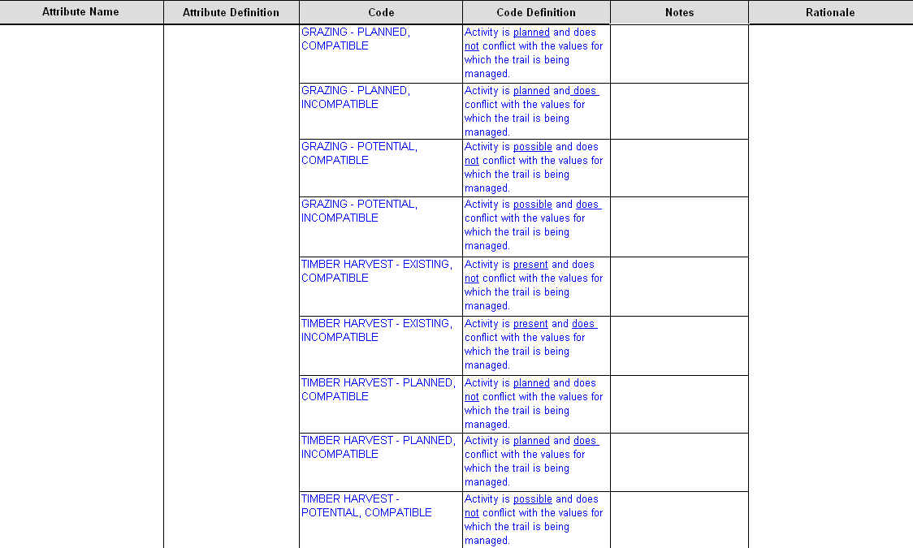
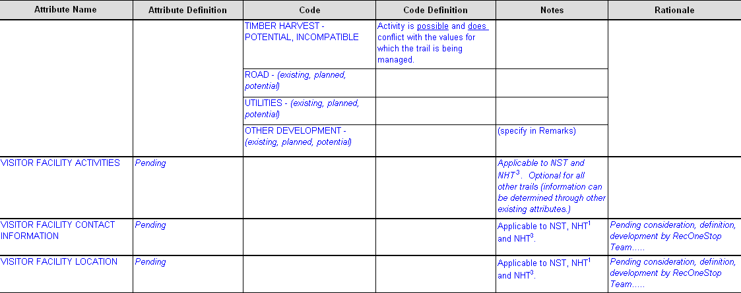

Appendix E

Chronology of the Project
- The Genesis of the Interagency Trail Data Standards: May 2001
At a meeting of federal National Trails System administrators in Denver, Colorado, participants affirm a collective need to inventory, assess and map trail locations and trail resources across multiple jurisdictions throughout the United States. They also recognize that consistent standards would facilitate the exchange of trail data.
- GPS Data Dictionary Team: May 2001 to December 2001
A team of agency representatives discuss the challenge and decide to pursue the production of two GPS (Global Positioning System) data dictionaries. One would be for National Scenic Trails and the other for National Historic Trails. Drafts of both data dictionaries are created.
- Evolution of the GPS Data Dictionary Team into the Interagency Trail Data Standards Team: December 2001
The GPS Data Dictionary Team realizes that the scope of the work needs to expand in order to fully address the needs first identified by the federal National Trails System administrators. The Federal Interagency Council on Trails concurs and calls for the formation of an interagency team of trail, data, and subject-matter specialists who would develop national-level interagency trail data standards. The authority to form the team is based on a provision in the January, 2001, Memorandum of Understanding for the Administration and Management of National Historic and National Scenic Trails.
- Interagency Core Trail Data Standards Charter and Action Plan: February 2002
Agency representatives meet in Phoenix, Arizona to draft a charter for the Interagency Trail Data Standards Team. The charter calls for the establishment of a Core Trail Data Set to be used by the Bureau of Land Management, National Park Service and US Forest Service in the collection, recording and retrieval of trails data for National Scenic Trails, National Historic Trails and other agency trails. Two potential action plans are outlined.
- Interagency Core Trail Data Identification Meeting: July 2002
At a meeting in Phoenix, Arizona, Interagency Core Trail Data needs are identified, the objectives and expectations of the Interagency Draft Charter and Action Plan are reviewed, Core Data Review Criteria are established, the Interagency Definition of a “Trail” is crafted, and Interagency Core Trail Questions (Desired Data Outputs) are identified.
The Interagency Trail Data Standards Team begins the identification of data attributes, definitions and lists of values. Two interagency work groups are created to follow-up on identifying and defining the remaining attributes.
- Completion of Draft Interagency Trail Data Standards: August 2002 to April 2003
The two work groups meet several times via conference calls and/or meetings to complete discussion, review and development of the Draft Interagency Trail Data Standards. The Interagency Trail Data Work Group focuses on the draft standards applicable to all system trails, while the Interagency National Historic Trails (NHT) Data Work Group focuses on an additional subset of unique draft standards applicable only to National Historic Trails.
- Internal Agency Review of Draft Interagency Trail Data Standard: May 1 to May 30, 2003
The draft standards are circulated within the Bureau of Land Management, the National Park Service, and the US Forest Service for review and comment.
- Refinement of Draft ITDS Based on Comments Received from the Internal Agency Review: June 2003 to April 2004
The Interagency Trail Data Standards Team meets in Phoenix, Arizona in July 2003 to review the comments received from the internal agency review. Over the next several months, the team meets via conference calls to complete the crafting of a disposition document and the editing of the data standards files.
- External Review of Draft Interagency Trail Data Standards (ITDS Version 1): May 1 to June 30, 2004
The Draft Interagency Trail Data Standards (ITDS Version 1) are posted on a web site (http://www.nps.gov/gis/trails/ ) for review by agency partners, state trail coordinators, and other interested trail groups and individuals.
- US Fish and Wildlife Service Joins the Team: October, 2004
- Refinement of ITDS Version 1 Based on Comments Received from the External Review: July, 2004 to September, 2006
The Interagency Trail Data Standards Team meets in Denver, Colorado in July 2004 to review the comments received from the external review. Periodic conference calls continue the work.
Members of the team advance the incorporation and implementation of the Interagency Trail Data Standards within the Department of the Interior (National Park Service, Bureau of Land Management, and US Fish and Wildlife Service). Implementation is almost completed within the USDA Forest Service.
A task team works with GIS professionals to refine the geospatial component of the data standards. A second task team contracts with North Carolina State University to do a proof of concept pilot project in which the ITDS is applied to a selected area in the Greater Yellowstone ecosystem.
Core members of the ITDS team meet in Anchorage, Alaska in September 2006 to thoroughly review the ITDS Spreadsheet (Attributes, Definitions, LOVs, etc.)
- Next Step – ITDS to FGDC Trail Data Standard: FY 2007
ITDS Version 2 is released to the public via posting on the web.

The North Carolina State University team is contracted to transform the ITDS into a Federal Geographic Data Committee (FGDC) Trail Data Standard. The Standard will be in two separate parts:
- Data Content provides semantic definitions of a set of objects. This part specifies and defines the data elements associated with trails.
- Data Transfer describes how to produce or consume packages of data, independent of technology and applications that will facilitate moving data between agencies and systems.

Appendix F

Acronyms and Abbreviations
4WD | Four Wheel Drive
ACHP | Advisory Council on Historic Preservation
ADMIN | Administrative
ATV | All-terrain vehicle
BIA | Bureau of Indian Affairs (in Department of the Interior)
BLM | Bureau of Land Management (in Department of the Interior)
BMP | Beginning measure point
BOR | Bureau of Reclamation (in Department of the Interior)
CFR | Code of Federal Regulations
Desig | Designated
DEV | Developed
DOD | Department of Defense
DOE | Department of Energy
E-gov,  E-Government | The Presidential E-Government Initiatives; Electronic Government
EMP | Ending measure point
ESRI | Environmental Systems Research Institute
FAA | Federal Aviation Administration (in Department of Transportation)
FAMS | Facility Asset Management System (Bureau of Land Management)
FGDC | Federal Geographic Data Committee
FMSS | Facility Management Software System (National Park Service)
FS | USDA Forest Service (in Department of Agriculture) [same as USFS]
FWS | United States Fish and Wildlife Service (in Department of the Interior)
FY | Fiscal year
GIS | Geographic Information System
GPRA | Government Performance and Results Act of 1993 (P. L. 103-62)
GPS | Global Positioning System
GVW | Gross Vehicle Weight
HR | Heritage Resource(s)
Infra | USFS Infrastructure Database (corporate database)
INTERP | Interpretive
ITDS | Interagency Trail Data Standards
Lat/Long | Latitude/Longitude
LOV | List of Values (also known as: “Code List”, “Coded Domain”, or “Coded Value Domain”)
MAXIMO ™ | Off-the-shelf asset-based work identification, work management, and work analysis program
MGMT | Management
MP | Milepost
MTR | Motorized
MOU | Memorandum of Understanding
NA | Not applicable
NEPA | National Environmental Policy Act of 1969
NGO | Nongovernmental Organization
NHT | National Historic Trail
NMTR | Non-motorized
No. | Number
NPS | National Park Service (in the Department of the Interior)
NRHP | National Register of Historic Places
NSPC | Not specified
NSSDA | National Standards for Spatial Data Accuracy
NST | National Scenic Trail
NTS | National Trails System
OCTA | Oregon-California Trails Association
OHV | Off-highway vehicle
OMB | Office of Management and Budget
ORG | Organization
OSV | Over-snow vehicle
P. L. | Public Law
Paleo | Paleontological
REC, Rec | Recreation
RecOneStop | Recreation One-Stop (http://www.recreation.gov/)
Reg | Regular
ROS | Recreation Opportunity Spectrum
ROW | Rights-of-Way
SAMMS | Service Asset Maintenance Management System (US Fish and Wildlife Service)
SDG | Standards Development Group (for FGDC trail standards, the SDG is primarily comprised of the ITDS Team)
SHPO | State Historic Preservation Office
SWG | FGDC Standards Working Group
U.S. | United States
USACE | United States Army Corps of Engineers (in Department of Defense)
USC | United States Code [of Federal Regulations]
USDA | United States Department of Agriculture
USFS | USDA Forest Service (in Department of Agriculture) [same as FS]
USGS | United States Geological Survey
VRM | Visual Resource Management
WROS | Wilderness Recreation Opportunity Spectrum
WSR | Wild and Scenic River

